**Lesson Demo**

**Histograms**

●    How many orders have been placed in bin 4? (**Note**: Enable Labels)

●    Which customer is generating the highest profit, and what is the value and number of orders placed by that customer?

**Overview:**

* Create a calculated field to show distinct orders placed by the customer using an LOD calculation
* Create a calculated field to generate the rank of customers using the index function
* Create a view using these calculated fields
* Break the view by placing the customer name in detail
* Color the view with profit
* Set the scope of table calculation applied to rank as customer name
* Sort the calculations in ascending order based on profit
* Change the default color of marks using the color property

The result should resemble the image given below:

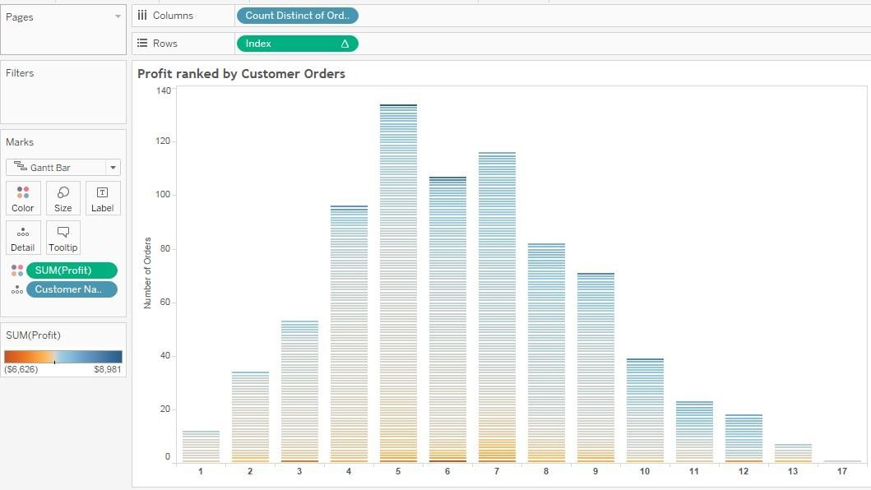

**Detailed Instructions:**

1. Open a new sheet in the same workbook
2. Select the **Create Calculated Field** on the analysis menuGraphical user interface, application

   Description automatically generated
3. Select **Count Distinct Orders** in the name box of calculated field window
4. In the formula box, type: **{FIXED [Customer Name]:COUNTD([Order ID])}**
5. Click **OK**

1. Create another calculated field for **Index**
2. In the formula box, type **INDEX()**
3. Click **OK**

1. To create a view, drag and drop **Count Distinct Orders** from dimensions to columns

1. Right-click on **Count Distinct Orders** pill to change into **Dimension**

1. From measures, drag and drop **Index** to **Rows**

1. From measures, locate and drag **Customer Name** to **Detail**

1. To add a table calculation, right-click on **Index** and from context menu select **Edit Table Calculation**

1. Select **Specific Dimensions** from the **Table Calculation** windowGraphical user interface, application

   Description automatically generated
2. Drag and drop **Customer Name** above **Count Distinct Orders**
3. Select the **Customer Name** checkbox

1. Select **Custom Sort** in the **Sort Order** drop-down
2. Select **Profit** from the drop-down list and set aggregation as **Sum**
3. Make sure the **Ascending** radio button is selected and close the window

1. Click the **Automatic** drop down and select **Gantt** under **Marks**

**Note**: The Gantt chart is made.

1. Drag the **Profit** measure to **Color**

1. Click **Color** and select **Edit Colors** to edit color

1. Select the **Orange-Blue Diverging** palette from the **Edit Colors** window

1. Click **OK**

1. Right-click on the Y-axis or X-axis to change the intervals. In the **Edit Axis window,** select **Major Tick Marks** as **Fixed** and set the interval as **20** or as required

1. Rename this sheet as **Profit ranked by Customer Orders**

1. Save this workbook as **Lesson 7 - Exercises**
2. Close the workbook

**Answers**

Based on the view, these are the answers to the questions in the problem statement:

* How many orders have been placed in the bin 4? Answer: **96**
* Which customer is generating highest profit and what’s the value and number of orders placed by that customer?

Answer: **Tamara Chand, $8981, and 5**