**Lesson 03 Demo 01**

**Joins and Data Extract**

* Which is the least profitable state?
* Customers from which state have returned the highest number of products?

**Overview:**

* Combine the Orders, Returns, and People tables
* Use inner join to combine Orders and People tables
* Use the left join between Orders and Returns table
* Create the required view
* Enable mark labels
* Create an incremental refresh extract using the order date field

The result should resemble the following image:

**Detailed Instructions**



**

2.On the home page, under **Connect**, under **To a File**, click **Excel**

3.Browse and connect to the **Sample - Superstore Excel file**

4. Drag and drop **Orders** and **People** tables to the canvas area

5.Make sure the **Inner join** is selected

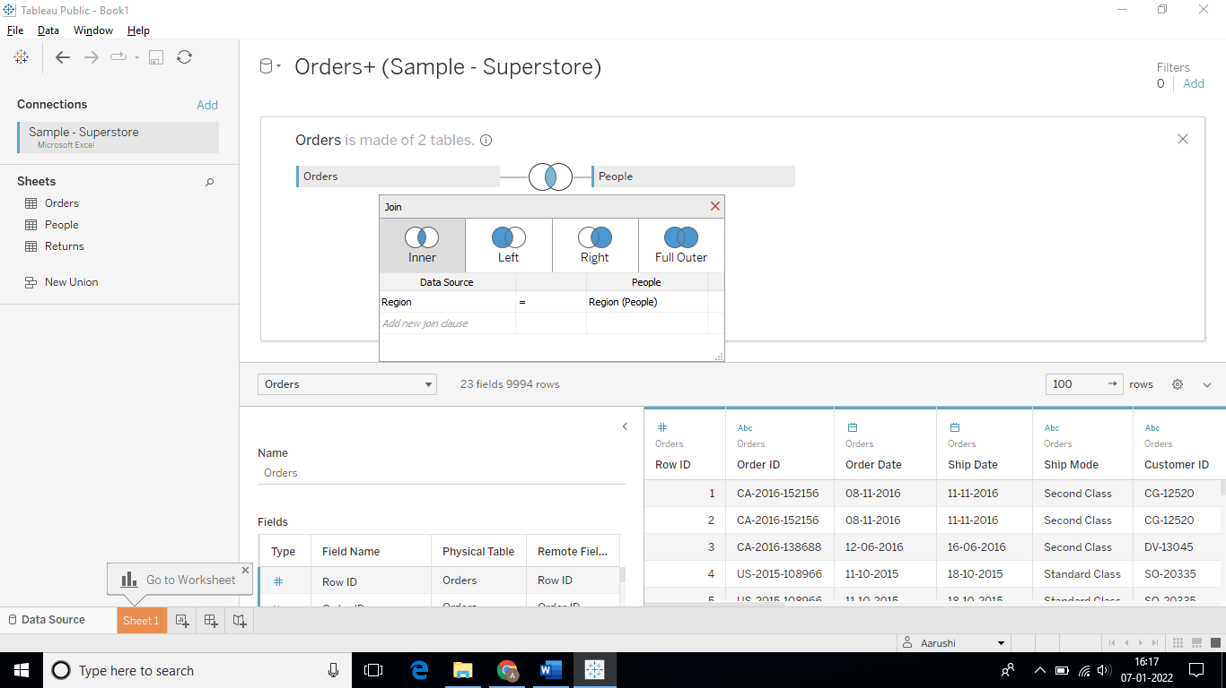

6.Place the **Returns table** in the canvas area and select **Left Join**

7.To create a view, go to **Sheet 1**

8.From Dimensions, locate **State** and **Person** and place them on rows

9.From Measures, locate **Profit** andplace it on columns

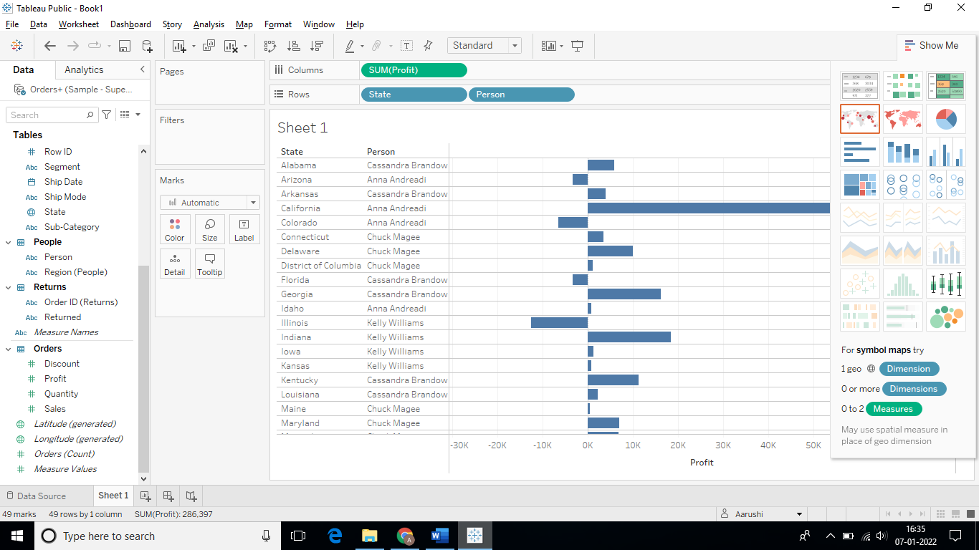

10.On the toolbar, use the **Sort icon** to sort the view in descending order

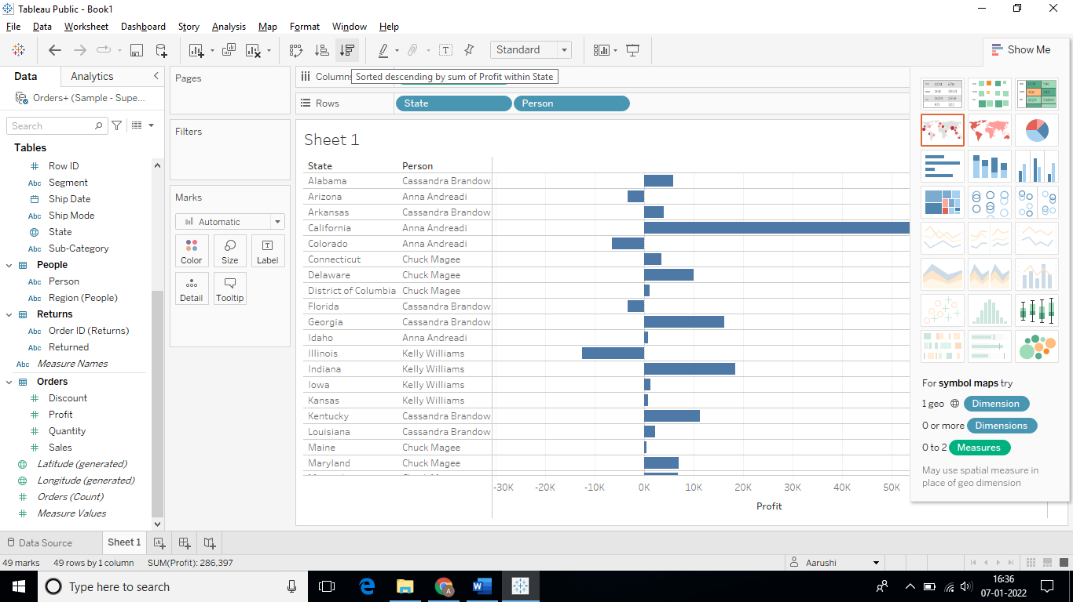

The sorted view is as follows:

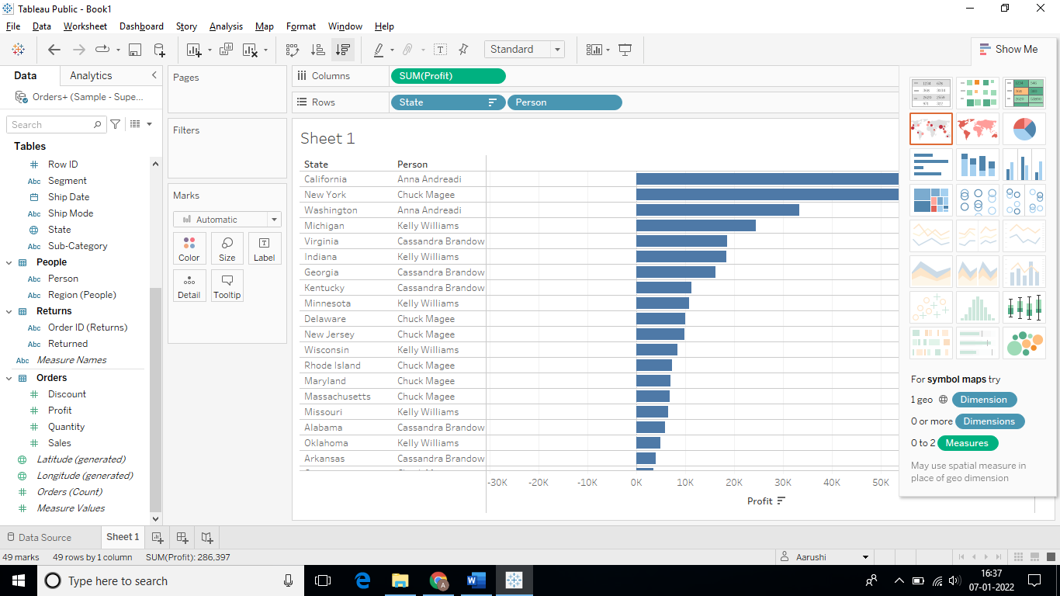

11.To count the number of orders placed, locate **Order ID (Returns)** from Dimensions and place them on columns

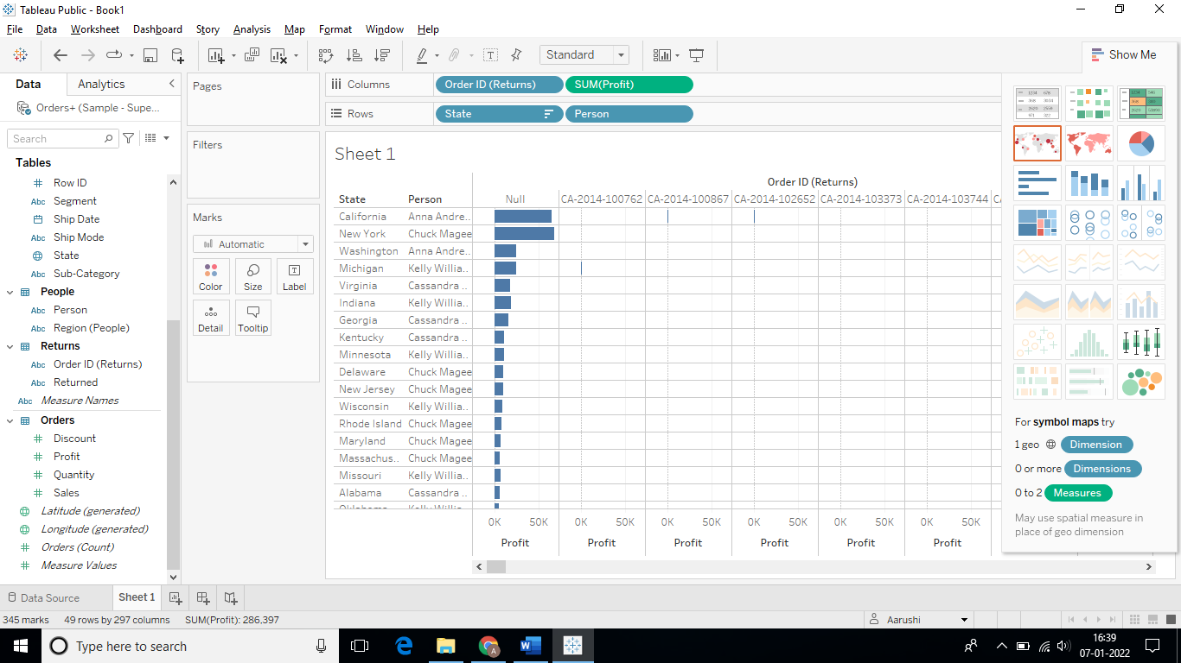

12.Select aggregation as **Count Distinct**

(Right click on **Order ID (Returns)** in **Columns** -> **Measure** -> **Count Distinct)**

The result will be as follows:

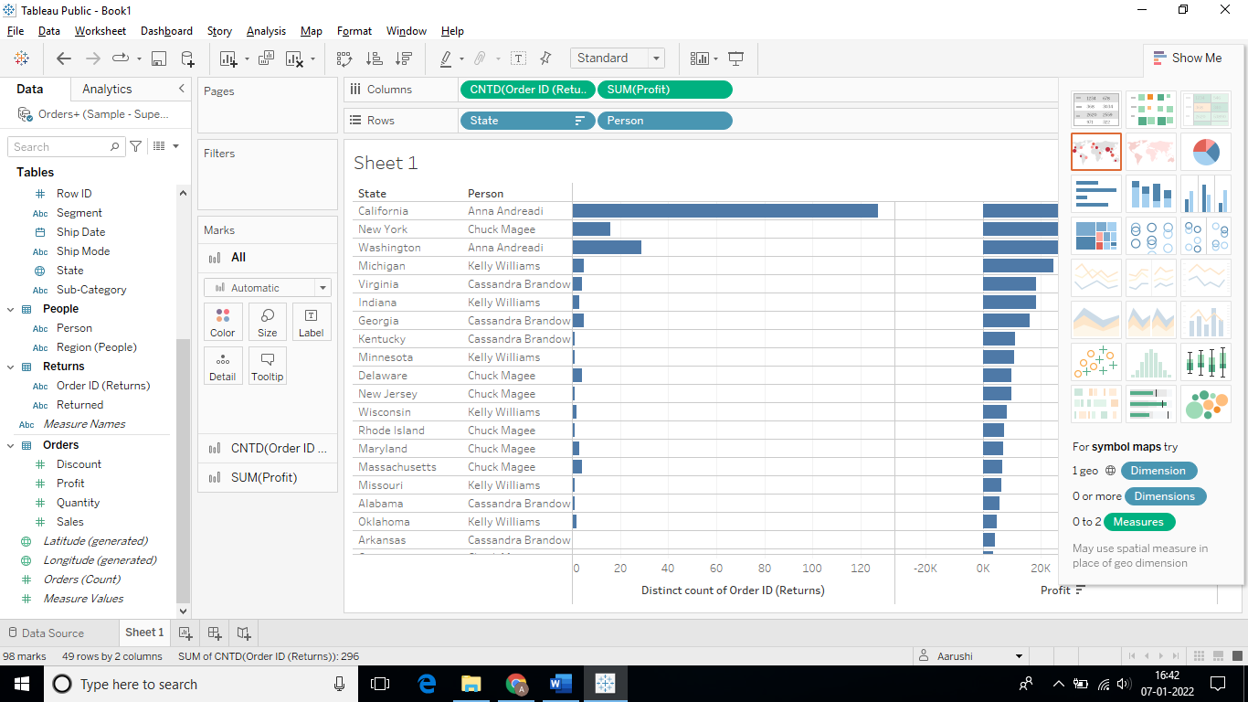

13.To create an extract, under **data** -> **Orders + (Sample – Superstore)** -> **Extract Data**

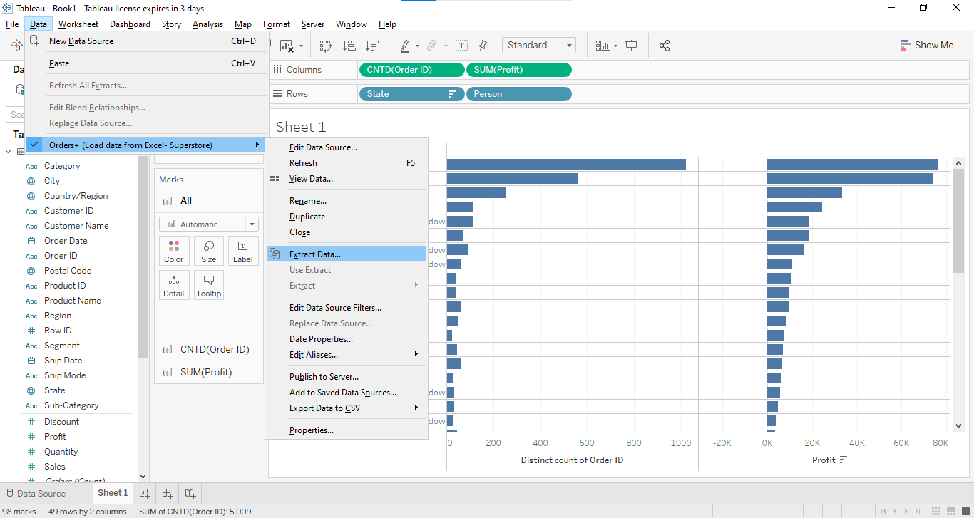

14.In the **Extract Data window**, select the **Incremental Refresh** check box

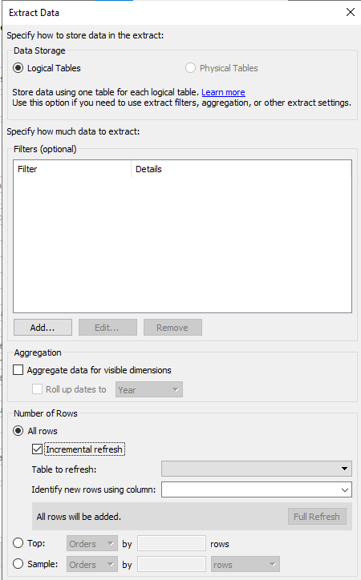

15.From the drop-down, select **Order Date** andclick **Extract**

16.Specify a path for the extract and rename the worksheet as **Profit by State**

17.Save the workbook as **Lesson 3 – Exercises**

Keep the workbook open to perform the next exercise.

**Answers:**

Based on the view, these are the answers to the questions in the problem statement:

* Which is the least profitable state?

Answer: **Texas**

* Customers from which state have returned the highest number of products?

Answer: **California**