**Lesson 9 Demo 01**

**Parameters**

* Which Sub-Category has the lowest profit?
* Which customer has generated the highest sales?

**Overview:**

* Create a parameter to dynamically change Dimensions in a view
* Create a parameter to dynamically change Measures in a view
* Create the calculated fields using these parameters
* Create a view using these calculated fields

The result should resemble the image given below:

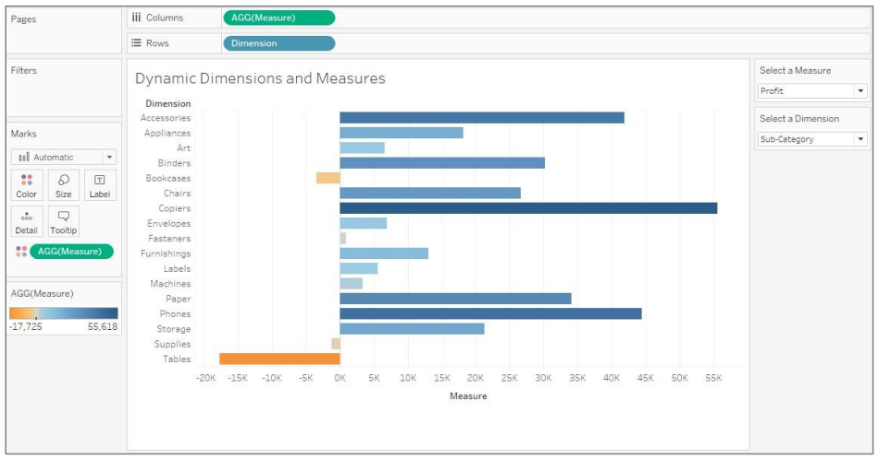

**Detailed Instructions:**

1. Open **Tableau 10.x** (You can go to Start Menu -> All Programs -> Tableau 10.x).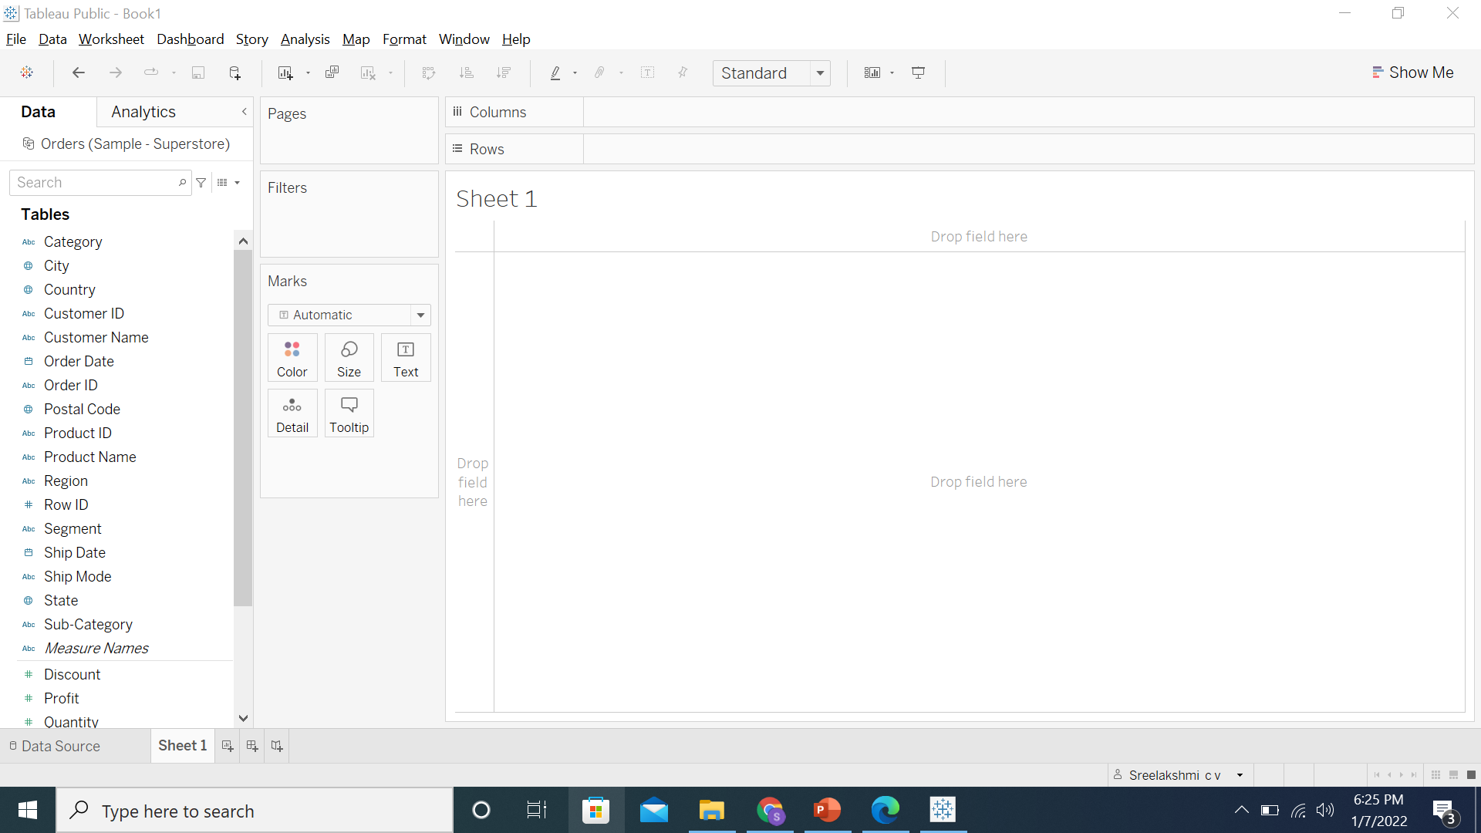
2. From the home page, connect to the saved **Sample – Superstore** dataset

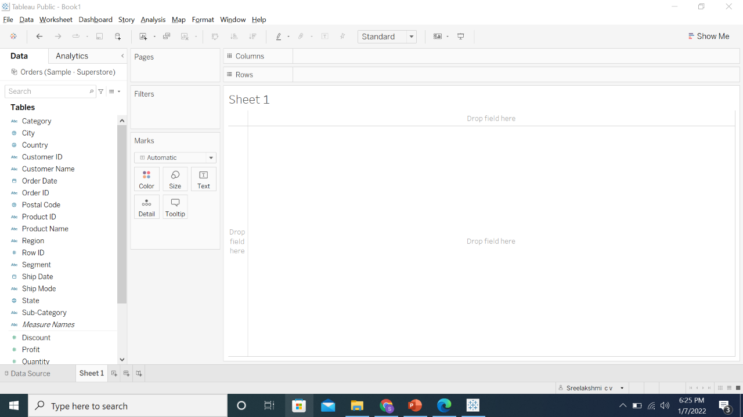

1. Create a parameter called **Select a Dimension**

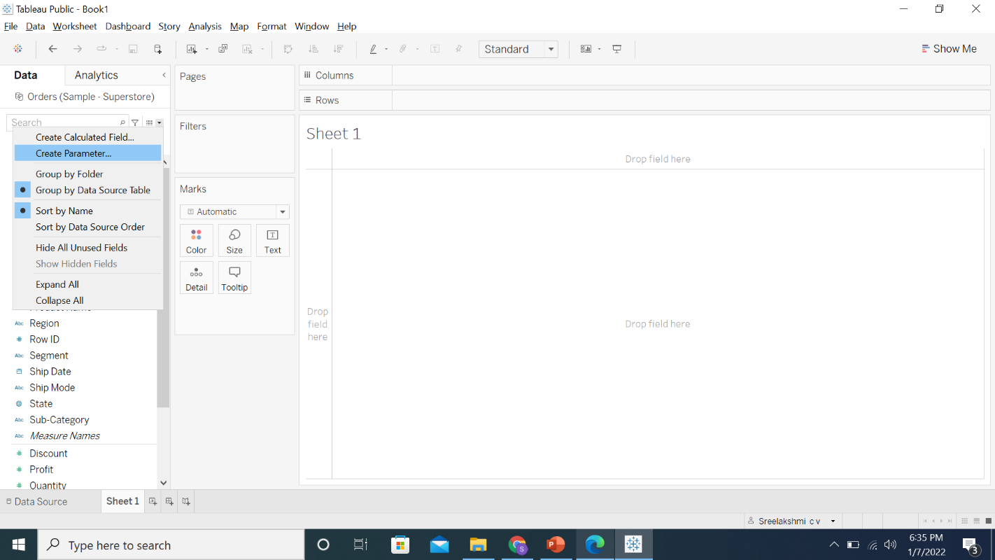

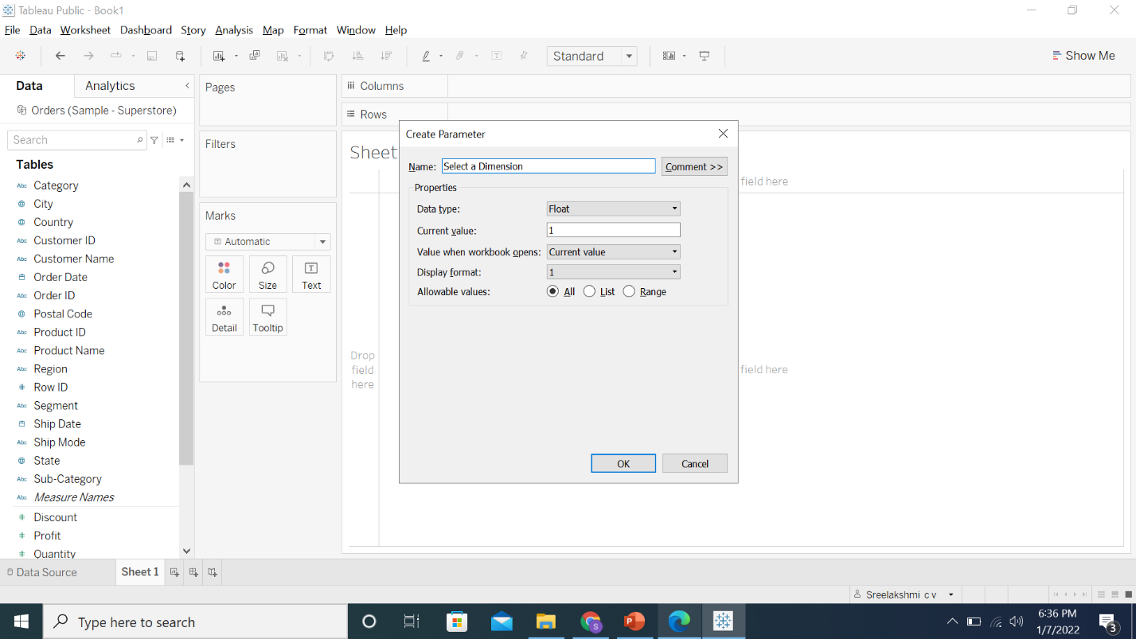

1. In the parameter editor, select the Data type as **Integer**

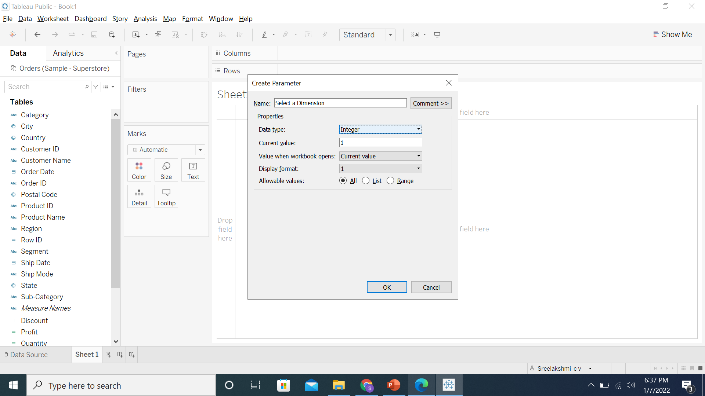

1. Select the **List** radio button

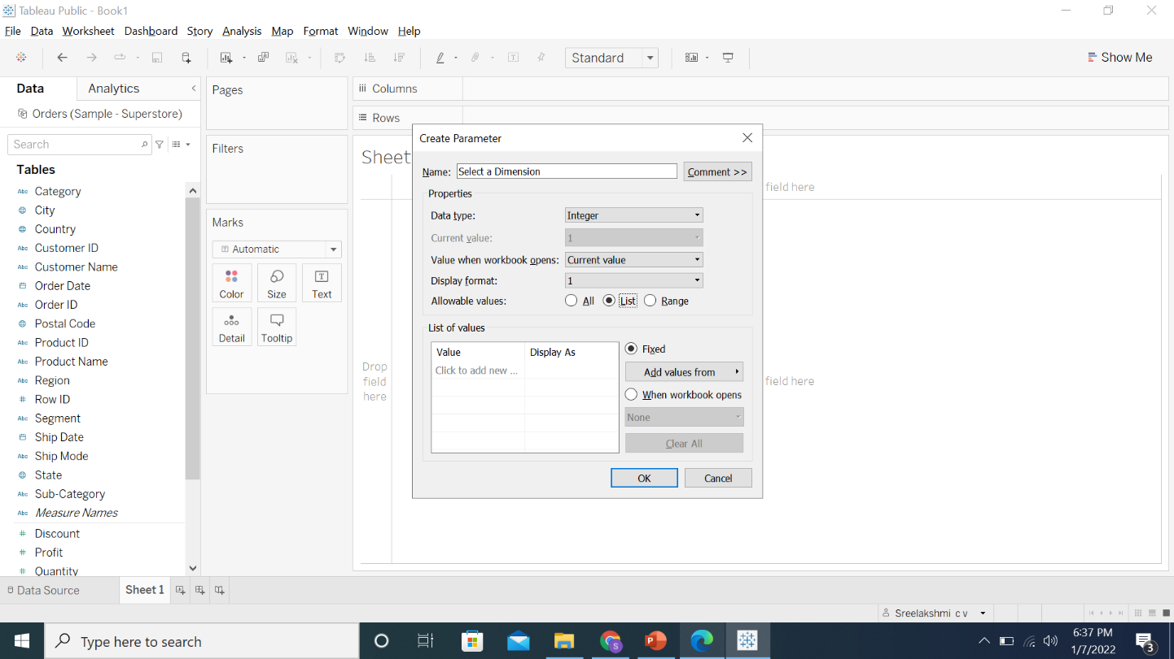

1. Enter the list as below:

**1 Sub-Category**

**2 Region**

**3 Customer Name**

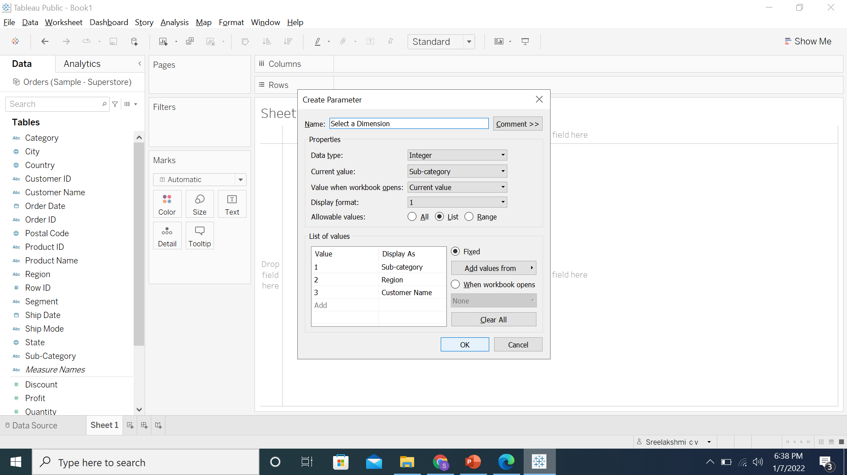

1. Create a calculated field using this parameter

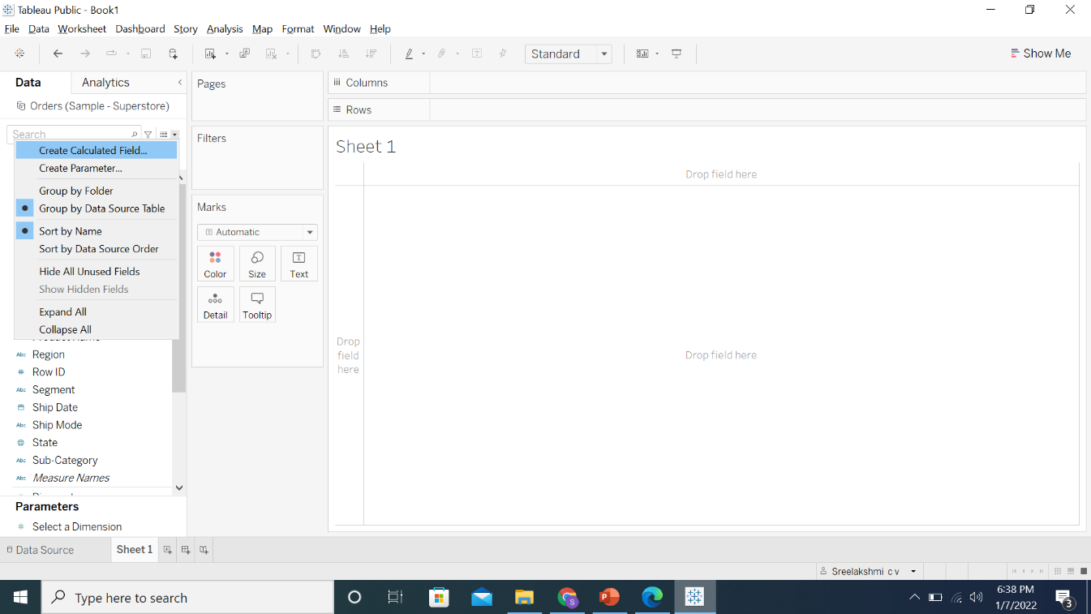

1. Name this calculation **Dimension** and enter the formula below:

**CASE [Select a Dimension]**

**WHEN 1 THEN [Sub-Category]**

**WHEN 2 THEN [Region]**

**ELSE [Customer Name]**

**END**

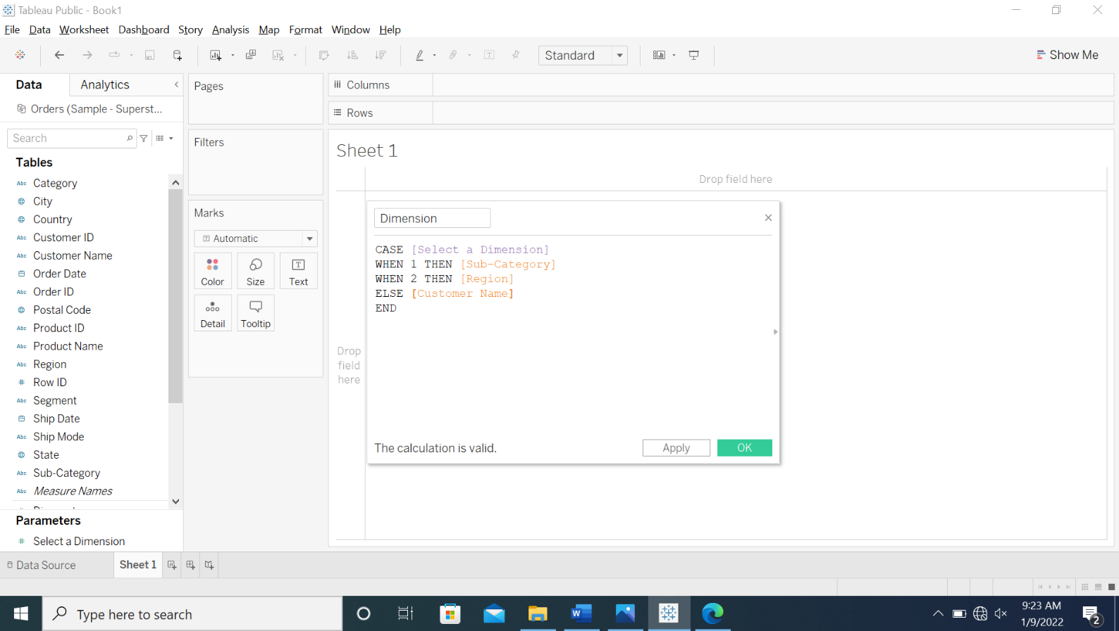

1. Click **OK**

1. To create another parameter, repeat steps 3 to 5. Name this parameter as **Select a Measure**. Ensure that your output looks like the image below

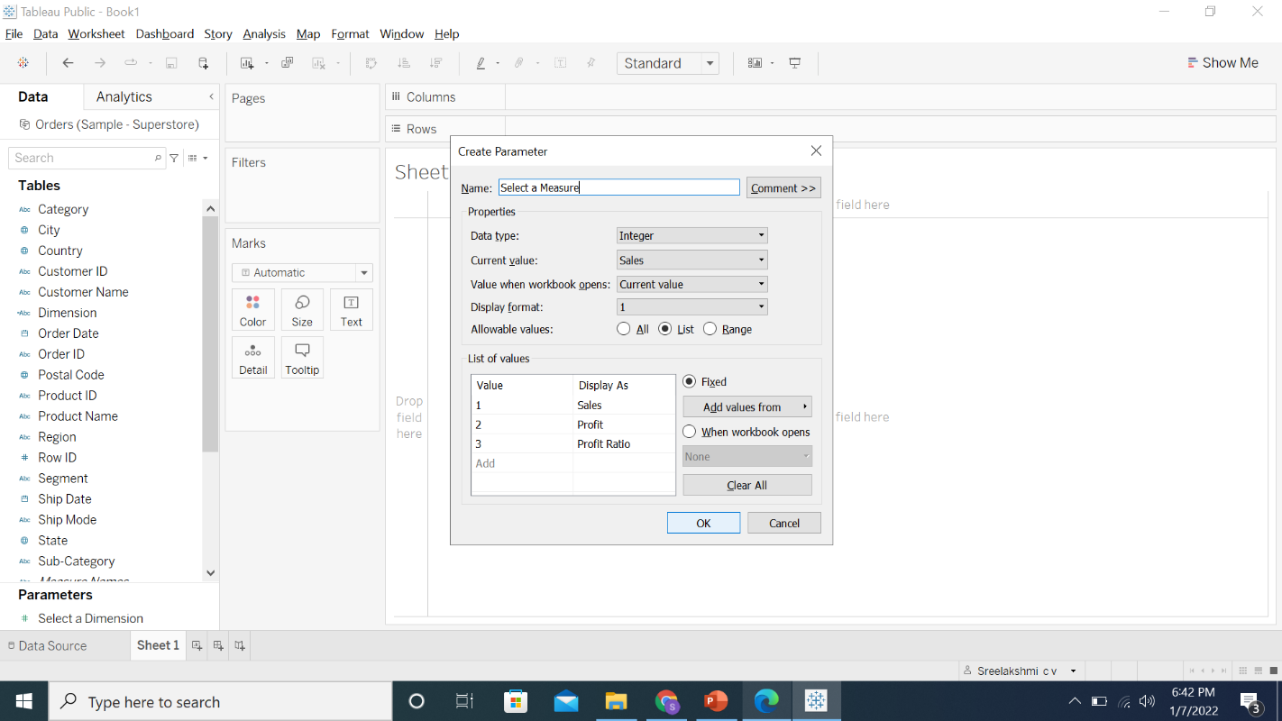

1. Create another calculated field using this parameter

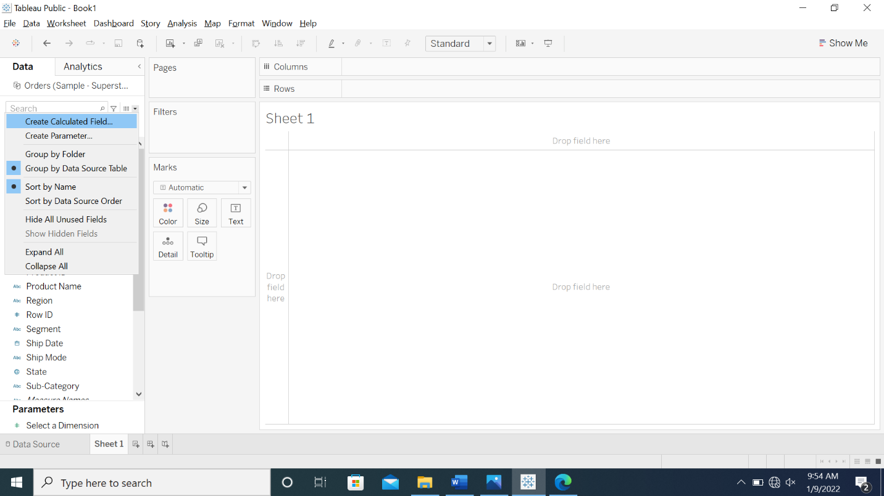

1. Name this calculation **Measure** and enter the formula below:

**CASE [Select a Measure]**

**WHEN 1 THEN SUM([Sales])**

**WHEN 2 THEN SUM([Profit])**

**ELSE [Profit Ratio]**

**END**

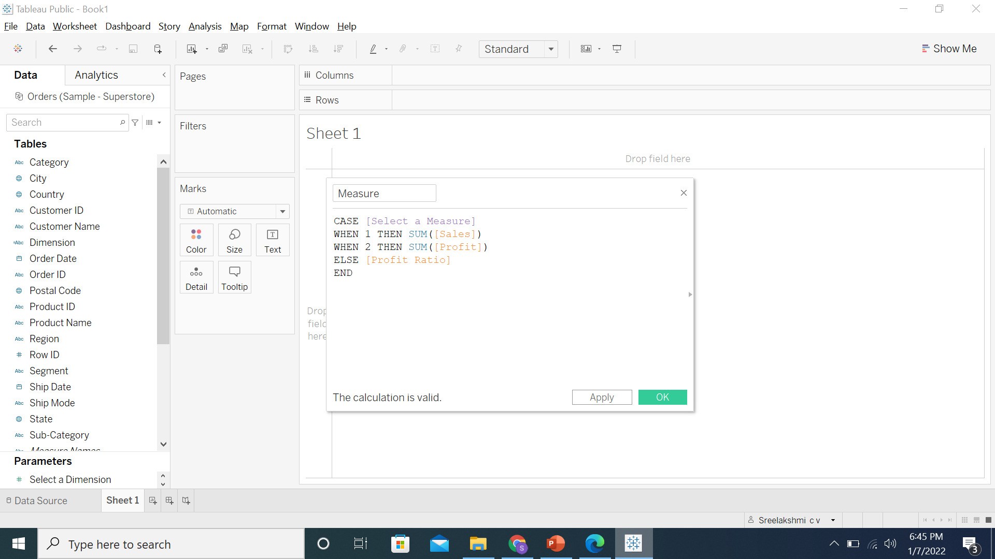

1. Click **OK**



1. To create a view, drag the **Dimension** calculated field to **Rows** and **Measure** to **Columns**

1. To show parameter control, right-click the parameters and select **Show Parameter**

15.1. Right-click on **Select a Measure** and select **Show Parameter**

15.2. Right-click on **Select a Dimension** and select **Show Parameter**

1. To color the marks, drag the **Measure** calculated field to **Color**

1. Rename the sheet as **Dynamic Dimensions and Measures**

1. Save the workbook as **Lesson 9 - Exercise**

**Answers**

Based on the view, these are the answers to the questions in the problem statement:

* Which Sub-Category has the lowest profit?

Answer: **Tables**

* Which Customer has generated the highest sales?

Answer: **Sean Miller**