**Lesson 8 Demo 02**

**Calculated Fields and Tableau Calculations**

**Business Scenario:**

Comparing quarterly earnings is an important way to measure a company's financial performance during a specific year. This gives analysts, investors, and other participants an idea of how much a company's sales are increasing over time. For this, the data analyst of a consumer product company needs to analyze the difference between the average orders and the current orders for this year and all previous years every quarter. This will give the investors an idea of how well the company is doing.

**Overview:**

* Use the Sample–Superstore excel sheet as the data source
* Create a calculated field to calculate this year’s average difference using the formula: SUM ([Quantity]) - WINDOW_AVG (SUM ([Quantity]), First (), Last ())
* Create another calculated field to calculate the average difference over all years using the formula: ZN (SUM ([Quantity])) – Window_AVG (SUM ([Quantity]))
* Use the Order Date dimension and perform drilling to break the data into quarters
* Use the newly created calculated fields and order quantity to complete the view
* Use the Category dimension to differentiate the data using colors

The result should resemble the image given below:

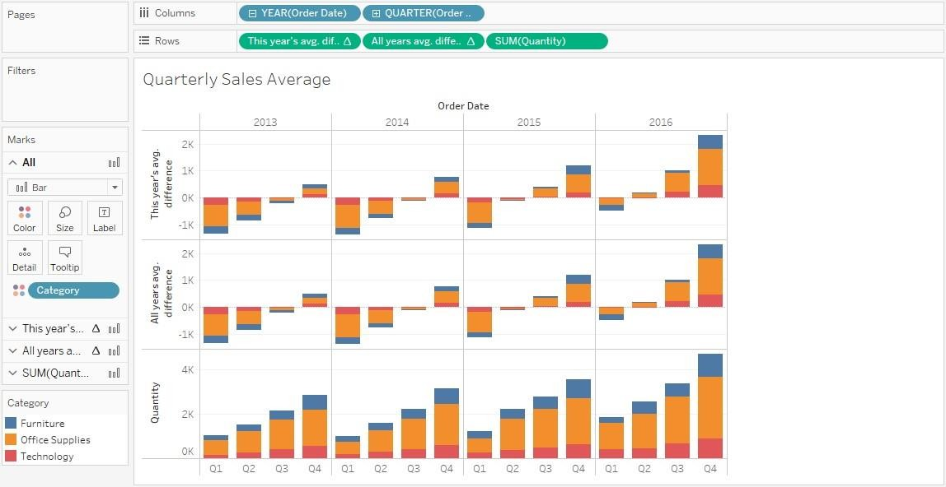

**Detailed Instructions:**

1. Navigate to a new sheet

1. Click the drop-down in the data pane of the Dimension header and select **Create Calculated Field**

1. Name the new field as **This Year's Avg. Difference**

1. In the Formula text box, type the following:

**SUM ([Quantity]) - WINDOW_AVG (SUM ([Quantity]), First (), Last ())**

1. Click **OK**

1. Click the drop-down in the data pane of the dimension header and select **Create Calculated Field**

1. Name the new field as **All Years’ Avg. Difference**

1. In the formula text box, type the following:

**ZN (SUM ([Quantity])) - Window_AVG (SUM ([Quantity]))**

1. Click **OK**

1. Under dimensions in the data pane, locate and drag **Order Date** to the **Columns** shelf

1. Drill from **Year (Order Date)** to **Quarter (Order Date)** by clicking the **+** icon on **Year (Order Date)** on the **Columns** shelf

1. Under dimensions in the data pane, locate and drag **This Year’s Avg. Difference**, **All Years Avg. Difference**, and **Quantity** to the **Rows** shelf

1. Select **Bar** in the marks card of the drop-down list

1. Under dimensions in the data pane, locate and drag **Category** to **Color** shelf in the marks card

1. Rename the sheet as **Quarterly Sales Average**

1. Save this workbook as **Lesson 6 - Exercise**

