Lesson 7 Demo 1

Scatter plots and Motion charts

# 

In the West region, which state has only one product? (**Hint:** Filter using the State dimension with one product)

* Which product had the highest Profit and Sales in the East Region a couple of years back? (**Hint**: Change the level of **Order Date** in the **Pages** shelf to **YEAR (Order Date)**)

# Overview:

* Create a scatter plot with Sales, Profit, Region, and Product Name
* Add Category to the Color shelf
* Use the Pages shelf to create a motion chart with Order Date at the Monthly level

The result should resemble the image below:

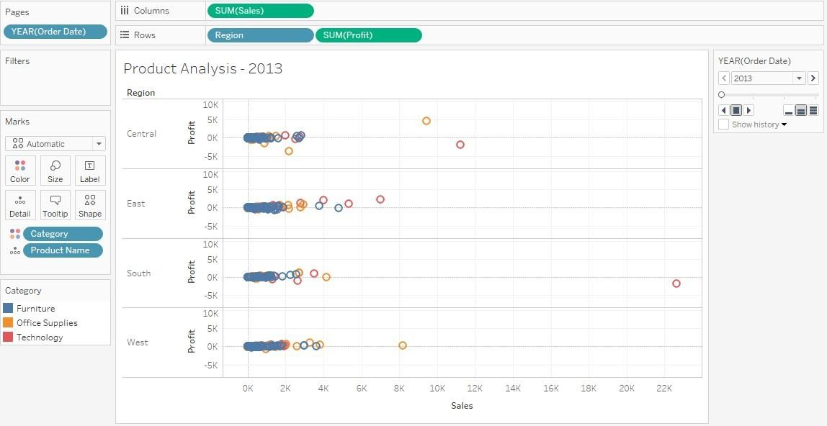

# Detailed Instructions:

1. Open **Tableau 10.x** (You can go to Start Menu -> All Programs -> Tableau 10.x)

1. Connect to the saved **Sample - Superstore** data source

1. Open a new sheet

1. Drag **Profit** to **Rows** and **Sales** to **Columns** and then go to **Show Me** and select **Scatter plots**

1. Add **Region** to the **Rows** shelf

1. Add **Category** to the **Color** shelf

1. Add **Product Name** to the **Detail** shelf

1. Drag **Order Date** to the **Pages** shelf, right-click on it, and select **Month** under **YEAR (Order Date)**

1. Hit the **Play** button to set the view in motion

1. Rename the worksheet as **Product Analysis**

## Note: Keep the workbook open to perform the next exercise.

## Answers:

Based on the view, these are the answers to the questions in the problem statement:

* In the West region, which state has only one product?

Answer: Wyoming

* Which product had the highest Profit and Sales in the East Region in the year 2016?

Answer: Canon imageCLASS 2200 Advanced Copier