**Lesson Demo**

**Using Custom Dates**

1. In August 2014, which category recorded the highest sales?
2. Which month in 2015 has the highest accumulated profit ratio across all product categories?

**Overview:**

1. Create a custom date on Order Date at Month/Year level
2. Create a Highlight table with Order Date (Month/Year), Category, and Sales
3. Add Profit Ratio to the tooltip
4. Sort months by profit ratio in descending order

The result should resemble the image given below:

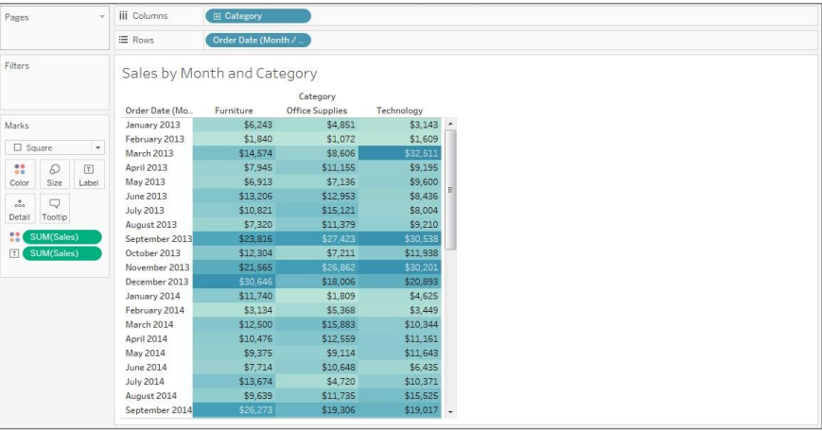

**Detailed Instructions:**

1. In the workbook from Exercise 10.1, click on **New worksheet** icon

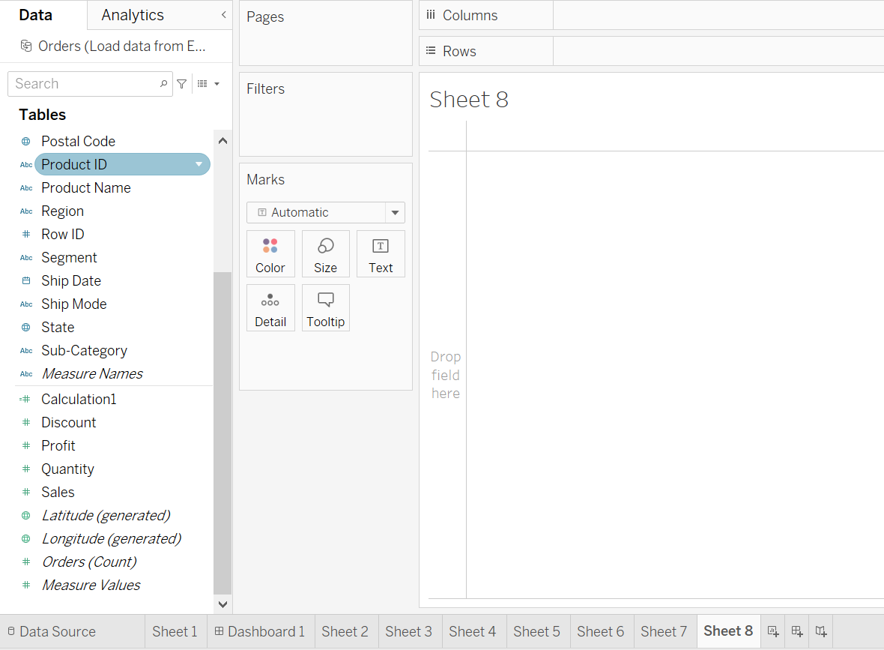

1. To create a custom date, right-click on **Order Date** dimension, and from **the Create menu**, select **Custom Date**

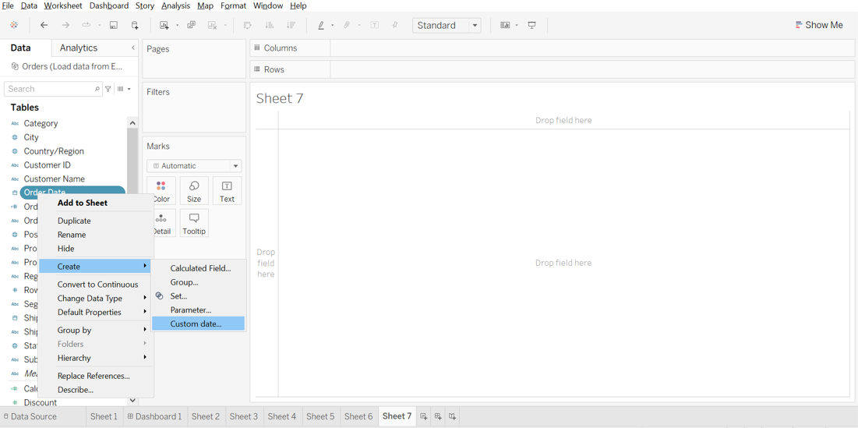

1. In the Create Custom Data [Order Date] window, choose Detail as **Month/Year** and click **OK**

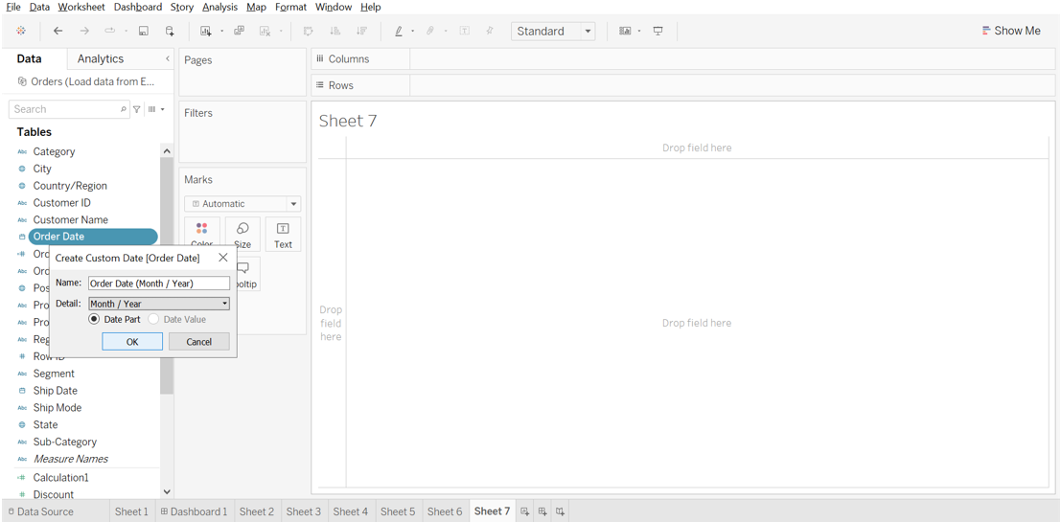

1. This creates a new dimension: **Order Date (Month/Year)**

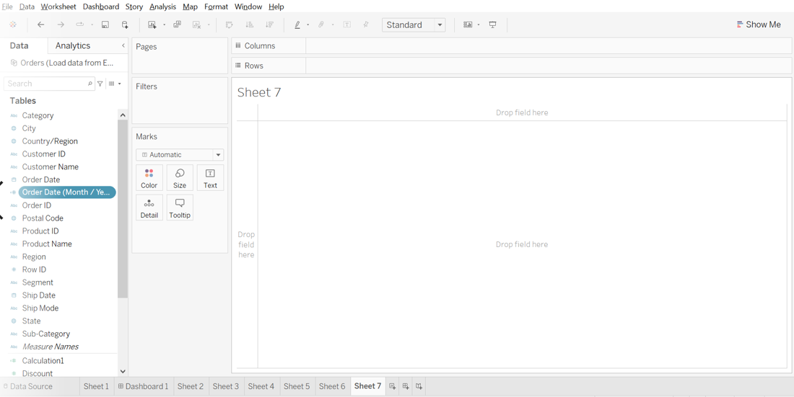

1. Create a highlight text table with **Order Date (Month/Year)** in **Rows**, **Product Category** in **Columns**, and **Sales** in **text**

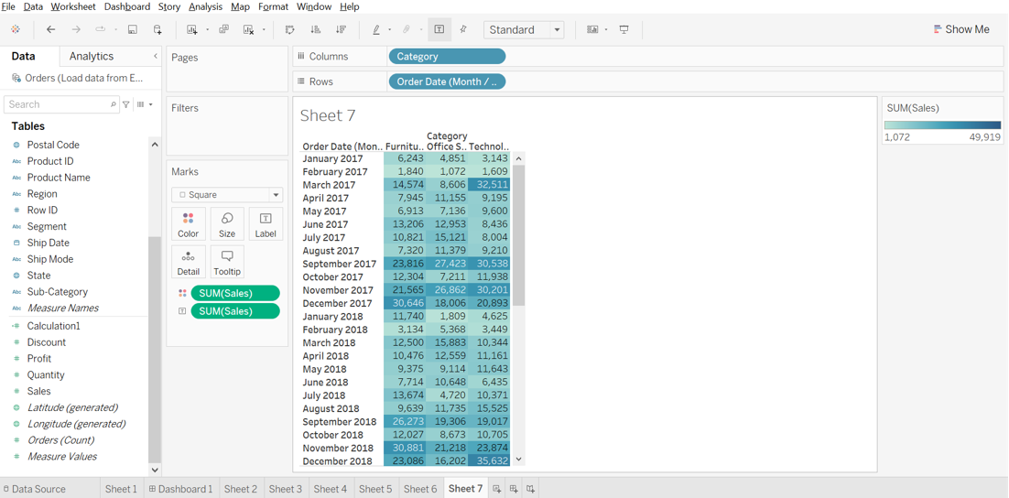

1. Add **Profit** to the **Tooltip** shelf

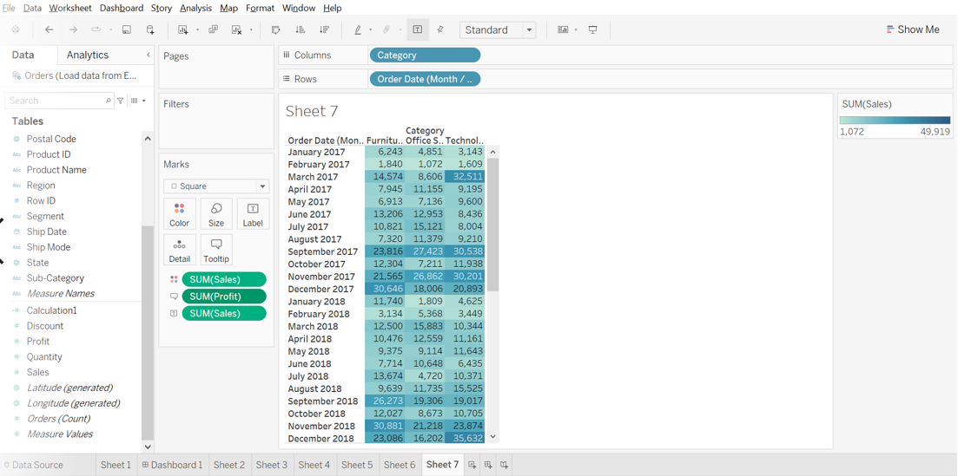

1. Now, rename the worksheet as **Sales by Month and Category,** **Save** the workbook as **Lesson 10 Exercise**, and **Close** it

Based on the view, these are the answers to the questions in the problem statement:

• In August 2014, which category recorded the highest sales?   
 Answer: **Technology**

• Which month in 2015 has the highest accumulated profit ratio across all product categories?   
 Answer: **October**