**Lesson 7 Demo 2**

**Plotting Pie charts on a Map**

* Which state has the highest percentage of contribution of sales?
* What is New York’s Profit Ratio for the Corporate segment?

**Overview:**

* Create a filled map with State dimension and Color it by Region
* Create a dual axis map
* Change the second map to a symbol map
* Size the Marks by Percent contribution of Sales, and Color by Segment
* Change the mark type to Pie

The result should resemble the image given below:

**Detailed Instructions:**

1. Open **Tableau 10** (You can go to Start Menu -> All Programs -> Tableau )
2. Chart

   Description automatically generated with medium confidence On the home page, under **Connect**, under **To a file**, click **Microsoft Excel**.

Browse and connect to the **Sample - Superstore** Excel file

(NOTE: Provided in assisted practice)

1. Drag and drop **Orders** table to the canvas area

1. Create a filled map with the **State** dimension and add **Country** dimension in the **Detail** shelf

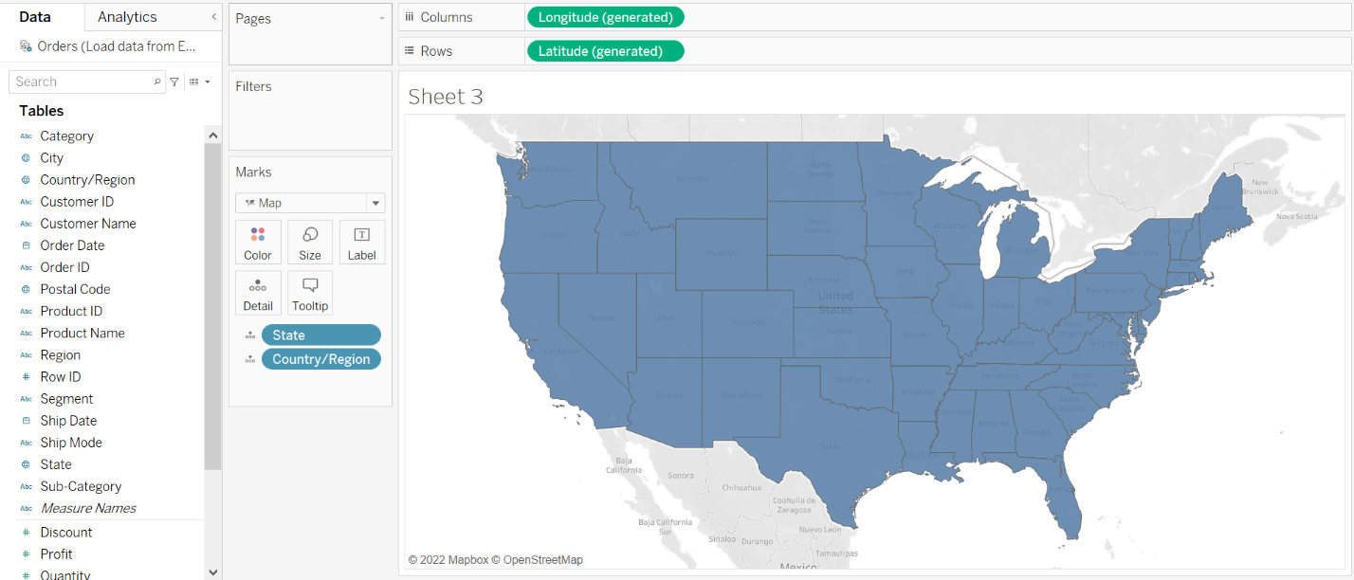

1. Drag the **Region** to the **Color** shelf

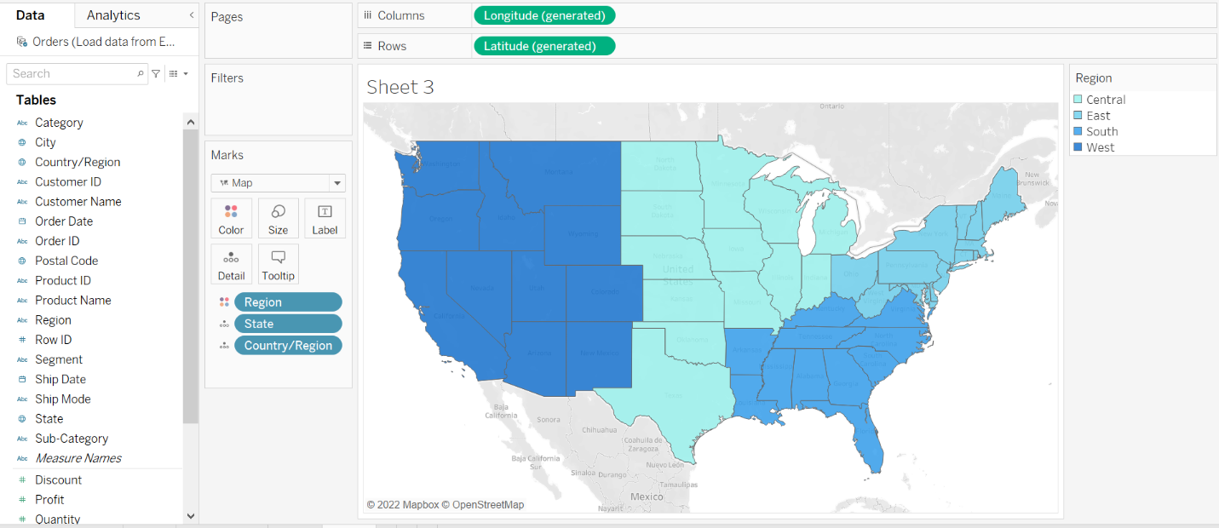

1. Drag another instance of **Latitude (generated)** to the **Rows** shelf

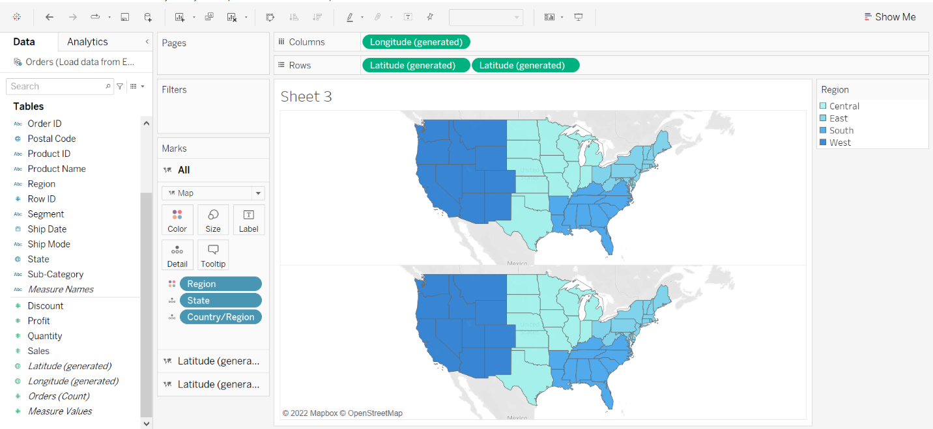

1. Under the Marks card for the second **Latitude (generated)**, select the **Mark Type** as **Pie**

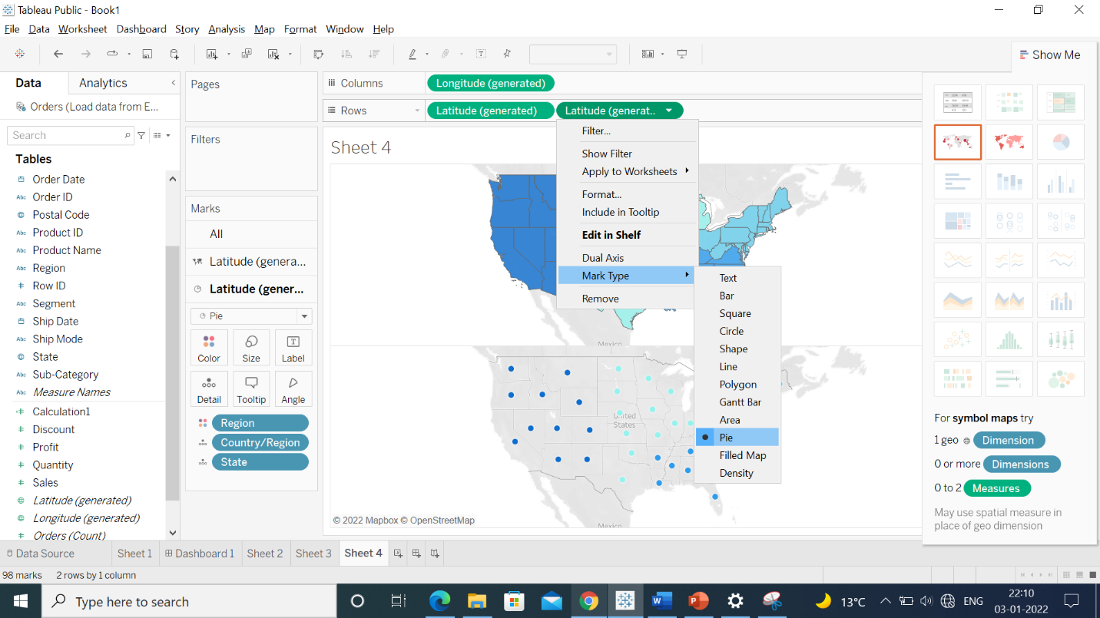

1. Drag the **Segment** dimension to the **Color** shelf and the **Sales** measure to the **Size** shelf

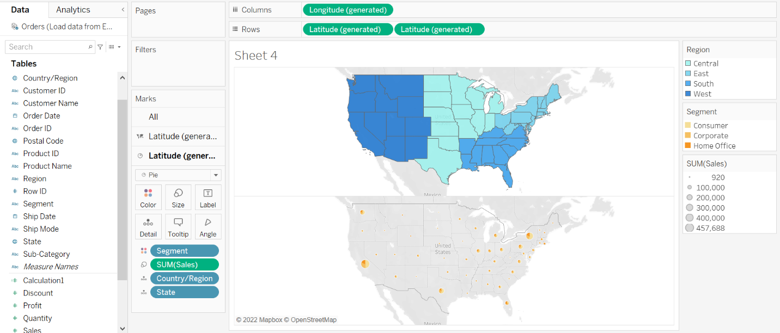

1. To show the percentage of contribution of sales, right-click the **Sales** measure in the **Marks** card and select **Quick Table Calculation > Percent of Total**

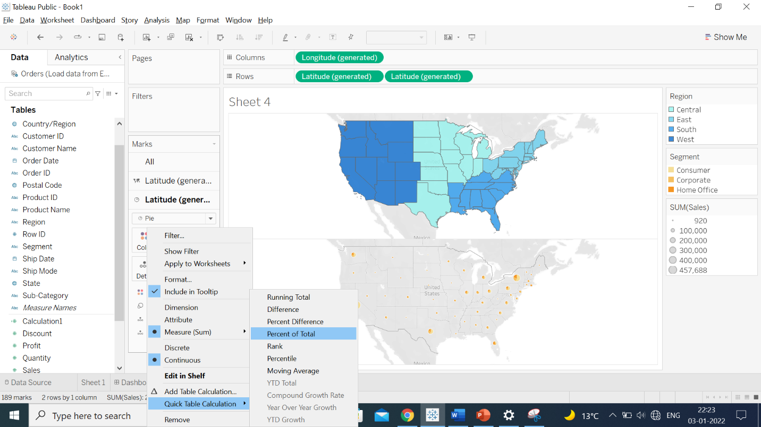

1. Right-click the second **Latitude (generated)** pill in the **Rows** shelf and select **Dual Axis**

Note: You can change the color according to your preference.

Based on the view, these are the answers to the questions in the problem statement:

* Which state has the highest percentage of contribution of Sales?

Answer: **California**

* What is New York’s Profit ratio for the Corporate segment?

Answer: **17**