**Lesson 9 Demo 3**

Reference line, Trend line, and Forecasting

* What is the R-Squared value for an exponential trend model?
* What is the P-value for a polynomial trend model with degree 3?

**Overview:**

* + Create a line chart with a continuous order date at the month level and sales
  + Add a reference line and customize the label
  + Add forecasting to the view
  + Add a trend line excluding the forecasted values
  + Show labels only for minimum and maximum values, excluding the forecasted values

The result should resemble the image given below:

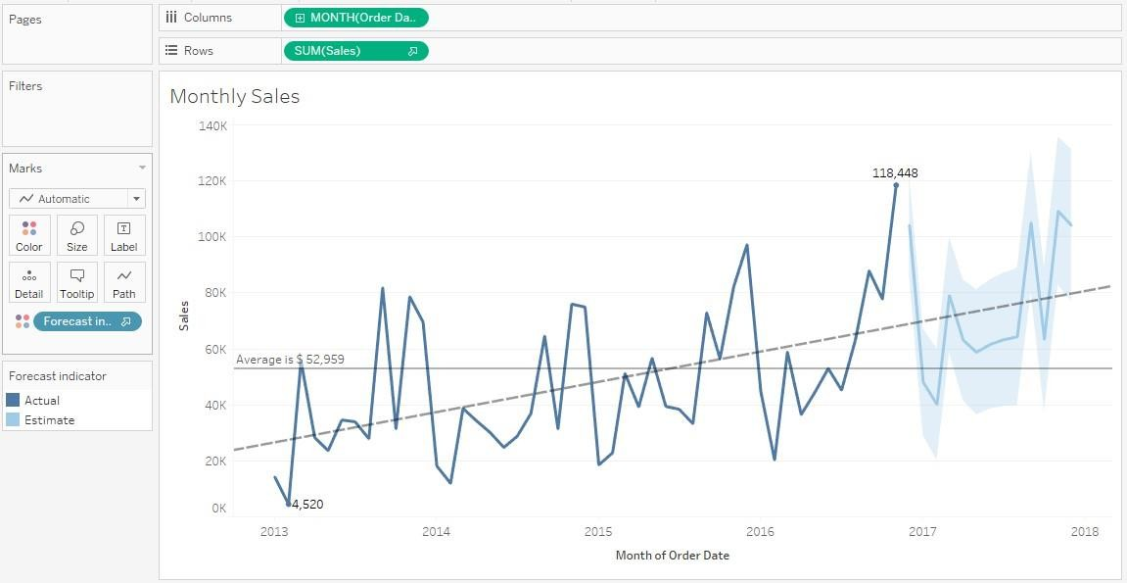

**Detailed Instructions:**

1. Navigate to a new sheet and use the **Sample – Superstore** saved data source
2. Create a line chart with the **Order Date** at month level and **Sales**
3. To achieve this, drag the **Order Date** dimension to **Columns** and the **Sales** measure to **Rows**

1. Right-click the **Year Order Date** pill and change it to **Continuous Month**

1. Right-click the view, navigate to **Trend Lines**, and select **Show Trend Lines**

**Note**: A trend line is drawn.

1. To enable the forecast option, right-click the view and select **Forecast > Show Forecast**

**Note**: The forecast is shown.

1. To modify the trend line, right-click the **Trend Line** and select **Edit Trend Lines**
2. To display a single trend line, in the trend line options window, exclude **Forecast Indicator**
3. To disable confidence bands, un-check the **Show Confidence Bands** option
4. Click **OK**

1. To add a reference line, right-click the **Sales** axis and select **Add Reference Line**
2. Select the scope as **Entire** **Table,** and select **Sum(Sales)** under the value section
3. To customize the label, select **Custom** in the label drop-down list
4. Click the drop-down arrow, select **Computation** type **$**, and select **Value**. The Custom text should look like: **<Computation> is $<Value>**
5. Click **OK**

1. Click **Label** on the **Marks** card to display labels
2. Select **Show Mark Labels**
3. Select **Min/Max** in the marks to label options showing the minimum and maximum values

**Note**: The minimum and maximum values are shown.

1. Rename this sheet as **Monthly Sales**

1. Save the workbook as **Lesson 8 - Exercises**
2. Close the workbook

**Answers:**

Based on the view, these are the answers to the questions in the problem statement:

* + What is the R-Squared value for an exponential trend model?

Answer: **0.352608**

* + What is the P-value (significance) for a polynomial trend model with degree 3?

Answer: **0.0001**