Test image insertion
Replace me here

Test replacing
<<HDImgData_VarName_[]1>>

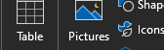
After image

<<HDBoookMark_Varname2>>

