Toolpath Overview Tab — Strip Down Documentation

Application Overview
This application consists of six tabs, as listed below:
- Overview
- Setup
- Tools
- Strategy
- Estimate
- Estimate (Beta)
This document provides a complete strip-down of the first tab: the Overview Tab.
Upon uploading a complex weldment part, the tool automatically breaks it down into separate components and displays a 3D view of each part along with the machining operations required for it.
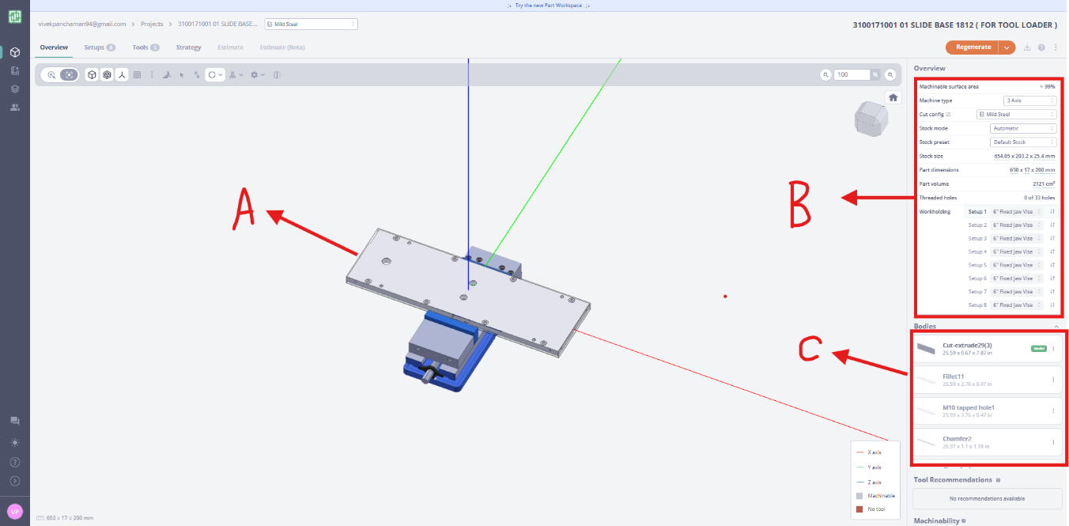
In the image above, three areas have been highlighted and labelled as Item A, Item B, and Item C. Each of these items is explained in detail in the following sections.

Item A: 3D Part Viewer
Once a weldment part is uploaded into the tool, it is automatically broken down into individual components (as described in the Item C section below). Item A displays a 3D view of the currently selected component within the full assembly. Users can toggle between individual components; each component is listed in the Item C panel.
By default, the selected part is placed in a vice. The workholding setup can be changed by selecting an alternative option from Item B.

Item B: Machining Configuration Panel
Item B displays the full machining configuration for the selected part. The table below provides a brief explanation of each field shown in this panel.

Field Descriptions
Field | Description
Machinable Surface Area (99%) | Indicates that 99% of the part’s surfaces can be reached and machined using the selected CNC machine. The remaining 1% may require an additional setup or a different machine.
Machine Type (3 Axis) | The part is planned to be machined on a 3-axis CNC mill, which moves along the X, Y, and Z axes.
Cut Config (Mild Steel) | The selected material is Mild Steel, which allows the CAM software to apply appropriate cutting speeds, feeds, and tooling parameters.
Stock Mode (Automatic) | The software automatically determines the size of the raw material (stock) required, eliminating the need for manual input.
Stock Preset (Default Stock) | Uses the default stock generation settings provided by the CAM software.
Stock Size (654.05 × 203.2 × 25.4 mm) | The dimensions of the raw material block before machining begins.
Part Dimensions (650 × 17 × 200 mm) | The finished part’s dimensions after machining is complete.
Part Volume (2,121 cm³) | The total volume of the finished component, useful for estimating material usage and machining time.
Threaded Holes (0 of 33 holes) | The part contains 33 holes, but none are currently defined as threaded (tapped) holes. If threads are required, they must be specified manually.
Workholding | Specifies how the workpiece will be clamped and secured during machining.

Workholding
The software recommends 8 different machining setups, each using a:
- 6" Fixed Jaw Vise
A fixed jaw vise is one of the most common CNC workholding devices. It securely clamps the workpiece while the machine performs cutting operations.
Multiple setups are required when:
- Different faces of the part need to be machined.
- Certain features are inaccessible in a single orientation.
- The part must be flipped or rotated to reach all required surfaces.

Why This Information Matters
These configuration settings enable the CAM tool to:
- Select the correct machine.
- Estimate machining time accurately.
- Calculate material usage.
- Plan the machining sequence.
- Determine whether the part can be fully machined in one or multiple setups.
- Generate accurate toolpaths for CNC machining.

Dropdown Options Reference
The table below lists the available dropdown options for each configurable field.
Option | Available Dropdown Values
Machine Type | 3 Axis
 | 3+2 Axis
Cut Config | Stainless (Metric)
 | Mild Steel (Metric)
 | Aluminum (Metric)
 | Stainless
 | Mild Steel
 | Aluminum
 | Sample Aluminum (Inch)
 | DFM Cut Config
Stock Mode | Automatic
 | From Body
 | From Box
 | From Cylinder
Stock Preset | Default Stock

Item C: Component Bodies Panel
Item C lists all individual bodies (components) that the weldment has been broken into. This is one of the tool’s standout features — it allows users to select each component individually for review and machining setup.
Each component entry has a three-dot menu ("…") on the side. Clicking it reveals an option to Set as Model. Once selected, that particular body will be displayed in the Item A viewer.
After setting a body as the active model, click the Regenerate button at the top of the screen. This will recalculate and display the complete machining setup for the selected body in Item A.

