Toolpath — Setup Tab

Overview
The Setup tab displays the complete machining setup for the part selected in the Overview tab. It shows how the part must be machined on the selected machine, including its positioning and orientation for each setup. For example, the part used in this document requires 10 machining setups. The following sections explain what is shown in Setup 1.

Setup 1: Panel Layout
The image below shows the Setup tab interface for Setup 1.
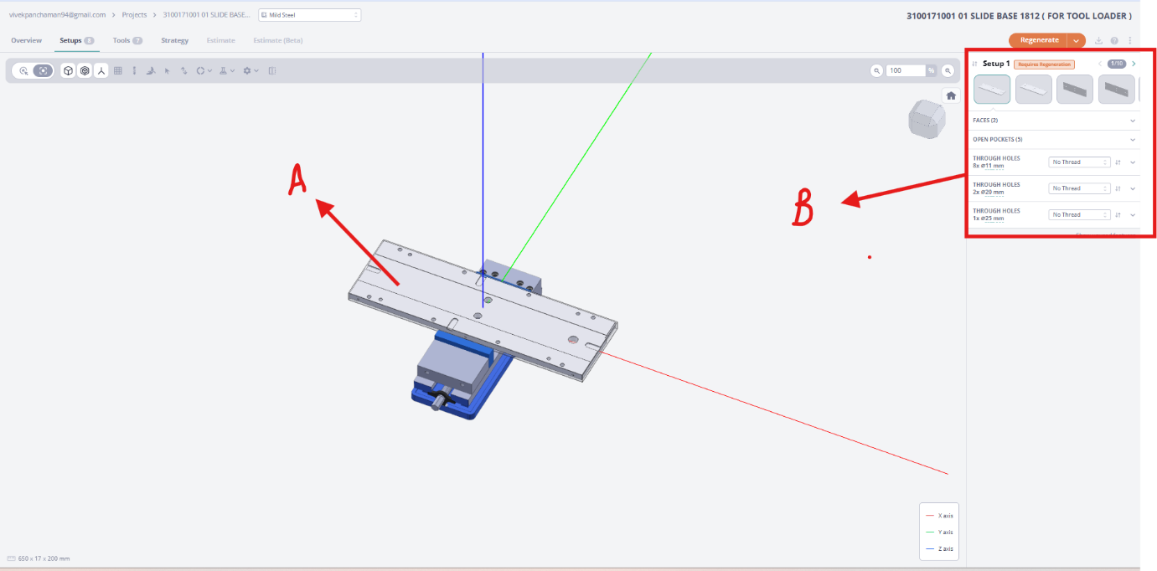
Figure 1: Setup Tab — Setup 1 Overview
The interface is divided into two main areas:
- Item A — 3D Viewer: Displays the 3D view of the part selected from the Overview tab, showing how it is positioned for the current setup.
- Item B — Operations Panel: Lists all detected machining operations for this setup, grouped into the following categories:
  - Faces — Shows all facing operations to be performed on this setup.
  - Open Pockets — Shows all open pocket operations to be performed on this setup.
  - Holes — Lists all hole operations to be performed on this setup.

Feature Details Panel
Clicking any operation in Item B opens the Feature Details panel. At the same time, the corresponding feature is highlighted in the Item A 3D viewer, making it easy to identify which part of the geometry the operation applies to.
The image below shows an example of the Feature Details panel after clicking an Open Pocket operation.
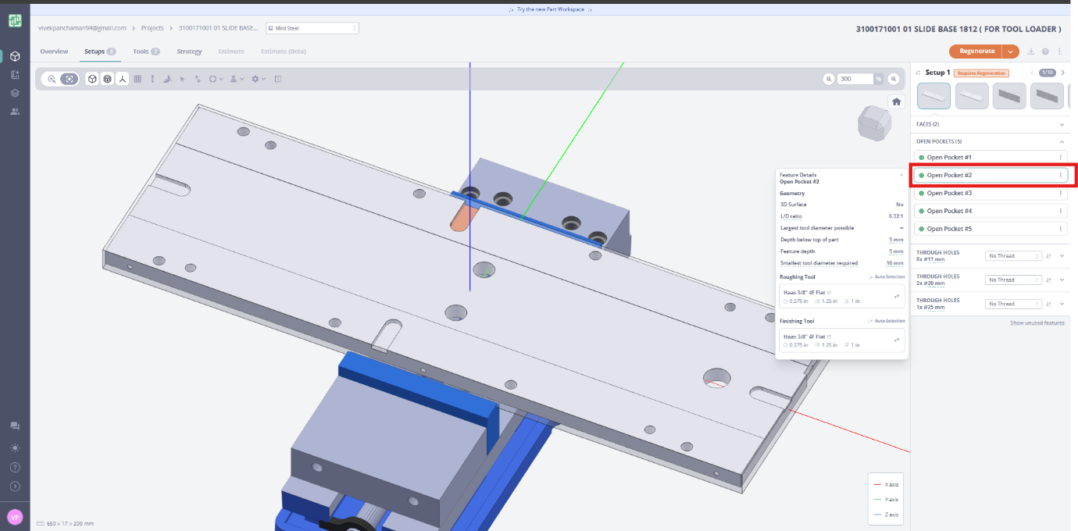
Figure 2: Feature Details panel for Open Pocket #2 (example)
The Feature Details panel is divided into three sections: Geometry, Roughing Tool, and Finishing Tool. Each is described below.

Geometry
The Geometry section describes the physical characteristics of the selected feature. The table below shows the fields displayed, using Open Pocket #2 as an example.
Geometry
3D Surface | No
L/D Ratio | 0.32:1
Largest Tool Diameter Possible | ∞
Depth Below Top of Part | 5 mm
Feature Depth | 5 mm
Smallest Tool Diameter Required | 16 mm

Roughing Tool
The Roughing Tool section shows the tool selected to perform the initial material removal (roughing pass) for this feature. By default, the tool is chosen automatically based on the feature geometry.
Roughing Tool
Selection Mode | Auto Selection
Tool | Haas 3/8" 4F Flat
Diameter | 0.375 in
Length of Cut | 1.25 in
Overall Length | 1 in

Finishing Tool
The Finishing Tool section shows the tool selected for the final precision pass on this feature. Like the roughing tool, it is automatically selected by default.
Finishing Tool
Selection Mode | Auto Selection
Tool | Haas 3/8" 4F Flat
Diameter | 0.375 in
Length of Cut | 1.25 in
Overall Length | 1 in

Manual Tool Selection
Within the Feature Details panel, there is also a Tools option that allows the user to override the automatic tool selection and choose a tool manually. When a different tool is selected, the feature details (such as geometry constraints and cut parameters) are automatically recalculated based on the newly selected tool.

