Kickstart My Chart

Vinayak Dixit

6/16/2019

**Conclusions from the data set**

1. Out of the total data set, roughly 54% kickstarters turn into successful endeavor while there is almost equal chance (46%) of failure. Overall “Theater” category has more activities (in terms of # of crowd funded start-ups) going on (33%) followed by Music (17%), technology (15%) and film & video (13%)



Fig 1: State of the kickstarter calculated as percentage of grand total.

Amongst all the successful start-ups (fig 2), theater(38%), music (25%) and fil & video lead (14%) lead the pack. However theatre (33%) also shows high rate of failure amongst all the failed endeavors.



Fig 2: Sate of the kickstarter calculated as percentage of column total

From fig 3, Music has relatively higher percentage of success (77%) w.r.t. failures (17%). So as an investor may want to look deeper in the music industry for higher chances of success followed by Theater (60% success, 35% failure) and film&video (58% success and 35% failure). Investing in technology has almost equal chance of being success or failure (35% successful, 36% failed).



Fig 3: State of the kickstarter calculated as percentage of row

1. Amongst the theater category “Plays” are backed heavily and those turn out to be more successful than “musical” and “spaces” from same category.

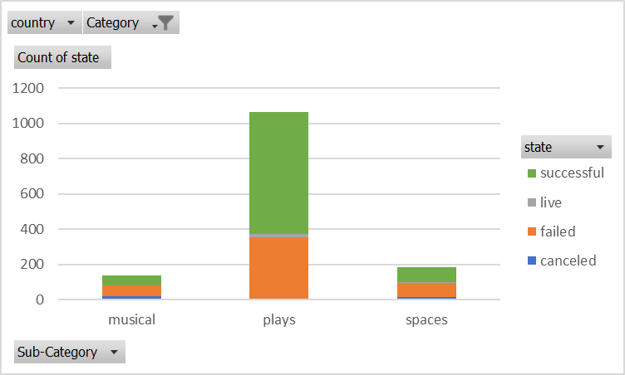

Fig 4: Subcategories under “theater”

In the film and video category (fig 5), there are clear winners and losers and results can be almost predicted perfectly based on where one makes an investment. E.g all the documentaries are successful followed by shorts and television but all animation and drama endeavors are a failure.

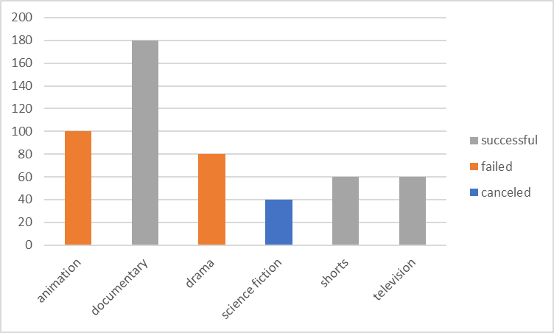

Fig 5: Sub Categories under “film and video”

In the music category (fig 6) trend is similar to the film and music where outcomes are predictable based on the subcategories. “Rock” rocks in pure and indie form while “jazz” and faith” music almost turns to be failure with and exception of few in faith music whichare currently still “live”.

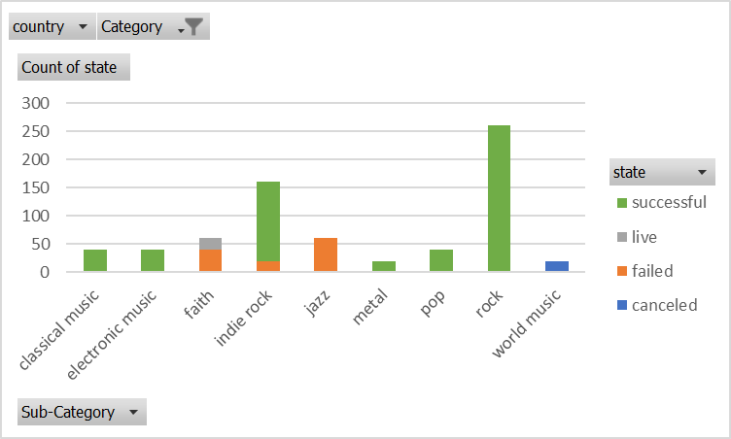

Fig 6: sub-categories under “music”

1. From fig 7,There is not a strong trend to predict failures or canceled start-ups based on which month they start. There is marginal pattern which shows that more successful startups are started in month of May than in month of December which is the lowest. However one should not conclude to invest in a start-up just based on when it was started.

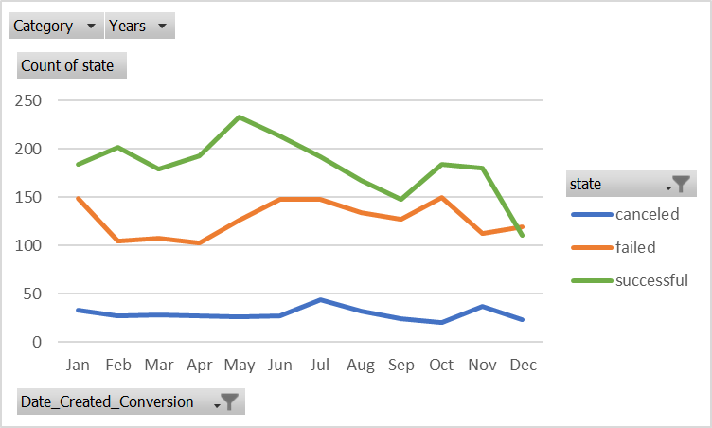

Fig 7: Trends based on starting month of the kickstarters

**Limitations of the data set:**

1. For an investor, returns are important number to make a thoughtful decision. This data set provides if the start-up is successful or not but does not provide data to calculate any means of returns that would be more meaningful to the investor.
2. Dataset does not provide how the pledged amount collected e.g amount pledged, or backers added in 30-60-90 days of launch date. This information can help the predicting the success based on response from the backers.
3. Post kickstart condition, in quantitative manner, of the business is not reported in this dataset making difficult to make choice of one start-up over the other.
4. Dataset does not define what some of the columns mean such as “staff pick” or” spotlight”

**Possible charts and tables:**

This data can be sliced and diced in many ways to dig deeper in the data to find better insights.

1. Pareto chart of the categories and then within the subcategories to identify top 20% successful and top 20% failed kickstarter types.
2. Charts/tables using slicers which can enable to select the filters of interest and see impact on the “success” and “failed” bars instantly.

**Outcomes based on Goals:**

Based on the data and chart in fig 8 below, it can be inferred that higher goal results in more failed or canceled startups and lower goal have high success rate.

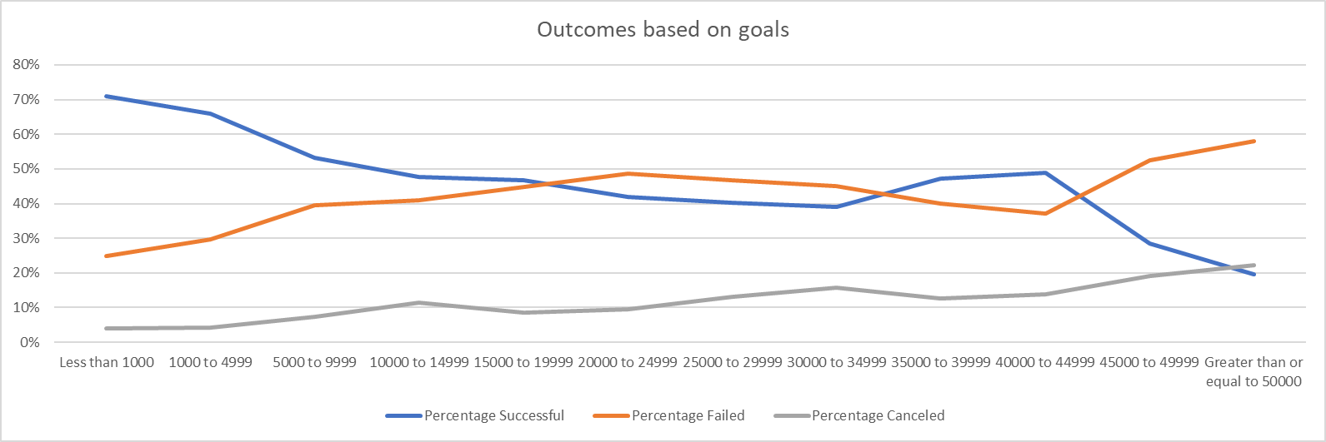

Fig 8: Outcomes based on goals

**Statistical Analysis:**



* Average number of backers could be a low predictor of the success or failure of the kickstarter. On an average 194 supporters are needed for a successful startup and chances of failure could be high if the supporters are less than 18.
* High standard deviation (and variance) in successful startups indicate that average number of backers is weak predictor of the success while relatively low standard deviation in failed startups can predict the state (failure) based on the low number of average backers.
* As obvious, and confirmed by “minimum” statistics, one need at least 1 backer to be successful and zero backers is a certain failure.
* Median and maximum statistics infer that lower the number of backers higher the chances of failure.