**Titan**

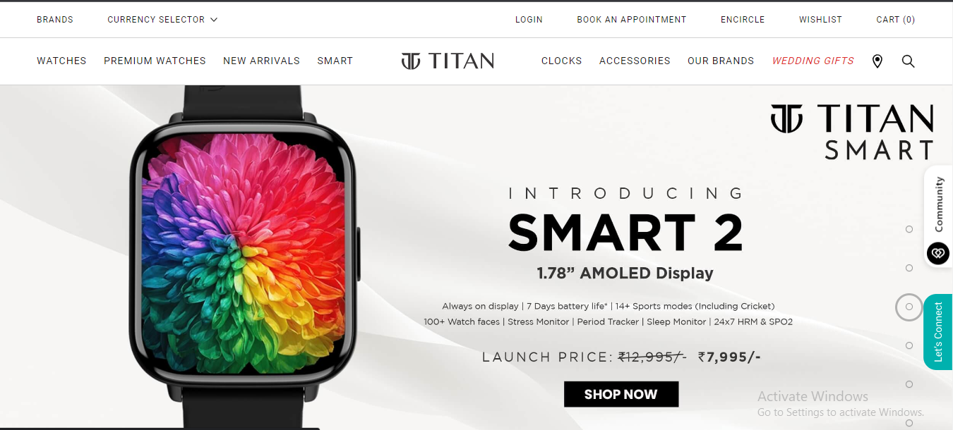

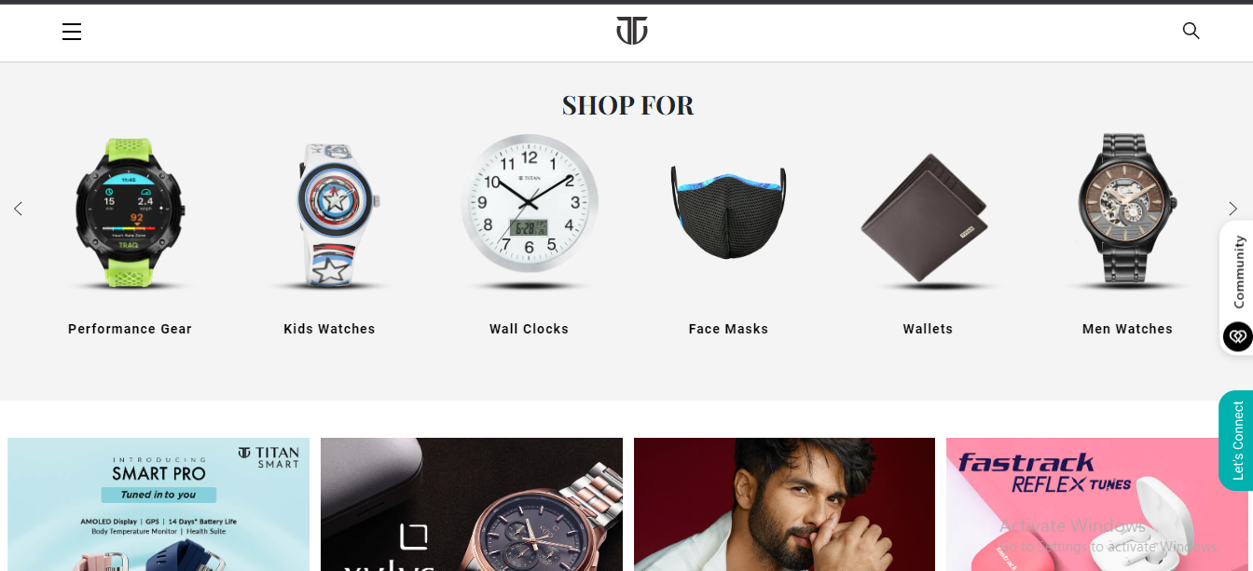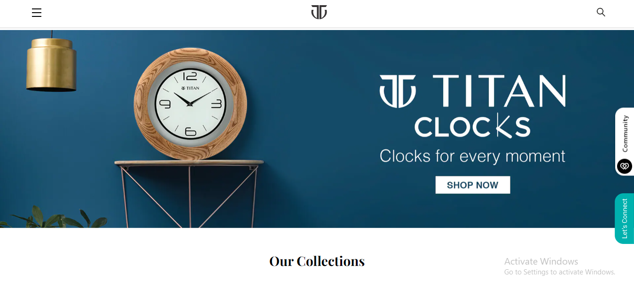

**Overview:**

Titan Company Limited is an Indian products company that mainly manufactures fashion accessories such as jewellery, watches and eyewear.

Titan has its own website where it sells own products.

<https://www.titan.co.in/>

**Page structure:**

**Login Page:**

System asks for username and password.

**Home Page:**

Nav bar

* Profile
* Wishlist
* Cart
* Watches
* Clocks

Search bar

Product Advertise photos

**Product Page:**

* Product details
* Discount price and actual price
* Wishlist button
* Add to cart
* Buy now

**Buying options:**

* Credit card/ Debit card/ Net banking/ Wallet payment
* Pay using no cost EMI
* UPI payment

**Basic Features:**

**Login Page:**

* User id input(*Required)
* Password input(*Required)
* Login button

**Sign up page:**

* Title(*Required)
* First name(*Required)
* Last name(*Required)
* Mobile number(*Required)
* Email id(*Required)
* Password(*Required)
* Register button

**Home Page:**

Search bar to search the products

Product images inside the cards

Link to profile page: All the personal details entered during the registration

**Cart page:**

Product details of the added products

Buy button

**Payment page:**

Different payment option