**4B. define the rules that govern how you send interpret text message**

* **Who Regulates Text Message Laws?**

There are a few layers of regulation governing text message marketing. Let’s explore each one in descending authority.

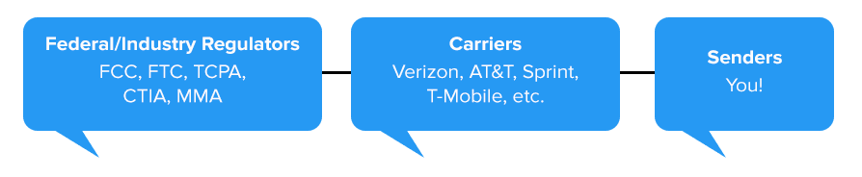

* *Federal/Industry Regulators*: These are the lawmakers who put forth the rules every subsequent party in the chain must follow. They include…
  + **Federal Communications Commission (FCC)**: The FCC regulates media and phone communications in the U.S. You mostly know them from setting TV ratings. They set the wireless carriers’ regulations, and issue the rules and orders implementing the TCPA.
  + **Federal Trade Commission (FTC)**: The enforcers. The FTC collects complaints about businesses theft, deception, and violence through the media. They crack down on businesses who use texts, calls, or faxes to scam people.
  + **Telephone Consumer Protection Act (TCPA)**: This is the actual legislation that was passed in 1991 with the rules surrounding telemarketing calls, auto-dialed calls, prerecorded/artificial voice calls, text messages (even though the law doesn’t mention them by name), unsolicited faxes, and the national Do-Not-Call list.  The FCC also has enforcement authority under the TCPA.
  + **Cellular Telecommunications Industry Association (CTIA)**: This trade group is how telecommunications moguls get a seat at the table from a legislative standpoint. This group represents the interests of the wireless industry.
* *Mobile Carriers*: Without them, texting wouldn’t exist. With that power comes some say over how some texts are sent. For example, AT&T has recently made the decision to not allow messaging from [shared short codes](https://simpletexting.com/short-codes-vs-long-codes/) to their customers. This has forced messaging providers to shift their attention towards text enabling landlines and other toll-free numbers.
* *Messaging Providers*: We’re the groups who make text marketing possible. At SimpleTexting we take our compliance very seriously. We constantly monitor accounts for suspicious activity and take an active role in cutting down on deceptive business practices.
* *Senders:* That’s you and your business! While you may not have a seat at the law-making table, you do have an ethical responsibility to your audience. As such, it’s your responsibility to learn the rules and stick to them!
* **The Text Marketing Rules:**

We’ll begin with the most straightforward do’s and don’ts of every text marketing campaign. If you’re new to SMS regulations, or just want a little more clarity, we’ll dive a little deeper into these text rules and concepts below.

* You **cannot** buy lists of phone numbers and add them as subscribers.
* For commercial texts, your consent **must** be in writing.
* You cannot send copyrighted or trademarked material that has not been licensed for your use.
* In your confirmation, the CTIA wants the consumer to understand if they’re agreeing to a single-message response or a recurring-messages campaign.
* For non-commercial, informational texts (such as those sent by or on behalf of taxexempt non-profit organizations, political purposes, and other non-commercial purposes, like school closings) you still need prior express consent (but the consent does not necessarily need to be written).
* You can only send messages pertaining to alcohol to age-verified subscribers.
* You cannot send confidential information, threats of violence, hate speech, or graphic violence.
* **Text Message Laws:**

Now that you’re more familiar with the rules, let’s take it a step further and engage with the laws that compliment compliance. At SimpleTexting we support all major mobile carriers across the U.S. and Canada, so we’ll touch on the most prevalent regulations in both countries

* Telephone Consumer Protection Act:

As we previewed above, the TCPA is the U.S. legislation passed to govern the use of autodialers, prerecorded/artificial voice, and faxes. The main takeaway from this legislation is that businesses and organizations MUST obtain written consent from individuals before texting them commercial messages with an autodialer. This applies in cases even when you’ve already collected a customer’s information. Just because you have their number doesn’t mean you can send them automated promotional texts. You must have their express, written, consent given in response to a clear and conspicuous disclosure that the person is agreeing to receive marketing messages sent by an autodialer, and that consent is not the condition of a purchase. In addition to providing TCPA consent, your organization is also responsible for complying with the CTIA’s guidelines requiring you to provide your identity in your confirmation message as well as in message opt-out instructions.

For any legal buffs out there, you may be familiar with two big cases that brought the TCPA into the national spotlight.

The first was Moser v. FCC which was essentially the first rebuttal of telemarketers to the new legislation. The outcome was the law and its industry restrictions being held up as constitutional. Another interesting Ninth Circuit case came into play after the millennium. It evaluated whether the TCPA applied in cases of text advertising. Finally, there was the iconic 2014 case which saw Capital One fall in a class action lawsuit that resulted in $75.5 MILLION in penalties for utilizing an automated dialer without consent.

* Conclusion:

1. Never purchase a list of phone numbers.

2. Follow the TCPA; get express written consent from *every* contact.

3. Tell people what they’re signing up for, and how often you’ll text them in your Call to Action.

4. Don’t send texts about sex, hate, alcohol, firearms, or tobacco.

We hope this puts you at ease about using SMS to reach your audience. If you have any questions, don’t hesitate to reach out to us by clicking the blue chat bubble at the corner of the screen.

**Disclaimer**: Please note that this advice is for informational purposes only and is neither intended as nor should be substituted for consultation with appropriate legal counsel and/or your organization’s regulatory compliance team.