Assignment 1:

1. docker --version:

This command gives the version of the docker installed

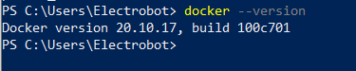

1. docker --help

This command gives the list of commands and the available options

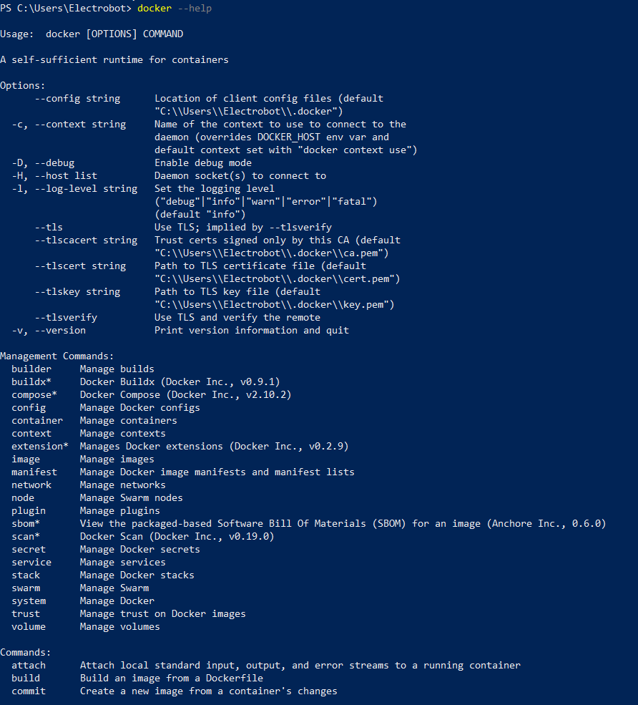

1. docker pull:

This command pulls a new docker image from the docker hub

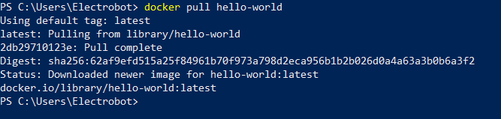

1. docker images:

This command lists down all the docker images in the local repository

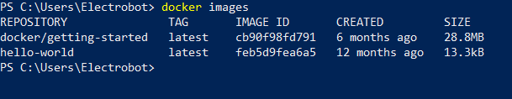

1. docker run:

This command creates a container to run the docker image in the local repository.

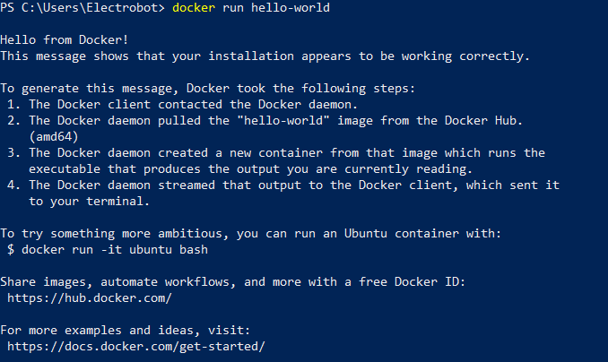

1. docker build:

This command builds the entire docker image specified in that folder.

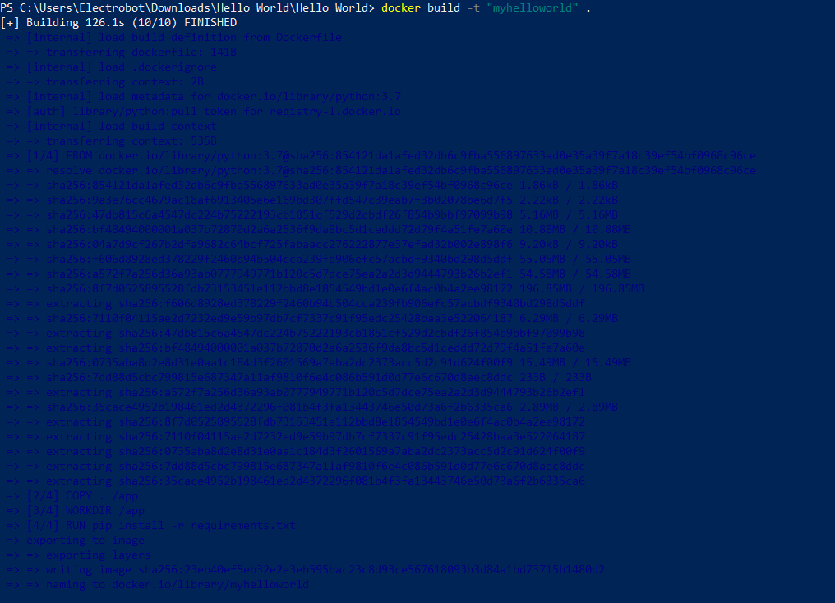

1. docker container logs:

This command gives the log of the container ID.

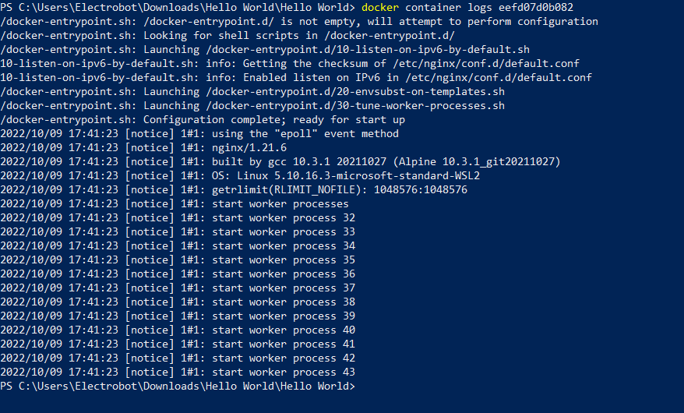

1. docker ps -a:

This command lists all the docker containers available in our local repository including the shutdown containers.



1. docker container rm:

This command removes the specified container ID from the repo



1. docker login:

This command authenticates with existing credentials to docker repo

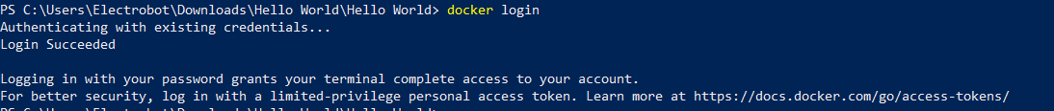

1. docker tag:

This command tags the local repo image specified to the logged in account in docker hub and it is ready for pushing



1. docker push:

This command pushes the image to docker hub

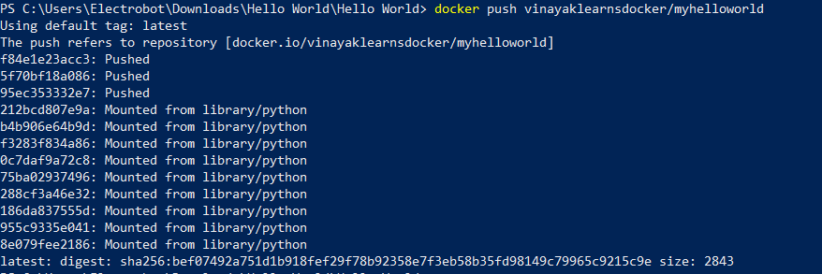

1. Docker ps:

This command will list all the running containers in the host

1. docker stop:

This command stops the running container gracefully

1. docker kill:

This command stops the running container forcefully.