Assignment 2:

1.docker pull:

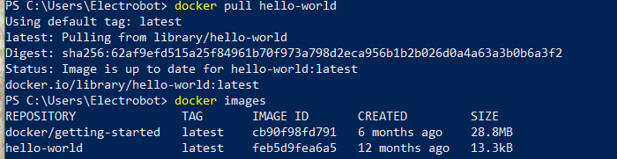

1. docker run

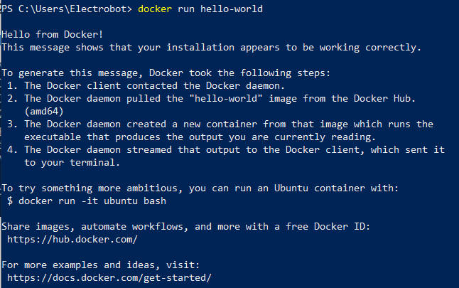

We can do a docker run without giving the docker pull command