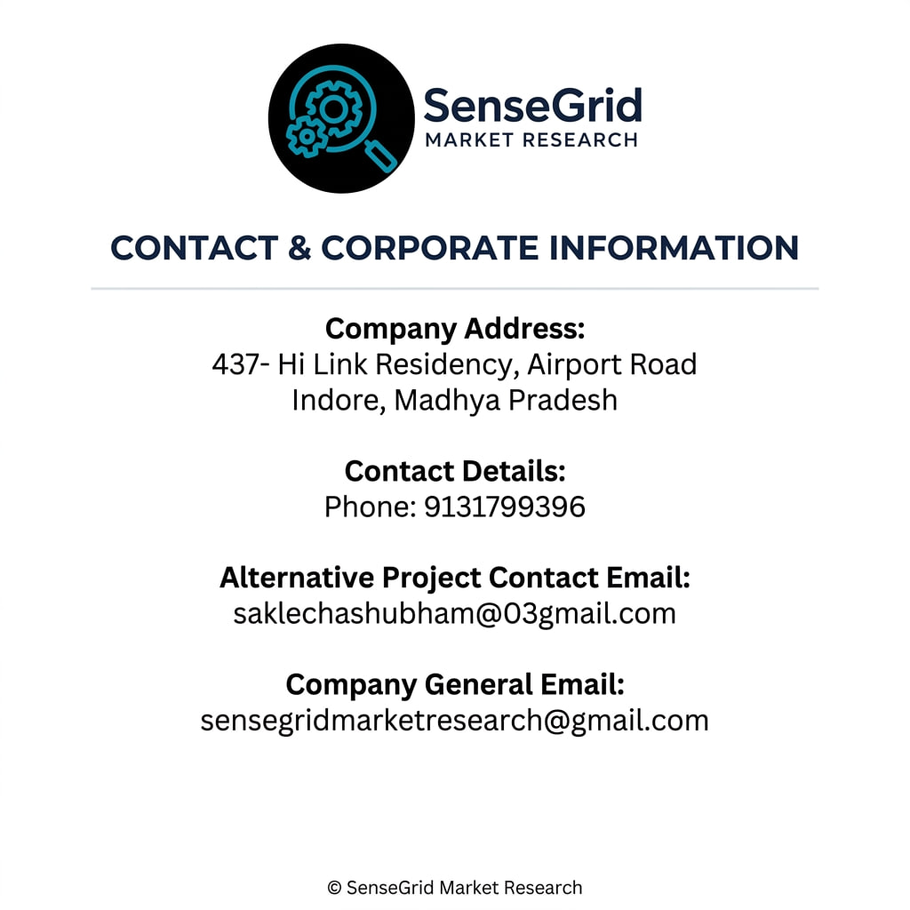

Internship Offer & Terms Document
Date: 08 June 2026

Candidate Details
Name: Anurag Rathod
Email ID: anuragrathod916@gmail.com
Contact Number: 7240842568
Position Applied For: Market Research Intern

Internship Offer Letter
Dear Anurag,
We are pleased to offer you the position of Market Research Intern at SenseGrid Market Research. Your selection is based on your profile, communication skills, and interest in research-related projects.

Internship Details
Position: Market Research Intern
Company: SenseGrid Market Research
Internship Mode: Remote / Work From Home
Joining Date: 09 June 2026
Internship Duration: 45 days
Working Hours: Flexible
Reporting Manager: Shubham Sir

Roles & Responsibilities
- Conduct secondary market research
- Collect and organize industry-related data
- Prepare reports and presentations
- Support research analysts with ongoing projects
- Maintain confidentiality of company information
- Complete assigned tasks within deadlines

Internship Guidelines
- Interns are expected to maintain professionalism during the internship.
- All information shared by the company must remain confidential.
- Work submitted by the intern should be original and free from plagiarism.
- The company reserves the right to terminate the internship in case of misconduct or non-performance.
- Completion certificate may be provided upon successful completion of the internship.

Stipend (If Applicable)
Stipend Amount: Unpaid
Payment Terms: NA

Confidentiality Clause
All reports, documents, research data, and company-related information shared during the internship are confidential and must not be shared with any third party without written permission from SenseGrid Market Research.

Declaration
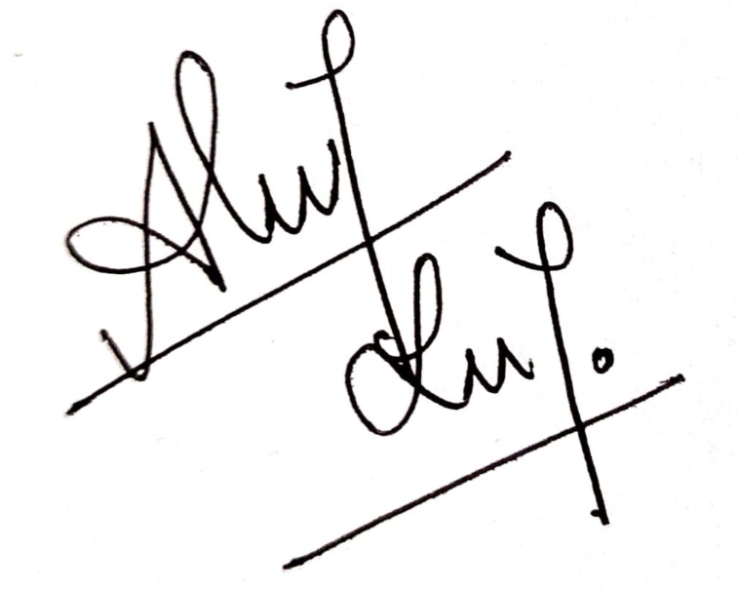
I hereby confirm that the information provided by me is accurate and I agree to follow the terms and conditions mentioned above.
Candidate Signature:
Name: Anurag Rathod
Date: 08 June 2026
Authorized Signatory
SenseGrid Market Research
Name: ____________________
Designation: ____________________
Signature & Stamp: ____________________

