- Inspect your favourite website and change something on the page which is displayed.

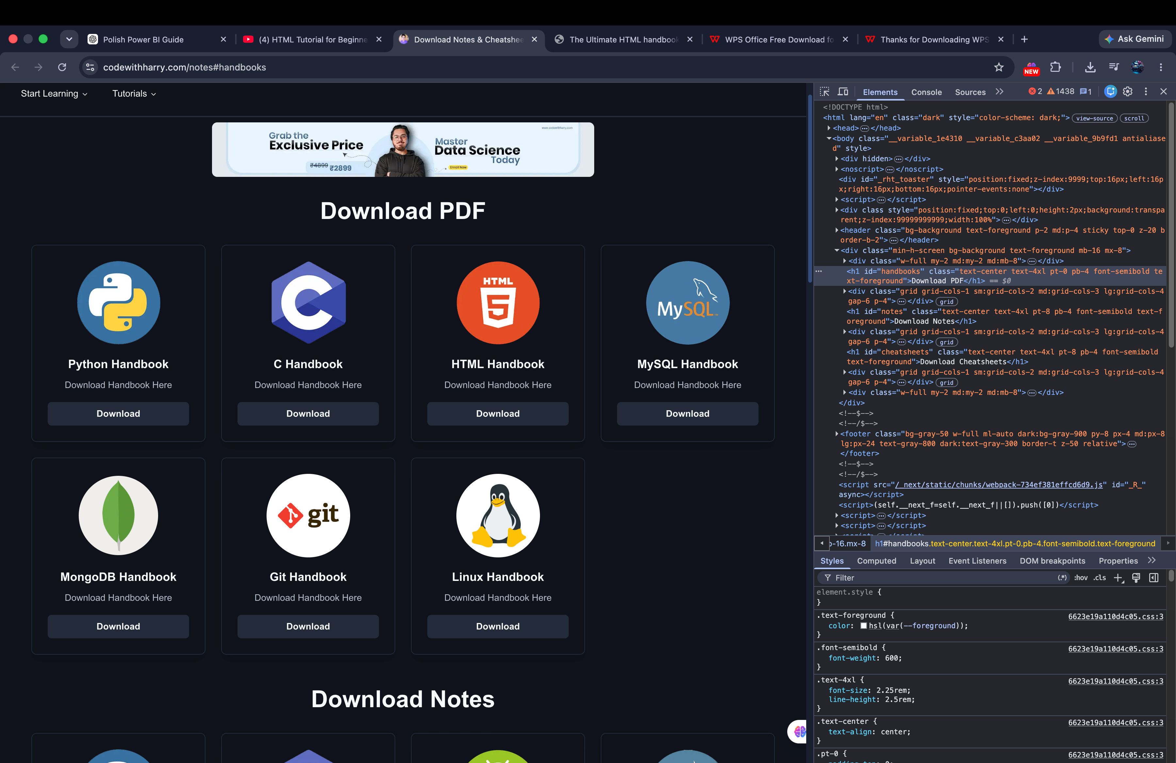

2. Go to your favourite website and try to view the page source and write the exact lines of code. Does it clone the website? Why?
You can copy the HTML code from the page source, but it only gives you the client-side source code (such as HTML, CSS, and JavaScript). It does not clone the complete website because the website’s server-side code, databases, and other back end systems are not included in the page source.
3. Write any HTML code inside a text file. Does it work if you write it using Notepad?
Yes, it works if you write HTML code using Notepad. You need to save the file with the .html extension (for example, index.html) instead of .txt. Then you can open the file in a web browser to see the web page.

