Text Classification NLP Streamlit App

Project by – Vinayak Mohitkar
Email - vvm25.comp@coeptech.ac.in
Subject – Natural Language Processing
Institute & department – COEP Technological University, PG Diploma.

Introduction
This project is a web-based tool that helps you classify text like tweets or short messages into different sentiment categories (such as positive, negative, or neutral). It’s built to be easy to use, even if you don’t have a technical background. The app uses machine learning models trained on real Twitter data to make its predictions.

Project Motivation
With the explosion of social media, understanding the sentiment behind text has become important for businesses, researchers, and anyone interested in public opinion. This project aims to make sentiment analysis accessible to everyone through a simple web interface.

What Can You Do With This App?
• Type or paste any text (for example, a tweet or a review).
• Choose a machine learning model (Naive Bayes or Logistic Regression).
• Get an instant prediction of the text’s sentiment.
• See how confident the model is about its prediction.

Why Only Two Models?
While three models were trained (Naive Bayes, Logistic Regression, and Random Forest), only the first two are available in the app. This is because GitHub’s free version doesn’t allow uploading files larger than 100 MB, and the Random Forest model file is too large. If you’re interested in the Random Forest model, feel free to reach out for alternative ways to access it.

How to Set Up and Use the App
1. Install the Required Packages:
pip install -r requirements.txt
2. Start the App:
streamlit run app.py
3. Try It Out:
- Select a model from the sidebar.
- Enter any text you want to analyse.
- Click the “Predict” button.

What’s Inside Each File?
• app.py – The main file for the web app.
• twittersentimentanalysis_nlp_project.py – The script used to train the machine learning models.
• requirements.txt – A list of all the Python packages you need to install.

Where Does the Data Come From?
The models were trained on a public dataset of tweets from Kaggle. The training script cleans up the tweets, turns them into numbers that the computer can understand, and then teaches the models to recognise patterns in the text.

How Does the App Work?
1. Model Loading: When you start the app, it loads the Naive Bayes and Logistic Regression models that were trained earlier.
2. User Input: You type or paste your text into the app.
3. Prediction: The app uses the selected model to predict the sentiment of your text.
4. Results: The predicted sentiment and the model’s confidence are displayed on the screen.

Limitations
• Only Naive Bayes and Logistic Regression models are available in the app due to file size restrictions on GitHub.
• The app is designed for short texts (like tweets). Results may be less accurate for longer or very different types of text.
• The predictions are only as good as the data and models used. For critical applications, further validation is recommended.

How to Train Your Own Models
If you want to retrain the models or use your own data:
1. Download the Twitter sentiment dataset from Kaggle.
2. Run twittersentimentanalysis_nlp_project.py to train and save new models.
3. Make sure the new model files are in the same folder as app.py.

Contact
If you have questions, suggestions, or want access to the Random Forest model, feel free to reach out!

Acknowledgements
• Twitter Sentiment Analysis Dataset from Kaggle
• Streamlit for the web interface
• scikit-learn for machine learning
LINK TO STREAMLIT APP :
https://text-classification-nlp-app-5wsrnhueuxnmwgbfh4kg53.streamlit.app/

Relevant Screenshots
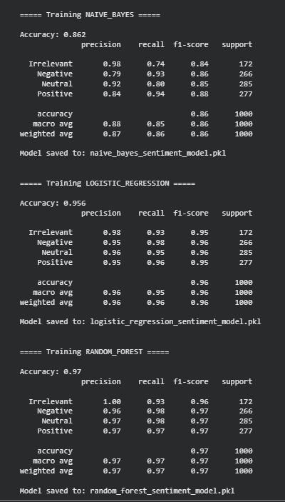
Figure 1 Model Training

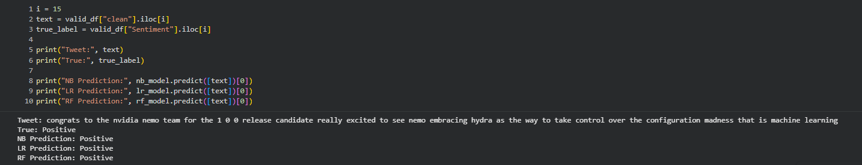
Figure 2 Model Testing
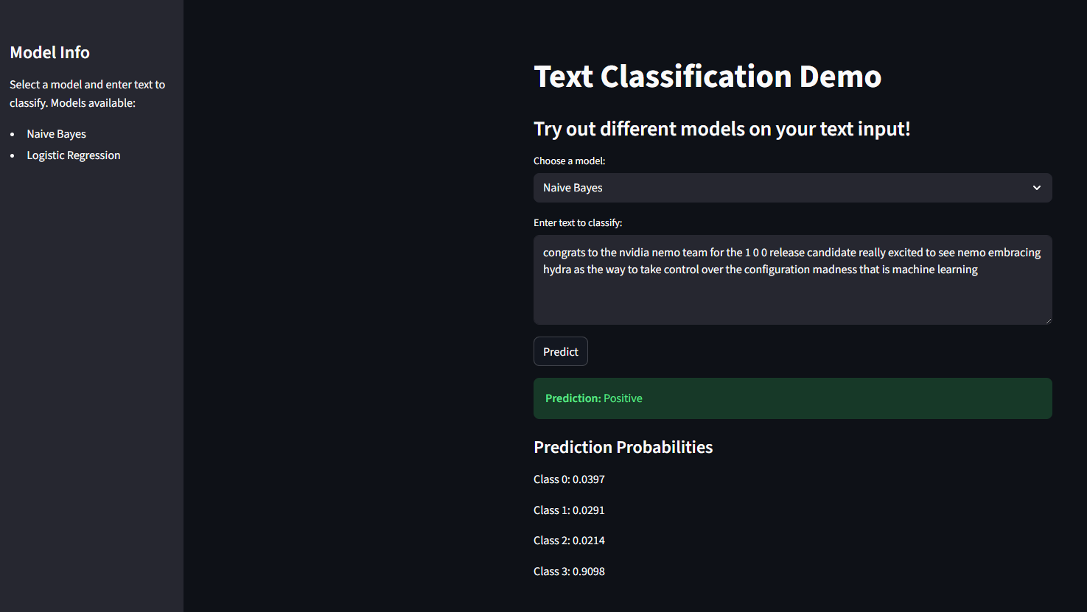
Figure 3 Streamlit App Demo – NB
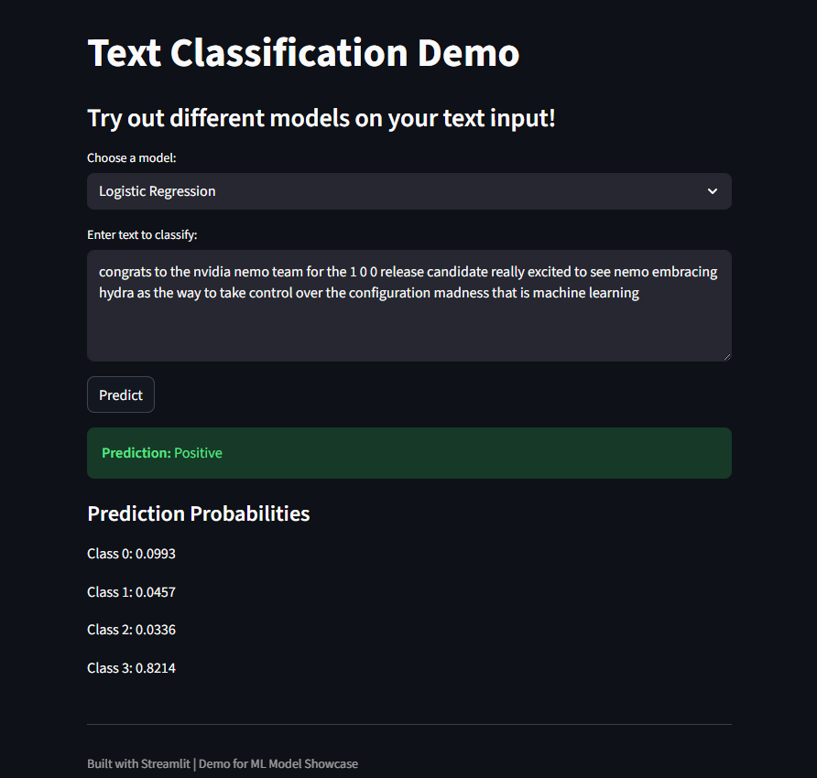
Figure 4 Streamlit App Demo - Logistic Regression

