SOLID

S -> SRP (Single Responsibility Principle)
1) "A class should have only one reason to change."
2) Each class should have only one job or responsibility.
//Check below code violating SRP.
class Employee {
private:
string name;
double salary;

public:
// HR responsibilities
void calculatePay() { /* salary calculations */ }
void saveToDB() { /* database operations */ }

// Reporting responsibilities
void generateReport() { /* report generation */ }
void printReport() { /* printing logic */ }

// Business logic
void promoteEmployee() { /* promotion logic */ }
};
//Code Following SRP
class Employee {
private:
string name;
double salary;
public:
string getName() const { return name; }
double 5() const { return salary; }
};

class PayrollCalculator {
public:
double calculatePay(const Employee& emp) { /* salary calculations */ }
};

class EmployeeRepository {
public:
void save(const Employee& emp) { /* database operations */ }
};

class ReportGenerator {
public:
string generateReport(const Employee& emp) { /* report generation */ }
};
O -> OCP (Open/Closed Principle)
1) "Software entities should be open for extension but closed for modification."
2) You should be able to add new functionality without changing existing code.
Example:
If I have a class DBStorage which saves in MySQL DB, & I want to add new feature to store data in file also in NOSQL DB then I can not add methods for file and NOSQL storage in same class.
We can use following methods to follow OCP-> Interface, Inheritance, Polymorphism.

L -> LSP (Liskov’s Substitution Principle)
1) "Objects of a superclass should be replaceable with objects of its subclasses without breaking the application."
2)Derived classes must be substitutable for their base classes.
Example:
Consider we have following diagram.
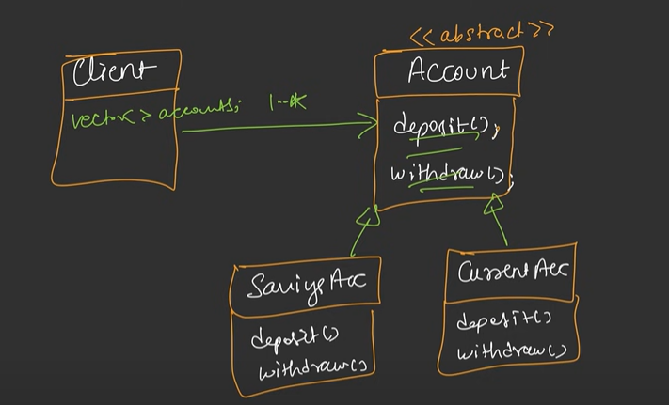
In above example class Account is a base class. Which has deposit & withdraw methods same methods are there in it’s both child class. But If we add one more class as show in below diagram.
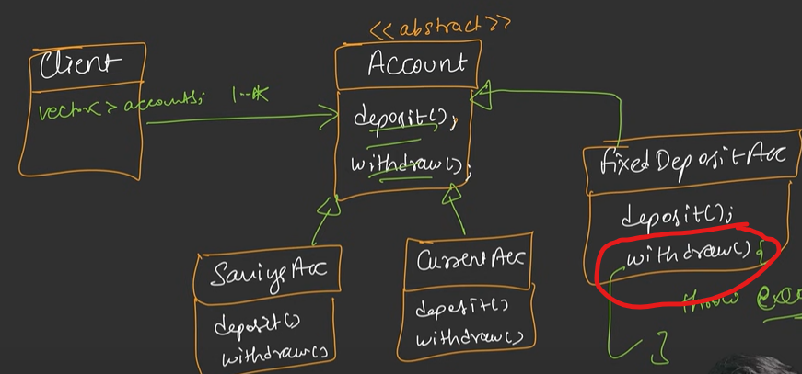
Notice we added FixedDepositeAcc Class which doesn’t have any withdraw method. This will break code. Cause Idea here is we have our interfaces client or other developer doesn’t need to know this he should be able to use our class without worrying about inside logic.
- We can not just add withdraw method in above case because it may break code if we return some default value and client doesn’t know how to handle it. We need to change design little bit as show in below. (So that no changes are required on client side. Else conditional check will be required at client side to handle FixedDepositAcc object)

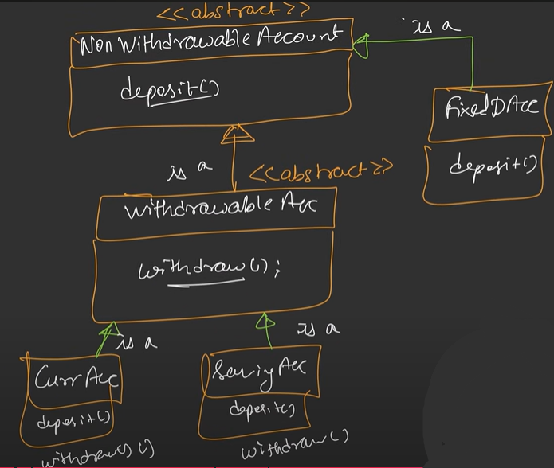
- Now above example is neater and cleaner and follows LSP. Also, now client doesn’t have withdraw() method in base class so won’t call it even accidentally.
- Note that signature of function should be same in base class & derived.
(IMP while overriding method make sure to use override keyword.)
- Function return type should also be same or it should be of narrower type. As in parent class method Func is returning Animal type then child class should also return Animal or narrower type i.e., Dog type, LivingBeing type won’t work as client must be expecting Animal return type.
- This returning Dog type is called Covariance.
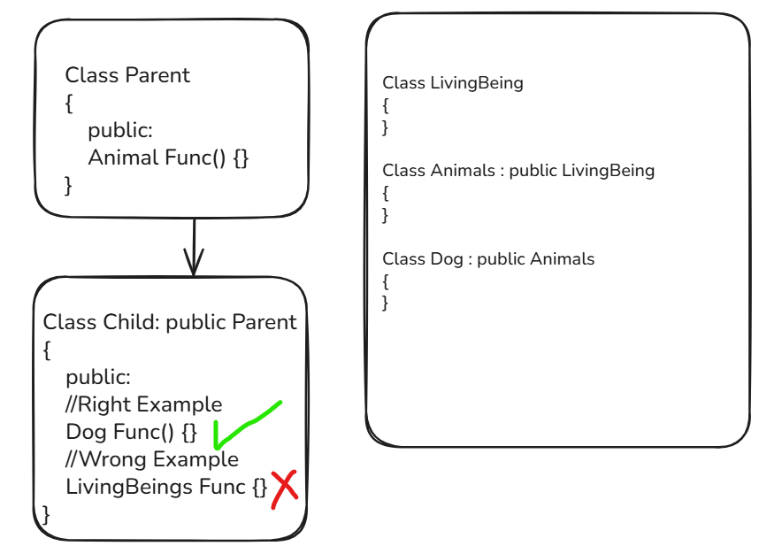

- Property:
- Class Invariant: Properties (rules) of base class should also be followed in derived class. Consider example of bank card class here balance can not be negative but what if it’s credit card. It can be negative.
Notice our idea is to build production ready application in this. Client may pass anything as input.
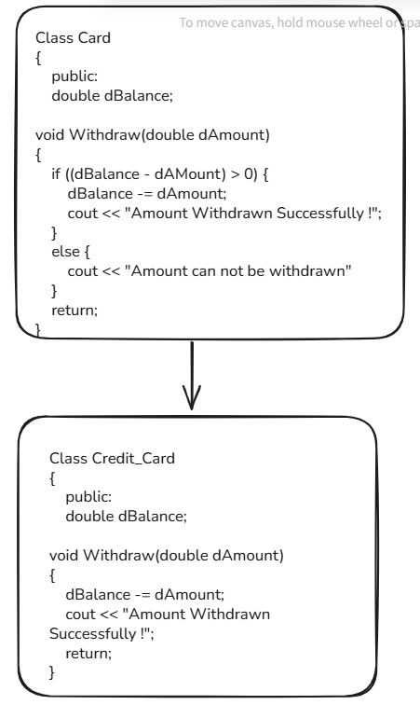
The good solution on this one is following
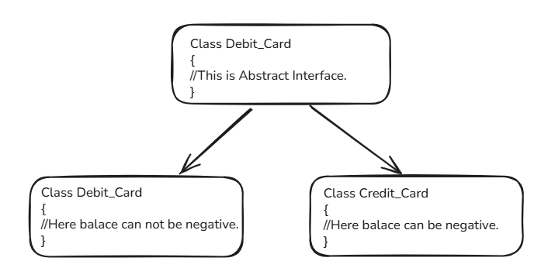

I -> ISP (Interface Segregation Principle)
“A client should not be forced to implement an interface it doesn't use.”
Create specific, focused interfaces rather than large, general-purpose ones.
Violating ISP
- Notice cube has extra method to calculate volume. It should have different interface.
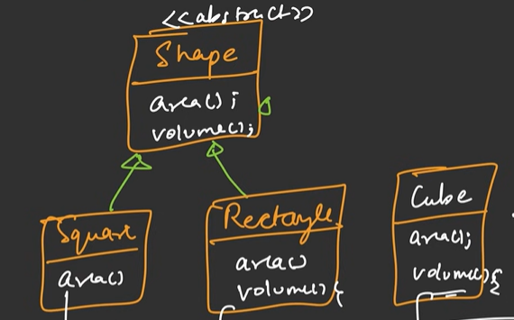

Create specific interfaces (i.e., segregate them properly)
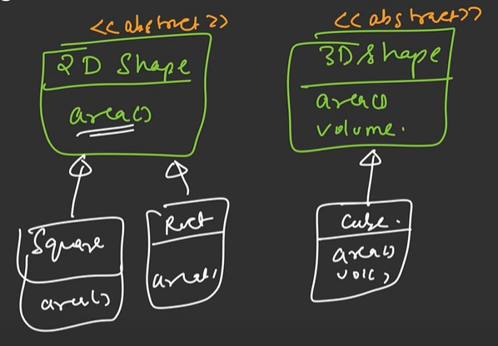

D -> DIP (Dependency Inversion Principle)
"High-level modules should not depend on low-level modules. Both should depend on abstractions."
Depend on interfaces, not concrete implementations.
For Example. Application (High Level Module) should not interact with low level module. There should be one interface to with which application will interact with database. Like QuickInMemoryInterface.

