1. Array Part 2 ->

4> Find duplicate in array of n+1 integers ->

Floyd Warshall’s algorithm (Hare & tortoise)

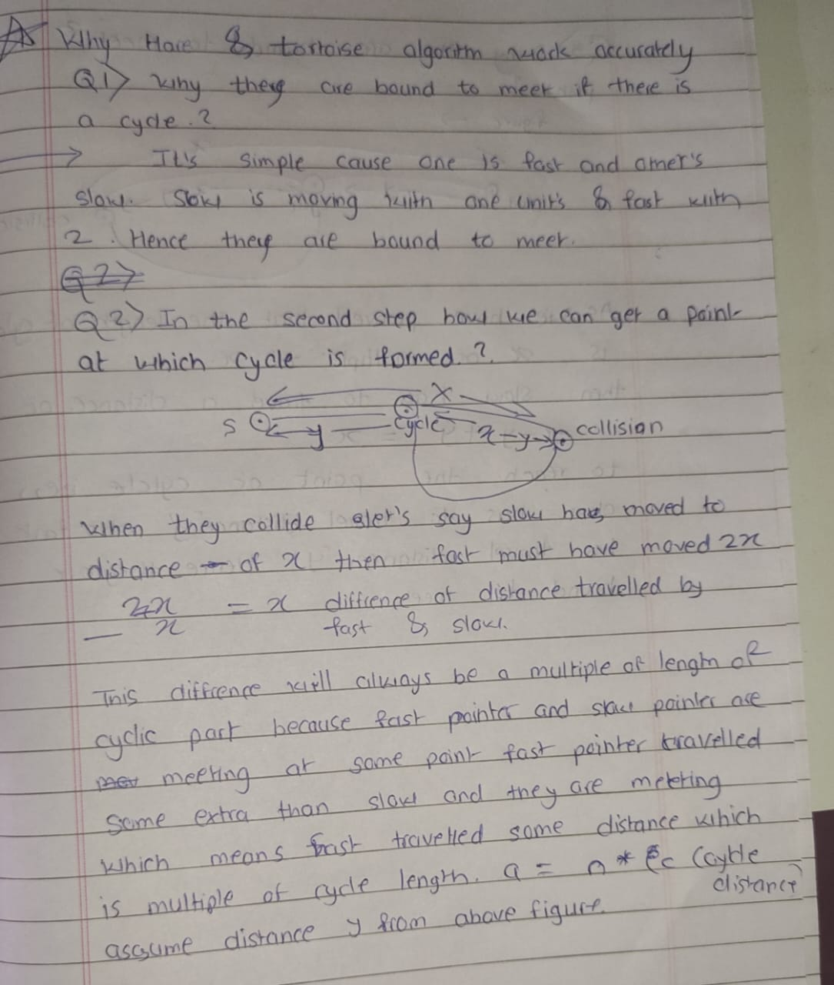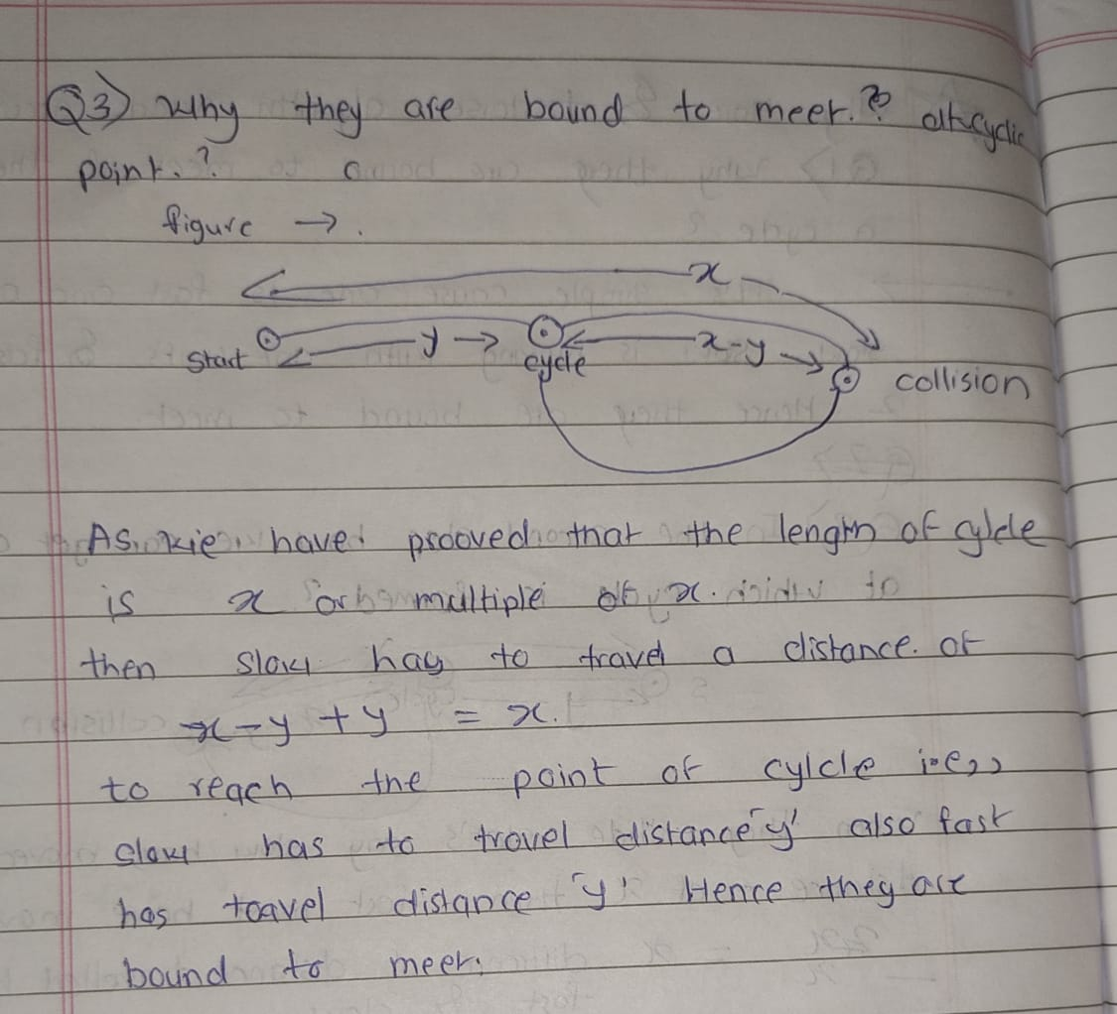

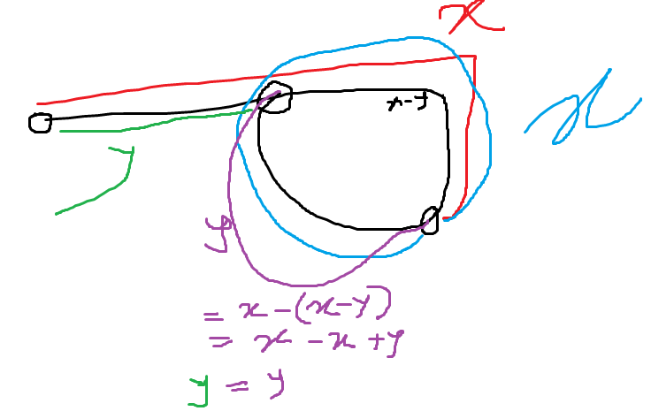

5> Find repeat and missing element in an array ->

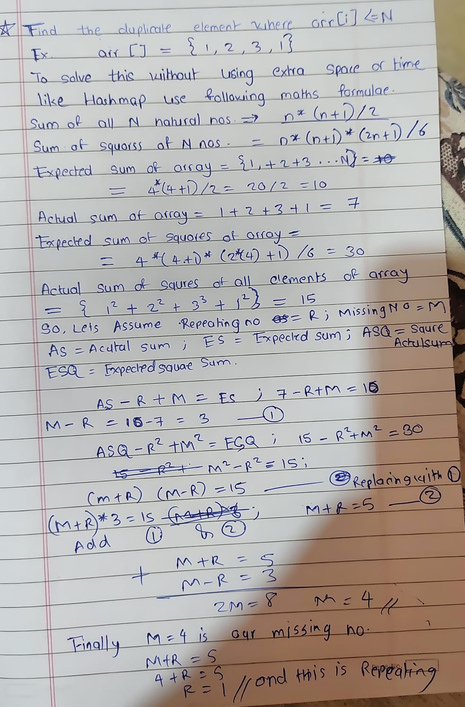

M2 – R2 = (M+R) \* (M-R) //This works only when we subtract squares…

1. Arrays Part 4 ->

4> Largest Subarray with sum k

To generate all possible subarrays we keep track of all cumulative sum calculated from the beginning of array till that point. We keep perv sum of all indexes in map.

