4> Find duplicate in array of n+1 integers ->

Floyd Warshall’s algorithm (Hare & tortoise)

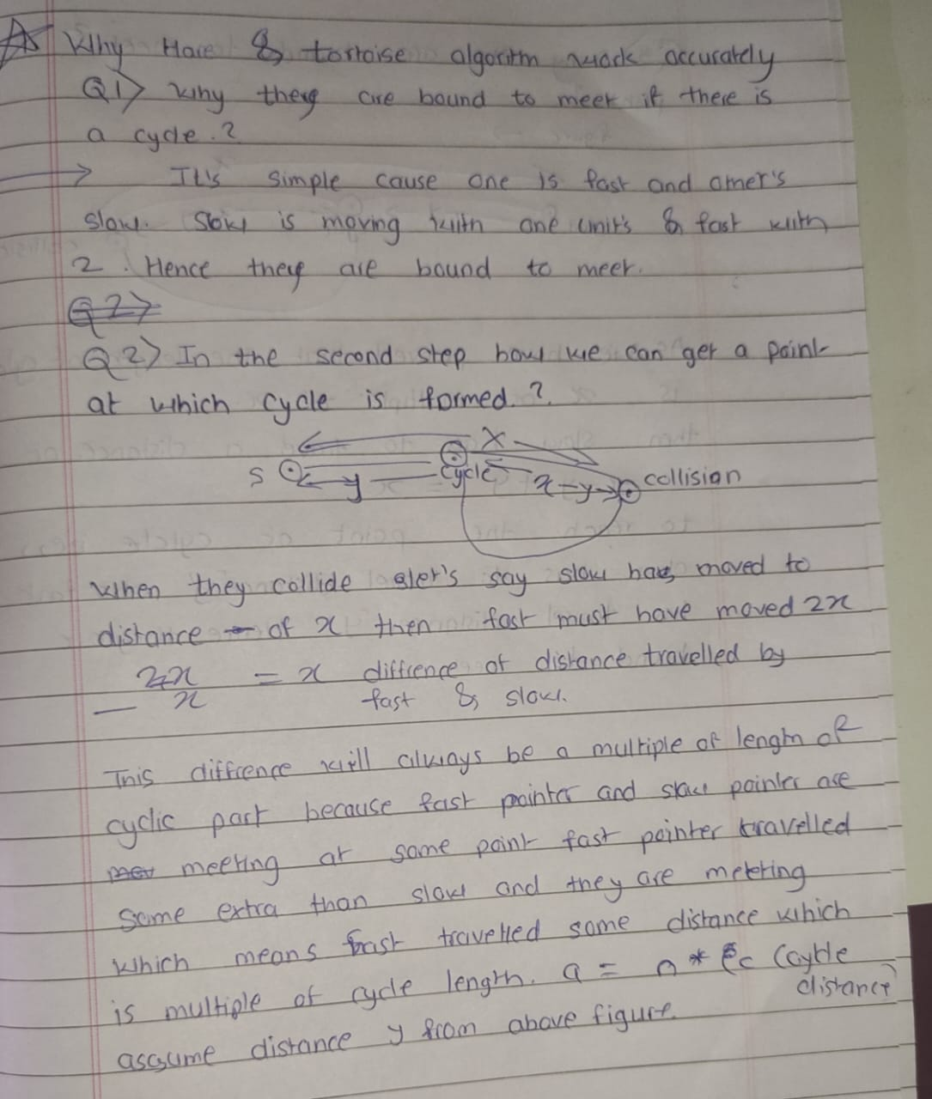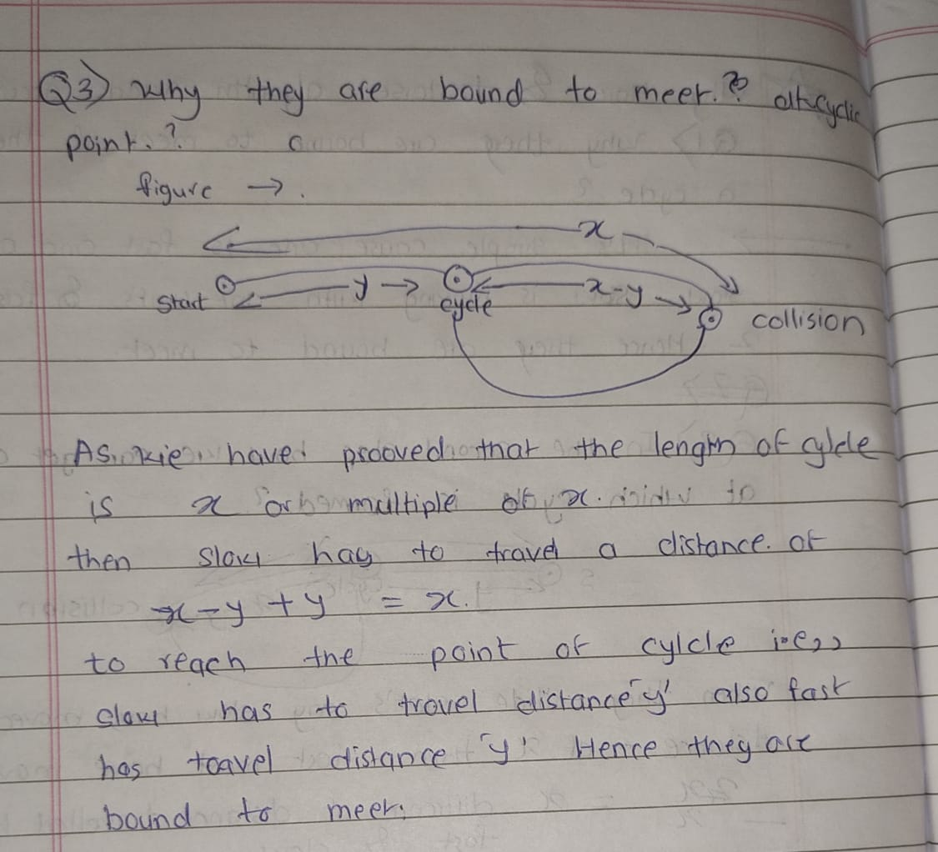

5> Find repeat and missing element in an array ->

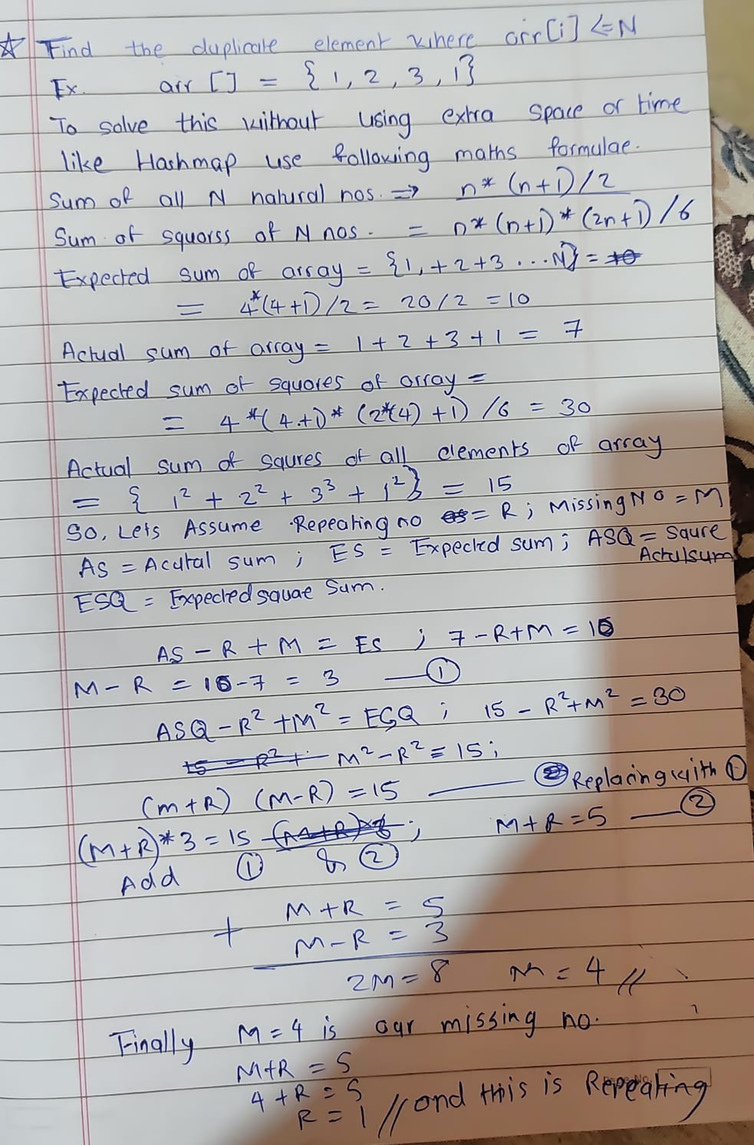

M2 – R2 = (M+R) \* (M-R) //This works only when we subtract squares…