Tress Data Structure

1> Preorder Traversal:

1. First visit and print the node.
2. Visit left subtree.
3. Visit right subtree.

2> Inorder Traversal:

1. Visit left subtree.
2. Print the node visit it.
3. Visit right subtree.

3> Postorder Traversal:

1. Visit left subtree.
2. Visit right subtree.
3. Print the node visit element.

4> 6Left & Right View of Binary Tree.

While solving a problem consider below corner case. For each level of binary tree we have to insert only one node whichever explored first in recursion. It is also possible that we print right child when we see left view of tree and vice-versa.

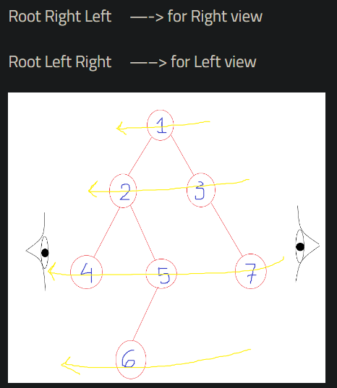

5> Bottom View Of Binary Tree.

Why we used level order traversal over a recursive traversal techniques?  
look below corner case for line 0 recursive traversal would have given wrong ans.

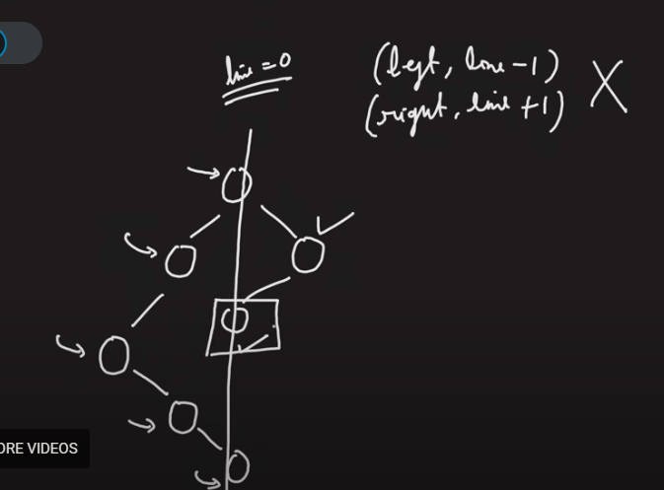

6> Top view of a binary tree.

Consider below corner case.

