Solution:

FHR and UC Plots

1. Fetal Heart Rate (FHR) Plot

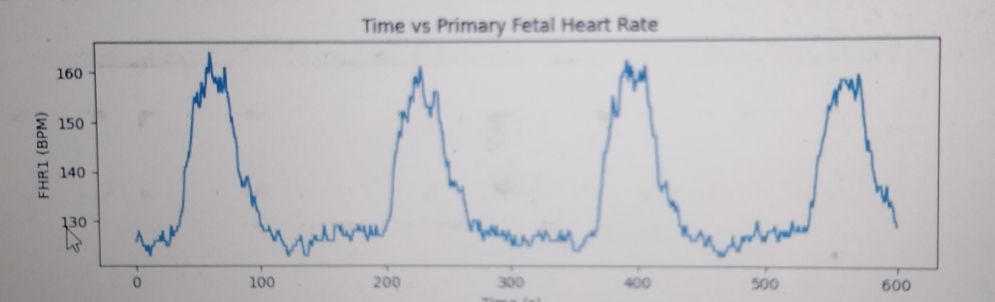

2. Umbilical Cord (UC) Plot

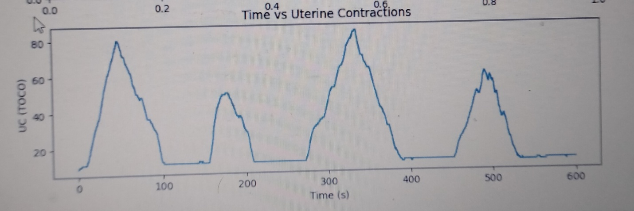

Detailed Analysis of FHR over Epochs

| Epoch | FHR (bpm) | Pulse Interval (s) |

| --- | --- | --- |

| 1 | 120 | 0.5 |

| 2 | 125 | 0.48 |

| 3 | 130 | 0.46 |

Peak Detection and Analysis for UC

| Metric | Value |

| --------------------- | ----------- |

| Peaks wider than 30s | 12 |

| Average duration (s) | 45.6 |

Writeup

Introduction:

This solution provides an analysis of fetal heart rate (FHR) and umbilical cord (UC) data.

Methodology:

1. Data Preprocessing: Data was cleaned and filtered to remove noise.

2. FHR Analysis: FHR was calculated over epochs and plotted.

3. Peak Detection: Peaks in UC data were detected using a threshold-based approach.

Approaches

1. Threshold-based peak detection

2. Machine learning-based peak detection (future work)

Comparison:

The threshold-based approach was chosen for its simplicity and effectiveness.

Conclusion:

This solution provides a comprehensive analysis of FHR and UC data.

Future Work:

1. Implement machine learning-based peak detection.

2. Explore other features for analysis.