Experiment No 10

Title : Recursive decent parser

Aim : To understand the concept of recursive decent parser.

Objective : Implement recursive decent parser.

Method :

It is a kind of Top-Down Parser. A top-down parser builds the parse tree from the top to down, starting with the start non-terminal.
A Predictive Parser is a special case of Recursive Descent Parser, where no Back Tracking is required.
By carefully writing a grammar means eliminating left recursion and left factoring from it, the resulting grammar will be a grammar that can be parsed by a recursive descent parser.

Input : i
Output : Accept

Input : aia
Output : Not accept

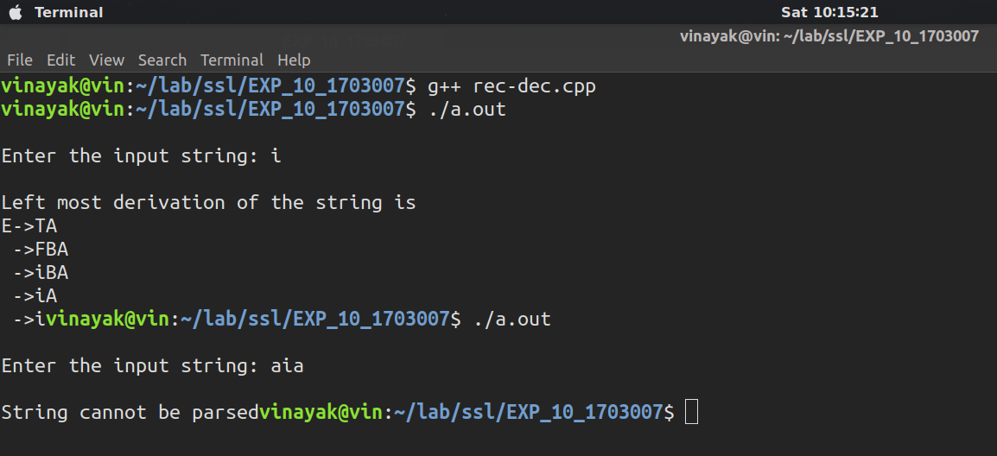

Conclusion : From this experiment we understand the concept of recursive decent parser. Also how to parse string too a grammer.

