Experiment No. 1

Title: Counts a number of words, white spaces from given input.

Aim: Program to count a number of words, white spaces from given input.

Objective: To write program to count a number of words, white spaces from given input. Understanding language, letters & string. Understanding compiler work & optimization.

Implementation:

- Introduction:
First to count a numbers of words & space from input we had to take input file from user. Even user can give string. Here we use file. Second thing is using bufferreader, read that file.
Then we will split word from file, as we take whole file as string even input will be consider as string so we required to spilt string into words, so that each single word will be consider as string. Now we generate counter that will be increased when spilted string read reader. So that we get count of Number of string. Instead of checking character by character, this method reduce compiler efforts.
Now problem generate with counting white space, as we spilt string in words, so we do Number of white space equals to number of string minus one.

- Logic:
1] Read input file as string
2] Split string as word
3] Count word as string
4] white space = count of string - 1

- Sample input:
this is the file and you want count word in this file

- Output:
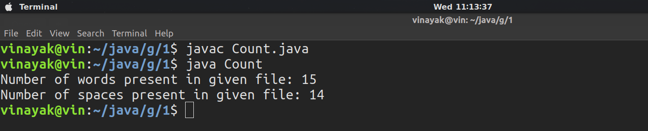

Conclusion:
Reading file character by character make lengthy & time consuming process also extra load to compiler. While string by string wil reduce compiler efforts.

