Experiment No 7

Title : Left Factoring

Aim : To undestand concept of left factoring

Objecting : To implement program for removing of left factoring.

Method :

Left factoring is removing the common left factor that appears in two productions of the same non-terminal. It is done to avoid back-tracing by the parser. Suppose the parser has a look-ahead ,consider this example-
A -> qB | qC
where A,B,C are non-terminals and q is a sentence. In this case, the parser will be confused as to which of the two productions to choose and it might have to back-trace. After left factoring, the grammar is converted to-
A -> qA’
A’ -> B | C
In this case, a parser with a look-ahead will always choose the right production.
Logic :
1. First thing is to avoid back-tracing by parser.
2. Now find the common factor in production.
3. Store that in ariable as string, find againg for sub one.
4. Now make new production which must be back-traceless.

Input :
A -> aA|aB|aC
Output :

Your answer is :
A -> aA'
A' -> A|B|C

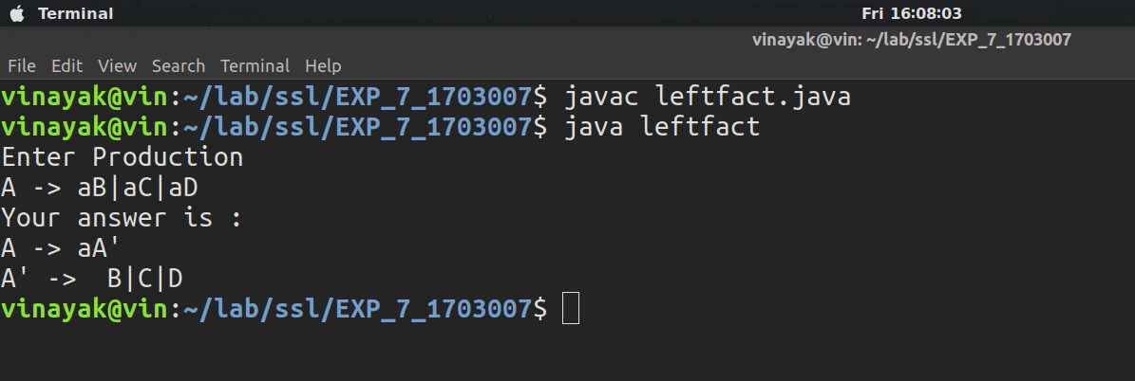

Conclusion :
From this experiment we undestand how to remove left recursion & also back tracing on parser.

