Experiment No 8

Title : First & Follow

Aim : To understand concept of first & follow.

Objective : To implement first & follow.

Method :

There are certain rules to obtain first & follow.

FIRST is applied to the r.h.s. of a production rule, and tells us all the terminal symbols that can start sentences derived from that r.h.s.
first of first(a) is always ‘a’
Follow is used only if the current non-terminal can derive e then we're interested in what could have followed it in a sentential form.
Logic :
1. first find First as first symbol
2. Put $ in follow as first symbol
3. If e not there then follow will directly placed else consider as that particular string is not exist and move ahed

Input : input strore in dict. Gram
E -> E+T|T
T -> T*F|F
F -> (E)|i
Output :
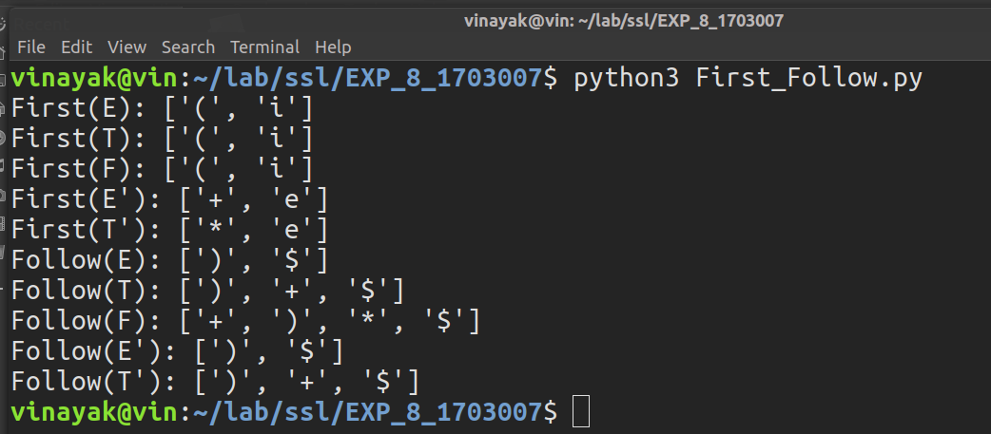

Conclusion : From this experiment we able to find first & follow.

