**Voice Library Tester**

1)Download the tsapi_phone.zip file in local System.

2)Move tslib.ini file in the downloaded folder to C:\Windows\

3)Open Command Prompt as Administrator.

4)Execute the Command regsvr32.exe "D:\LocalPath\tsapi_phone\AXS_INPROC.dll"

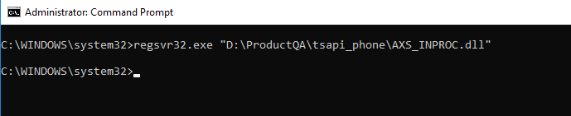

5)Open D:\LocalPath\tsapi_phone\VoiceLibraryTester.exe

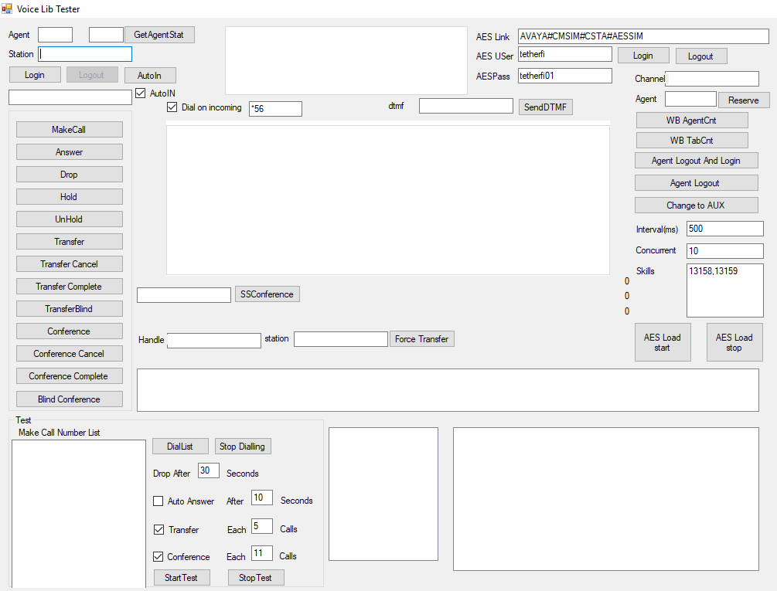

6)Enter AES Link, AES Username and password then press “Login” button next to AES User fields.

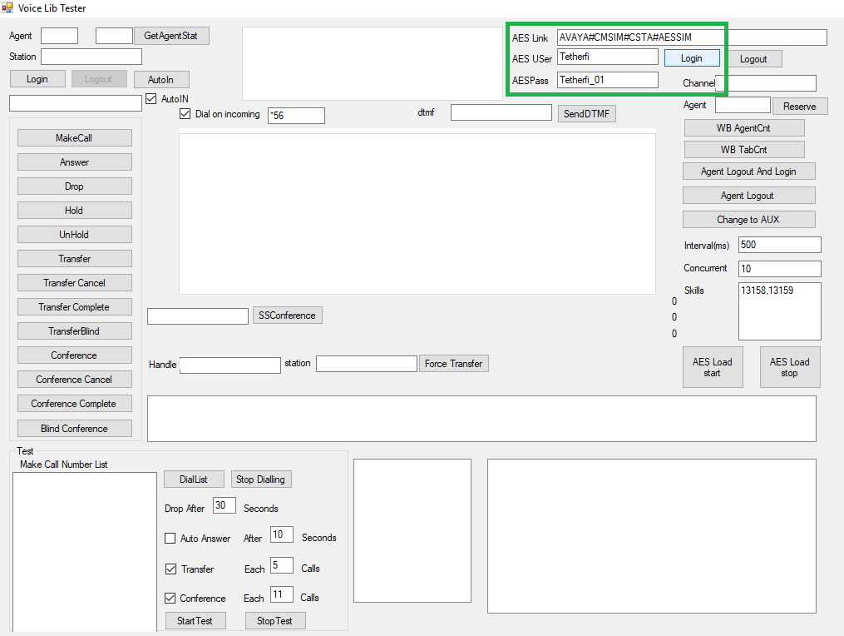

7) Enter AgentID and Station id then press login button.

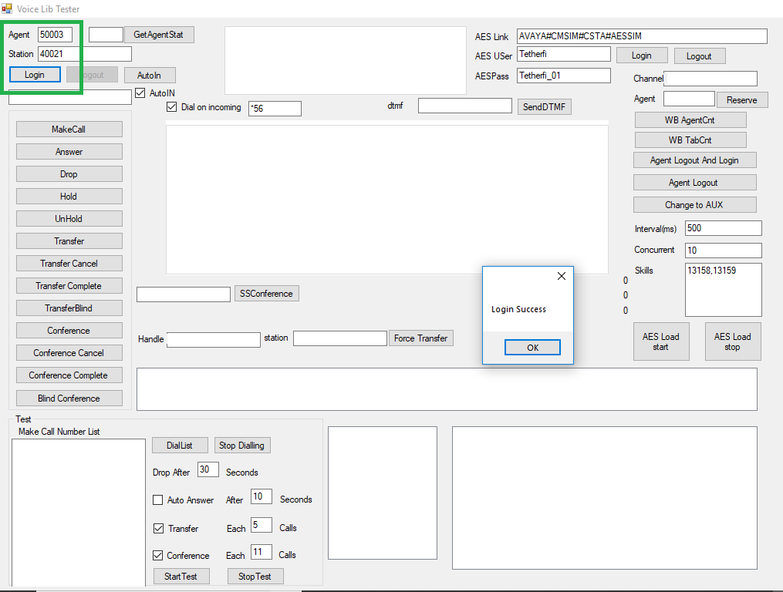

8)Enter Make Call Number List. Enter number list to dial. Choose Drop call and Auto Answer as per the requirement. Click on Start test.

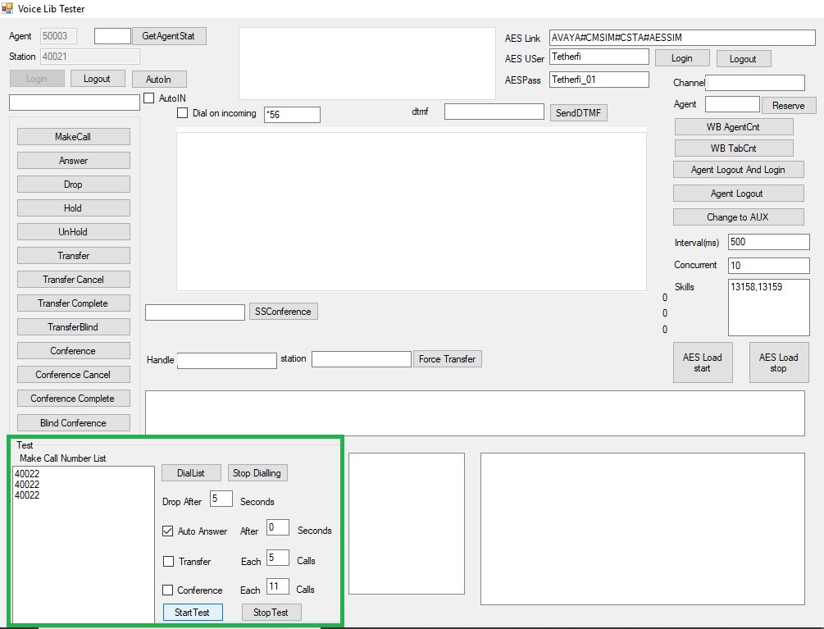

9)Call will be auto triggered for the Number List provided.

