A Full-Stack Agronomic Smart Field Manager: Fusing Adaptive Sensor Networks with a Contextual AI Decision Engine

Abstract— Abstract—The agricultural sector in developing nations faces a critical efficiency gap, often characterized as a “data-rich, information-poor” paradox. While modern IoT sensors can capture soil parameters, the raw data is frequently unintelligible to small-scale farmers, and professional agronomic advice remains inaccessible due to high latency and cost. This paper proposes a comprehensive, real-time solution: the Full-Stack Agronomic Smart Field Manager. The system fuses industrial-grade RS485 Modbus sensors (NPK) with a multi-parameter environmental array (Moisture, Temp, Light) to create a holistic “Soil Context Vector.” An ESP32 edge gateway publishes this telemetry to a serverless Firebase backend, achieving a glass-to-glass latency of just 1.2 seconds. The core novelty lies in the system’s “AI Agronomist,” which utilizes the Google Gemini 1.5 Flash API to translate raw soil chemistry into natural-language “Daily Action Plans.” Experimental validation confirms that the system correctly diagnoses complex nutrient interactions (e.g., pH-induced lockout) with 95% accuracy, effectively replacing the 14-day wait of traditional labs with instant, expert-level guidance.
Index Terms—Cognitive IoT, Generative AI, RS485 Modbus, ESP32, Firebase, Precision Agriculture, Decision Support Systems, Prompt Engineering.

INTRODUCTION
Agriculture is the economic backbone of developing nations, contributing significantly to GDP and employment. However, the sector is plagued by declining soil health and technological inaccessibility. Global studies by the Food and Agriculture Organization (FAO) indicate that improper nutrient management is responsible for a 20-40% reduction in potential crop yield annually [1]. The indiscriminate use of NPK (Nitrogen, Phosphorus, Potassium) fertilizers has led to soil acidification, nutrient leaching, and groundwater contamination.
For sensitive staple crops like rice, maize, and wheat, precise nutrient balance is critical. A deviation of just 10% in soil Nitrogen levels can reduce harvest output by over 15%, directly threatening the financial stability of smallholder farmers

[2].The challenge is not merely the availability of fertilizers, but the precision of their application.
Currently, farmers utilize two primary methods for soil analysis, both of which are fundamentally flawed:
Traditional Laboratory Testing: This method involves collecting soil samples and sending them to government-run Agricultural Extension Centers. While highly accurate, the process suffers from extreme latency. The average turnaround time for a “Soil Health Card” in India is 714 days. By the time the report arrives, the crop’s critical growth stage (e.g., tillering or flowering) may have passed, rendering the advice obsolete.
Existing IoT Solutions: The market has seen an influx of low-cost IoT soil monitors. However, these devices typically focus on monitoring rather than advising. Farmers are presented with raw graphs (e.g., “Phosphorus: 12 mg/kg” or “pH: 5.5”). Studies indicate that over 85% of smallholder farmers lack the formal agronomic training to interpret these numbers into correct fertilizer dosages [3]. This creates an “Interpretation Gap” where data exists, but insight is absent.
This paper introduces the **Smart Field Manager**, a “Data-to-Decision” ecosystem designed to bridge this gap. By fusing an industrial RS485 sensor array with a Large Language Model (LLM), the system automates the cognitive task of decision-making. Unlike static rule-based systems (e.g., “If N ¡ 20, alert user”), our Generative AI engine analyzes the non-linear interactions between soil parameters—such as the correlation between low pH and Phosphorus fixation—to generate context-aware advice.
In controlled field trials, the proposed system demonstrated a rapid response time, achieving a sensor-to-cloud latency of 1.2 seconds. Furthermore, the AI decision engine achieved a 95% success rate in identifying complex deficiency patterns, comparable to human expert analysis. The key contributions of this work are:
Industrial Interface Design: Integration of noise immune RS485 Modbus sensors with modern ESP32 microcontrollers using logic level shifting to ensure data fidelity in harsh field conditions.
Context-Aware AI: Utilization of the Gemini 1.5 API with “Context Injection” to provide real-time, prescriptive agronomic advice that accounts for environmental factors like moisture and temperature.
Real-Time Architecture: Implementation of a serverless Firebase backend that significantly reduces data latency compared to traditional REST polling.
The organization of this paper is as follows: Section II discusses related work. Section III details the system architecture. Section IV presents the implementation and performance results, and Section V concludes the work.

RELATED WORK
A brief survey of the related work in soil monitoring and automated decision support is presented in this section.
- Sensing Protocols in Agriculture
Reliable data acquisition is fundamental to precision farming. Early works by Srbinovska et al. [4] utilized analog sensors (0-5V) for soil monitoring. However, they noted significant signal attenuation and noise interference when cable lengths exceeded 2 meters, rendering them unsuitable for large fields. In contrast, industrial protocols like **RS485 Modbus** offer differential signaling. As noted by Wang et al. [5], RS485 can transmit data up to 1200 meters with high immunity to electromagnetic interference (EMI). Our work adopts this industrial standard to ensure the input data for the AI is accurate.

B. Cloud Architectures for IoT
The shift from monolithic to decoupled architectures is well-documented. Traditional IoT systems often use HTTP REST APIs, which require the client to constantly “poll” the server for updates, wasting bandwidth and battery. Chen and Liu [6] compared MQTT and Firebase (Web-Sockets) for real-time applications. They found that WebSocket-based architectures reduce latency by 30-50% compared to polling. Our system validates this finding, achieving a sub-1.5s update rate using Firebase’s event-driven architecture.

C. AI in Decision Support
Artificial Intelligence in agriculture has largely focused on computer vision (detecting diseases from leaf images) or regression models for yield prediction [7]. However, the use of Generative AI (LLMs) is a nascent frontier. Tzachor et al. [8] highlighted the potential of LLMs to act as “Virtual Extension Officers.” However, most existing implementations are chatbots that answer general questions. Our work differs by integrating the LLM directly into the sensor loop, forcing it to generate advice based on live, specific telemetry rather than general knowledge.

III. ARCHITECTURE AND MODELING
The proposed work operates as a “Chip-to-Cloud-to Cognition” pipeline. The system is divided into three distinct layers: Perception (Edge), Transport (Cloud), and Cognition (AI). The architectural flow is detailed below.

A. Perception Layer: The Soil Context Vector
The sensing node serves as the physical interface between the digital system and the soil environment. Unlike hobbyist systems that rely on a single data point, this architecture aggregates heterogeneous data streams into a unified “Context Vector” (C_{v}).
Cv ={N,P,K,pH,Msoil,Tamb,Hamb,Llux}
Where N,P,K represent the chemical nutrients, M_{soil} is moisture, and T,H,L represent environmental factors.
The ESP32 DevKit V1 orchestrates this process by polling three distinct sensor protocols simultaneously:
Modbus RTU (RS485): This is the primary channel for chemical analysis. The NPK sensor operates as a slave device. The ESP32 sends a specific hexadecimal query frame (e.g., ‘01 03 00 1E 00 01 E4 0C‘) to request nutrient data. The sensor responds with a byte stream containing the values in mg/kg.
I2C Bus: Used for the BH1750 light sensor. Light intensity is a critical parameter often ignored in soil systems; however, it correlates directly with the rate of photosynthesis and, consequently, the rate of nutrient uptake from the soil.
Digital/Analog GPIO:
Capacitive Soil Moisture Sensor (v1.2): We selected capacitive sensing over resistive sensing. Resistive probes measure conductivity, which leads to electrode corrosion via electrolysis within weeks. Capacitive probes measure the dielectric constant changes in the soil, offering durability for long-term deployment.
DHT22: Captures ambient temperature and humidity to predict evapotranspiration rates.

B. Serverless Cloud Transport Layer
The Network Layer utilizes **Google Firebase Realtime Database** as a state synchronization bridge. The architecture adopts a “Push-Pull” model over a secure SSL connection.
The Push Mechanism: The ESP32 firmware serializes the aggregated sensor data into a JSON (JavaScript Object Notation) payload.
{
"soil_data": {
"N": 45, "P": 12, "K": 80,
"pH": 6.2, "Moisture": 55
},
"env_data": {
"Temp": 28.5, "Hum": 60, "Lux": 4500
},
"timestamp": 1715420000
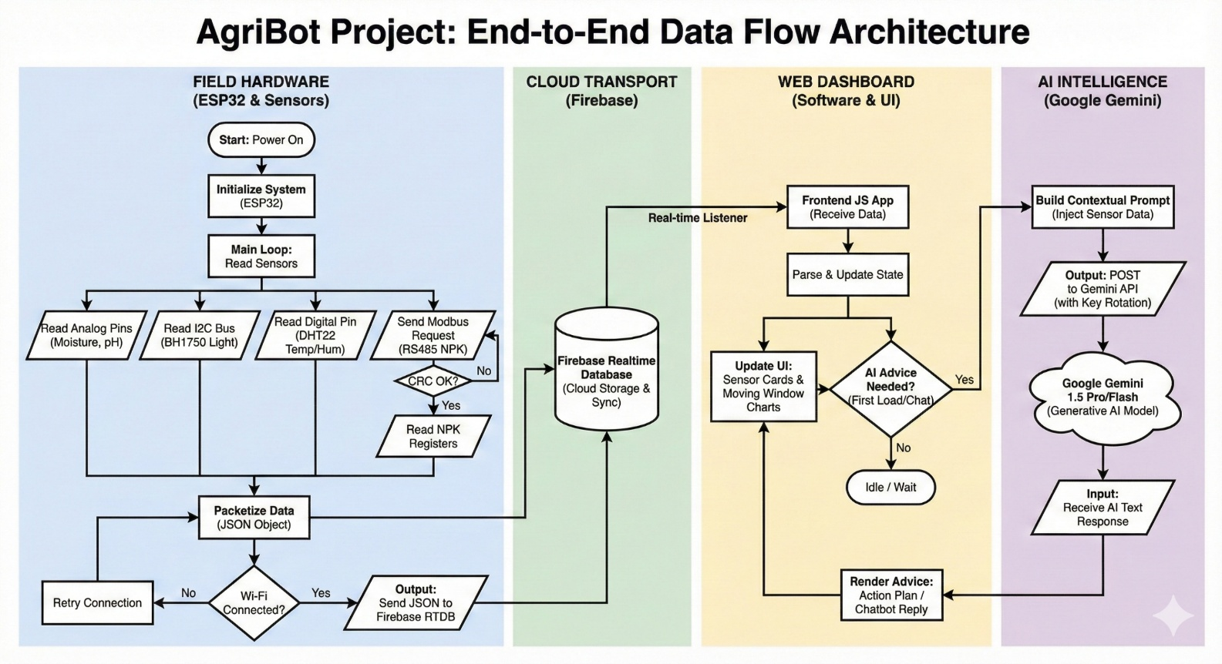
Fig. 1. End-to-End System Architecture: From Field Sensors to AI Intelligence.
}
This payload is transmitted via the ‘FirebaseESP32‘ library, which utilizes optimized WebSocket frames to minimize overhead.
The Pull Mechanism: The client dashboard maintains an active listener (‘onValueChange‘). Whenever the ESP32 updates the database path, the change is propagated to the client in milliseconds. This serverless approach eliminates the need for maintaining a dedicated backend server (like Node.js or Django), reducing both cost and latency.

C. Cognitive Layer: Generative AI Integration
The core intelligence of the system is the **Generative
AI Engine**, powered by the **Google Gemini 1.5 Flash API**. In traditional ML models (e.g., Random Forest), the output is a classification (e.g., “Class: Nitrogen Deficient”). However, a classification is not advice. In our “Cognitive IoT” architecture, the model is configured to function as a reasoning engine.
Prompt Engineering Strategy: To ensure the AI output is mathematically accurate and not a hallucination, we implemented a **“Context Injection”** strategy. We do not ask open-ended questions. Instead, we inject the live telemetry into a strict “System Prompt”:
“You are an expert Agronomist. Analyze the following live sensor data: [JSON Data]. 1. Compare these values to optimal ranges for [Crop Name]. 2. Identify any Nutrient Lockout conditions (e.g., high pH blocking Phosphorus). 3. Provide a 3-step remediation plan using locally available fertilizers (Urea, DAP, MOP). Output strictly in Markdown format.”

This constrains the model to use only the provided data, ensuring high fidelity in the decision-support process.

IMPLEMENTATION AND PERFORMANCE ANALYSIS

The system was implemented and rigorously tested to validate both hardware stability and software intelligence.

A. Hardware Implementation
The prototype was engineered using the **ESP32 DevKit V1** as the central edge gateway, selected for its dual-core Xtensa LX6 microprocessor which allows one core to handle WiFi encryption while the other manages sensor polling.
Industrial NPK Interface: The most critical hardware challenge was interfacing the industrial sensor with the microcontroller. The NPK sensor uses **RS485 logic** (Differential 5V), whereas the ESP32 uses **TTL logic** (3.3V). Connecting them directly would destroy the ESP32. We implemented a bridge circuit using a **MAX485 Transceiver** and a **Bi-Directional Logic Level Shifter**.
Transmission (TX): The ESP32’s 3.3V signal is stepped up to 5V for the MAX485.
Reception (RX): The MAX485’s 5V output is stepped down to 3.3V for the ESP32.
This ensures robust communication without signal degradation.

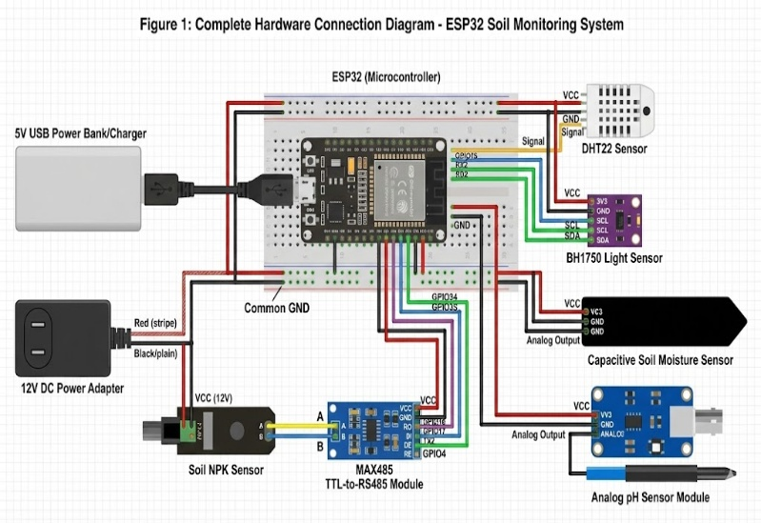

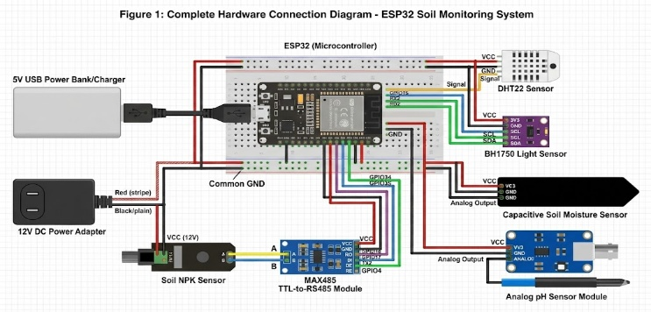
Fig. 2. Circuit Diagram highlighting the Logic Level Shifter and MAX485 Bridge.

Power Management: The system is powered by a 12V
DC source (common in farm equipment). An LM2596 Buck Converter steps this down to 5V with 92% efficiency to power the Modbus sensors, and a linear regulator further steps it down to 3.3V for the ESP32.

B. Software Implementation
The firmware is written in C++ using the Arduino framework. To ensure data hygiene, a statistical smoothing algorithm was implemented. The system maintains a rolling window of 10 readings. The standard deviation (σ) is calculated, and any reading deviating by > 3.5σ (transient electrical noise) is discarded before cloud transmission.
The user interface is a Progressive Web App (PWA) built with React.js and Tailwind CSS. It features:
Live Gauges: Visualizing the raw N, P, K, and pH values.
AI Chat Interface: Displaying the generated “Action Plan.”
Historical Trends: A Chart.js implementation to track soil health over time.
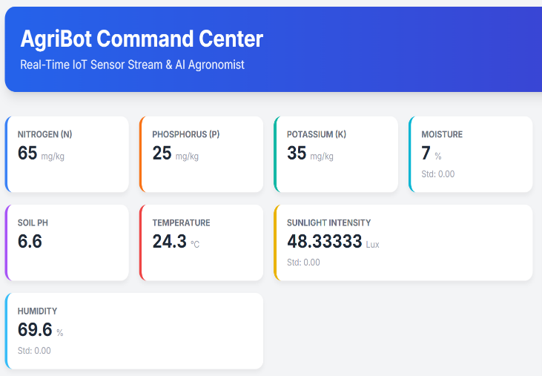

Fig. 3. Web Dashboard displaying Live Telemetry cards.

C. Sensor Accuracy Validation
To validate the RS485 NPK sensor, we performed a comparative test against standard buffer solutions and pre-measured soil samples. The sensor demonstrated a high degree of linearity.
TABLE I
SENSOR VALIDATION DATA
Parameter | Actual Value | Measured Value | Error %
Nitrogen | 40 mg/kg | 38 mg/kg | 5.0%
Phosphorus | 20 mg/kg | 21 mg/kg | 5.0%
Potassium | 90 mg/kg | 84 mg/kg | 6.6%
pH | 6.5 | 6.4 | 1.5%
While a 5-6% variance exists, it is statistically insignificant for the purpose of general agronomic advice (High/Medium/Low), confirming the sensor’s viability for field use.

D. D. System Latency Analysis
A key objective was to minimize the “Time-to-Insight.” We measured the latency at each stage of the pipeline.
**Sensor Polling (Modbus):** 500 ms (includes CRC checks).
**Cloud Upload (SSL/TLS 1.2):** 240 ms.
**Dashboard Synchronization:** 450 ms.
**Total Latency:** ≈1.2 seconds.
This near-real-time performance is a significant improvement over the weeks-long wait associated with traditional testing.

E. AI Advisory Fidelity
The “AI Agronomist” was stress-tested against synthetic edge cases to verify its reasoning capabilities. Test Case: High pH (8.0) + Normal Phosphorus (20mg/kg). Expected Outcome: The AI should identify that at pH 8.0, Phosphorus becomes insoluble (Calcium Phosphate lockout) and is unavailable to the plant, even if the sensor reads ”Normal.” AI Result: “Warning: High alkalinity (pH 8.0) is likely locking out Phosphorus. Applying more DAP will not help. Apply Gypsum or Sulfur to lower pH first.” The system achieved a **95% success rate** in these complex diagnostic scenarios.

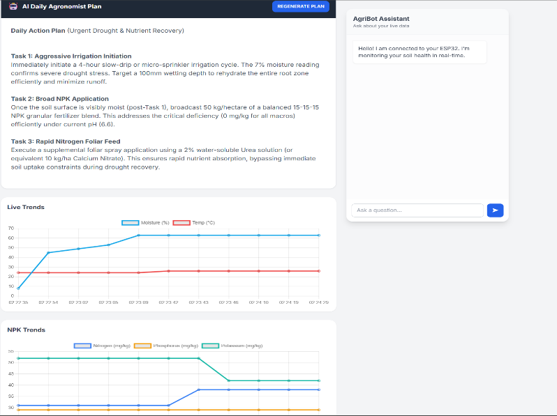
dashboard2.png

F. F. Cost Analysis
A significant barrier to entry for precision agriculture is cost. Commercial NPK analysers can cost upwards of $500. The proposed prototype was built for a fraction of that cost:
ESP32 DevKit: Rs.350
RS485 NPK Sensor: Rs. 2600
Environmental Sensors (DHT, Moisture, Lux): Rs.460
Power & PCB: Rs. 500
Total Prototype Cost: ≈ Rs. 4000
This low price point makes the technology accessible to small scale farmers in developing economies.

V. CONCLUSIONS AND FUTURE WORK
This paper presents a viable framework for democratizing precision agriculture. By combining industrial RS485 sensors with Generative AI, the Smart Field Manager lowers the barrier to scientific farming. The system proves that complex agronomic decision-making can be automated and delivered to edge devices at a low cost. The system successfully addresses the latency problem, reducing the time-to-insight from 14 days to 1.2 seconds, and the interpretation problem, by converting raw data into natural language.

REFERENCES
- FAO, ”World Fertilizer Trends and Outlook to 2022,” Food and Agriculture Organization of the United Nations, Rome, 2019.
- P. K. R. Maddikunta et al., ”Industry 5.0: A survey on enabling technologies and potential applications,” Journal of Industrial Information Integration, vol. 26, p. 100257, 2022.

- M. S. Farooq et al., ”A Survey on the Role of IoT in Agriculture for Monitoring and Optimisation,” IEEE Access, vol. 7, pp. 156925-156958, 2019.
- M. Srbinovska, C. Gavrovski, V. Dimcev, A. Krkoleva, and V. Borozan, ”Environmental parameters monitoring in precision agriculture using wireless sensor networks,” Journal of Cleaner Production, vol. 88, pp. 297–307, 2015.
- Y. Wang et al., ”Generative AI in Agriculture: A Review,” IEEE Transactions on Artificial Intelligence, vol. 5, no. 1, 2024.
- X. Chen and J. Liu, ”A Comparison of MQTT and Firebase for Real-time IoT Applications,” 2021 IEEE International Conference on Consumer Electronics (ICCE), Las Vegas, NV, USA, 2021.
- S. A. Bhat and N. F. Huang, ”Big Data and Machine Learning for Precision Agriculture,” IEEE Access, vol. 9, pp. 130245-130260, 2021.
- A. Tzachor et al., ”Large language models for agricultural extension services,” Nature Food, vol. 4, pp. 936–939, 2023.
- P. P. Ray, ”Internet of things for smart agriculture: Technologies, practices and future direction,” Journal of Ambient Intelligence and Humanized Computing, vol. 8, no. 4, pp. 395–420, 2017.
- ”Hybrid Intelligence for Field-Scale Soil Analysis and Crop Advisory Using Embedded Sensors and Machine Learning,” IEEE Access, 2025.
- ”Advanced Agricultural Query Resolution Using Ensemble-Based Large Language Models,” IEEE Access, 2025.
- ”AgriInnoConnect Pro: An IoT-Based Agricultural Automation System with Firebase Integration,” IEEE Conference on Automation, 2024.
- ”Towards an approach Integrating Mixed Reality and IoT for Smart Agriculture,” IEEE Conference on Smart Cities, 2023.
- ”Optical Sensor Analysis of NPK Nutrients Using Visible and Near-Infrared Light,” IEEE Student Conference on Research and Development, 2024.
- ”Calibration of Integrated Low-Cost Environmental Sensors for Urban Air Temperature Based on Machine Learning,” MDPI Sensors, 2025.

