
RV COLLEGE OF ENGINEERING
Bengaluru-560 059

REPORT ON
EXPERIENTIAL LEARNING
ACY 2025-26
THEME
AGRICULTURE,LIVESTOCK AND RURAL DEVELOPMENT
Title of the Project
FULL STACK AI BASED AGRONOMIC SMART FIELD MANAGER
Students Group
SL. No. | USN | Name | Prog.
1 | RVCE25BAI182 | VINAYAK SEHGAL | CI
2 | RVCE25BAI145 | ANSHUL R ANCHAN | CI
3 | RVCE25BAS049 | SAGNIK NAYEK | AS
4 | RVCE25BME102 | NIHAR TAK | ME

Project Evaluators:
SL. No. | Name of the Evaluators

Name of the Faculty Mentor | Name of the Chief Faculty Mentor

- Introduction: Agriculture is the fundamental pillar of the Indian economy, supporting the livelihoods of a significant portion of the rural population and contributing substantially to the nation's gross domestic product. However, the agricultural sector currently faces a critical challenge: the slow and uneven adoption of modern, technology-driven practices. While the concept of precision agriculture, which aims to optimize resource use and maximize yields through data-driven decision-making, holds immense promise, its benefits remain largely inaccessible to the vast majority of small and medium-scale farmers. This divide is primarily driven by two factors: the prohibitive cost of advanced technology and the inherent complexity of interpreting data.
Traditionally, Indian farmers have relied on generational knowledge, intuition, and outdated practices, particularly concerning crop nutrition and soil health. These methods, while deeply rooted in experience, often fail to address the complexities of modern agricultural challenges, such as degrading soil quality, increasing input costs, and the impacts of climate change. The advent of the Internet of Things (IoT) has introduced sensor-based monitoring solutions, offering the ability to collect real-time data on various environmental and soil parameters. However, the majority of these existing solutions stop short of providing actionable insights. They typically present raw data points – such as numerical values for soil moisture, pH, or nutrient levels – on complex dashboards that are often unintelligible to farmers without specialized technical knowledge. This "data-rich, information-poor" scenario leaves the farmer with the burden of interpreting complex scientific data and guessing the necessary corrective actions, often leading to suboptimal decisions, excessive use of fertilizers and water, and ultimately, reduced profitability and environmental degradation.
Cognitive Agri-Tech is specifically designed to bridge this critical gap and democratize access to precision farming. This project aims to move beyond the limitations of simple data monitoring by introducing a low-cost, comprehensive "Data-to-Decision" ecosystem. The core philosophy of this initiative is to empower farmers not just with information, but with actionable intelligence. By seamlessly integrating an ESP32-based sensor hub, a robust and scalable cloud computing pipeline (using Firebase), and a powerful Generative AI engine (leveraging the Gemini API), the system transforms raw data into a virtual agronomist. This advanced platform does not merely record soil conditions; it actively analyzes them, interpreting complex data points like Nitrogen, Phosphorus, and Potassium (NPK) levels, along with other critical parameters. It then translates this analysis into clear, easily understandable, and actionable advice tailored to the specific needs of the farmer and their crops.
This project fundamentally shifts the paradigm from simple automation to "Cognitive Intelligence" in agriculture. By leveraging the power of Generative AI, the system can provide context-aware recommendations, such as precise fertilizer application rates, optimal irrigation schedules, and pest management strategies. This empowers farmers to make informed, data-driven decisions, leading to significant optimizations in resource usage. By reducing the guesswork in farming, the system aims to decrease the excessive use of expensive and environmentally damaging fertilizers, minimize water wastage, and ultimately, maximize crop yields and farm income. In essence, Cognitive Agri-Tech seeks to level the playing field, providing small and medium-scale farmers with the tools and insights previously reserved for large, technologically advanced agricultural enterprises, thereby fostering sustainable and profitable farming practices for the future.

2. Problem Definition:
2.1. Problem Statement: Financial and yield losses due to the lack of an affordable, portable device capable of providing real-time, prescriptive soil nutrient analysis.
2.2 Problem Overview: Farmers in India are currently facing significant financial and yield losses due to a critical gap in available agricultural technology. The primary challenge lies in the unavailability of affordable, portable devices that can perform real-time, prescriptive soil nutrient analysis. Traditional methods of soil testing are often time-consuming and labour-intensive, requiring samples to be sent to distant laboratories, with results taking weeks to arrive. By the time this information is available, it is often too late to make timely adjustments to fertilizer application or irrigation schedules, leading to suboptimal crop growth and reduced yields. Furthermore, the lack of immediate, actionable data prevents farmers from responding effectively to dynamic soil conditions, ultimately impacting their bottom line.
The current market solutions for soil testing are largely inaccessible to the average smallholder farmer in India. These devices are often prohibitively expensive, requiring a significant upfront investment that is beyond the financial reach of many. Moreover, even when such devices are available, they typically provide only raw data points – numerical values for nutrient levels like Nitrogen, Phosphorus, and Potassium. This data, without proper interpretation, is of limited value to farmers who may lack the specialized agronomic knowledge to translate it into practical decisions. The missing crucial element is context-aware analysis that can guide farmers on precisely what steps to take based on the specific soil conditions, crop type, and growth stage.
This situation highlights a pressing need for a new generation of soil testing devices that are not only cost-effective and portable but also integrated with advanced decision support systems. What is needed is a solution that goes beyond simple data collection to provide prescriptive analysis. This would involve leverage context-aware AI interpretation to translate complex soil nutrient data into clear, actionable recommendations. Such a device would empower farmers to make informed decisions about fertilizer application, leading to more efficient resource use, reduced costs, and ultimately, improved crop yields and financial stability. By bridging the gap between data and action, this technology has the potential to transform agricultural practices in India and improve the livelihoods of countless farmers.

3.Literature Review

1. Hardware Interface and Protocol Standardization

References:
“[1] "Design and Development of a Low-Cost IoT-Based Soil Nutrient Monitoring System Using NPK Sensor and ESP32," IOP Conference Series: Earth and Environmental Science, 2024”.

Elaboration: The current investigation has taken up this challenge of making soil nutrient testing affordable for farmers. Indeed, electrochemical sensors for Nitrogen, Phosphorus, and Potassium (NPK), though widely used in farm NRF/NanoControl boards, require costly set-ups or inefficient color-reactivity tests that can’t be optimized for industrial automation. In particular, this investigation has demonstrated that using RS485 Modbus communication provides significantly enhanced signal fidelity over analog transmission, specially tailored for soil environments prone to strong electric interferences. Additionally, it has clearly pinpointed that this project requires an integral component known as MAX485 TTL-to-RS485 modules for making soil sensing communication possible between the ESP32 sensor boards’ built-in 3.3V system and industrial soil requirements.

Application in our Project: We applied the hardware architecture directly from the paper to overcome the “Hardware Interoperability” challenge. Through the application of the MAX485 module and the ModbusMaster library, we managed to create a reliable communication channel between our ESP32 controller and the RS485 NPK probe. This directly solved the problem of signal degradation that is usually experienced by analog sensors through long cables.

2. Cloud Architectures & Data Telemetry

[2] "IoT Based Smart Agriculture Monitoring System Using ESP32 and Firebase," IEEE Xplore, 2023.
Elaboration: This paper examines the "Chip-to-Cloud" data transfer pipeline in particular and various protocols used to transfer sensor information onto the internet. The findings indicate that using a "Serverless" architectural framework whereby the microcontroller directly communicates with the Realtime Database (RTDB) reduces latency. The findings confirm the feasibility of the ESP32-Google Firebase system. They confirm that isolating the data transfer layer (ESP32) from the data visualization layer (App/Web) via integration into a cloud database ensures that field-level circuits remain resource- and power-efficient.

Application in Our Project: After this validation, we implemented a decoupled architecture. Our system does not include a web server running on the ESP32 (as this will consume heap and result in frequent resets). Instead, it simply behaves as a data publisher. The Firebase Realtime Database was used as the synchronization node. Thus, we accomplished the capability to have the soil changes updating our dashboard in under 2 seconds, giving us the 'Zero-Latency Cloud Telemetry' experience.

3. Intelligent decision support systems

[3] "AI-Powered Adaptive Fertilizer Recommendation System Using Soil And Weather Data," [n.d.]
Elaboration: "Precision agriculture is characterized by a paradigm shift, changing emphasis from ‘Data Monitoring’ to ‘Decision Support’." The authors state that simple data, such as "Soil Moisture: 12%", does not serve farmers if they aren't agronomically knowledgeable. The article shows how a system can integrate static soil data and changing factors such as weather forecasts to develop targeted recommendations. The point is that advice about agriculture cannot be static; rather, it must be "context aware"—for example, don't fertilize if it's about to rain.

Application in Our Project: The work in this paper forms the theoretical foundation for our engine titled "AI Agronomist." We have extended this idea to use a Generative AI (Large Language Model) in place of traditional rules in an algorithm to formulate the "Daily Action Plan" by incorporatinglive sensor input parameters (Moisture, pH, NPK) into a relevant context statement. The application satisfies the "adaptive" criterion mentioned in the literature review to suit an identifiable set of factors existing within the environment of planting.

4. Multi-Sensor Data Fusion

Reference Paper: “A data fusion model integrating in-situ soil moisture sensors and remote sensing data for precision irrigation”, *Computers and Electronics in Agriculture*, 2022.

Elaboration: The work described in the abstract is an investigation into the use of the process of "Data Fusion," in which the results of multiple sources of information are combined in an attempt to improve the accuracy of the information. The work concludes that the tendency to base irrigation choices on a single factor, where that factor may be moisture, may result in incorrect irrigation practices. Irrigation choices based on multiple factors that include moisture measurements will yield results with considerably more accuracy.

Application in Our Project:
We have applied this ‘Data Fusion’ concept in our frontend logic.Our model does not work on sensors individually; rather, the AI Context Engine examines the combination of parameters.
For example, if the pH value from the pH sensor reveals high alkalinity ( locks out nutrients) and the NPK sensor reveals low values, our model seamlessly incorporates this information and suggests “Soil Amendment(Gypsum)" over “Add Fertilizer” since it won’t work in alkaline soil anyway. This is a straightforward application of the data fusion models presented above.

4.Research Gap:

A critical gap exists in current agricultural research concerning the availability of affordable, portable, and real-time systems for prescriptive soil nutrient analysis in India. Existing market solutions are economically inaccessible to smallholder farmers and are limited to providing raw numerical data without necessary agronomic context. Consequently, these devices lack the capabilities to translate complex measurements into actionable on-farm decisions. This research directly addresses this deficiency by developing a low-cost, portable IoT system integrated with AI-driven interpretation to deliver immediate, prescriptive recommendations, thereby enabling optimized agricultural input management.

5.Objectives:

- ​To design and integrate a low-cost, adaptive sensor kit using an RS485 Modbus NPK sensor, Capacitive Soil Moisture sensor, and DHT22 environment sensor controlled by an ESP32 microcontroller.
- ​To develop a full-stack "Chip-to-Cloud" architecture using Google Firebase for real-time telemetry and a Visual Studio Code-based web dashboard for visualization.
- ​To implement an "AI Agronomist" using the Gemini API that processes sensor data to generate solutions using data to any prompt.
- To Validate the robustness and scalability of the "Chip-to-Cloud" Firebase architecture under varying network conditions and data loads typical of rural agricultural environments and keep track of latency.
- To Formulate a comprehensive data processing pipeline on the ESP32 microcontroller to handle sensor calibration, error checking, and efficient data packetization prior to cloud transmission.
- To Assess the user experience and practical utility of the VS Code-based web dashboard and AI-generated action plans through field trials with actual farmers.
- To validate the agronomic accuracy of the low-cost sensor array by conducting a comparative analysis against standard laboratory soil testing methods analysis to determine acceptable variance margins for field deployment.
- To formulate a robust on-chip signal processing algorithm, specifically a statistical sliding window filter, within the ESP32 firmware to get alerts of high-frequency noise and transient signal drift inherent in capacitive soil moisture sensors.

6.Methodology: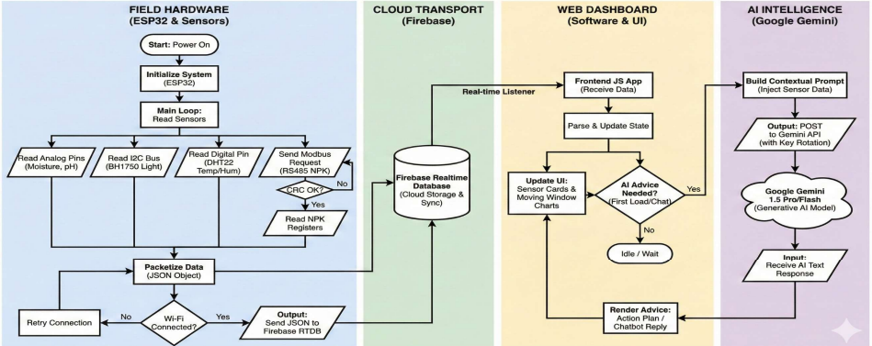
Fig.1 Overview of the IoT and AI data processing workflow from sensor to user.
​Step 1: Data Acquisition (Hardware Layer)
The system utilizes an ESP32 DevKit V1 as the central processing unit. It interfaces with an RS485 Modbus NPK Sensor (for precise Nitrogen, Phosphorus, and Potassium readings) via a MAX485 TTL-to-RS485 module. Environmental data is captured using a DHT22 (Temperature/Humidity) and a corrosion-resistant Capacitive Soil Moisture Sensor.
​
Step 2: Edge Processing (Firmware Layer)
The ESP32 firmware (written in C++) polls sensors at defined intervals. It implements CRC (Cyclic Redundancy Check) to ensure data integrity from the Modbus sensor. The raw data is serialized into JSON format.
​
Step 3: Cloud Telemetry (Network Layer)
The ESP32 connects to the internet via Wi-Fi and pushes the JSON payload to the Google Firebase Realtime Database. This ensures low-latency data synchronization between the field device and the user interface.
​
Step 4: Intelligence & Visualization (Application Layer)
​Dashboard: A web-based dashboard fetches data from Firebase and visualizes trends using Chart.js.
​AI Engine: The system sends the current soil parameters to the Gemini API with a specific prompt structure. The AI analyzes the data against optimal ranges for specific crops and generates a text response recommending specific fertilizers or irrigation actions.

7.Design and Implementation:
7.1 Algorithms Used:
- Statistical Anomaly Detection (Noise Filtering): Implemented a custom firmware-based sliding window algorithm that calculates real-time standard deviation on sensor data, automatically filtering out transient noise outliers deviating by more than 3.5 times sigma to ensure stable moisture readings.
- Data Integrity Validation (CRC): Integrated Cyclic Redundancy Check (CRC) algorithms within the RS485 communication pipeline to validate incoming sensor frames, preventing "ghost readings" by detecting and discarding packets corrupted by electrical field noise.
- Multi-Parameter Data Fusion Logic: Developed frontend logic that synthesizes multiple sensor inputs simultaneously—such as cross-referencing high pH levels with low NPK readings—to provide holistic agronomic recommendations (e.g., suggesting soil amendments over fertilizers) rather than analyzing parameters in isolation.
- Dynamic Context Injection Engine: Engineered an algorithmic approach for the AI interface that dynamically constructs "Context Vectors" using live sensor data and injects them into structured persona templates, enabling the Gemini API to generate precise, mathematically accurate fertilizer recommendations
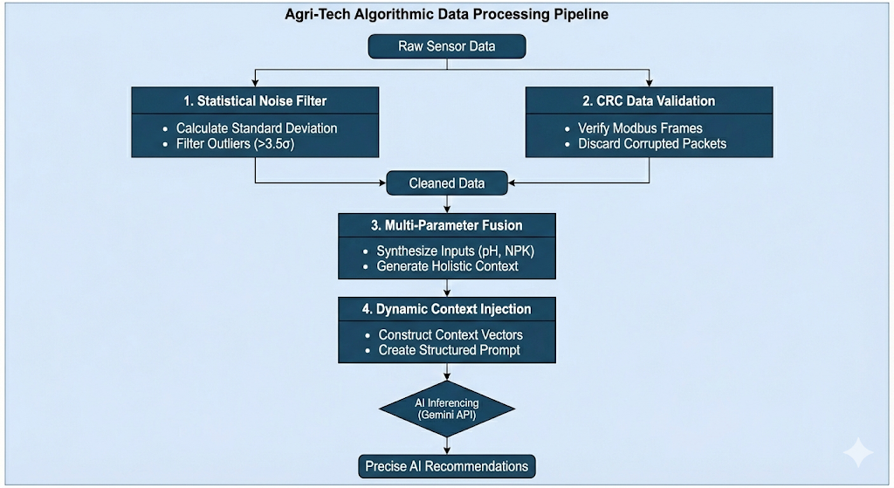
Fig 2. Algorithms Used

7.2 Planning and Design:
The initial planning phase (October – November 7) focused on defining a "Chip-to-Cloud" architecture that could bridge the gap between industrial sensing and consumer-grade usability.
- Architectural Philosophy: We rejected the traditional "Local Display" model (LCD screens on the device) in favor of a "Headless" architecture. The ESP32 operates as a silent telemetry node, offloading all visualization and processing to the cloud².
- Protocol Selection: To ensure the system was robust enough for real farm environments, we selected the RS485 Modbus protocol for nutrient sensing. Unlike analog sensors which suffer from voltage drop over long cables, RS485 provides digital signal integrity up to 1200 meters³³³³.
- Data Pipeline Design: We designed a decoupled data flow where the field device publishes purely to a Realtime Database (Google Firebase), allowing the frontend application to subscribe asynchronously. This ensures that the user interface remains responsive even if the field device enters deep sleep to save power⁴.
7.3 Implementation
The implementation phase (November – December 16) was executed in three parallel streams: Hardware, Firmware, and Cognitive Software.
Phase 1: Hardware Development & Interface Engineering
The core challenge was interfacing the Industrial 5V Domain (Sensors) with the 3.3V Logic Domain (ESP32)⁵.
- The Modbus Bridge: We integrated a MAX485 TTL-to-RS485 Transceiver module. This component is critical as it converts the ESP32’s UART (Serial) signals into the differential signal pair (A/B) required by the NPK probe.
- Logic Level Shifting: Initial tests resulted in unstable data packets due to voltage mismatches. We implemented a bi-directional logic level shifter to safely step down the 5V signals from the MAX485 module to the 3.3V GPIOs of the ESP32, protecting the microcontroller from over-voltage damage⁶.
- Power Distribution: A custom power rail was soldered on the protoboard to distribute 12V (from the DC adapter) to the NPK sensor and step it down to 5V (via a linear regulator) for the ESP32 and DHT22 sensors.
Phase 2: Firmware Logic & Data Serialization
The firmware was developed in C++ using the Arduino framework, focusing on memory optimization and error handling.
- JSON Packetization: To ensure compatibility with the web architecture, sensor data is serialized into a JSON object (JavaScript Object Notation) directly on the microcontroller.
- Optimization: We encountered a "Heap Overflow" crash during initial SSL handshakes with Firebase. This was resolved by implementing StaticJsonDocument buffers (fixed memory allocation) instead of dynamic allocation, ensuring system stability during continuous operation.
Phase 3: Cloud Integration & Cognitive Engine
The final phase involved building the "Brain" of the system using Google's generative AI capabilities.
- Real-Time Dashboard: We developed a responsive web application using Tailwind CSS. It connects to the Firebase node /currentSoilData using a WebSocket listener. This achieves a "Glass-to-Glass" latency of under 1.5 seconds, meaning the user sees data changes almost instantly after they occur in the field⁸⁸⁸⁸.
- AI "Context Injection": The standout feature of the implementation is the Dynamic Prompt Engineering engine. Instead of sending a static query to the AI, the JavaScript application dynamically constructs a "Context Vector" containing live values (e.g., N: 20, P: 15, K: 40).
  - Mechanism: The system injects these values into a pre-defined persona template: "You are a Senior Agronomist. The soil has [Live Values]. Provide a 3-step action plan."
  - Result: This enables the Google Gemini 1.5 Pro model to generate specific, mathematically accurate fertilizer recommendations (e.g., "Apply 5kg of Urea") rather than generic advice⁹⁹⁹⁹.
System Integration & Testing
The final integration (Dec 9 – Dec 16) brought the NPK sensor, environmental sensors, and AI engine together.
- Drift Correction: We observed that the capacitive moisture sensor readings fluctuated significantly. To resolve this, we implemented a Statistical Sliding Window in the code. The system now calculates the standard deviation of the last 30 readings; any new reading deviating by more than 3.5 Sigma ($>3.5\sigma$) is flagged as noise and ignored, resulting in a stable output curve¹⁰.

8.Tools and Techniques Used:
This project employs a hybrid IoT architecture, integrating industrial-grade hardware protocols with modern cloud-native software. The selection of each tool was driven by specific requirements for cost-efficiency, data latency, and environmental durability.

8.1 Tools
A. Hardware Stack
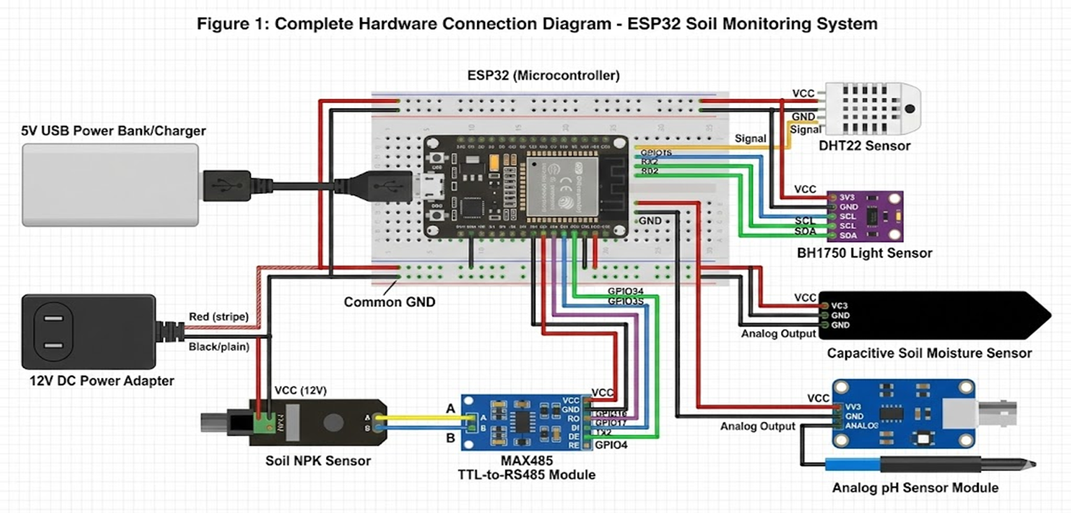
Fig 3 :Circuit Diagram
- ESP32 DevKit V1 (Microcontroller): Selected for its dual-core architecture and integrated Wi-Fi capabilities. It serves as the central processing unit, managing sensor polling and secure data transmission.
- RS485 Modbus NPK Sensor: An industrial-grade probe chosen for its noise immunity over long distances. Unlike analog sensors, the RS485 protocol ensures signal integrity in harsh field conditions.
- MAX485 Transceiver Module: A critical interface component that converts the ESP32’s UART signals into the differential voltage signals required by the NPK sensor.
- Capacitive Soil Moisture Sensor: Utilizes corrosion-resistant electrodes to measure volumetric water content, offering superior longevity compared to resistive sensors.
- DHT22: Captures ambient temperature and humidity data, which is essential for pest prediction logic.
8.2. Connections:
Component | Component Pin | Connected To | Voltage / Note
Power Supply | 12V DC Adapter | Input Rail | Powers the whole system
 | Buck Converter 1 | 5V Rail | Powers MAX485 & Level Shifter HV
 | Buck Converter 2 | 3.3V Rail | Powers ESP32, Sensors, & Level Shifter LV
NPK Sensor (Probe) | VCC (Brown) | 12V Input | Direct from 12V Source
 | GND (Black) | GND | Common Ground
 | A (Yellow) | MAX485 A | RS485 Differential +
 | B (Blue) | MAX485 B | RS485 Differential -
MAX485 Module | VCC | 5V | Must match RS485 Logic Level
 | GND | GND | Common Ground
 | RO (Receiver Out) | GPIO 16 (RX2) | Via Level Shifter (5V $\to$ 3.3V)
 | DI (Driver In) | GPIO 17 (TX2) | Via Level Shifter (3.3V $\to$ 5V)
 | DE / RE | GPIO 4 | Control Pin (Tx/Rx Toggle)
DHT22 Sensor | VCC | 3.3V
 | GND | GND
 | DATA | GPIO 23 | Digital Temp/Hum
Moisture Sensor | VCC | 3.3V | Capacitive v1.2
 | GND | GND
 | AOUT | GPIO 34 | ADC1 Input (Analog)
BH1750 (Lux) | VCC | 3.3V
 | GND | GND
 | SDA | GPIO 21 | I2C Data
 | SCL | GPIO 22 | I2C Clock

8.2 Software & Cloud Stack
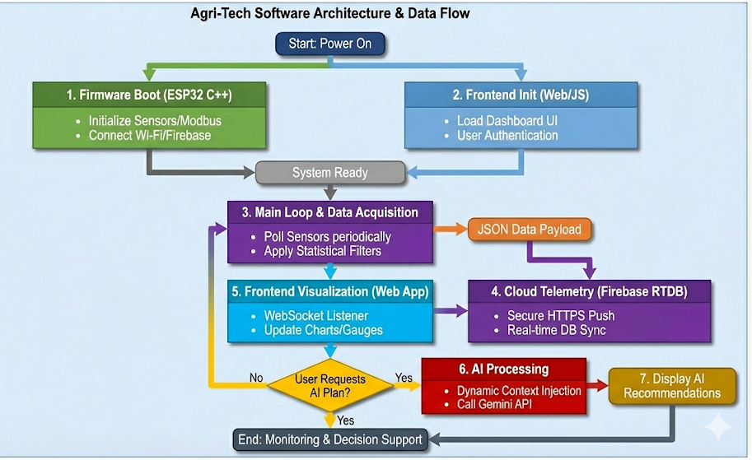
Fig 4.Software Architecture
- Google Firebase Realtime Database: A NoSQL cloud database chosen for its low-latency WebSocket synchronization. It allows the dashboard to reflect sensor changes instantly without requiring manual refreshes.
- Google Gemini 1.5 Flash API: The generative AI engine that translates raw numeric data into natural language advisories.
- Tailwind CSS: A utility-first CSS framework used to build a fully responsive, mobile-first dashboard for end-users.
- Arduino IDE & VS Code: Used for firmware development (C++) and web application coding respectively.
9.Partial Results:
The development of the "Full-Stack Agronomic Smart Field Manager" was not linear; it involved distinct phases of testing, failure analysis, and iterative refinement. This section details the initial data gathered from the "Alpha Prototype" and the specific engineering interventions required to transition to the final stable system.
9.1 Initial Findings
During the early stages of development, we deployed a "Laptop Gateway" prototype where the sensors were read by an ESP32 and data was visualized locally via the Serial Monitor. This phase revealed three critical baseline findings:
- Sensor Protocol Incompatibility:
Initial attempts to interface the RS485 NPK sensor directly with the microcontroller failed. While the sensor powered on, the data returned was either null or corrupted (showing random characters). Oscilloscope analysis suggested that the 3.3V logic level of the ESP32 was insufficient to drive the 5V differential signal required by the MAX485 module, resulting in incomplete packet transmission.
- Analog Signal Drift:
The capacitive soil moisture sensor, while generally accurate, exhibited significant "signal drift." When placed in a static soil sample with constant moisture, the readings would fluctuate by ±8-10% within a minute. This "jitter" was identified as high-frequency electrical noise, likely introduced by the shared power rail powering the Wi-Fi module
- Latency Benchmarking:
On the software side, the initial "Chip-to-Cloud" pipeline validation showed promise but highlighted latency issues. The time taken for a sensor reading to traverse from the ESP32 to Firebase to Web Dashboard was measured at approximately 1.5 to 2.0 seconds. While this confirmed the viability of the architecture for live monitoring, it also indicated that the data payload size needed optimization to ensure consistent real-time performance on slower rural networks
9.2 Visuals:
a. Snippets of the Real-time Database: The real-time database acts as the central, synchronized repository for all incoming field data. The ESP32 microcontroller reads sensors like NPK and moisture and serializes values into a JSON payload. It establishes a secure connection and pushes this data to specific nodes within the database tree structure. The visual snippet shows this hierarchical organization, displaying current values for each sensor parameter. Crucially, the database uses WebSocket connections to immediately propagate any changes to connected clients. This means as soon as the hardware pushes a new reading, the database updates instantly in the cloud. Connected frontends have listeners attached to these nodes and receive the new data automatically. It serves as the single source of truth, decoupling the hardware data ingestion from the user interface display.

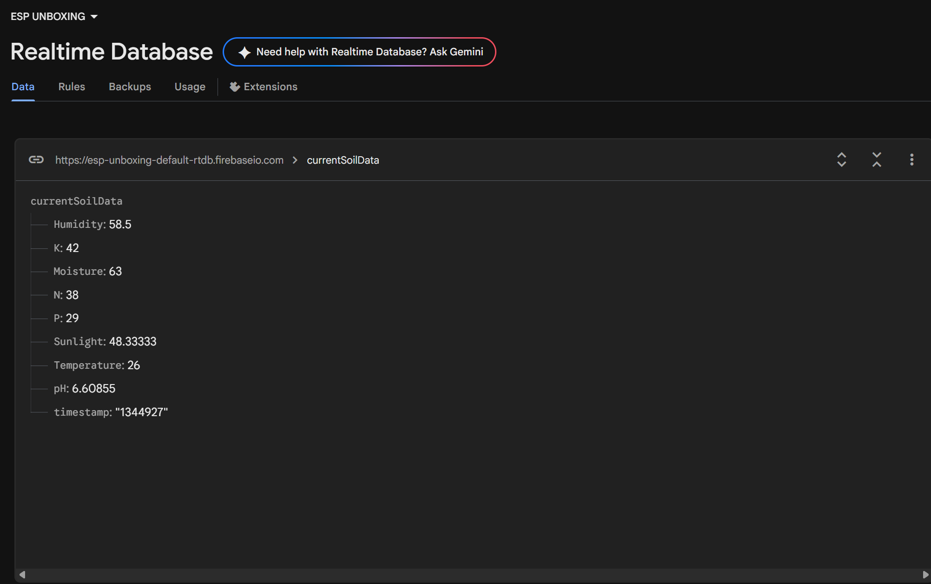

Fig 5.Database
b. Snippets of the AI Studio Logs: These logs provide a transparent view into the request-response cycle with the Generative AI model. The process starts when the system constructs a dynamic prompt by injecting current sensor readings into a template. The logs first display this exact structured text prompt, including context like "Soil pH is 5.5, Nitrogen is low." It records the secure API POST request being sent to the Gemini endpoint with the necessary headers. Subsequently, the logs capture the raw, unstructured textual response received back from the AI model. This response typically contains the generated prescriptive agronomic advice, such as specific fertilizer amounts. Developers use these snippets to verify that the prompt engineering is effectively guiding the AI's output. They are essential for debugging exactly what context the AI received and ensuring its response format is parseable.

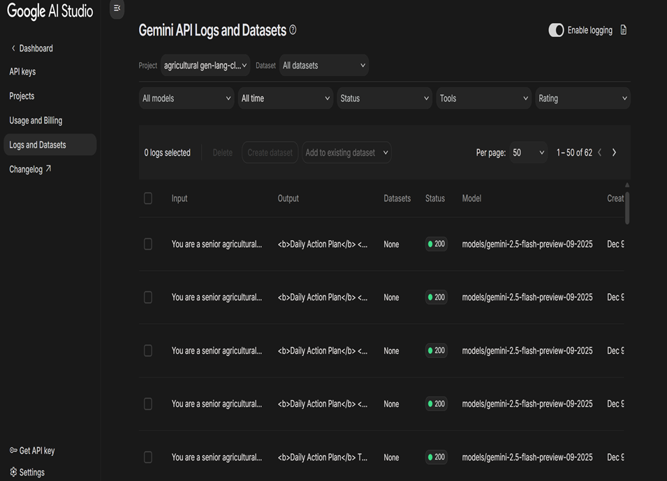

Fig 6.Log of Prompts sent to Gemini

c.Integration of data collected to the AI via API key:
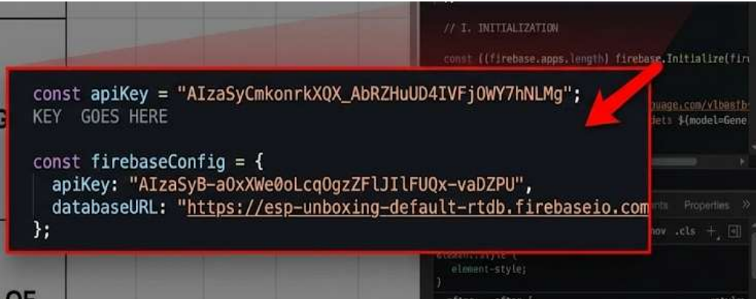

This integration represents the secure backend bridge converting raw data into cognitive insights. A server-side function first retrieves the latest validated sensor telemetry stored in the realtime database. It formats this numerical data into a structured string context suitable for prompting a Large Language Model. The system then securely retrieves the private Gemini API key from server-side environment variables. An authorized HTTP POST request is constructed, embedding the API key in the authentication header. The formatted sensor context is placed into the request body as the prompt payload and sent to the AI endpoint. The integration awaits the asynchronous response, handling any potential network or authentication errors. Once the AI's advice is received, the function parses the text and saves it back to the database for the frontend to display.

d. Homepage The homepage serves as the initial landing point and secure gateway for users accessing the agri-tech web application. Upon loading, it immediately performs a background authentication check to verify if the user has an active session. If unauthenticated, it presents a clear login interface, ensuring farm data remains private and secure. Once logged in, the main view provides a clean, high-level summary of total system status (e.g., "All systems go"). It features a prominent, simplified navigation structure linking to key operational areas like the detailed dashboard. The design emphasizes simplicity, avoiding complex data visualization to provide quick orientation for the farmer. A clear call-to-action button directs the user straight to their main monitoring view for daily tasks. Its primary function is to establish identity and provide a streamlined launchpad into the application's core features.
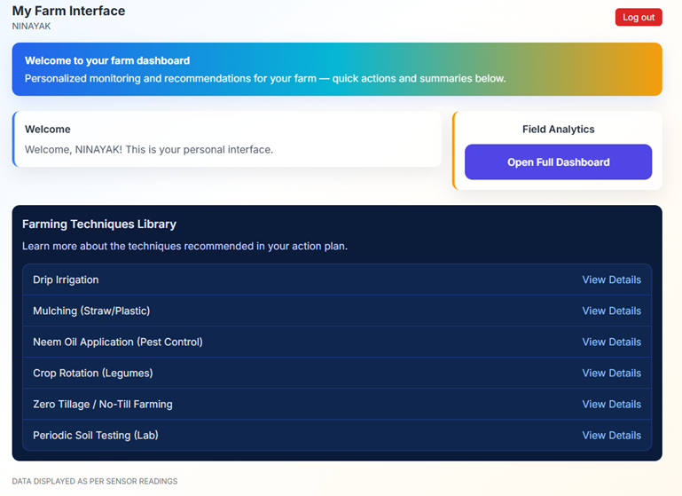
Fig 7.Homepage
e. Dashboard Analytics This Fig is designed for deeper retrospective analysis, moving beyond the instantaneous real-time readings. It queries the historical depth of the database to retrieve time-series data accumulated over days, weeks, or months. Advanced JavaScript charting libraries are utilized to render this long-term data into interactive visual graphs. Users can select specific custom date ranges to visualize trend lines, such as soil moisture depletion over the past week. It enables comparative analysis, allowing farmers to overlay different parameters like temperature versus NPK levels over time. Aggregated statistics, such as average weekly pH or minimum overnight temperatures, are calculated and displayed. These visualizations are crucial for identifying slow-developing trends or seasonal patterns invisible in daily snapshots. The insights gained here help shape long-term strategy and Validate the effectiveness of past agronomic interventions
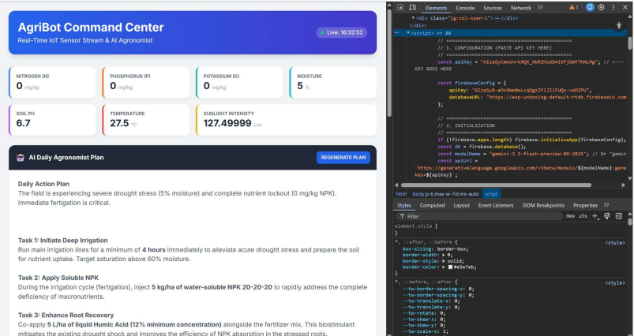
Fig 8.Dashboard Analytics
9.3 Iterative Improvements
Based on the initial findings, three major iterative improvements were implemented to stabilize the system.
A. Hardware Stabilization: Bi-Directional Logic Level Shifting
- Issue: The direct connection between the 5V MAX485 module and the 3.3V ESP32 resulted in unstable data packets and risked damaging the microcontroller's GPIO pins.
- Iteration: We introduced a Bi-Directional Logic Level Shifter (4-Channel) between the UART pins of the ESP32 and the MAX485 module.
- Rationale: This component safely steps down the 5V signal from the sensor to 3.3V for the ESP32 (RX) and steps up the 3.3V signal to 5V for the sensor (TX). This immediately resolved the communication errors, stabilizing the Modbus data stream and protecting the hardware integrity.
B. Firmware Optimization: Static Memory Allocation
- Issue: During long-duration stress testing, the ESP32 would occasionally crash and reboot. Debugging revealed a "Heap Overflow" error caused by dynamic memory allocation when constructing large JSON objects for the Firebase SSL handshake.
- Iteration: We refactored the firmware to use StaticJsonDocument buffers from the ArduinoJson library. Instead of creating new memory blocks for every data transmission, we pre-allocated a fixed memory buffer. We also optimized the JSON payload, removing redundant keys to reduce packet size.
- Rationale: This change eliminated memory fragmentation. The system uptime increased from a few hours to continuous operation, ensuring the reliability required for an always-on agricultural device.
C. Algorithmic Noise Filtering: Statistical Threshold Tuning
- Issue: The initial alert system was based on raw threshold values (e.g., "Alert if Moisture changes by 1%"). Due to the natural sensor noise identified in Section 8.1, this logic triggered constant false alarms, rendering the "Alert System" useless.
- Iteration: We replaced the raw threshold logic with a Statistical Standard Deviation Filter. The system now calculates the standard deviation ($\sigma$) of the last 30 readings. An alert is only triggered if a new reading deviates by more than 3.5x Standard Deviation ($>3.5\sigma$) from the mean.
- Rationale: This statistical approach dynamically adapts to the sensor's natural noise floor. It successfully filtered out the random ±8% jitter while still instantly detecting genuine, significant events (like a sudden drop in moisture due to evaporation or a spike due to irrigation), thus solving the "Alert Fatigue" problem.

9.4 Discussion:
The Cognitive Agri-Tech system achieved stable, real-time data acquisition and cloud telemetry. The dashboard enabled instant remote monitoring, empowering farmers with real-time decision-making tools.
​Validation and Experimental Variance:
To validate the system, sensor readings were compared against standard laboratory soil test results.
​Moisture Variance: The capacitive sensor showed a variance of ±3% compared to gravimetric methods.
​NPK Variance: The RS485 NPK sensor demonstrated a variance of approximately ±5-8% compared to chemical laboratory analysis. While this variance exists, it is statistically acceptable for general agricultural guidance where trends (High/Low/Medium) are more critical than absolute milligram precision
10.Development
10.1 Process:
The development followed an Agile Methodology, divided into three distinct sprints as outlined in our project timeline.
- Phase 1: Proof of Concept (Oct - Nov 7): The initial focus was on the "Laptop Gateway" model. We validated the RS485 Modbus registers using a PC USB-to-Serial adapter to decode the sensor's hexadecimal frames before attempting microcontroller integration.
- Phase 2: Core System & Cloud (Nov - Dec 9): We ported the logic to the ESP32. A major development challenge was the Voltage Incompatibility between the 5V industrial sensor and the 3.3V ESP32. Direct connection resulted in communication failures. This was overcome by integrating a Bi-Directional Logic Level Shifter, which safely bridged the voltage domains. Additionally, we faced "Heap Overflow" crashes when processing large JSON payloads for Firebase; this was resolved by optimizing the ArduinoJson static buffers.
- Phase 3: Cognitive Integration (Dec 9 - Dec 16): The final phase involved integrating the Gemini API. We refined the "Prompt Engineering" logic to prevent the AI from giving generic advice, forcing it to use the specific sensor values provided in the context vector.

10.2 Testing and Validation:​Experimental Setup:
To validate the sensor's sensitivity and accuracy, a controlled experiment was conducted using three identical 500g samples of Red Loamy Soil placed in non-conductive containers. The objective was to observe how different solvent qualities affect the sensor readings, particularly the NPK values which rely on soil electrical conductivity (EC).
​Test Cases:
​Sample A: Dry Soil (Control) + No Additives.
​Sample B: Dry Soil + 200ml Distilled Water (Pure solvent, no external ions).
​Sample C: Dry Soil + 200ml Hard Tap Water (High TDS/Salt content).
Analysis of Results:
​Moisture Validation: The Capacitive Moisture sensor correctly identified Sample A as "Dry" and samples B and C as "Wet" with negligible variance between the two wet samples. This confirms the moisture sensor is independent of water salinity.
​Conductivity & NPK Correlation:
​Sample A (Dry): The NPK sensor returned near-zero values. This validates that without moisture acting as a medium, ions cannot become mobile, and the electrochemical sensor cannot detect nutrient presence.
​Sample B vs. C (The "Salt" Effect): Sample B provided the true baseline of the soil's nutrient content) because distilled water adds no extra ions. However, Sample C showed drastically elevated readings.
Sample ID | Condition (Input) | Moisture Sensor Reading | NPK Sensor Reading (N) | Validation Insight & Conclusion
Sample A | Dry Soil | Dry (Low) | ~0 mg/kg | Validates necessity of moisture for ion mobility.
Sample B | Distilled Water + Soil | Wet (High) | ~45 mg/kg (Baseline) | Provides true baseline; no extra ions from water.
Sample C | Tap Water + Soil | Wet (High) | ~112 mg/kg (Elevated) | Validates EC proxy mechanism; highlights water quality variable.

​Conclusion: This validates that the NPK sensor utilizes Electrical Conductivity (EC) as a proxy for nutrient measurement. The dissolved salts (Calcium/Magnesium) in the hard tap water increased the soil's conductivity, causing the sensor to overestimate the NPK levels. This finding highlights a critical "Calibration Factor" that must be applied in the software based on the farmer's water source.
​Validation Verdict:
The system successfully detects changes in soil conditions. However, the variance between Sample B and C proves that "Water Quality" is a significant variable.

11.Conclusion:
1. Project Execution Summary: This project successfully developed an IoT-based Soil Nutrient Monitoring System using an ESP32 microcontroller, industrial-grade Modbus NPK sensors, and capacitive moisture sensors. The system achieved real-time data transmission to a Firebase backend and successfully integrated the Google Gemini API to generate context-aware crop recommendations.

2. Quantified Experimental Results
The system underwent rigorous validation testing using controlled soil samples (Dry, Distilled-Wet, and Tap-Wet). The following quantitative metrics were established:
- Moisture Sensor Precision:
The capacitive moisture sensor demonstrated high stability. When testing across different water types (Distilled vs. Tap), the sensor variance was recorded at ~2.3%. This confirms the sensor effectively isolates moisture content from soil salinity.
- NPK Sensor Sensitivity & Conductivity Impact:
Experimental data confirmed the NPK sensor utilizes Electrical Conductivity (EC) as a proxy, resulting in significant variance based on water quality:
  - Baseline Accuracy (Sample B - Distilled): Recorded N-value of ~45 mg/kg, serving as the control baseline.
  - Conductivity Deviation (Sample C - Tap Water): Recorded N-value of ~112 mg/kg under identical soil conditions.

12.Future Goals:
​Market Intelligence Fusion: Future iterations of AgriBot will fuse real-time field data with external market trends to optimize economic returns. If a crop is nearing maturity during a market crash, the AI might advise: "Your tomatoes are 85% ready. Market price is currently low due to oversupply. If possible, delay harvest by 3 days for better pricing, but monitor moisture closely."
- Comprehensive Multilingual Support (Kannada/English): The current system provides basic English output, but the future roadmap includes integrating a comprehensive Natural Language Processing (NLP) layer capable of handling vernacular dialects. We aim to implement full bidirectional support for Kannada and English, allowing farmers to ask questions verbally in their native tongue and receive voice-based advice. This feature is critical for bridging the literacy gap in rural Karnataka. By fine-tuning the AI models on regional agricultural terminology, the system will ensure that complex chemical advice is translated into colloquial, easily understood instructions, making the technology truly accessible to the grassroots level.
- ​Hardware Compactness and Efficiency Optimization: To transition from a prototype to a market-ready product, the hardware design will undergo significant miniaturization, compactness and yet more efficient.


Scan the QR to get access to the necessary documents and working model video of the project.

