**Table of contents:**

| **SL No** | **Content** | **Page No** |
| --- | --- | --- |
| 1. | Description | 2-3 |
| 2. | Requirements | 4-6 |
| * HLR |
| * LLR |
| 3. | Block diagrams | 6-8 |
| 4. | Components used | 8-10 |
| 5. | Applications | 10 |

1. **Description:**

An embedded system is a microprocessor-based computer hardware system with software that is designed to perform a dedicated function, either as an independent system or as a part of a large system. At the core is an integrated circuit designed to carry out computation for real-time operations.

It is a combination of Processing unit, Memory unit, I/O ports, Timers counters and Power source, etc.

In this case study I’m trying to analyze an embedded system by disintegrating it into its individual components as mentioned above.

The systems I have selected to work on are

* Simple embedded system:

Simple calculator

* A mid level complex embedded system:

Two wheeled balancing robot

**1.1 Simple calculator as an embedded system:**

A calculator is the embedded system that was developed very early. In the calculator, we give input from the keyboard; the embedded system performs the given function like Add, Subtract etc and displays the result on LCD. These calculators have the ability to perform complex mathematical functions.

1. **Requirements:**
2. **2.1 High level requirements:**

| **Test ID** | **Description** | **Category** | **Status** |
| --- | --- | --- | --- |
| HL_01 | Capable of doing mathematical calculations. | Functional | To be Implemented |
| HL_02 | Capable of handling mathematical interrupts. | Technical | To be Implemented |
| HL_03 | Power ON and OFF functionalities. | Functional | To be Implemented |
| HL_04 | Capable of having multiple modes of operations.  (Scientific, operational, Number manipulation, etc) | Technical | To be Implemented |
| HL_05 | Capable of taking inputs from the keyboard. | Technical | To be Implemented |
| HL_06 | Capable of displaying input and output parameters in a display. | Technical | To be Implemented |

**2.2 Low level requirements:**

| Test ID | Description | HLR_id | Status |
| --- | --- | --- | --- |
| LLR_01 | Representing numbers in binary | HL_01 | To be Implemented |
| LLR_02 | Using logic gates with binary | HL_01 | To be Implemented |
| LLR_03 | Implementing through adders, multipliers, etc | HL_01 | To be Implemented |
| LLR_04 | Error message when calculation interrupts encountered. | HL_02 | To be Implemented |
| LLR_05 | Presence of power ON and OFF keys. | HL_03 | To be Implemented |
| LLR_06 | Processing unit capable of doing complex math/logical operations. | HL_04 | To be Implemented |
| LLR_07 | Keypad sensors to read inputs. | HL_05 | To be Implemented |
| LLR_08 | LCD for displaying inputs and results. | HL_06 | To be Implemented |

1. **Block Diagrams:**

**3.1 Component Diagram:**

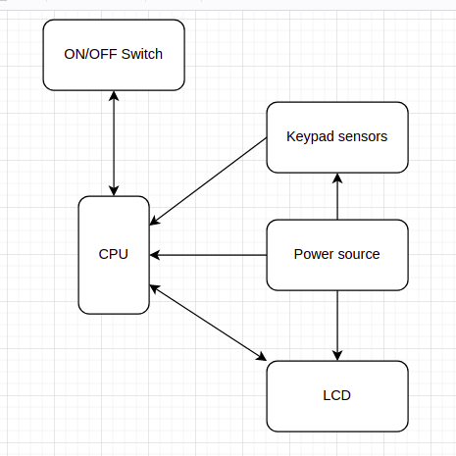

**3.2 Use case diagram:**

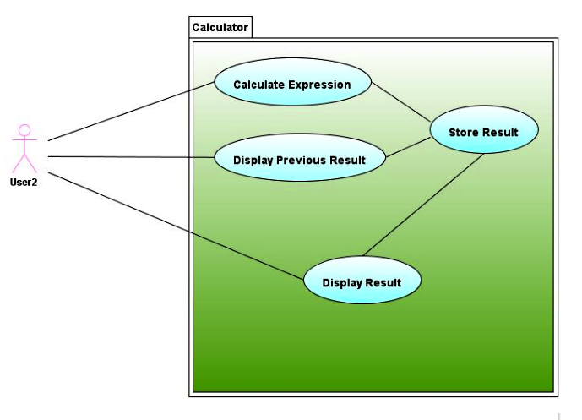

**3.3 Flowchart:**

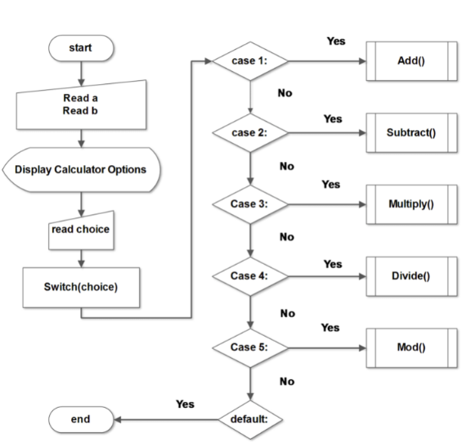

1. **Components used:**

**4.1 Microprocessor:**

* Intel 4004, It included a central processing unit (CPU) chip the 4004 as well as a supporting read-only memory (ROM) chip for the custom applications programs, a random-access memory (RAM) chip for processing data, and a shift-register chip for the input/output (I/O) port.

**4.2 Memory Unit:**

### Calculators also have the ability to store numbers into [computer memory](https://en.wikipedia.org/wiki/Computer_memory). Basic calculators usually store only one number at a time. More specific types are able to store many numbers represented in [variables](https://en.wikipedia.org/wiki/Variable_(mathematics)).

### The variables can also be used for constructing [formulas](https://en.wikipedia.org/wiki/Formula). Some models have the ability to extend [memory](https://en.wikipedia.org/wiki/Computer_memory) capacity to store more numbers; the extended [memory address](https://en.wikipedia.org/wiki/Memory_address) is termed an [array](https://en.wikipedia.org/wiki/Array_data_structure) index.

**4.3 Keypad sensor**:

* On-board TTP229 capacitive touch sensor IC.
* On-board power indicator LED.
* Working Voltage Range: 2.4 V to 5.5 V.
* Configurable output mode.

1. Applications:

 A calculator is a device that performs arithmetic operations on numbers. The simplest calculators can do only addition, subtraction, multiplication, and division. More sophisticated calculators can handle exponential operations, roots, logarithm s, trigonometric functions, and hyperbolic functions. Internally, some calculators actually perform all of these functions by repeated processes of addition.

* **A mid level complex embedded system:**

1. **Two wheeled balancing robot:**

Two- wheeled self balancing robot is designed using the concepts of embedded system design. This embedded system is an assembly of various sensors and actuators with Arduino as a processing unit. It is automatic that carries a payload from source location to the destination according to user commands by balancing itself based on sensory inputs.

1. **Decomposing main function into primary, secondary and tertiary functions**

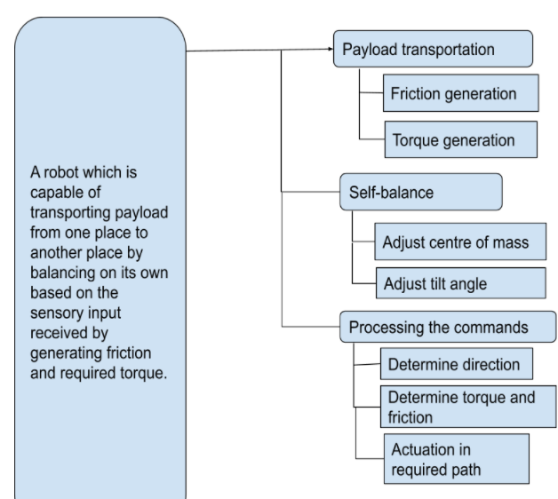

1. **Flow charts:**
   1. **Component diagram:**

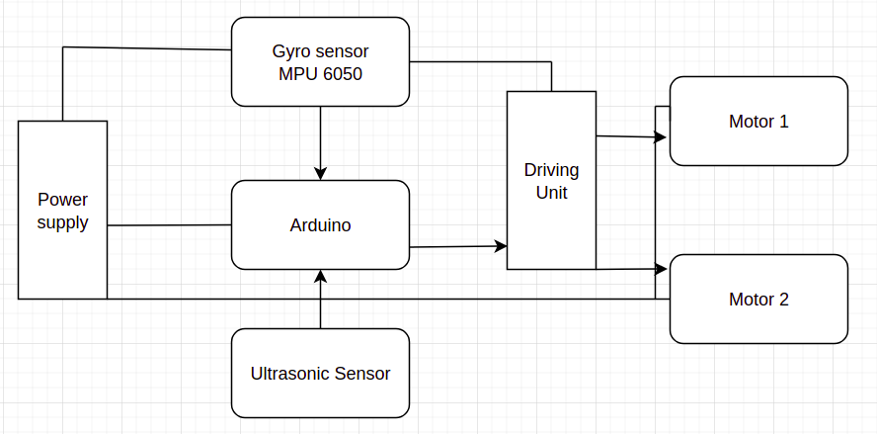

* 1. **Embodiment diagram:**

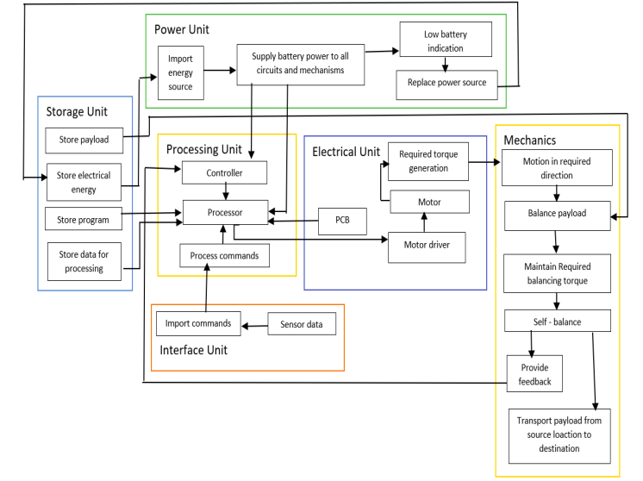

**3.3 UML Diagram:**

