# Clustering

Unsupervised learning is contrasted from supervised learning because it uses an **unlabeled** training set rather than a labeled one.

In other words, we don't have the vector y of expected results, we only have a dataset of features where we can find structure.

Clustering is good for:

* Market segmentation
* Social network analysis
* Organizing computer clusters
* Astronomical data analysis

## K-means Algorithm

The K-Means Algorithm is the most popular and widely used algorithm for automatically grouping data into coherent subsets.

1. Randomly initialize two points in the dataset called the cluster centroids.
2. Cluster assignment: assign all examples into one of two groups based on which cluster centroid the example is closest to.
3. Move centroid: compute the averages for all the points inside each of the two cluster centroid groups, then move the cluster centroid points to those averages.
4. Re-run (2) and (3) until we have found our clusters.

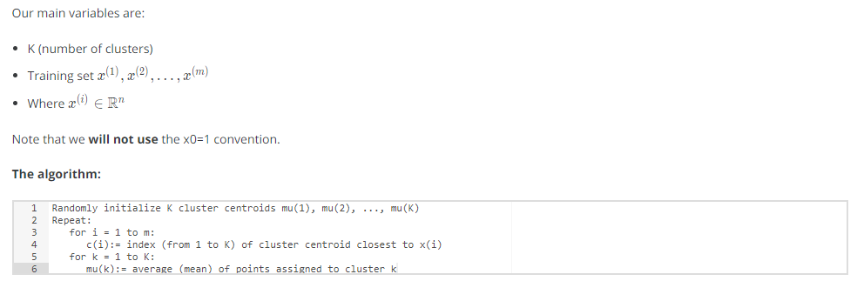

The **first for-loop** is the 'Cluster Assignment' step. We make a vector c where c(i) represents the centroid assigned to example x(i).

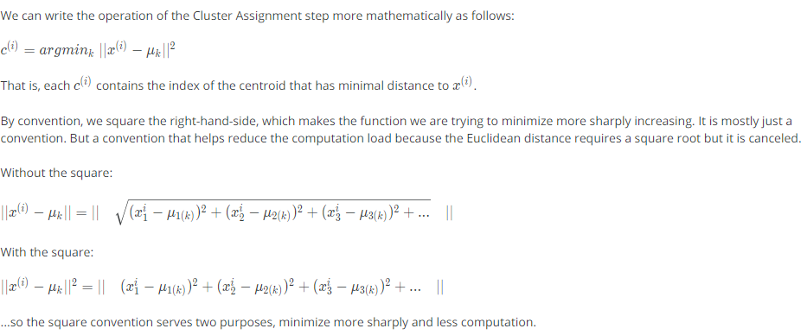

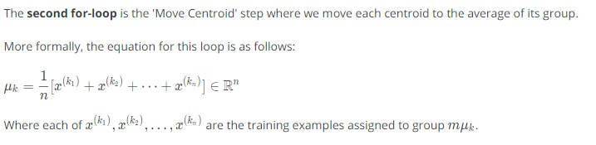

If you have a cluster centroid with **0 points** assigned to it, you can randomly **re-initialize** that centroid to a new point. You can also simply **eliminate** that cluster group.

After a number of iterations the algorithm will **converge**, where new iterations do not affect the clusters.

**Note on non-separated clusters**: Some datasets have no real inner separation or natural structure. K-means can still evenly segment your data into K subsets, so can still be useful in this case.