1. **Describe the enumerations programming constructs, which provides a human-readable form of a series of related constant values in C#..**

using System;

using System.Collections.Generic;

using System.Linq;

using System.Text;

namespace EnumerationDemo

{

class ProgramOne

{

enum Colors

{

Green,

Blue,

Yellow,

Violet,

Red,

Orange,

Pink

}

static void Main(string[] args)

{

foreach (var color in Enum.GetValues(typeof(Colors)))

{

Console.WriteLine("{0} : {1}", color, (int)color);

}

Console.Read();

}

}

}

**OUTPUT**

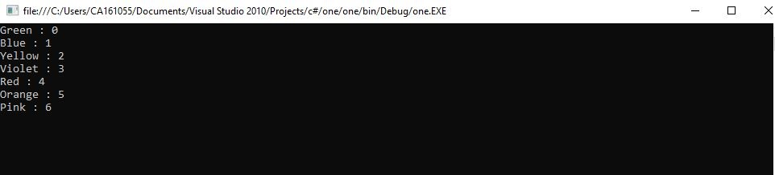

1. **Check Whether the Entered Year is a Leap Year or Not**

using System;

using System.Collections.Generic;

using System.Linq;

using System.Text;

namespace ProgramTwo

{

class Program

{

static void Main(string[] args)

{

try {

Console.Write("Enter The Year : \n");

long year = Convert.ToInt64(Console.ReadLine());

Console.WriteLine("\n-----------------------------------------");

if (year % 400 == 0) {

Console.WriteLine("\t{0} is a Leap Year",year);

}

else if (year % 100 == 0) {

Console.WriteLine("\t{0} is not a Leap Year", year);

}

else if (year % 4 == 0)

{

Console.WriteLine("\t{0} is a Leap Year", year);

}

else {

Console.WriteLine("\t{0} is not a Leap Year", year);

}

}

catch(Exception ex) {

Console.WriteLine("Enter valid year");

}

Console.ReadKey();

}

}

}

**OUTPUT**

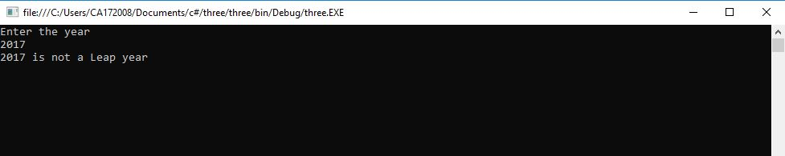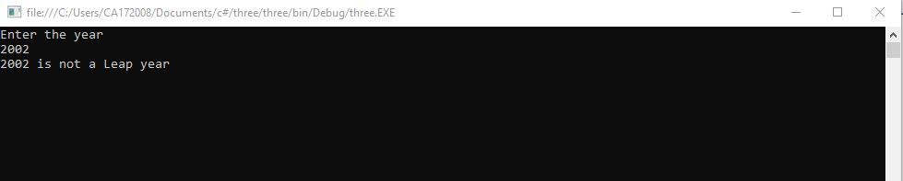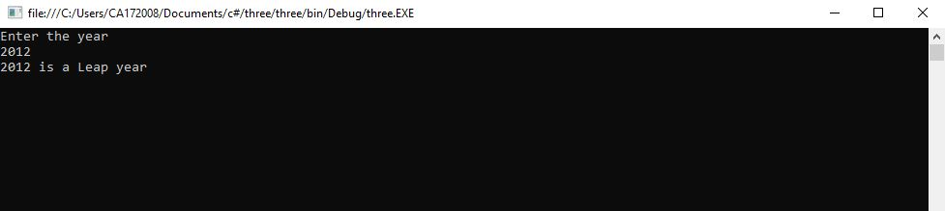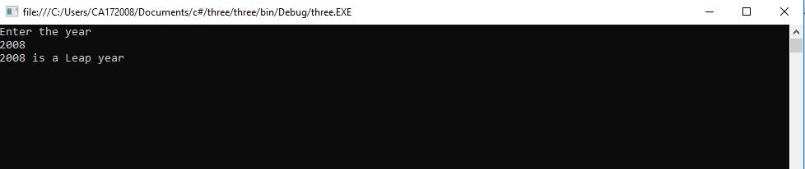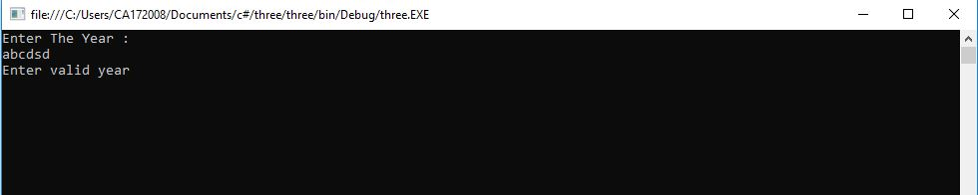

1. **Program to display the addition using the windows application.**

using System;

using System.Collections.Generic;

using System.ComponentModel;

using System.Data;

using System.Drawing;

using System.Linq;

using System.Text;

using System.Windows.Forms;

namespace three

{

public partial class Form1 : Form

{

public Form1()

{

InitializeComponent();

}

private void button1_Click(object sender, EventArgs e)

{

int num1 = Int16.Parse(textBox1.Text);

int num2 = Int16.Parse(textBox2.Text);

int sum = num1 + num2;

textBox3.Text = "sum of two number :" + sum;

}

}

}

**OUTPUT**

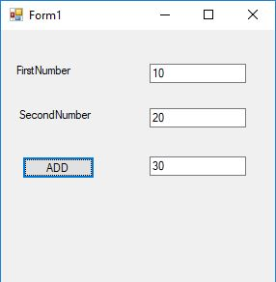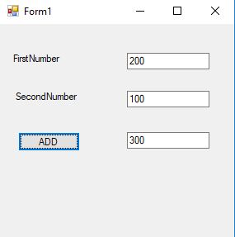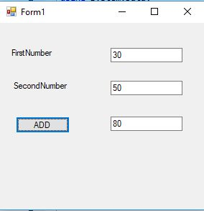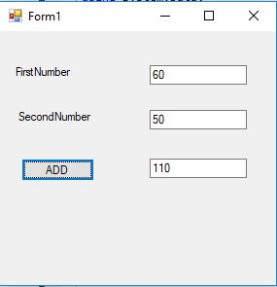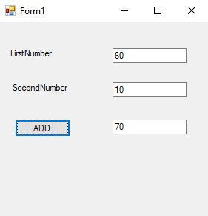

1. **Program to display the addition, subtraction, multiplication and division of two number using console applications.**

using System;

using System.Collections.Generic;

using System.Linq;

using System.Text;

namespace ProgramFive

{

class Program

{

static void Main(string[] args)

{

double num1, num2;

double sum, sub, mul, div;

Console.WriteLine("Enter the two numbers");

num1 = Double.Parse(Console.ReadLine());

num2 = Double.Parse(Console.ReadLine());

sum = num1 + num2;

sub = num1 - num2;

mul = num1 * num2;

div = num1 / num2;

Console.WriteLine();

Console.WriteLine("----------------------------");

Console.WriteLine("Addition: {0}", sum);

Console.WriteLine("Substraction: {0}", sub);

Console.WriteLine("Multiplication: {0}", mul);

Console.WriteLine("Division: {0}", div);

Console.WriteLine("----------------------------");

Console.ReadLine();

}

}

}

**OUTPUT**

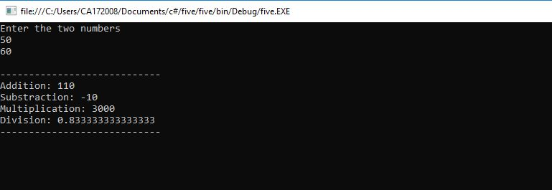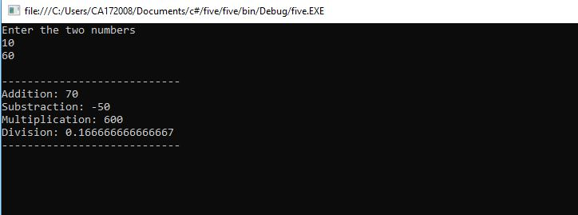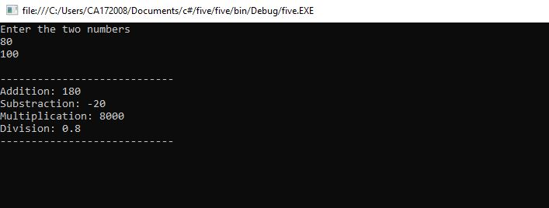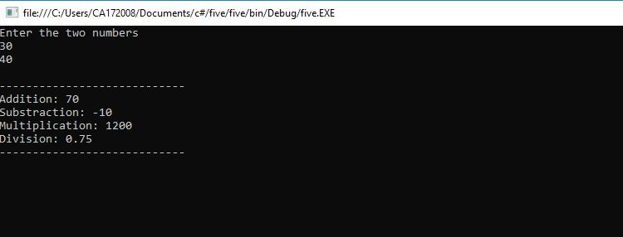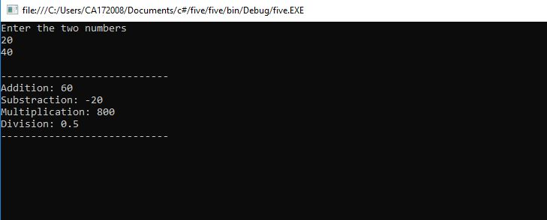

1. **Program to display the first 10 natural numbers and their sum using console application**

using System;

using System.Collections.Generic;

using System.Linq;

using System.Text;

namespace ProgramSix

{

class Program

{

static void Main(string[] args)

{

int sum = 0;

Console.WriteLine("------------------");

Console.WriteLine("First 10 natural numbers");

Console.WriteLine("------------------");

for (int i = 1; i <= 10; i++)

{

sum += i;

Console.WriteLine(i);

}

Console.WriteLine("------------------");

Console.WriteLine("Sum: {0}", sum);

Console.WriteLine("------------------");

Console.ReadLine();

}

}

}

**OUTPUT**

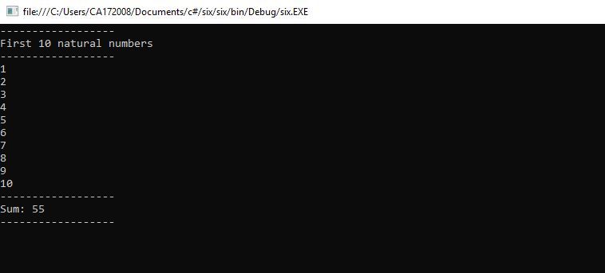

1. **Write a program to convert input string from lower to upper and upper to lower case.**

using System;

using System.Collections.Generic;

using System.Linq;

using System.Text;

namespace LowUp

{

class Program

{

static void Main(string[] args)

{

string str1;

char[] arr1;

int l,i;

l=0;

char ch;

Console.Write("Input the string : ");

str1 = Console.ReadLine();

l=str1.Length;

arr1 = str1.ToCharArray(0, l);

Console.Write("\nAfter conversion, the string is : ");

for (i = 0; i < l; i++)

{

ch = arr1[i];

if (Char.IsLower(ch))

Console.Write(Char.ToUpper(ch));

else

Console.Write(Char.ToLower(ch));

}

Console.ReadLine();

}

}

}

**OUTPUT**

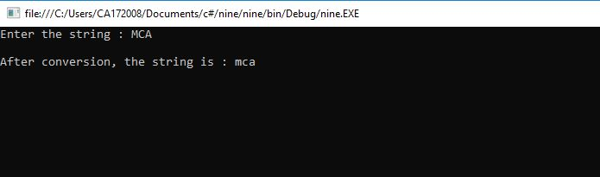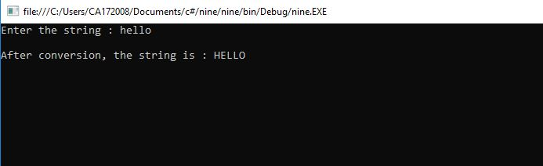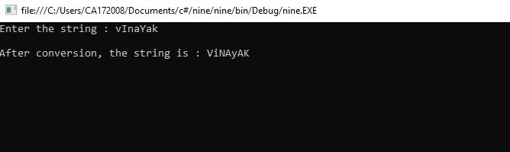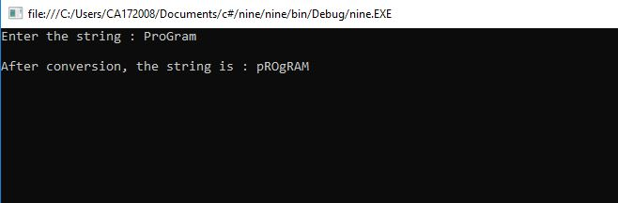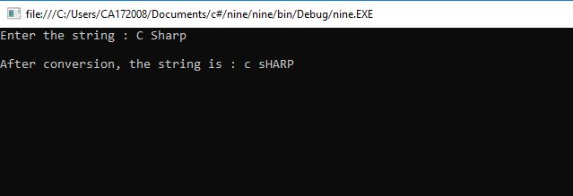

1. **Demonstrate Command line arguments processing.**

using System;

using System.Collections.Generic;

using System.Linq;

using System.Text;

namespace Sixteen

{

class Program

{

static void Main(string[] args)

{

Console.WriteLine("\nNumber of CommadLine Arguments :" + args.Length);

Console.Write("\nCommandline Arguments Are :\t");

for (int i = 0; i < args.Length; i++)

{

Console.Write(args[i] + "\t");

}

Console.ReadLine();

}

}

}

**OUTPUT**

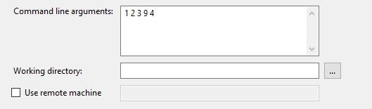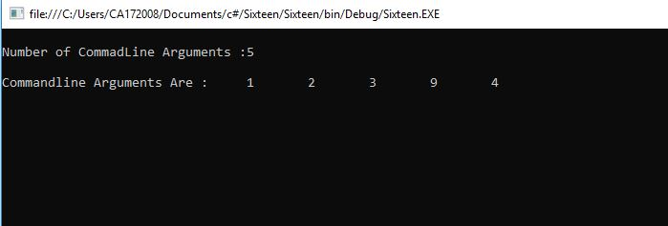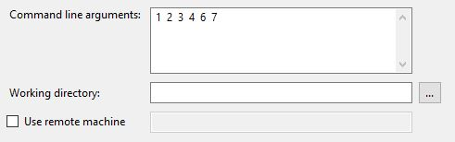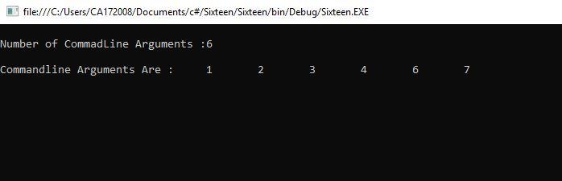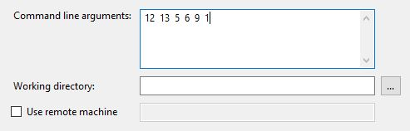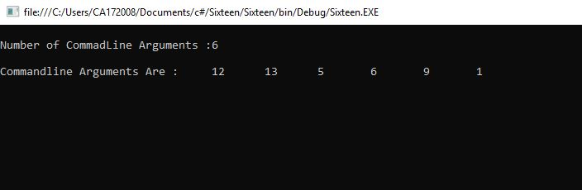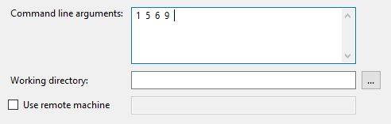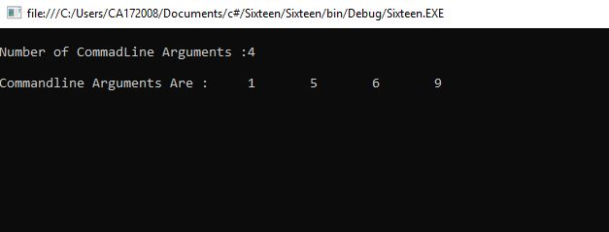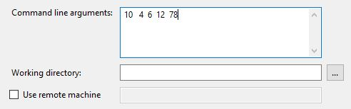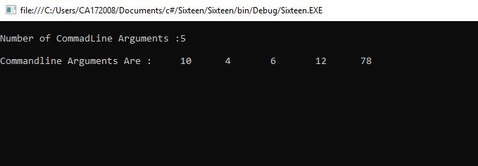

1. **Find the second largest element in a single dimensional array.**

using System;

using System.Collections.Generic;

using System.Linq;

using System.Text;

namespace pgm14

{

class Program

{

static void Main(string[] args)

{

try

{

int[] arr = new int[5];

Console.WriteLine("Enter 5 element in array : ");

for (int i = 0; i < 5; i++)

{

arr[i] = int.Parse(Console.ReadLine());

}

Console.WriteLine("---------------------");

Array.Sort(arr);

Array.Reverse(arr);

Console.WriteLine("Sorted Array in Reverce Order");

for (int i = 0; i < 5; i++)

{

Console.WriteLine("A[" + i + "] = " + arr[i]);

}

Console.WriteLine("Second Largest Value in Array : " + arr[1]);

}

catch (Exception ex) {

Console.WriteLine("Provide Valid Array Element.\nOnly Numeric Values are

allowed.");

}

Console.ReadKey();

}

}

}

**OUTPUT**

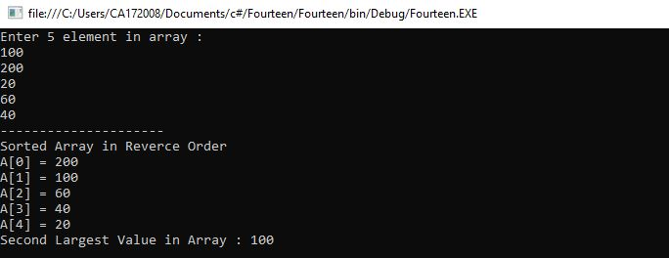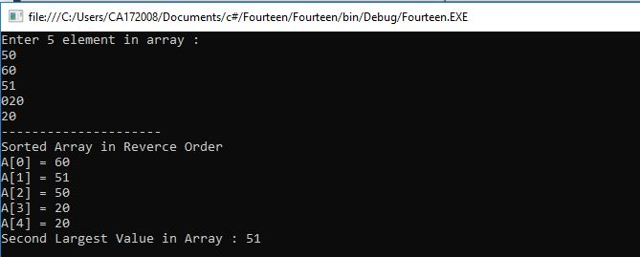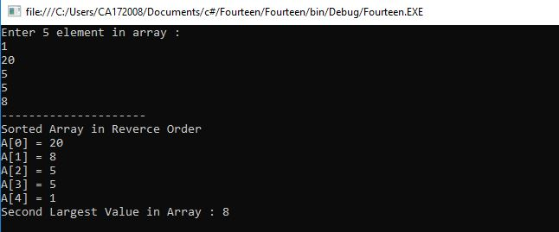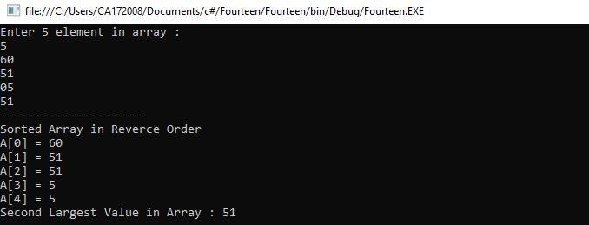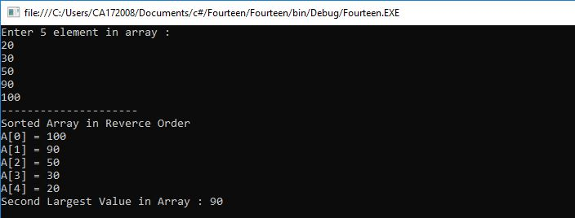

1. **Program to illustrate the use of different properties in C#.**

using System;

using System.Collections.Generic;

using System.Text;

namespace Program

{

class PropertiesDemo

{

private string name;

private int age;

public string Name

{

set

{

name = value;

}

get

{

return name;

}

}

public int Age

{

set

{

if (value > 0)

age = value;

}

get

{

return age;

}

}

static void Main(string[] args)

{

PropertiesDemo p = new PropertiesDemo();

p.Name = "Vinayak";

p.Age = 23;

PropertiesDemo d = new PropertiesDemo();

d.Name = "Zutti";

d.Age = 22;

Console.WriteLine("{0} : {1}", p.Name, p.Age);

Console.WriteLine("{0} : {1}", d.Name, d.Age);

Console.ReadLine();

}

}

}

**OUTPUT**

