1. Submit a word document with screen shots of the following:
2. The project showing that you can view the data tables in PyCharm.

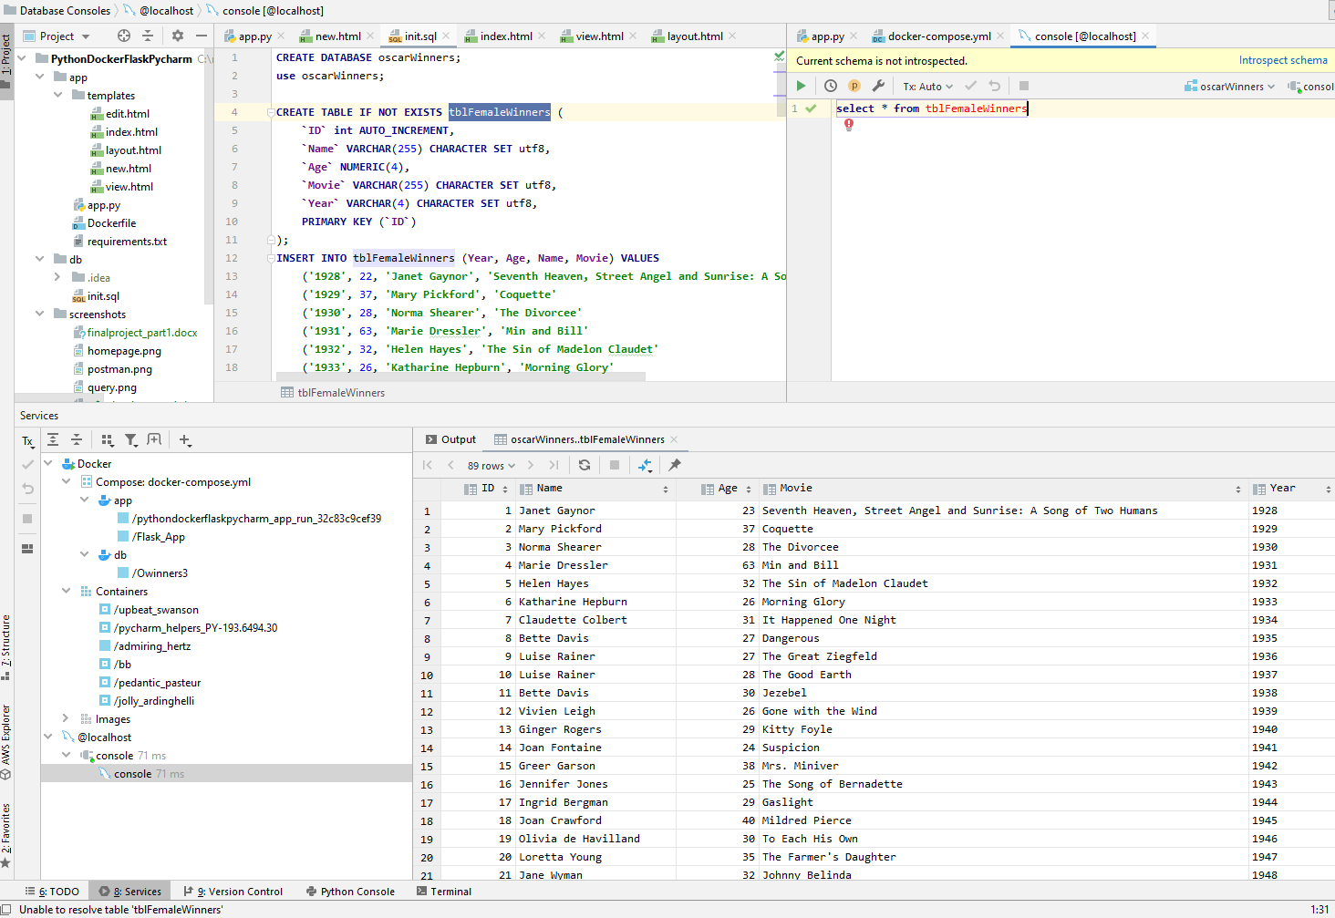

1. The project running correctly in the browser displaying your homepage with the data.

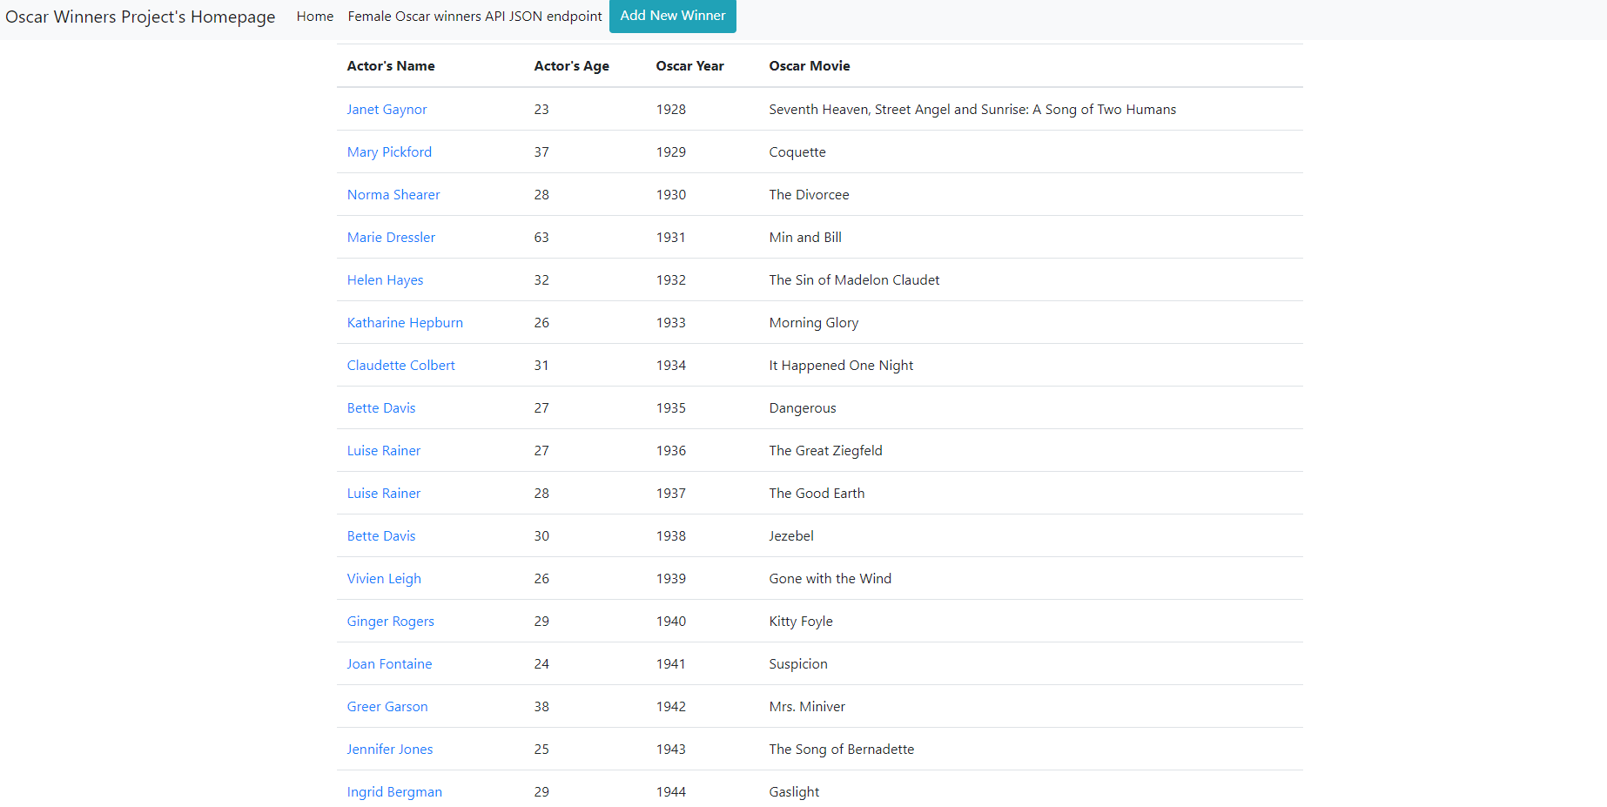

1. The project running correctly in the browser displaying the data record as a view of one record

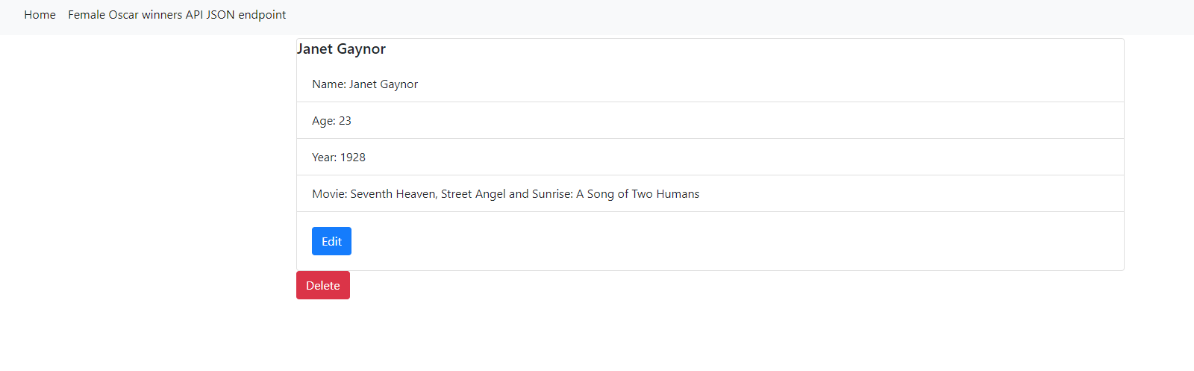

1. The project running correctly in the browser displaying a new record added to the home page

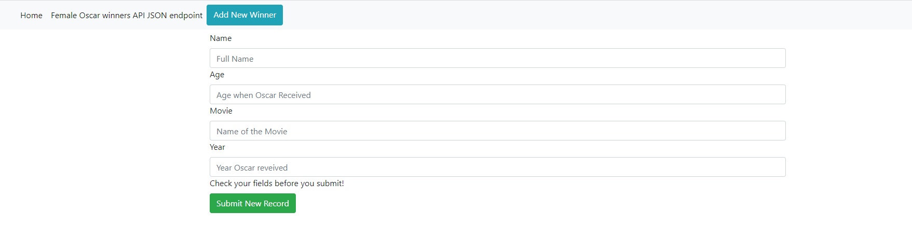

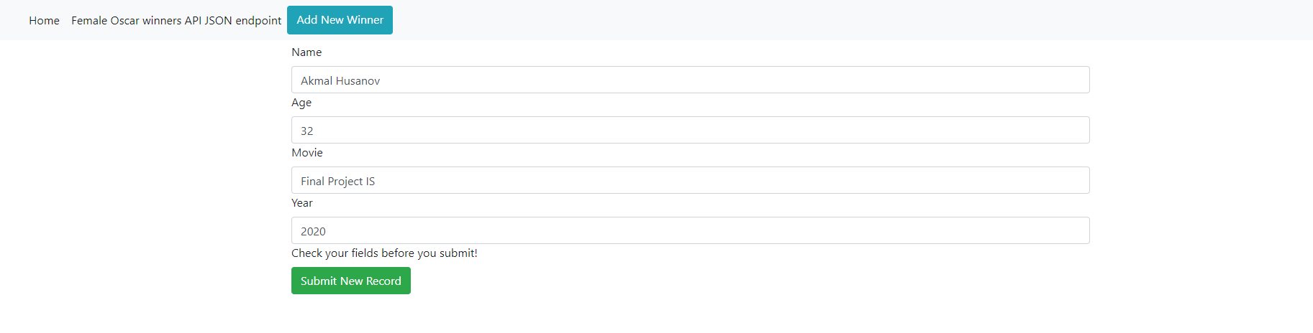

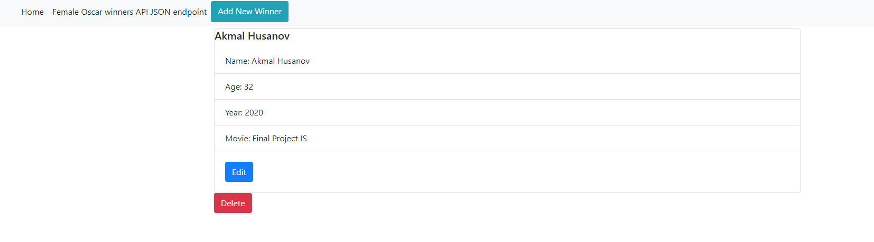

e. The project running correctly in the browser displaying an updated record added to the home

page

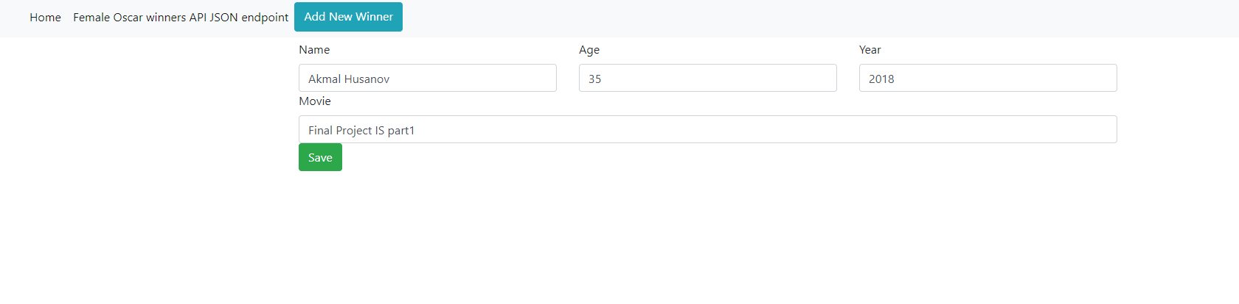

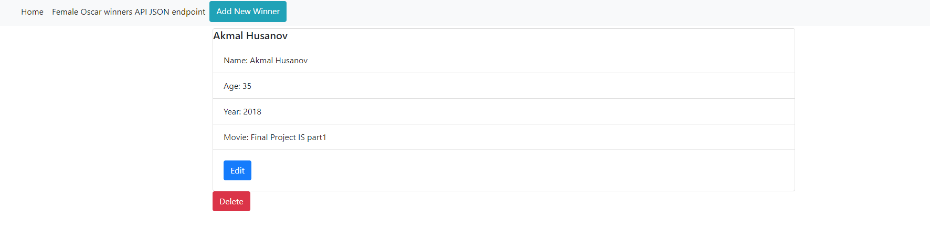

f. The project running correctly in the browser displaying a deleted record added to the home

page

