A word document with screen shots of the following:

1. The project showing postman listing all records

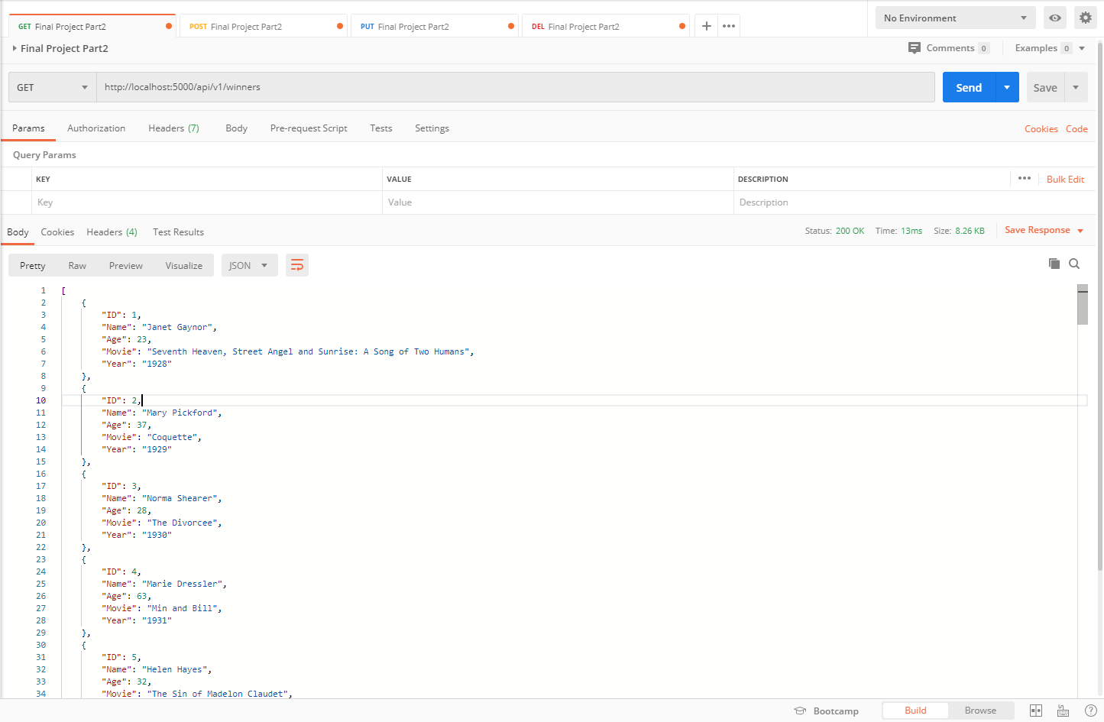

2. The project showing postman showing one record with a get request

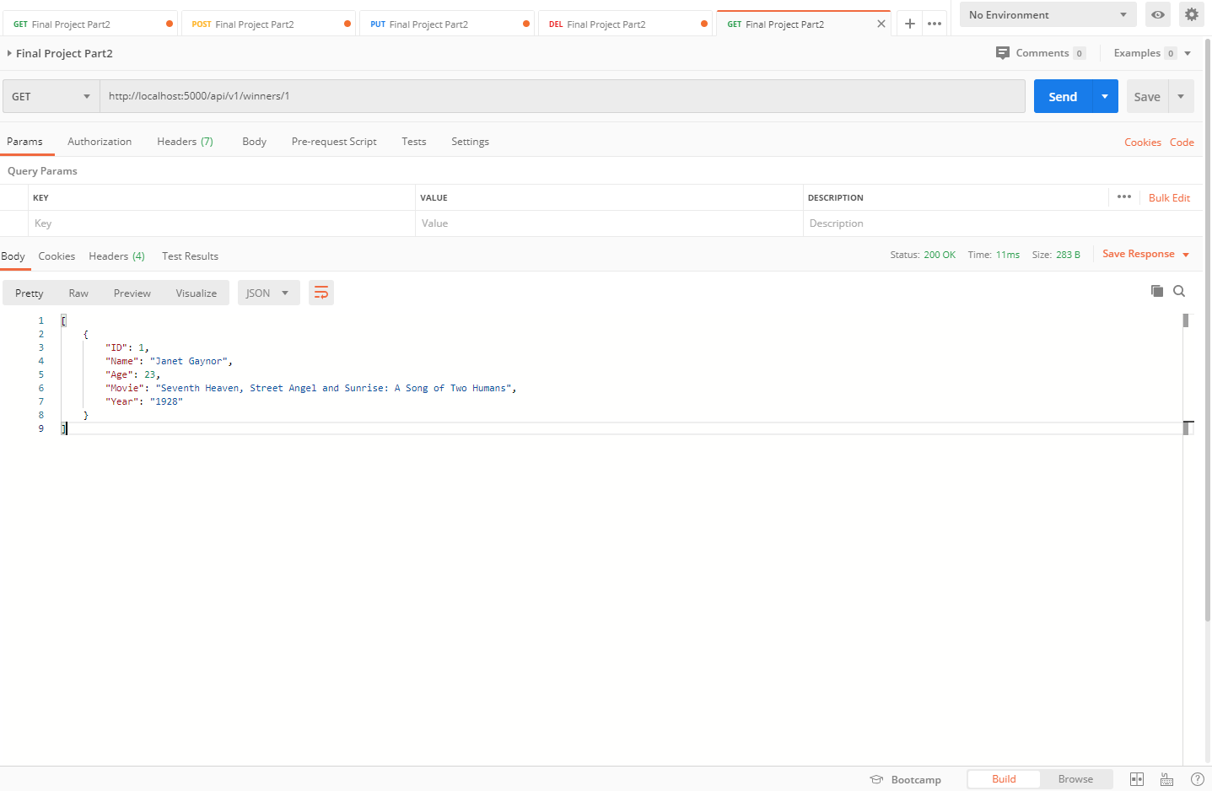

3. The project showing postman creating a record by showing the post request and the results in the record listing

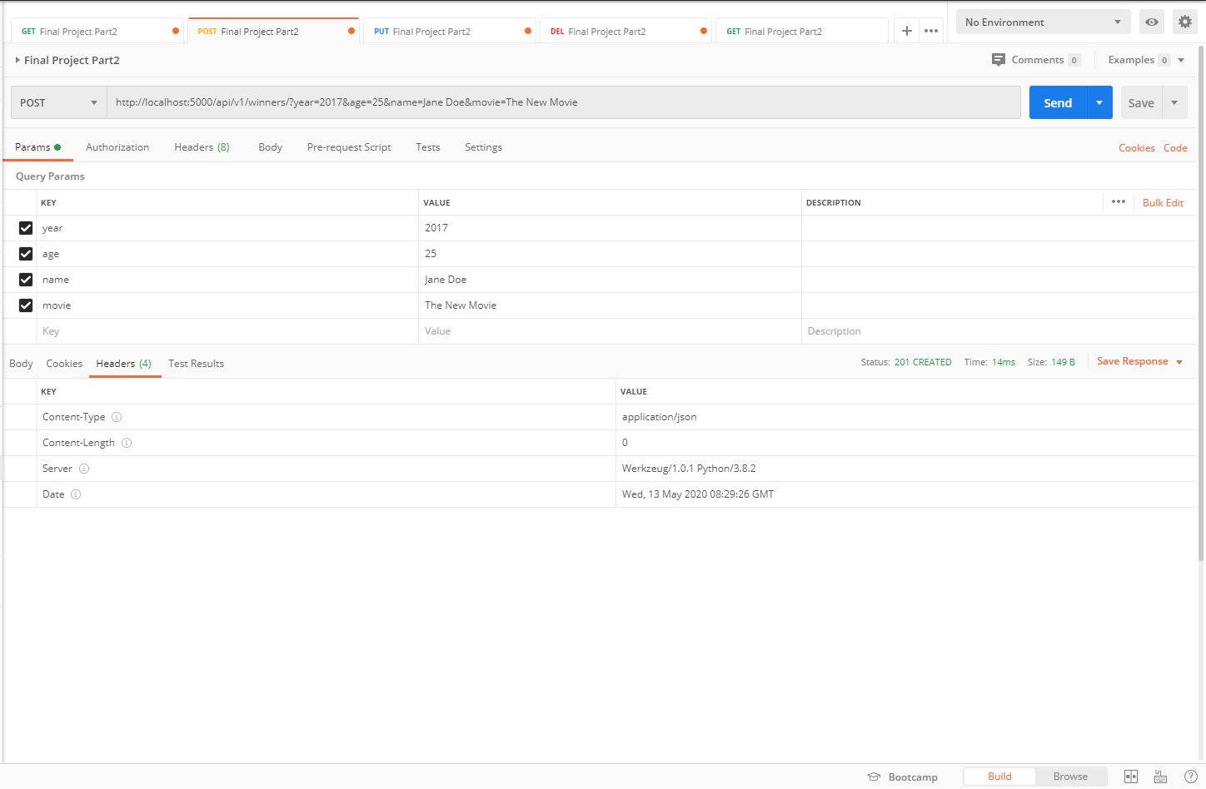

4. The project showing postman edit a record by showing the put request and the results in the record listing

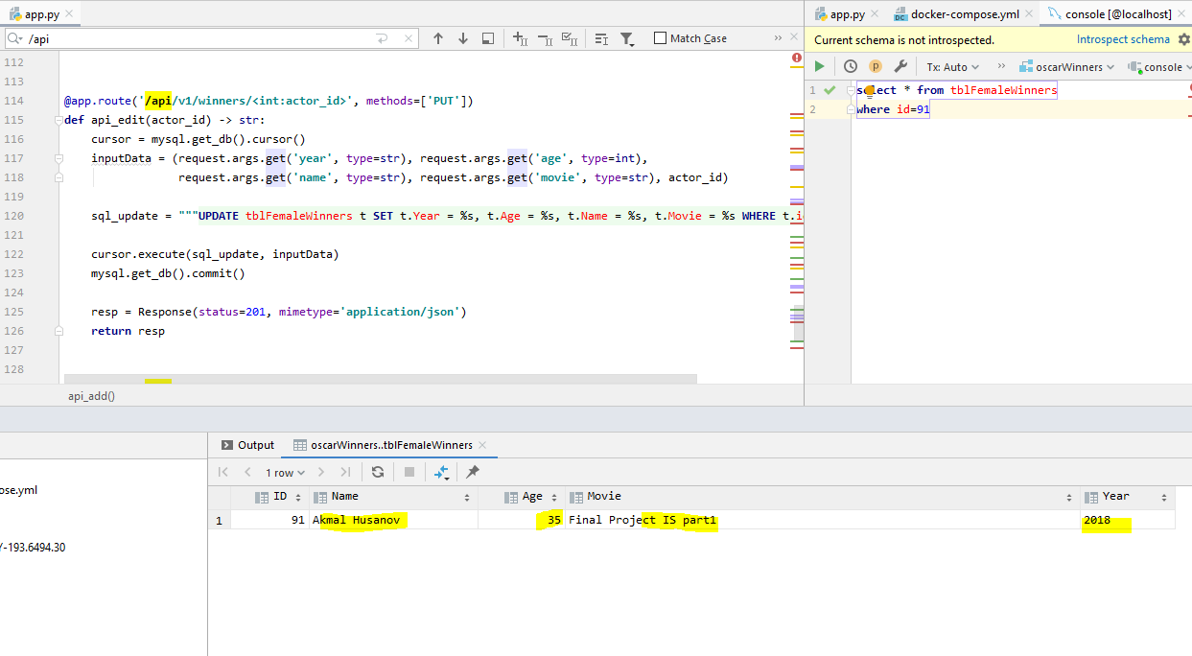

5. The project showing postman delete a record by showing the delete request and the results in the record listing

