**ASSIGNMENT 1:**

**Module 2: Basic Python Concepts**

**Task 1: Perform Basic Mathematical Operations**

**Problem Statement: Write a Python program that does the following:**

**1.** **Takes two numbers as input from the user.**

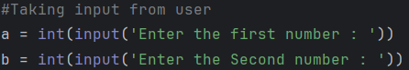

**2.** **Performs the basic mathematical operations on these two numbers:**

o **Addition**

o **Subtraction**

o **Multiplication**

o **Division**

**3.** **Displays the results of each operation on the screen.**

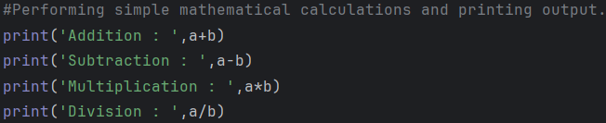

**Output :**

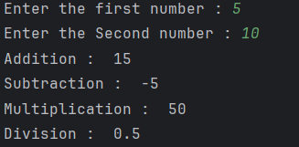

**Task 2: Create a Personalized Greeting**

**Problem Statement:** Write a Python program that:

1. Takes a user's first name and last name as input.

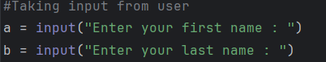

2. Concatenates the first name and last name into a full name.

3. Prints a personalized greeting message using the full name.

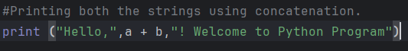

**Output :**

