**ASSIGNMENT 2:**

**Module 3: Control Structures in Python**

**Task 1: Check if a Number is Even or Odd**

**Problem Statement:** Write a Python program that:

1. Takes an integer input from the user.



2. Checks whether the number is even or odd using an if-else statement.

3. Displays the result accordingly.

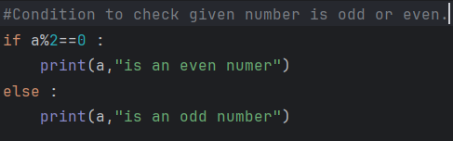

**Output :**





**Task 2: Sum of Integers from 1 to 50 Using a Loop**

**Problem Statement:** Write a Python program that:

1. Uses a **for loop** to iterate over numbers from **1 to 50**.

2. Calculates the **sum** of all integers in this range.

3. Displays the final sum.

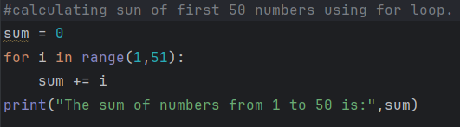

**Output :**

