**ASSIGNMENT 3:**

**Module 4: Functions & Modules in Python**

**Task 1: Calculate Factorial Using a Function**

**Problem Statement:** Write a Python program that:

1. Defines a function named factorial that takes a number as an argument and calculates its factorial using a loop or recursion.

2. Returns the calculated factorial.

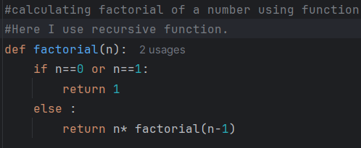

3. Calls the function with a sample number and prints the output.

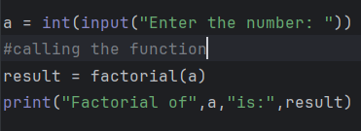

**Output:**



**Task 2: Using the Math Module for Calculations**

**Problem Statement:** Write a Python program that:

1. Asks the user for a number as input.

2. Uses the math module to calculate the:

o Square root of the number

o Natural logarithm (log base e) of the number

o Sine of the number (in radians)

3. Displays the calculated results.

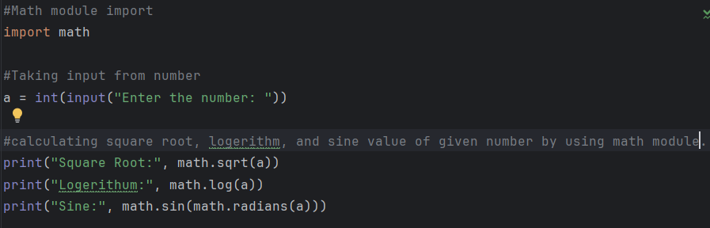

**Output:**

