**ASSIGNMENT 4:**

**Module 5: Files, Exceptions, and Errors in Python**

**Task 1: Read a File and Handle Errors**

**Problem Statement:** Write a Python program that:

1. Opens and reads a text file named sample.txt.

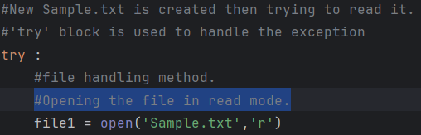

2. Prints its content line by line.

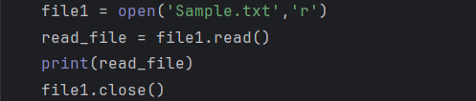

3. Handles errors gracefully if the file does not exist.

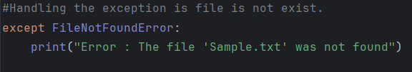

**Output:**

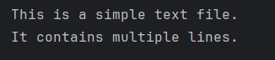



**Task 2: Write and Append Data to a File**

**Problem Statement:** Write a Python program that:

1. Takes user input and writes it to a file named **output.txt**.

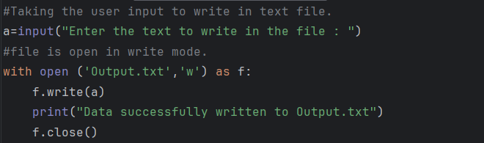

2. Appends additional data to the same file.

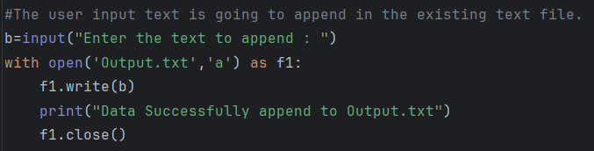

3. Reads and displays the final content of the file.

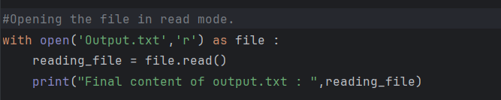

**Output:**

