**ASSIGNMENT 5:**

**Module 6: Data Structures and Strings in Python**

**Task 1: Create a Dictionary of Student Marks**

**Problem Statement:** Write a Python program that:

1. Creates a dictionary where student names are keys and their marks are values.



2. Asks the user to input a student's name.



3. Retrieves and displays the corresponding marks.

4. If the student’s name is not found, display an appropriate message.

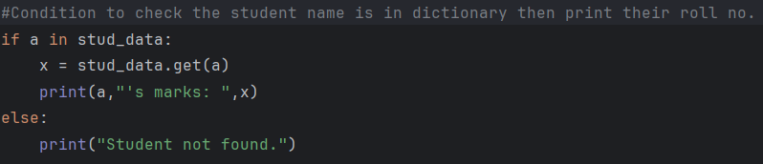

**Output:**



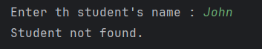

**Task 2: Demonstrate List Slicing**

**Problem Statement:** Write a Python program that:

1. Creates a **list** of numbers from **1 to 10**.

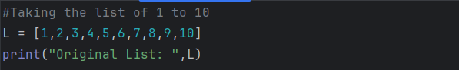

2. Extracts the **first five elements** from the list.

3. Reverses these extracted elements.

4. Prints both the extracted list and the reversed list.

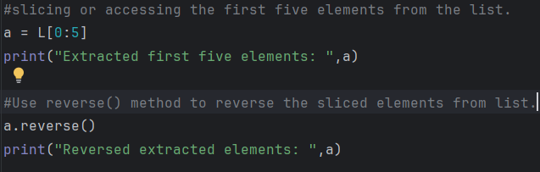

**Output:**

