Django

Python

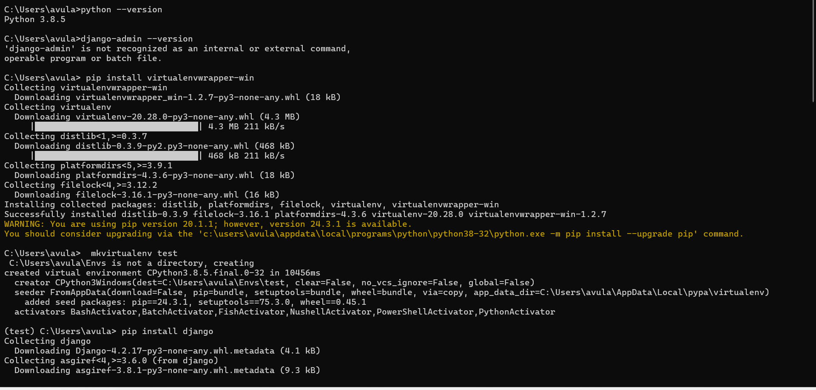

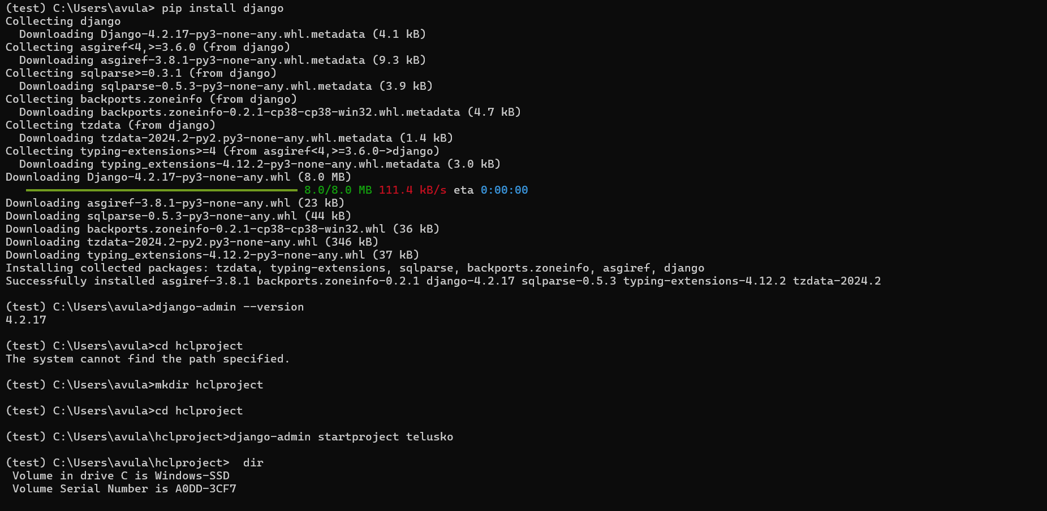

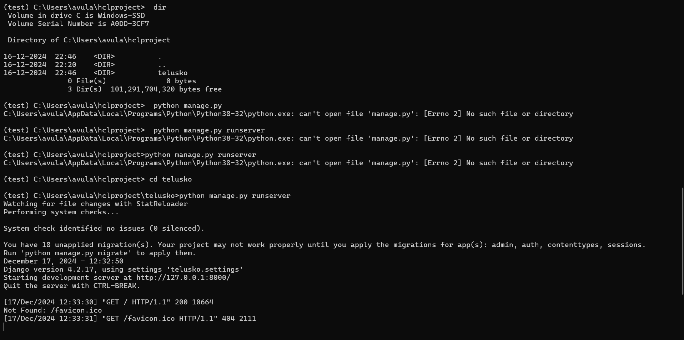

Microsoft Windows [Version 10.0.22631.4460]

(c) Microsoft Corporation. All rights reserved.

C:\Users\avula>python --version

Python 3.8.5

C:\Users\avula>django-admin --version

'django-admin' is not recognized as an internal or external command,

operable program or batch file.

C:\Users\avula> pip install virtualenvwrapper-win

Collecting virtualenvwrapper-win

Downloading virtualenvwrapper_win-1.2.7-py3-none-any.whl (18 kB)

Collecting virtualenv

Downloading virtualenv-20.28.0-py3-none-any.whl (4.3 MB)

|████████████████████████████████| 4.3 MB 211 kB/s

Collecting distlib<1,>=0.3.7

Downloading distlib-0.3.9-py2.py3-none-any.whl (468 kB)

|████████████████████████████████| 468 kB 211 kB/s

Collecting platformdirs<5,>=3.9.1

Downloading platformdirs-4.3.6-py3-none-any.whl (18 kB)

Collecting filelock<4,>=3.12.2

Downloading filelock-3.16.1-py3-none-any.whl (16 kB)

Installing collected packages: distlib, platformdirs, filelock, virtualenv, virtualenvwrapper-win

Successfully installed distlib-0.3.9 filelock-3.16.1 platformdirs-4.3.6 virtualenv-20.28.0 virtualenvwrapper-win-1.2.7

WARNING: You are using pip version 20.1.1; however, version 24.3.1 is available.

You should consider upgrading via the 'c:\users\avula\appdata\local\programs\python\python38-32\python.exe -m pip install --upgrade pip' command.

C:\Users\avula> mkvirtualenv test

C:\Users\avula\Envs is not a directory, creating

created virtual environment CPython3.8.5.final.0-32 in 10456ms

creator CPython3Windows(dest=C:\Users\avula\Envs\test, clear=False, no_vcs_ignore=False, global=False)

seeder FromAppData(download=False, pip=bundle, setuptools=bundle, wheel=bundle, via=copy, app_data_dir=C:\Users\avula\AppData\Local\pypa\virtualenv)

added seed packages: pip==24.3.1, setuptools==75.3.0, wheel==0.45.1

activators BashActivator,BatchActivator,FishActivator,NushellActivator,PowerShellActivator,PythonActivator

(test) C:\Users\avula> pip install django

Collecting django

Downloading Django-4.2.17-py3-none-any.whl.metadata (4.1 kB)

Collecting asgiref<4,>=3.6.0 (from django)

Downloading asgiref-3.8.1-py3-none-any.whl.metadata (9.3 kB)

Collecting sqlparse>=0.3.1 (from django)

Downloading sqlparse-0.5.3-py3-none-any.whl.metadata (3.9 kB)

Collecting backports.zoneinfo (from django)

Downloading backports.zoneinfo-0.2.1-cp38-cp38-win32.whl.metadata (4.7 kB)

Collecting tzdata (from django)

Downloading tzdata-2024.2-py2.py3-none-any.whl.metadata (1.4 kB)

Collecting typing-extensions>=4 (from asgiref<4,>=3.6.0->django)

Downloading typing_extensions-4.12.2-py3-none-any.whl.metadata (3.0 kB)

Downloading Django-4.2.17-py3-none-any.whl (8.0 MB)

━━━━━━━━━━━━━━━━━━━━━━━━━━━━━━━━━━━━━━━━ 8.0/8.0 MB 111.4 kB/s eta 0:00:00

Downloading asgiref-3.8.1-py3-none-any.whl (23 kB)

Downloading sqlparse-0.5.3-py3-none-any.whl (44 kB)

Downloading backports.zoneinfo-0.2.1-cp38-cp38-win32.whl (36 kB)

Downloading tzdata-2024.2-py2.py3-none-any.whl (346 kB)

Downloading typing_extensions-4.12.2-py3-none-any.whl (37 kB)

Installing collected packages: tzdata, typing-extensions, sqlparse, backports.zoneinfo, asgiref, django

Successfully installed asgiref-3.8.1 backports.zoneinfo-0.2.1 django-4.2.17 sqlparse-0.5.3 typing-extensions-4.12.2 tzdata-2024.2

(test) C:\Users\avula>django-admin --version

4.2.17

(test) C:\Users\avula>cd hclproject

The system cannot find the path specified.

(test) C:\Users\avula>mkdir hclproject

(test) C:\Users\avula>cd hclproject

(test) C:\Users\avula\hclproject>django-admin startproject telusko

(test) C:\Users\avula\hclproject> dir

Volume in drive C is Windows-SSD

Volume Serial Number is A0DD-3CF7

Directory of C:\Users\avula\hclproject

16-12-2024 22:46 <DIR> .

16-12-2024 22:20 <DIR> ..

16-12-2024 22:46 <DIR> telusko

0 File(s) 0 bytes

3 Dir(s) 101,291,704,320 bytes free

(test) C:\Users\avula\hclproject> python manage.py

C:\Users\avula\AppData\Local\Programs\Python\Python38-32\python.exe: can't open file 'manage.py': [Errno 2] No such file or directory

(test) C:\Users\avula\hclproject> python manage.py runserver

C:\Users\avula\AppData\Local\Programs\Python\Python38-32\python.exe: can't open file 'manage.py': [Errno 2] No such file or directory

(test) C:\Users\avula\hclproject>python manage.py runserver

C:\Users\avula\AppData\Local\Programs\Python\Python38-32\python.exe: can't open file 'manage.py': [Errno 2] No such file or directory

(test) C:\Users\avula\hclproject> cd telusko

(test) C:\Users\avula\hclproject\telusko>python manage.py runserver

Watching for file changes with StatReloader

Performing system checks...

System check identified no issues (0 silenced).

You have 18 unapplied migration(s). Your project may not work properly until you apply the migrations for app(s): admin, auth, contenttypes, sessions.

Run 'python manage.py migrate' to apply them.

December 17, 2024 - 12:32:50

Django version 4.2.17, using settings 'telusko.settings'

Starting development server at http://127.0.0.1:8000/

Quit the server with CTRL-BREAK.

[17/Dec/2024 12:33:30] "GET / HTTP/1.1" 200 10664

Not Found: /favicon.ico

[17/Dec/2024 12:33:31] "GET /favicon.ico HTTP/1.1" 404 2111

Microsoft Windows [Version 10.0.22631.4460]

(c) Microsoft Corporation. All rights reserved.

C:\Users\avula>python --version

Python 3.8.5

C:\Users\avula>django-admin --version

'django-admin' is not recognized as an internal or external command,

operable program or batch file.

C:\Users\avula> pip install virtualenvwrapper-win

Collecting virtualenvwrapper-win

Downloading virtualenvwrapper_win-1.2.7-py3-none-any.whl (18 kB)

Collecting virtualenv

Downloading virtualenv-20.28.0-py3-none-any.whl (4.3 MB)

|████████████████████████████████| 4.3 MB 211 kB/s

Collecting distlib<1,>=0.3.7

Downloading distlib-0.3.9-py2.py3-none-any.whl (468 kB)

|████████████████████████████████| 468 kB 211 kB/s

Collecting platformdirs<5,>=3.9.1

Downloading platformdirs-4.3.6-py3-none-any.whl (18 kB)

Collecting filelock<4,>=3.12.2

Downloading filelock-3.16.1-py3-none-any.whl (16 kB)

Installing collected packages: distlib, platformdirs, filelock, virtualenv, virtualenvwrapper-win

Successfully installed distlib-0.3.9 filelock-3.16.1 platformdirs-4.3.6 virtualenv-20.28.0 virtualenvwrapper-win-1.2.7

WARNING: You are using pip version 20.1.1; however, version 24.3.1 is available.

You should consider upgrading via the 'c:\users\avula\appdata\local\programs\python\python38-32\python.exe -m pip install --upgrade pip' command.

C:\Users\avula> mkvirtualenv test

C:\Users\avula\Envs is not a directory, creating

created virtual environment CPython3.8.5.final.0-32 in 10456ms

creator CPython3Windows(dest=C:\Users\avula\Envs\test, clear=False, no_vcs_ignore=False, global=False)

seeder FromAppData(download=False, pip=bundle, setuptools=bundle, wheel=bundle, via=copy, app_data_dir=C:\Users\avula\AppData\Local\pypa\virtualenv)

added seed packages: pip==24.3.1, setuptools==75.3.0, wheel==0.45.1

activators BashActivator,BatchActivator,FishActivator,NushellActivator,PowerShellActivator,PythonActivator

(test) C:\Users\avula> pip install django

Collecting django

Downloading Django-4.2.17-py3-none-any.whl.metadata (4.1 kB)

Collecting asgiref<4,>=3.6.0 (from django)

Downloading asgiref-3.8.1-py3-none-any.whl.metadata (9.3 kB)

Collecting sqlparse>=0.3.1 (from django)

Downloading sqlparse-0.5.3-py3-none-any.whl.metadata (3.9 kB)

Collecting backports.zoneinfo (from django)

Downloading backports.zoneinfo-0.2.1-cp38-cp38-win32.whl.metadata (4.7 kB)

Collecting tzdata (from django)

Downloading tzdata-2024.2-py2.py3-none-any.whl.metadata (1.4 kB)

Collecting typing-extensions>=4 (from asgiref<4,>=3.6.0->django)

Downloading typing_extensions-4.12.2-py3-none-any.whl.metadata (3.0 kB)

Downloading Django-4.2.17-py3-none-any.whl (8.0 MB)

━━━━━━━━━━━━━━━━━━━━━━━━━━━━━━━━━━━━━━━━ 8.0/8.0 MB 111.4 kB/s eta 0:00:00

Downloading asgiref-3.8.1-py3-none-any.whl (23 kB)

Downloading sqlparse-0.5.3-py3-none-any.whl (44 kB)

Downloading backports.zoneinfo-0.2.1-cp38-cp38-win32.whl (36 kB)

Downloading tzdata-2024.2-py2.py3-none-any.whl (346 kB)

Downloading typing_extensions-4.12.2-py3-none-any.whl (37 kB)

Installing collected packages: tzdata, typing-extensions, sqlparse, backports.zoneinfo, asgiref, django

Successfully installed asgiref-3.8.1 backports.zoneinfo-0.2.1 django-4.2.17 sqlparse-0.5.3 typing-extensions-4.12.2 tzdata-2024.2

(test) C:\Users\avula>django-admin --version

4.2.17

(test) C:\Users\avula>cd hclproject

The system cannot find the path specified.

(test) C:\Users\avula>mkdir hclproject

(test) C:\Users\avula>cd hclproject

(test) C:\Users\avula\hclproject>django-admin startproject telusko

(test) C:\Users\avula\hclproject> dir

Volume in drive C is Windows-SSD

Volume Serial Number is A0DD-3CF7

Directory of C:\Users\avula\hclproject

16-12-2024 22:46 <DIR> .

16-12-2024 22:20 <DIR> ..

16-12-2024 22:46 <DIR> telusko

0 File(s) 0 bytes

3 Dir(s) 101,291,704,320 bytes free

(test) C:\Users\avula\hclproject> python manage.py

C:\Users\avula\AppData\Local\Programs\Python\Python38-32\python.exe: can't open file 'manage.py': [Errno 2] No such file or directory

(test) C:\Users\avula\hclproject> python manage.py runserver

C:\Users\avula\AppData\Local\Programs\Python\Python38-32\python.exe: can't open file 'manage.py': [Errno 2] No such file or directory

(test) C:\Users\avula\hclproject>python manage.py runserver

C:\Users\avula\AppData\Local\Programs\Python\Python38-32\python.exe: can't open file 'manage.py': [Errno 2] No such file or directory

(test) C:\Users\avula\hclproject> cd telusko

(test) C:\Users\avula\hclproject\telusko>python manage.py runserver

Watching for file changes with StatReloader

Performing system checks...

System check identified no issues (0 silenced).

You have 18 unapplied migration(s). Your project may not work properly until you apply the migrations for app(s): admin, auth, contenttypes, sessions.

Run 'python manage.py migrate' to apply them.

December 17, 2024 - 12:32:50

Django version 4.2.17, using settings 'telusko.settings'

Starting development server at http://127.0.0.1:8000/

Quit the server with CTRL-BREAK.

[17/Dec/2024 12:33:30] "GET / HTTP/1.1" 200 10664

Not Found: /favicon.ico

[17/Dec/2024 12:33:31] "GET /favicon.ico HTTP/1.1" 404 2111