### **Key Insights**

Based on the above visualizations, we can derive the following insights:

1. **Demographics**:
   * The majority of users fall within the 25–40 age range, making this a critical demographic for marketing efforts.
   * Younger users tend to place more orders, indicating they are more frequent users.
   * 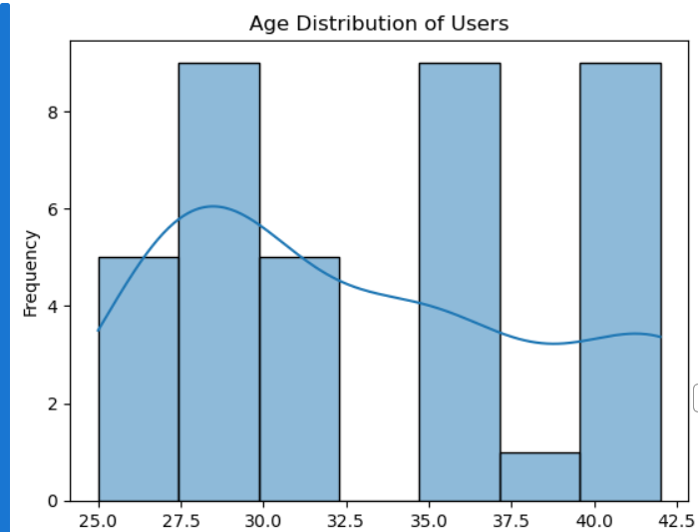
2. **Meal Preferences**:
   * Dinner is the most ordered meal type, suggesting that users are more likely to engage with the service for dinner-time meals. This could be an opportunity to market more dinner-based promotions or introduce exclusive dinner menus.

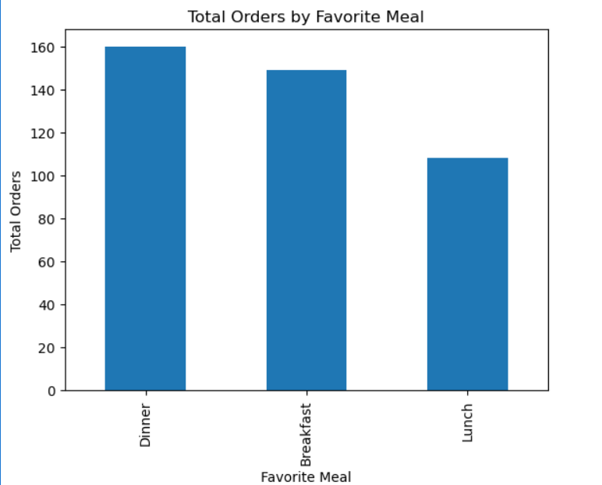

1. **Session Behavior**:
   * The session duration has a weak correlation with order amounts, indicating that other factors (e.g., type of meal, session quality) may have a more significant impact on total spending.
   * Orders placed at night generate more revenue compared to those placed in the morning or afternoon, suggesting that promoting evening deals or focusing on larger portion meals for dinner could be beneficial.

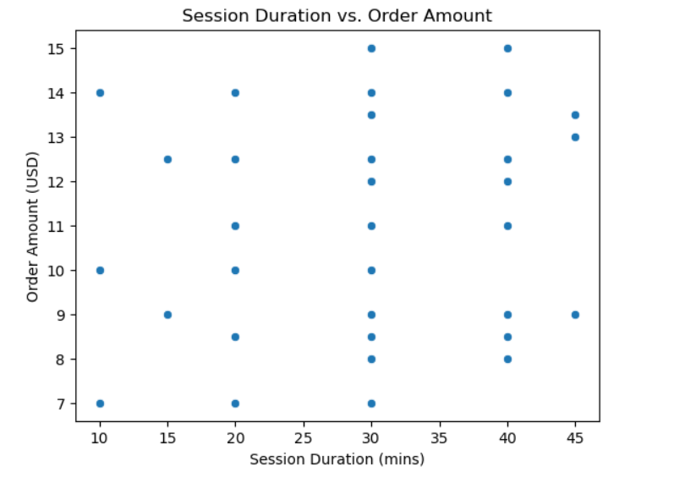

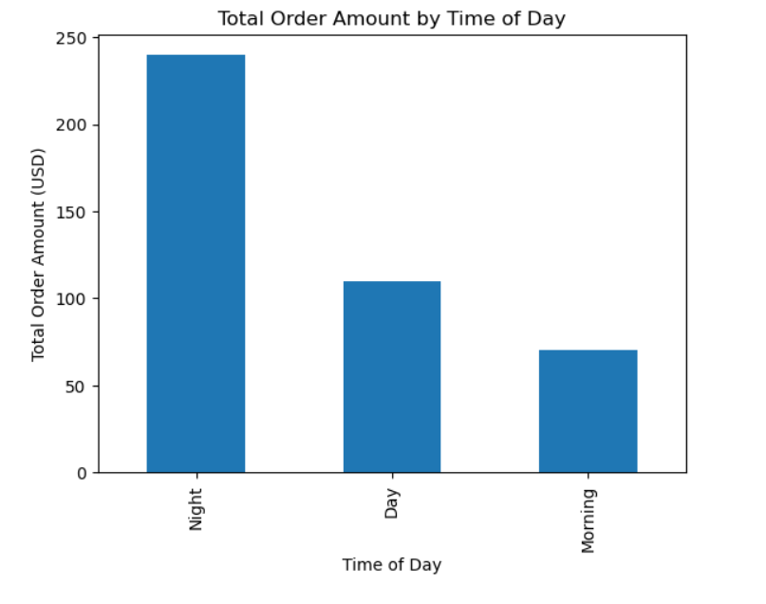

### **Business Recommendations**

1. **Targeted Marketing for Younger Users**:
   * Since younger users (aged 25–40) are the most active, tailor marketing campaigns to appeal to their preferences. Offering discounts or loyalty programs could increase retention.
2. **Promote Dinner-Time Orders**:
   * Given that Dinner accounts for the majority of orders, focusing marketing efforts on dinner-time meals could increase revenue. Special promotions, such as "Dinner of the Week," could further drive engagement.
3. **Optimize Session Duration and Quality**:
   * Since session duration and user satisfaction are weakly correlated, improving the overall quality of sessions (e.g., cooking tips, exclusive recipes) could enhance user experience, leading to more positive ratings and potentially higher spending.
4. **Focus on Night-Time Sales**:
   * Orders at night generate the most revenue. Consider offering nighttime deals, introducing a nighttime menu, or running special events to capitalize on this trend.
5. **Personalized Meal Options**:
   * Given the popularity of certain dishes, consider introducing personalized meal plans based on user preferences, such as “Dinner for You” packs or options that cater to different tastes and dietary needs.