Predicting the comportment of PM_{2.5} in Delhi in view of Stubble burning from bordering states using Stacking regression.

S.R Mani Shekhar
Department of Information Science and Engineering
Ramaiah Institute of Technology Bangalore, India
manisekharsr@gmail.com
Vinay Biradar
Department of Information Science and Engineering
Ramaiah Institute of Technology Bangalore, India
vinaybiradar1717@gmail.com
Sarthak Jain
Department of Information Science and Engineering
Ramaiah Institute of Technology Bangalore, India
sarthjain830@gmail.com
Umer Faruk
Department of Information Science and Engineering
Ramaiah Institute of Technology Bangalore, India
umer.gvt@gmail.com
Tilak Singh
Department of Information Science and Engineering
Ramaiah Institute of Technology Bangalore, India
tilaks484@gmail.com

Abstract— Urban air pollution prediction becomes a compelling alternative to restrain its detrimental consequences. A thick layer of smog blankets can be seen in Delhi in the month of November which is the main season of stubble burning. Out of all the parameters in analyzing air quality, the change in PM_{2.5} is considered data to analyze to the stubble burning and its effect on Delhi. Particulate Matter (PM) which is generally measured in terms of the mass concentration of particles within certain size classes: PM₁₀ (aerodynamic diameter less than 10 micron) and PM_{2.5} or fine ( aerodynamic diameter less than 2.5 micron). PM_{2.5} has a greater residing time in air when compared to PM₁₀ because of the balance between the downward acting force of gravity and aerodynamic drag force. Therefore, Particulates are the main component of air pollution. Numerous machine learning techniques have been adopted to forecast the air quality. But none on them focuses primarily on the issues of stubble burning and its effect on Delhi’s air. In this paper, we present an attempt to estimate the value of PM_{2.5} in the National capital mainly due to stubble burning in neighboring states. For this the PM_{2.5} data is taken into consideration for 9 ground-based continuous air quality monitoring stations in the neighboring states of Delhi for the duration of 6 months & 15 days in the calendar year of 2019 to analyze the agricultural reason behind the slumping of air quality in Delhi day by day. The model used here is based on Stacking regression which is an ensemble learning technique to combine the prediction capabilities of multiple regression models via a meta-regressor. The individual regression models or base models are trained using the out-of-folds predictions based on the complete training set then, the meta-regressor is trained based on the outputs (meta-features) of the individual regression models in the ensemble. The technique is then evaluated by RMSE (Root Mean Square Error), MSE (Mean absolute Error), R² (R-squared) and MAE (Mean Average Error). Finally, the model is validated with the real-time data of Delhi for the stubble burning period. The model will illustrate the effect of stubble burning and give us an estimate of PM_{2.5} based on the PM_{2.5} values of stubble burning hotspots in Haryana and Punjab which will help us to predict the extent of deterioration in air quality in case of increase in stubble burning. In this paper the model have achieved a R² (R-Squared) value of 0.866 for the test dataset.
Keywords: Stubble burning, Delhi, PM_{2.5,} Stacking Regression, SVR, Air Quality Index, Regression, Ensemble Learning.

Introduction

As winter starts to set in,National capital Delhi’s air is yet again severely polluted by a combination of factors: crop stubble burning, garbage incineration, industrial disposal, vehicular pollution and dust from construction sites out of these factors most of the factors are present all year around but one factor that is not common year around is stubble burning in Punjab and Haryana. Hence considering stubble burning a model can be made to get the extent of pollution in Delhi.

Over the past years, the air pollution levels in the National capital have started uprising sharply towards the end of October through early November and got even worse with the burning of firecrackers in Diwali. In the year 2020, the air quality index measuring over 900 in some areas [1], which is categorized by the Central Pollution Control Board as “severe”, poses the risk of respiratory illness[2].

This pollution phenomenon is now an regular occurrence in Delhi at this time of year, resulting to a toxic smog from bursting of firecrackers , the burning of crop stubble by farmers in the neighboring regions of Punjab and Haryana, and a cold shift in temperatures leading to the locking of fumes in fog. The blame goes on farmers in Punjab and Haryana for the hike in air pollution. After the harvesting is done, these farmers commence stubble burning from late September to early November. Since This is the cheapest way for the farmers to set their fields ready for the rabi or winter crop. Satellite images depicts that this stubble burning smoke generates pollution across Punjab and Haryana, which eventually carried forward to the Indo-Gangetic plain. Though the stubble burning happens in summer season as well but then the climatic conditions tends to depreciate the effect because of the fact that the average wind speed in Delhi in winter lies between one and three meters per second, which is approximately one-third of the average speeds in the summer months[3].

Literature Review
In this study [4] Ground-based ambient air monitoring was conducted at five different locations in Mandi-Gobindgarh (critically polluted area), Punjab, in order to determine the impact of stubble burning on the concentration of Particulate Matter (PM) in ambient air for one rice crop season (October 2012 to January 2013) and one wheat crop season (March 2013 to May 2013). the study reveals that the concentrations of both particulate matter were beyond the prescribed limits in the ambient air. Concentration of PM was found to be less in summers than in winters. ,And it was also concluded from the paper that field burning of agricultural crop residue was observed to be instrumental in further deteriorating the air quality of a critically polluted industrial area.

In [5], the authors have analyzed the Crop residue burning after the monsoon season in the neighboring places of Delhi that lead to frequent events of extreme pollution, which leads to premature marginal increase in rate of diseases and death rate. they have used multiple satellite measurements in combinations with actual field incidences data at the ground . They have quantified the share of biomass burning in deteriorating Delhi’s air quality during 2018 using the SAFAR chemical transport model that has been validated with dense observational network of Delhi. The impact of biomass burning on Delhi’s PM_{2.5} is found to vary on day-to day basis (peaking at 58%) .

In this paper [6], the air pollution events in the Delhi-National Capital Region (NCR), India, during the month of November have been studied. Measurements are reported from 16 ground-based continuous air quality monitoring stations (CAAQMS) in the Delhi-NCR for the years 2016 and 2017. Time series PM_{2.5} ground measurements were compared with the total Fire Radiative Power (FRP) from Moderate Resolution Imaging Spectroradiometer (MODIS) onboard Terra and Aqua satellites for the airshed for Delhi-NCR. To quantify the smoke contribution from the fire pixels to the Delhi- NCR, the Navy Aerosol Analysis Prediction System (NAAPS) smoke data were used. NAAPS simulations show that the smoke aerosol contribution to Delhi-NCR from stubble burning was ~5- 10 μg/m 3 during the pollution episodic days in 2016. NAAPS results along with the PM_{2.5} measurements at Ludhiana, Punjab, shows that the stubble burning may add up to 33- 66 μg/m³ to the PM_{2.5} concentration at Delhi depending on wind conditions and levels of emission at the source.

The above prescribed works mainly focuses on research field and prove the fact that the PM_{2.5} of Delhi is severely effected by the stubble burning episodes of Haryana and Punjab especially during the winter season but none of the above work estimates the PM_{2.5} level of national capital if stubble burning rise to a certain level. Therefore the prescribed work tries to build a model that can give an estimate of PM_{2.5} of national capital based on the stubble burning episodes in Haryana and Punjab.

In this study, an ensemble stacked regression model is developed to predict the value of PM_{2.5} of Delhi, based on PM_{2.5} values of surrounding cities which are stubble burning hotspots. Feature selection is performed using the correlation heatmap to select only the relevant features. Interpretable base models are selected to obtain the meta features on which final prediction is done through meta regressor to get the best performance metrics in order to predict the effect of stubble burning on the PM_{2.5} of National capital.

Modelling and Implementation

The idea is predicting the values of PM_{2.5} of Delhi using the PM_{2.5} values of various cities of Haryana and Punjab which lies in the vicinity and are favorable in terms of direction of wind which carry the minute particles of stubble along with the wind. In the model the stacked regression model is used to predict the PM_{2.5} values of the national capital. The air quality data is collected from 11 cities including Delhi which is further processed to form a new dataset and a model is trained with this dataset.
The model has been developed through various procedures which have been carried out in five phases starting right away from data collection to evaluation of model on the test data. A brief picture of phases in implementation is shown in Fig. 1. All through the training procedure, the concept of k-Fold cross validation is applied since the dataset we have is limited. The implementation k-fold cross validation is shown in Fig. 2.
Phases in Implementation

    - Collecting data.
    - Pre-processing of Data.
    - Splittig the Dataset into Training and Testing set.
    - Finding the Model which suites best for the available data (Algorithm Selection).
    - Training and Testing phase.
    - Evaluation of the Model.

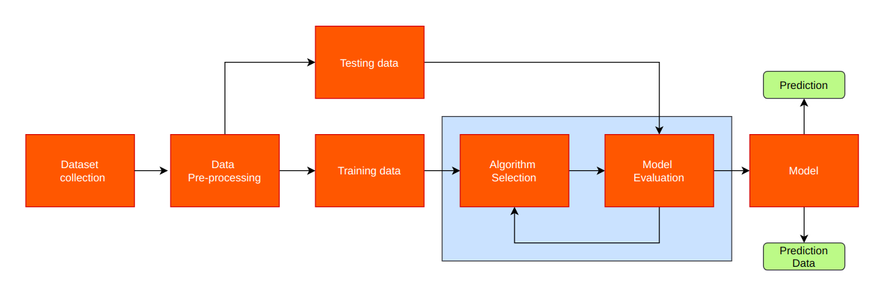
Fig.1 Phases in Implementation of our Model

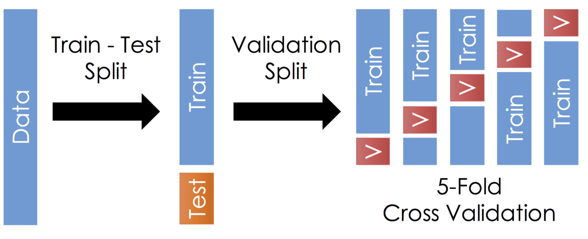
Fig.2 Data split and Implementation of 5-Fold Cross Validation

A) Dataset used
The dataset is formed by collecting air quality data from aqicn website which maintains a record of historical air quality data of Central Pollution Control Board (CPCB)[7] and Delhi Pollution Control Commitee (Government of NCT of Delhi) (dpccairdata.com). The air quality data of various cities of Haryana and Punjab which lies in close proximity to Delhi are taken in observation. The cities and of Haryana are Hisar, Panipat, Sirsa, Bhiwani, Jind, Karnal, Kaithal and Rohtak . And cities of Punjab are Ludhiana and Patiala. The data of Delhi is collected from air monitoring station of Delhi institute of tool engineering ,Wazirpur.

The air quality data contains daily average concentration of various parameters like PM_{2.5}, PM₁₀, O₃, NO₂, SO₂ and CO in μg/m³ for each city. The snapshot in fig.3 depicts the sample air quality data for Patiala. The PM_{2.5} data has been extracted for each city and combined on the basis of sampling date to form a new dataset of 12 columns where the first column represents the date of sampling and rest 11 columns represent the daily average concentration of PM_{2.5} in μg/m3 where in the starting 10 columns is for cities of Haryana and Punjab and the 11th column is of Delhi. The snapshot of newly formed dataset is shown in the fig.4.


Fig.3 A sample of air quality data for Patiala (taken from aqicn.org) which is processed to form the original dataset

The ‘date’ attribute in the dataset describes the sampling date and other parameters give the PM_{2.5} concentration of various cities taken in consideration. The data has been collected from 15th JUNE 2019 to 30th DECEMBER 2019 for critical analysis. The dataset has a total of 198 entries.

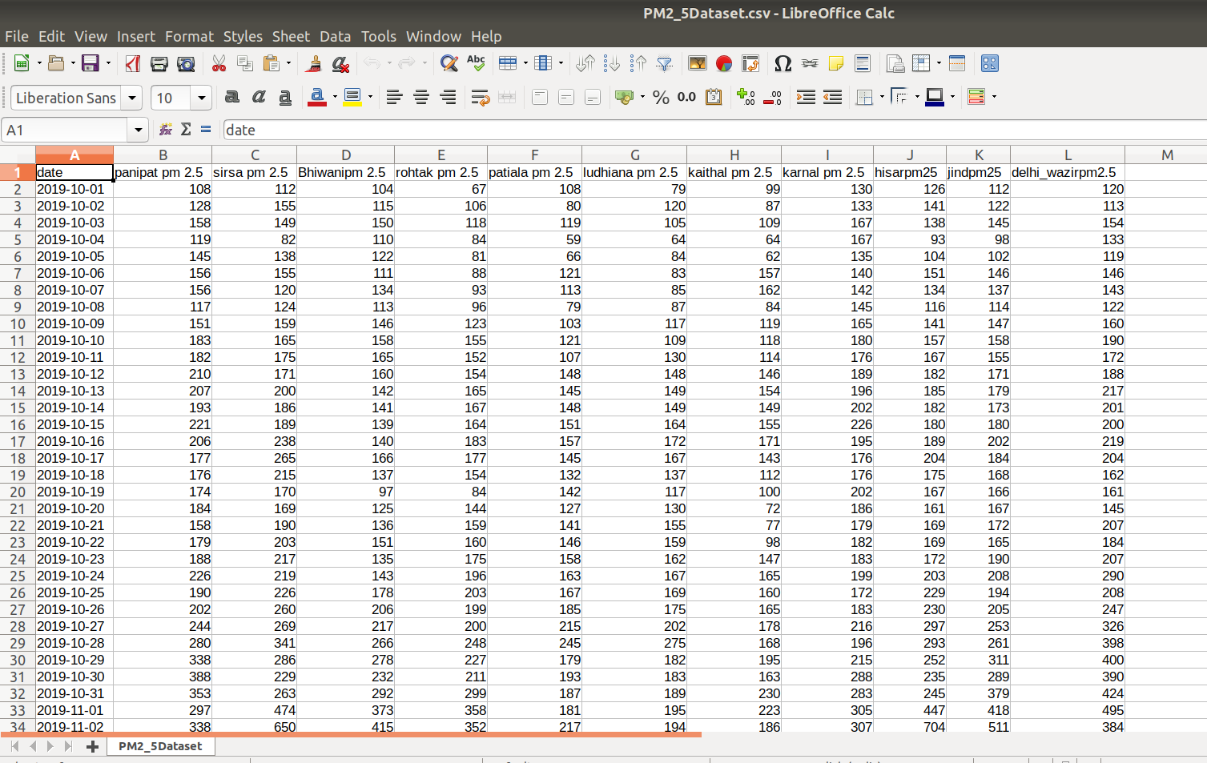
Fig.4 original Dataset formed from PM_{2.5} values of air quality data of various cities.

B) Pre-processing of Data

Initially the dataset has the columns, which contained the values of PM_{2.5} (fine particulate matter), PM₁₀ (respirable particulate matter), NO₂ (nitrogen dioxide), SO₂ (sulphur dioxide), CO (carbon monoxide) and O₃ (ozone). In this paper the study is only limited to PM_{2.5} since impact of stubble burning on ambient air quality significantly increases the PM₁₀ and PM_{2.5} concentrations during crop residue burning periods[4]. The PM_{2.5} (fine particulate matter) data of Delhi and its surrounding states Haryana and Punjab is taken under observation. The cities of Haryana and Punjab taken under consideration are Hisar, Panipat, Bhiwani, Jind, Karnal, Kaithal, Rohtak, Ludhiana and Patiala. The dataset was consisting of NULL values, which can lead to a bias in the Results therefore, the dataset was cleaned by dropping unnecessary attributes and also, by dropping the tuples with null value of one or more attribute. After that the dataset is divided into training set and test set in the ratio 3:1.

C) Training and Splitting

The data is divided into two parts which is training data and testing data. The whole procedure of training is carried out on the training data. The testing data is kept for for further evaluation of model to check how well the model
is performing. In this paper 75% of the data is used as training set and rest 25% is used to evaluate the models performance or lets say that 25% is used as test set.

D) Ensemble Model based on Stacking Regression

The ensemble method works on the principle of adding the predictions of several base estimators. To improve robustness and generalizability over a single predictor [8]. Stacking regressions is a method for forming linear combinations of different predictors to give improved prediction accuracy. The idea is to use cross-validation data and least squares under non negativity constraints to determine the coefficients in the combination[9]. In this paper a stacked ensemble model comprising of linear regression,random forest and KNN as base models and SVR as meta model is proposed.

According to the proposed approach a higher level Meta Regressor is trained on out of fold predictions of base models. Creating the final prediction of overall stacked model as depicted in Fig.4.
The steps illustrated below give brief information about the various steps involved in the stacked regression model. The procedure, for the training part, may be described as following steps:

Step1: Split the total training set into two sets such that they are disjoint (here train and holdout).
Step2: Train several base models on the first part (train).
Step3: Test these base models on the second part (holdout).
Step4: Use the predictions from 3) (called out-of-folds predictions) as the inputs, and the correct responsed (target variable) as the outputs to train a higher level learner called meta-model.

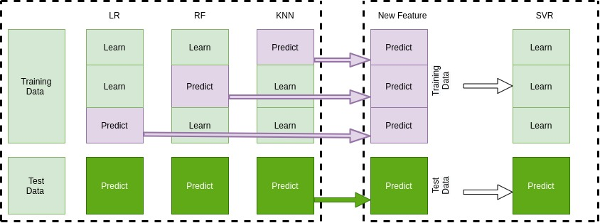
Fig.5 Stacked Ensemble Model
The first three steps are performed iteratively . Here a 5-fold stacking is taken. firstly the training data is divided into 5 folds. Then 5 iterations are performed. In each iteration, every base model is trained on 4 folds and predicted based on the remaining fold (holdout fold).
In this way, after 5 iterations, the entire data will get out-of-folds predictions such that a dataset with new features is obtained which is used to train our meta-model in the step 4.
For the prediction part , average the predictions of all base models on the test data and use them as meta-features on which, the final prediction is done with the meta-model.

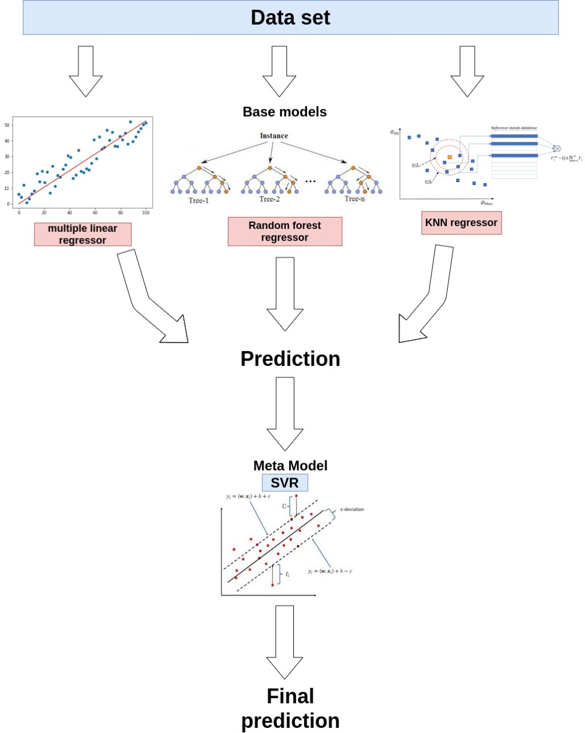
Fig.6 Working of our Stacked Regression Model

1) Base Models in Stacked Regression

Linear Regression
Simple linear regression where a single predictor variable X was used to model the response variable Y. In our applications there is more than one factor that influences the response. Multiple regression models [10] helps to describe how a single response variable Y depends linearly on a number of predictor variables.
A multiple linear regression model with k predictor variables Z₁, Z₂, ..., Zkand a response Y , can be written as

y = β₀ + β₁Z₁ + β₂Z₂ + … β_{k} Z _{k} + ε

Random Forest
This model is a type of additive model that makes predictions by combining decisions from a sequence of base models. The final model [11] in this is obtained from the addition of all models. These base models are constructed from the sub sample of data.

g(x) = f₀(x) + f₁(x) + f₂(x) +... f_{k}(x)

K-nearest Neighbors
The K-nearest neighbors (KNN) algorithm is a type of supervised machine learning algorithms. KNN [12] is very easy to implement in its most basic form, and yet performs quite complex classification tasks. It is a lazy learning algorithm since it doesn't have a specialized training phase. Rather, it uses all of the data for training while classifying a new data point or instance. KNN is a non-parametric learning algorithm, which means that it doesn't assume anything about the underlying data.

2) Meta Model in Stacked Regression

(a) Support Vector Regression
In SVR ,with Vapnik’s -insensitive approach [13], a flexible tube with minimum radius is developed symmetrically around the estimated function, such that the absolute values of errors which are less than a certain threshold are ignored both above and below the estimate. In this way,the points located outside the tube get penalty, but the ones inside the tube do get penalized. The main advantages of SVR is that its computational complexity is independent of dimensionality of the input space. Apart from this, it has great generalization capability, with excellent prediction accuracy [14].

E) Model Evaluation
The model is evaluated based on the test data which is formed at the time of splitting of data into training set and test set is kept for evaluation of model’s performance. The model is evaluated using this test set whose numerical result is presented in the Results and discussion section.

F) Validation of the Stacked Regression Model
The accuracy for these type of models can be measured by the following parameters:

RMSE =

MAE =

R² =

where,
is predicted value of Y
is mean value of Y
and ‘n’ represents the observation count.
The smallest the values of MAE and RMSE the better the model accuracy will be and also the model shows better accuracy if R² value is close to 1.

Results and Discussion

The results of the various applied algorithms are presented here with the help of various performance metrics such as RMSE, MAE and R-Squared in the form of graphs.A model is performing well if its R² (R-Squared) value is close to one. And RMSE,MAE values are lesser than other model Different outcomes have been compared as well. The feature importance analysis has also been done on the dataset which is discussed below.

A) Feature Importance Analysis:

To see the correlation between features and the target, the correlation Heatmap is plotted. The Heatmap indicates that Sirsa is least correlated with the target hence it is eliminated. The Heatmap is illustrated in Fig.6 which shows the correlation between PM_{2.5} of different cities in the dataset.

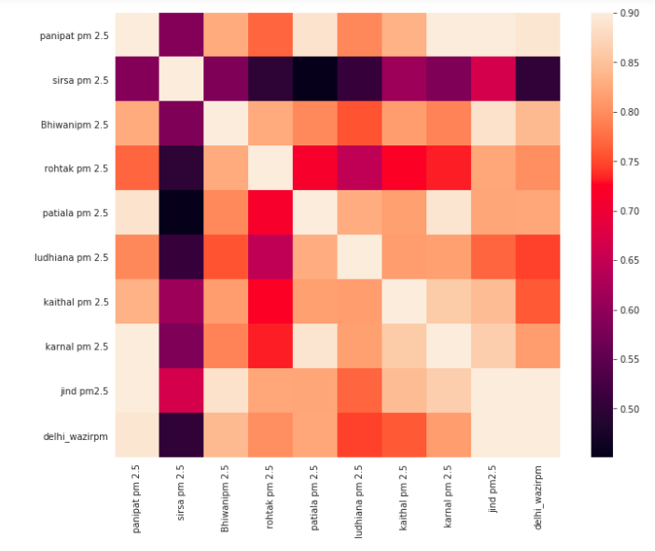
Fig.7 Correlation Heatmap showing correlation between different features of the dataset.

The results of the various applied algorithms are presented here with the help of various performance metrics such as RMSE, MAE and R-Squared in the form of graphs and different outcomes have been compared as well. For each model, a k-fold cross validation (where k = 5) is applied to identify the best performance measured at the training stage. The best results generated from each metric from the training set and testing set is highlighted in bold letters .

B) Numerical Results of Training Data on Various Models:
- R² (R-Squared) values:
Linear Regression | 0.7731
Random Forest Regressor | 0.8111
KNN Regressor | 0.8313
GBoost | 0.8258
XG Boost | 0.8514
SVR | 0.7622
Lasso | 0.7731
Stacked Regression | 0.8557

- RMSE values:
Linear Regression | 42.877
Random Forest Regressor | 38.8944
KNN Regressor | 36.2265
GBoost | 38.7571
XG Boost | 34.5043
SVR | 44.7869
Lasso | 42.8766
Stacked Regression | 34.3906

- MAE values:
Linear Regression | 31.8394
Random Forest Regressor | 27.6675
KNN Regressor | 26.5629
GBoost | 27.2981
XG Boost | 24.6452
SVR | 32.0245
Lasso | 31.8388
Stacked Regression | 24.335

C) Numerical Results of Testing Data on various Models:
1) R² (R-Squared) values:

Stacked Regression | 0.866
Random Forest Regressor | 0.8579
K-Neighbors Regressor | 0.8271
XG-Boost | 0.8103

2) RMSE values:
Stacked Regression | 42.7714
Random Forest Regressor | 44.1625
K-Neighbors Regressor | 48.7101
XG-Boost | 51.0294

3) MAE values:
Stacked Regression | 21.858
Random Forest Regressor | 23.422
K-Neighbors Regressor | 25.95
XG-Boost | 27.777

The results of the various applied algorithms are presented here with the help of various performance metrics such as RMSE, MAE and R-Squared in the form of graphs. Different outcomes have been compared as well.out of all the models it has been found that the stacked regression model has performed better for training set and tesing set as well.
The comparison of R² value for different models on testing set and training set have been shown in Fig. 8 and Fig. 9 respectively.Similarly Fig. 10 and Fig. 11 give us the comparison of RMSE values of tesing set and training set respectively on different models and MAE values on different models have been shown in Fig. 12 and Fig. 13 for testing set and training set respectively.

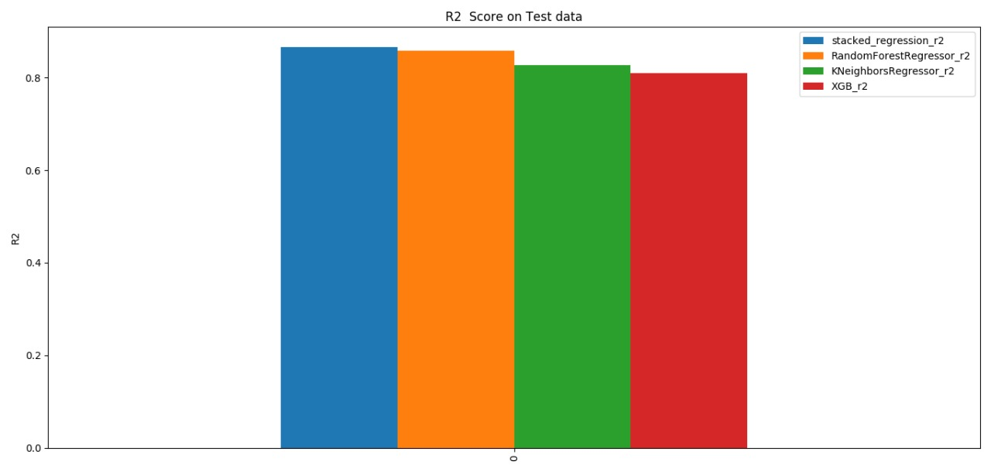
Fig.8 Comparative study of different models for R² value on Testing Dataset
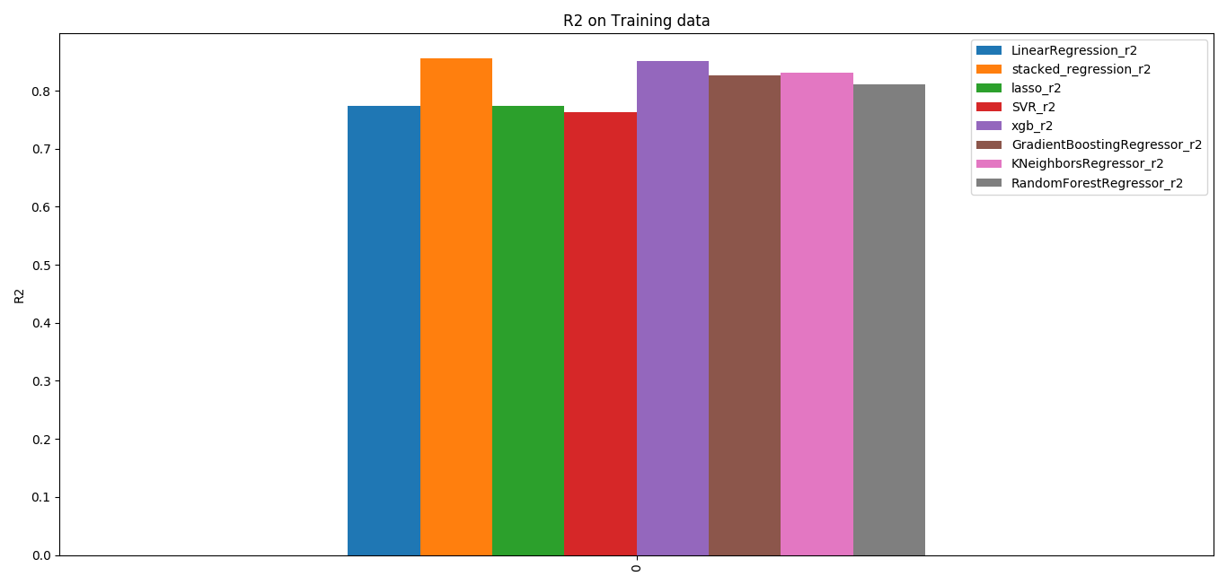
Fig.9 Comparative study of different models for R² value on Training Dataset
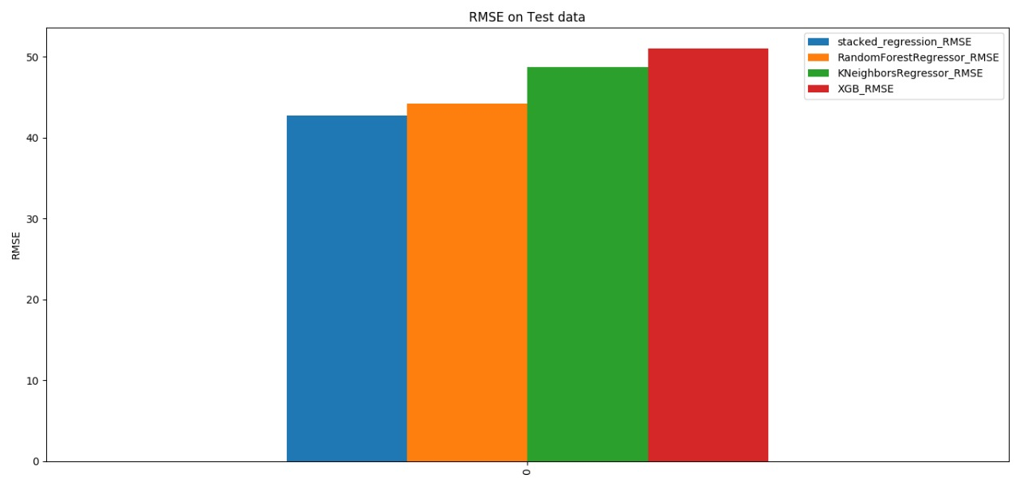
Fig.10 Comparative study of RMSE value on Testing Dataset
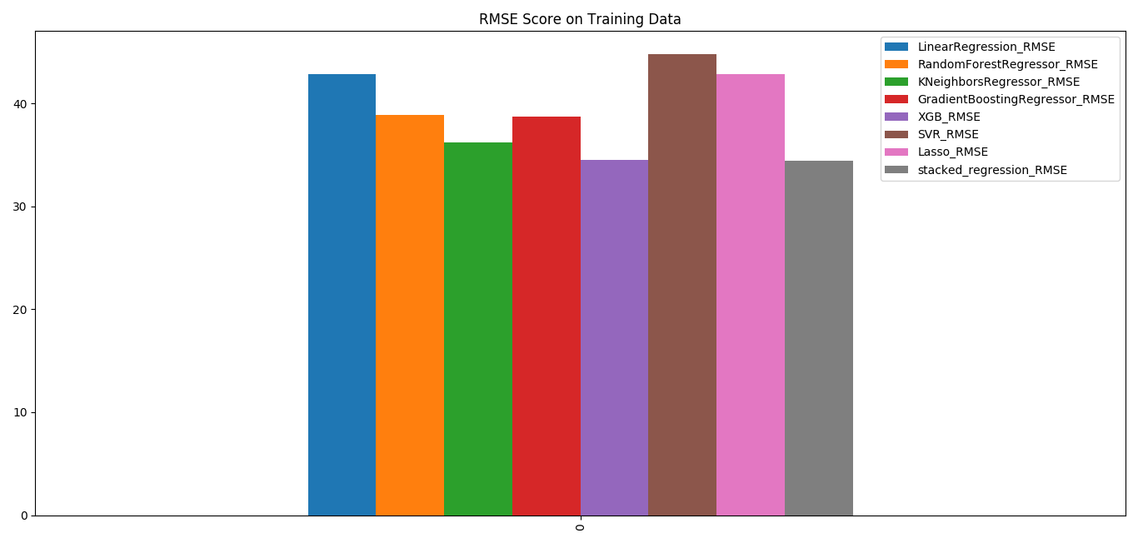
Fig.11 Comparative study of RMSE value on Training Dataset
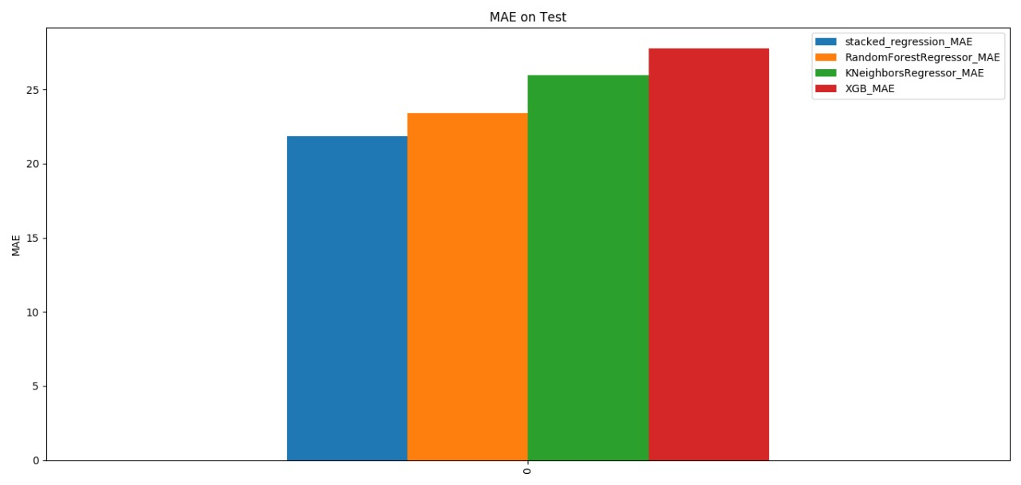
Fig.12 Comparative study of MAE value on Testing Dataset
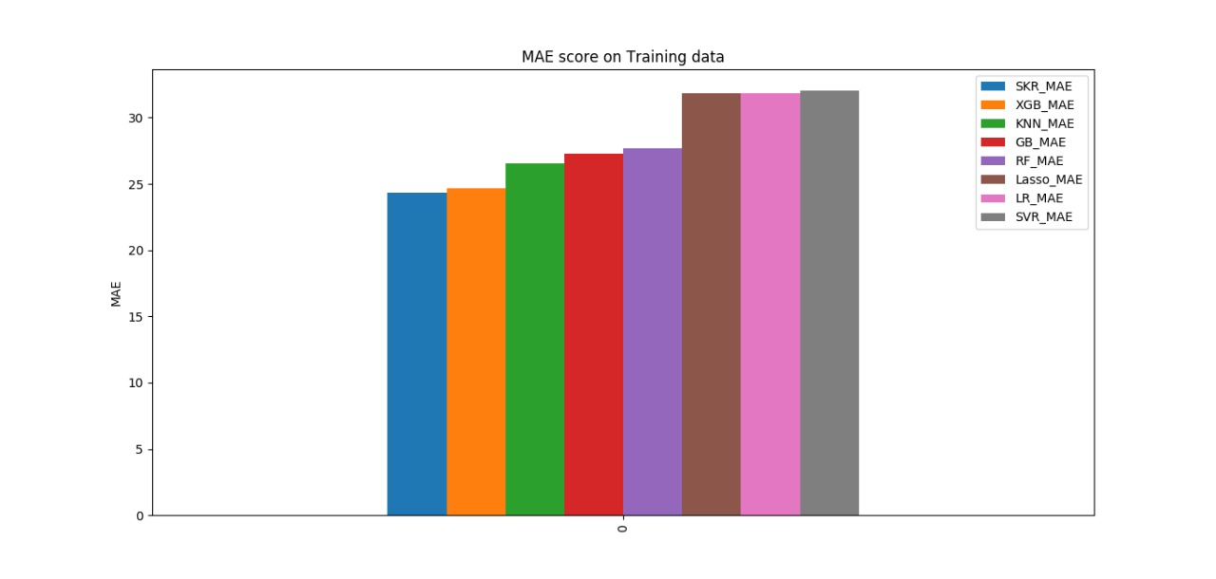
Fig.13 Comparative study of MAE value on Training Dataset
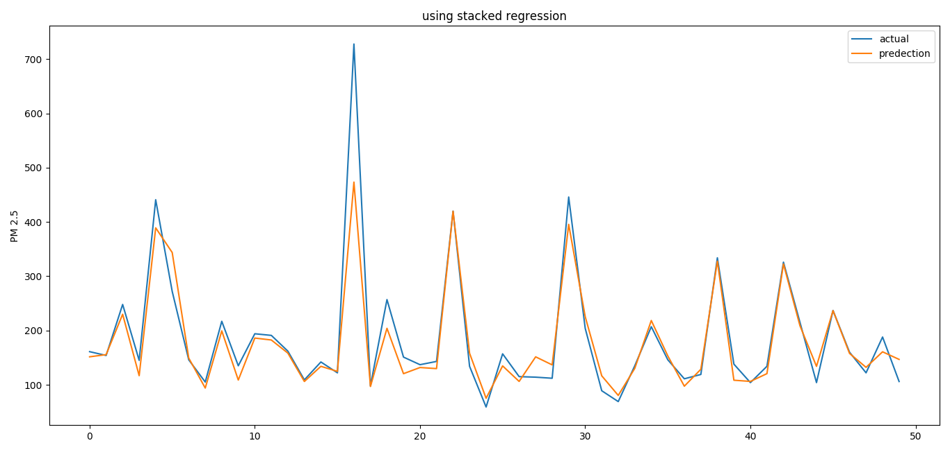
Fig.14 Actual vs Predicted values of PM_{2.5} for our Stacked Regression Model.

The above results shows that our stacked regression model performs well on training set as well testing set hence our model is validated. When the highest peek is observed in Fig.14 the conclusion can be drawn that the model is performing pretty poor since the dataset has only one observation of that kind. This problem can be eradicated if dataset is grown bigger which means having many observation of that type hence the model can be trained better to give more precise results.

Fig.15 shows the year wise trends of PM_{2.5} of Delhi over past five years ,it can be noted from the figure that there is
sudden rise in the PM_{2.5} concentration towards the end of the year that is, at the time of stubble burning periods.

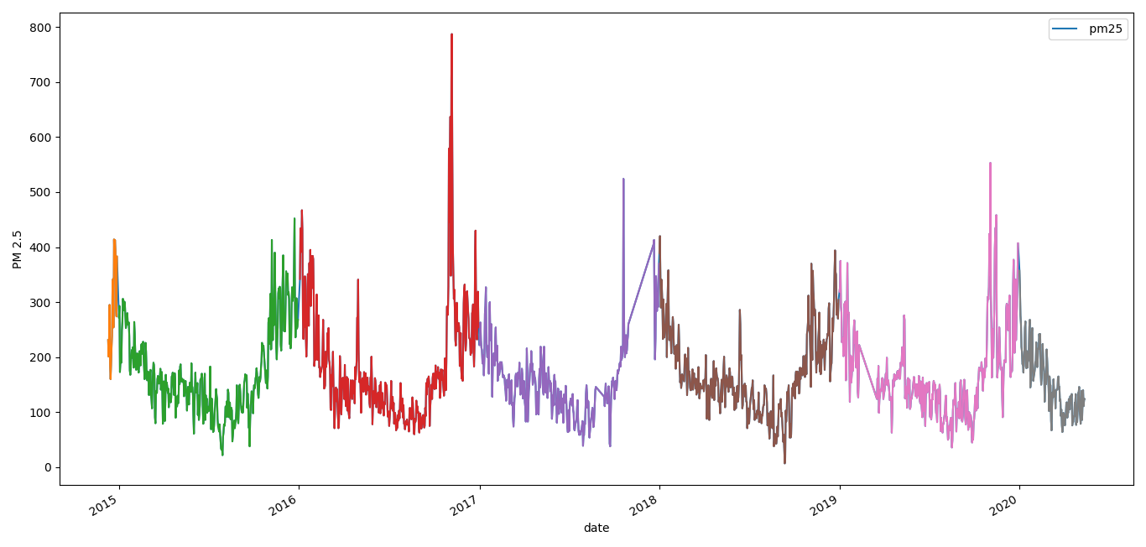
Fig.15 Year wise Trends of PM_{2.5} of Delhi over the past 5 years

Conclusion and Future work

An ensemble model based on the stacking of Linear, Random Forest, KNN and support vector regression (SVR) is built for estimating PM_{2.5} concentrations in Delhi, India based on the PM_{2.5} concentrations of neighboring stubble burning hotspots in Punjab and Haryana. The objective of the study is to develop a model which can illustrate the effect, stubble burning has on Delhi. Historical daily average PM_{2.5} concentrations of Delhi(Delhi Institute Of Tool Engineering, Wazirpur air quality monitoring station) and nine surrounding cities in neighboring states of Haryana and Punjab are considered for 15th June 2019 to 30th December 2019 are collected to fit the model with 75% of the samples taken as a training set and with the other 25% used as a test set. Feature selection is performed by using a correlation Heatmap the features which were less correlated was removed. The performance of the ensemble model is evaluated and compared to different single forecasting models and it is found that it outperforms in all the performance check measures.
The following values have been obtained from the testing dataset: R² (R-Squared) value of 0.866, RMSE (Root Mean Square Error) value of 42.7714 and MAE (Mean Absolute Error) value of 21.858 is obtained.
The examination of PM_{2.5} has been undertaken and change in Delhi due to the neighboring states is found. consideration of seasonality factor has not been taken in consideration since in summer seasons (April to June) when stubble burning takes place the particulate matter is not deposited over Delhi [15] hence the PM_{2.5} is less effected by stubble burning thereby model performs pretty bad. In future seasonality factor can also be considered as well Also, the data set was quite limited. So, in future more data can be accumulates and more accuracy can be achieved in the model . Furthermore, beside working on PM_{2.5} this project can be further implemented by examining other parameters like NO₂, SO₂, CO etc. In nutshell, it can be can agreed that the air quality of not only Delhi but throughout the globe is worsening day by day. We need to take action against the increase in air pollution by proposing different models or algorithms and working on it.

VI. References

- https://www.theguardian.com/world/2019/nov/03/flights-diverted-in-delhi-as-toxic-smog-hits-worst-levels-of-2019
- https://app.cpcbccr.com/AQI_India/
- https://qz.com/india/1448666/delhis-location-is-the-reason-it-suffers-smog-every-winter/
- Singh, R. P., Chanduka, L., & Dhir, A. (2015). Impacts of Stubble Burning on Ambient Air Quality of a Critically Polluted Area–Mandi-Gobindgarh. J Pollut Eff, 3(2).
- Beig, G., Sahu, S. K., Singh, V., Tikle, S., Sobhana, S. B., Gargeva, P., ... & Murthy, B. S. (2020). Objective evaluation of stubble emission of North India and quantifying its impact on air quality of Delhi. Science of The Total Environment,709, 136126.
- Rasma, K., Menon, R., Kumar, R., Gadhavi, H., & Sethi, V. (2019). Study of the Extent of Contribution of Regional Stubble Burning to the Air Pollution in Delhi-National Capital Region.
- https://app.cpcbccr.com/AQI_India/
- Wolpert, D. H. (1992). Stacked generalization. Neural networks, 5(2), 241-259.
- Breiman, L. (1996). Stacked regressions.Machine learning, 24(1), 49-64.
- Bremer, M. (2012). Multiple Linear Regression. Published in the Journal “Math 261A-Spring.
- https://turi.com/learn/userguide/supervised-learning/random_forest_regression.html
- https://stackabuse.com/k-nearest-neighbors-algorithm-in-python-and-scikit-learn/
- Vapnik, V. N. (1999). An overview of statistical learning theory. IEEE transactions on neural networks, 10(5), 988-999.
- Awad M., Khanna R. (2015) Support Vector Regression. In: Efficient Learning Machines. Apress, Berkeley,CA. https://link.springer.com/chapter/10.1007/978-1-4302-5990-9_4
[15] https://scroll.in/article/901029/delhi-could-blame-location-wind-speed-himalayas-for-its-terrible-air-or-it-could-blame-itself

