

IILM University, Gurugram
School Of Computer Science & Engineering
Assignment
Course: Version Control System

Submitted to : Dr. Puja Batra | Submitted By: Vinay Bisht
(Associate Professor) | Section – 3A
 | URN : 2581021

Problem Statement:
Identify an earlier commit and examine the version of a file stored in that commit.

Aim
To create a Git repository with multiple commits, identify an earlier commit from the commit history using git log, and examine the version of a file stored in that commit using git show.

Commands Used :

1. Initialize a Git Repository

2. Create a Text File, Stage It and Make the First Commit

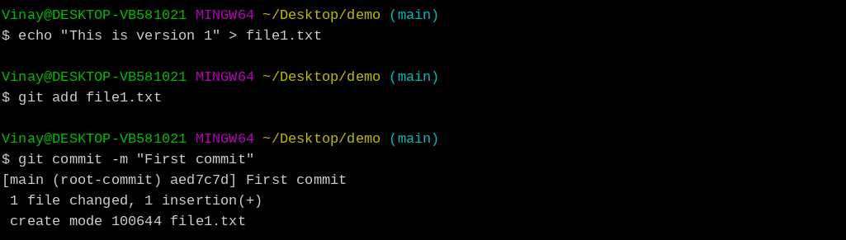

3. Modify the File and Make the Second and Third Commits

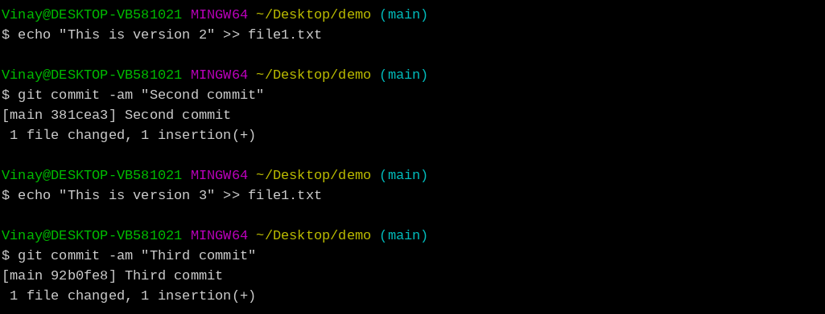

4. Identify the Earlier Commit (View Commit History)

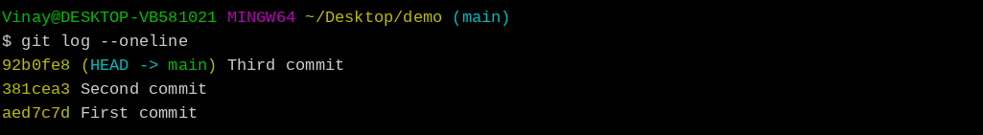

5. Examine the Earlier Commit (Changes Made in that Commit)

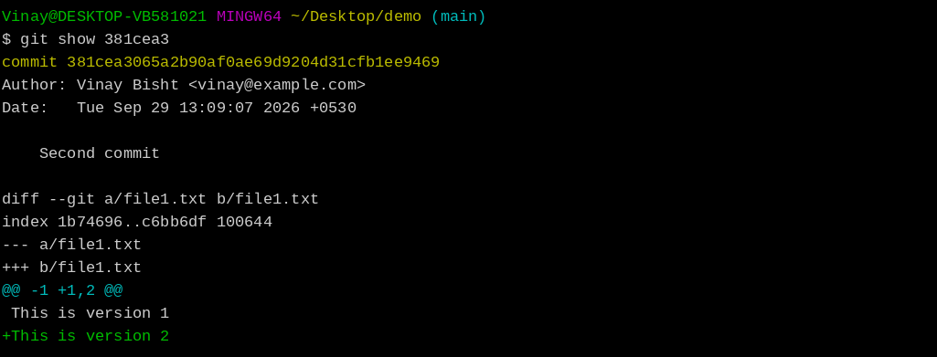

6. View the File Version Stored in the Earlier Commit

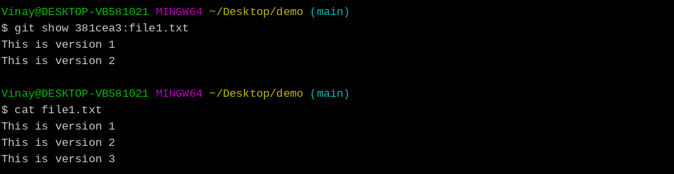

File Content of file1.txt in each commit:

First commit (aed7c7d): This is version 1
Second commit (381cea3): This is version 1 / This is version 2
Third commit (92b0fe8): This is version 1 / This is version 2 / This is version 3

Explanation:
- git init initializes a new Git repository.
- echo is used to create file1.txt and to add new lines to it.
- git add file1.txt moves the file to the staging area, and git commit saves a snapshot of it as a new commit.
- Each time file1.txt is modified and committed, Git stores a new version of the file in that commit.
- git log --oneline lists all commits with their short commit IDs (hashes), so an earlier commit such as 381cea3 can be identified.
- git show <commit-id> displays the details of that commit: author, date, message and the changes made.
- git show <commit-id>:file1.txt prints the exact content of file1.txt as it was stored in that commit (only version 1 and version 2 lines), while the current file also has the version 3 line.

Result:
An earlier commit (381cea3) was successfully identified using git log --oneline, and the version of file1.txt stored in that commit was examined using git show 381cea3:file1.txt. The output confirmed that the older version differs from the current version of the file.

Learning Outcomes:
- Learned how to create multiple commits in a Git repository.
- Learned how to view the commit history using git log --oneline.
- Understood that every commit has a unique commit ID (hash) that identifies it.
- Learned how to examine a particular commit using git show <commit-id>.
- Learned how to view the version of a file stored in an earlier commit using git show <commit-id>:<file>.
- Understood that Git keeps every version of a file, so earlier versions can be viewed at any time without changing the current working file.

