Insurance Claims Intelligence
Architecture Overview
Local agentic Hybrid RAG application for insurance claim investigation. A LangGraph agent calls deterministic tools and, when needed, hybrid policy retrieval. Execution is streamed to a React Flow canvas over Server-Sent Events (SSE). The system produces a structured report for human review and never approves, denies, settles, or pays claims.

Architecture diagram
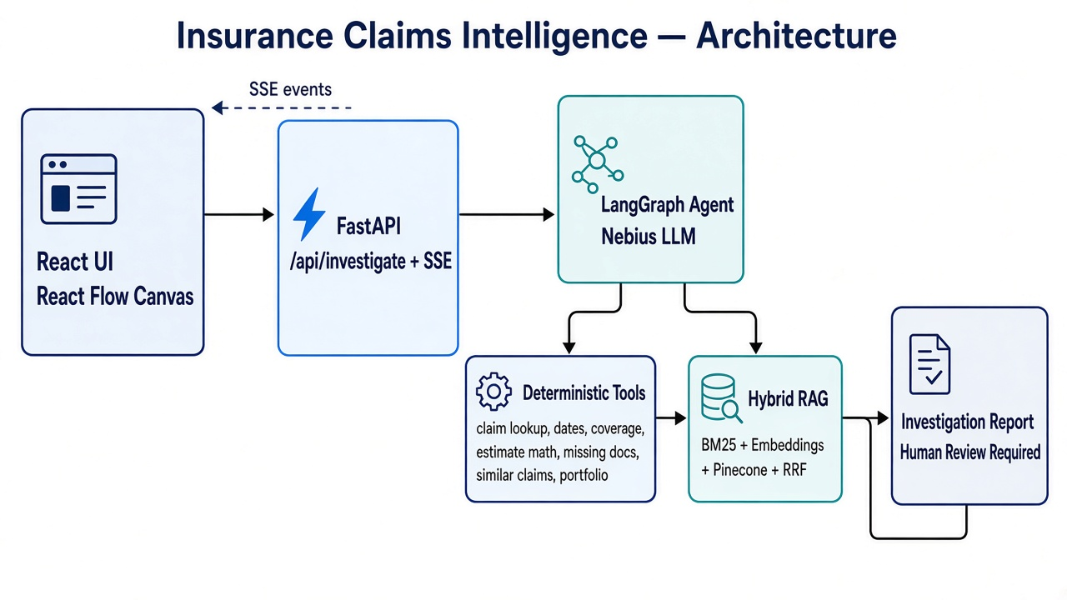
Figure 1. End-to-end request flow: UI → FastAPI → LangGraph → Tools / Hybrid RAG → Report (SSE back to UI).

High-level flow
- User asks a question in the React UI (claim selected or portfolio / no claim).
- UI calls POST /api/investigate; backend creates a run and starts the LangGraph agent.
- UI opens GET /api/runs/{run_id}/events (SSE) to receive live workflow events.
- Nebius chat model (via LangGraph) chooses tools based on the question.
- Structured tools read local JSON (claims, policies, estimates, checklists, portfolio stats).
- search_policy_documents runs Hybrid RAG: BM25 + Nebius embeddings + Pinecone + RRF.
- Canvas nodes update from SSE events as tools run.
- generate_investigation_report produces the final report; human review is always required.

Major components
Component | Responsibility
React UI + React Flow | Claim/portfolio question entry, live canvas, report panel
FastAPI | REST + SSE; starts investigation runs
LangGraph agent | Tool-calling loop with Nebius LLM
Deterministic tools | Dates, coverages, Decimal estimate math, missing docs, similar claims, portfolio lookup
Hybrid RAG | Policy document retrieval and citations (BM25 + dense + RRF)
Local data | policies/claims JSON and policy Markdown under backend/data
Nebius | Chat model + embedding model
Pinecone | Dense vector index for policy chunks

Hybrid RAG (when used)
RAG runs only through search_policy_documents when the question needs policy document language for a known policy_id (typically from the selected claim).
- BM25 — local lexical search over policy chunks (exact terms, form labels).
- Embeddings — Nebius embeds the user question.
- Pinecone — dense similarity search filtered by policy_id.
- RRF — fuses BM25 and dense rankings into final passages/citations.

Agent tools
Tool | Purpose | RAG?
get_claim_details | Claim + linked policy intake | No
search_policy_documents | Policy text retrieval (hybrid) | Yes
validate_policy_dates | Loss date vs effective/expiration | No
check_coverage_facts | Listed coverages + deductibles | No
analyze_repair_estimate | Decimal line-item math + duplicate flags | No
check_missing_documents | Required-doc checklist gaps | No
find_similar_claims | Similar claims over JSON | No
query_portfolio_data | Book-level counts/lists (no claim) | No
generate_investigation_report | Final structured report for UI | No

Key source files
- backend/app/main.py — FastAPI entrypoint
- backend/app/api/routes.py — /investigate and SSE events
- backend/app/agent/graph.py — LangGraph agent ↔ tools loop
- backend/app/agent/tools.py — tool implementations + schemas
- backend/app/rag/hybrid.py — BM25 + Pinecone + RRF
- backend/app/agent/prompts.py — system instructions
- frontend/src/pages/Dashboard.tsx — UI orchestration

Safety notes
- Policy-date membership is not a legal coverage determination.
- Coverage listed is not a coverage decision.
- Estimate nets are illustrative only.
- The system does not approve, deny, settle, or pay claims.
- Final decisions require a licensed human adjuster.

