**jVisualVM**

By-

Madhavilatha.kolla@cognizant.timeinc.com

Index

1. About jVisualVM: 3

2. Installation Process: 3

3. Java VisualVM Windows 3

4. Applications Window 4

5. Main Window 5

6. Java VisualVM Plugins 6

# About jVisualVM:

Java VisualVM is a tool that provides a visual interface for viewing detailed information about Java technology-based applications (Java applications) while they are running on a Java Virtual Machine (JVM).

Java VisualVM organizes JVM data that is retrieved by the Java Development Kit (JDK) tools and presents the information in a way that enables to quickly view data on multiple Java applications. It helps to view data on local applications and applications that are running on remote hosts.

It can also capture data about the JVM software and save the data to local system, and view the data later or share the data with others.

# Installation Process:

  Java VisualVM is bundled with JDK version 6 update 7 or greater. Once installed an appropriate JDK version, navigate to your JDK software’s bin directory and double-click the Java VisualVM executable.

On Windows this directory will be the following:

C:\Program Files\Java\jdk1.8.0_111\bin

Alternatively, navigate to your JDK software’s bin directory and type the following command at the command (shell) prompt:

C:\Program Files\Java\jdk1.8.0_111\bin>Jvisualvm (Press enter)

# Java VisualVM Windows

When you start Java VisualVM, the main Java VisualVM window opens. The main Java VisualVM window is divided into two windows.

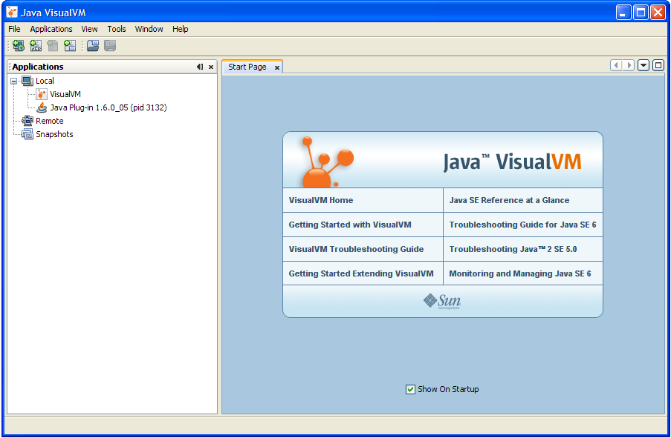

When you first start Java VisualVM, the Applications window is visible in the left side of the window and the Start Page is visible in the right side in the main window. The Start Page contains links to Java VisualVM documentation web pages and additional resources.  
**Note:** The Start Page opens by default each time you start Java VisualVM. You can open the Start Page at any time by choosing Help > Start Page from the main menu. You can also hide the Start page by unchecking the “Show on Startup” check-box.

# Applications Window

The Applications window opens in the left side of the main Java VisualVM window when you launch the application. The Applications window is the main point of entry for exploring the details of running applications. The Applications window uses a tree structure to enable you to quickly view the applications running on the local machine and any connected remote machines. You can also access core dumps (Solaris/Linux) and saved snapshots from the Applications window.

Right-clicking a node in the Applications window opens a popup menu that enables you to perform actions related to that node, including opening application tabs, taking heap and thread dumps and opening snapshots in the main window.

For more details about how to use the Applications window to view and save data, see the following pages:

* [Using the Applications Window](http://docs.oracle.com/javase/8/docs/technotes/guides/visualvm/applications_window.html)

<http://docs.oracle.com/javase/8/docs/technotes/guides/visualvm/applications_window.html>

* [Working with Local Applications](http://docs.oracle.com/javase/8/docs/technotes/guides/visualvm/applications_local.html)

<http://docs.oracle.com/javase/8/docs/technotes/guides/visualvm/applications_remote.html>

* [Working with Remote Applications](http://docs.oracle.com/javase/8/docs/technotes/guides/visualvm/applications_remote.html)

<http://docs.oracle.com/javase/8/docs/technotes/guides/visualvm/applications_remote.html>

* [Working with VM Coredumps](http://docs.oracle.com/javase/8/docs/technotes/guides/visualvm/coredumps.html)

<http://docs.oracle.com/javase/8/docs/technotes/guides/visualvm/coredumps.html>

* [Working with Snapshots](http://docs.oracle.com/javase/8/docs/technotes/guides/visualvm/snapshots.html)

<http://docs.oracle.com/javase/8/docs/technotes/guides/visualvm/snapshots.html>

# Main Window

Detailed information about applications is displayed in the main window. When you view data about an application, each application is represented by a tab in the main window that enables you to easily view and navigate the data. Saved thread dumps and heap dumps are also opened in the main window.

For information about the application data that can be displayed in the main window, see the following pages:

* [Application Overview Tab](http://docs.oracle.com/javase/8/docs/technotes/guides/visualvm/overview_tab.html)

<http://docs.oracle.com/javase/8/docs/technotes/guides/visualvm/overview_tab.html>

* [Monitoring an Application in the Monitor Tab](http://docs.oracle.com/javase/8/docs/technotes/guides/visualvm/monitor_tab.html)

<http://docs.oracle.com/javase/8/docs/technotes/guides/visualvm/threads.html>

* [Monitoring Threads in the Threads Tab](http://docs.oracle.com/javase/8/docs/technotes/guides/visualvm/threads.html)

<http://docs.oracle.com/javase/8/docs/technotes/guides/visualvm/threads.html>

* [Browsing a Heap Dump](http://docs.oracle.com/javase/8/docs/technotes/guides/visualvm/heapdump.html)

<http://docs.oracle.com/javase/8/docs/technotes/guides/visualvm/heapdump.html>

* [Profiling an Application in the Profiler Tab](http://docs.oracle.com/javase/8/docs/technotes/guides/visualvm/profiler.html) (local applications only)

<http://docs.oracle.com/javase/8/docs/technotes/guides/visualvm/profiler.html>

# Java VisualVM Plugins

You can add functionality to Java VisualVM by using the Plugins manager to install plugins from the Java VisualVM Plugins Center. You can also extend the functionality of Java VisualVM by developing your own plugins that can then be added to an update center.

For example, installing the Java VisualVM-MBeans plugin adds an [MBeans tab](http://visualvm.java.net/mbeans_tab.html) to the application tab that enables you to [monitor and manage MBeans](http://docs.oracle.com/javase/8/docs/technotes/guides/management/jconsole.html#gdeap) from within Java VisualVM.

To install a Java VisualVM plugin:

1. Choose Tools > Plugins from the main menu.
2. In the Available Plugins tab, select the Install checkbox for the plugin. Click Install.
3. Step through and complete the plugin installer.

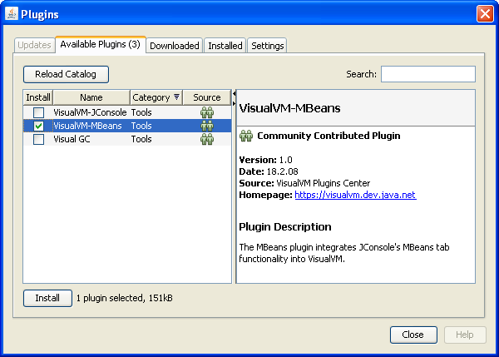

For more information about creating Java VisualVM plugins, see the following documents:

* [Getting Started Extending Java VisualVM](http://visualvm.java.net/api-quickstart.html)

<http://visualvm.java.net/api-quickstart.html>