1. POST /library/signUp

1. POST /library/signIn

1. GET /library/books

1. GET /library/books/:bookId

1. POST /library/checkout/:bookId

1. POST /library/checkout/return-book/:bookId

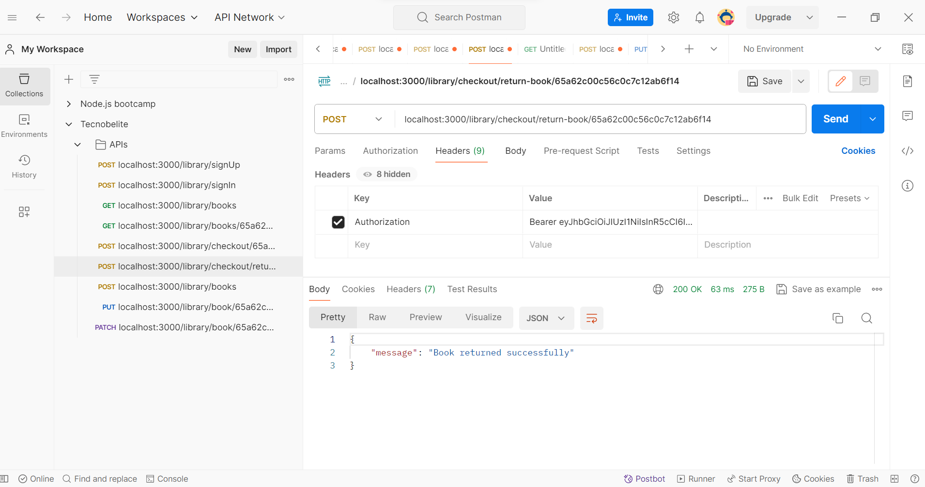

1. POST /library/book

1. PUT /library/:bookId

1. PATCH /library/:bookId

