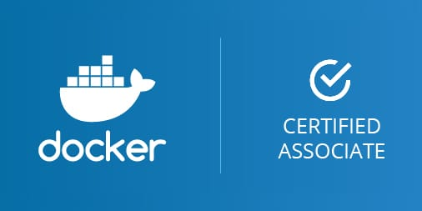 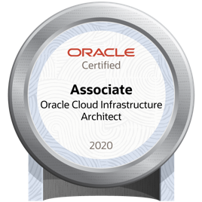

Bangalore  vinay.dhegde@gmail.com  +91 9742291074  www.vinaydhegde.in

 github.com/vinay-d-hegde

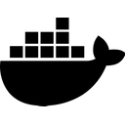 https://hub.docker.com/u/vinaydhegde 

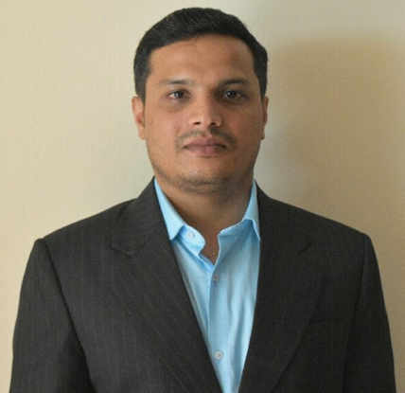

**VINAY HEGDE**

**Sr. Professional,**

**DEVOPS**

*Achievement-driven professional targeting challenging assignments in DevOps/ Build Automation with an organization of repute*

**Devops | Docker Certified Associate | CICD | Automation Scripting**

|  |  |  |
| --- | --- | --- |
| **Core Competencies**   * ***Container Orchestration***   *Docker, DockerSwarm, Kubernetes, Helm Charts*   * ***Cloud Computing Services***   *Oracle Cloud Infrastrcure, AWS*   * ***Scripting/Data serialization***   *Python, Perl, YAML & JSON*   * ***Monitoring Solution***   *Prometheus & Grafana*   * ***Continuous Integration***   *Jenkins*   * ***System Deployment/Infra Automation***   *Ansible & Terraform*   * ***Build Automation***   *Gmake, Omake, Maven, MSBuild*   * ***Version Control Management***   *GIT, ClearCase, TFS* |  | **Profile Summary**   * **Result-oriented professional** with experience of **14 years** in **Devops** and **Build** **Automation**      * **Docker Certified Associate** (DCA) * Oracle Certified **Associate** **Oracle Cloud Infrastructure (OCI) Architect** * Drove, designed, implemented, and maintained **deployment automation** from code check-in to production; supported development activities in all features in **Continuous Integration Platform** and managed all operational activities related to **DevOps systems** * Capable of **effectively communicating** for technical issues with Vendors, and Development, QA, Release Engineering Teams * Experience in continuous integration and continuous delivery framework like **Jenkins** * Skilled in **automating** **build & deploying activities** of applications on various environments using any automation build and deployment tools * Familiar with **Software Development Lifecycle (SDLC)** using the Agile methodology right from requirement analysis, documentation coding & testing, release & deployment, post deployment maintenance |

**Organisational Experience**

**Oracle India Pvt Ltd., Bangalore Aug’18 – till date**

* **Division**: PeopleSoft
* **Role**: Principle Software Engineer, Devops

**Key Result Areas:**

* Implemention of **Docker**/Containerization technique.
* Automate Software configuration in Build Servers using **Ansible**
* Develop/Design System Monitoring Dashboard using **Prometheus** & **Grafana**
* Migrate existing infra & build process to **OCI** (Oracle Clound Infra)
* Managing the build process for multiple concurrent releases
* Designing and configuring continuous integration build system
* Overseeing and ensuring timely software build & releases for organizations
* Performing build automation & support for various subsystems, which use **Python, PHP & Gmake** on different platforms like **Oracle Linux, AIX, HP, Solaris, ZOS & Windows**
* Generate deployment kits using **Python** & **Puppet**

**Philips India Ltd., Bangalore Jun’11– July’18**

**Joined as Technical Specialist & rose to the position of** **Specialist II - DevOps**

**Key Result Areas:**

* Building, deploying, automating and configuring **DevOps** IT solutions
* Managing the build process for multiple concurrent releases
* Maintaining various software feature branches using Version Control System
* Designing and configuring continuous integration build system through collaboration with development and IT teams
* Overseeing and ensuring timely software build & releases for organizations
* Building automated deployments through the use of configuration management technology; deploying new modules and upgrades and completing fixes within the production environment
* Building and supporting:
* Custom tools that facilitate development and QA teams
* Automation for deployment of various components of the product ecosystem

**Major Projects:**

* **Division**: CT, Healthcare
* **Role**: Specialist II - DevOps
* **Period**: Feb’18 – Jul’18
* **Responsibilities**:
* Ensuring source code maintenance using the version control tool- **GIT**, **SubVersion (SVN) & ClearCase**
* Facilitating deployment using **Docker,** clustering with **Kubernetes**
* Performing build automation & support for various subsystems, which use **Python & Ant, in Linux** (Ubuntu) environment
* Enabling continuous integration using **Electric Commander**
* Managing product release activities
* **Division**: MRI, Healthcare
* **Role**: Sr. Technical Specialist
* **Period**: Dec’14-Feb’18
* **Responsibilities**:
* Led development & maintenance of DevOps utilities using, **Ruby, Perl & Python**
* Devised ideas and implemented CI pipeline using **Jenkins**
* Migrated source code from **ClearCase to TFS-GIT**; streamlined build & CI process with TFS & Jenkins
* Facilitated build performance improvement: deep dive analysis & investigation on existing build process in Omake
* Performed POC on distributed build mechanism using **Electric Accelerator & Incredibuild**
* Defined a strategy for assembly referencing in **C# Visual Studio projects** and developed a utility to update the projects, using Ruby & Perl
* Represented DevOps Team in the **SAFe ART** (Agile Release Train)
* **Division**: CGTA, ITApps
* **Role**: Technical Specialist
* **Period**: Jun’11-Dec’14
* **Responsibilities**:
* Led the implementation of TFS as a ALM solution
* Performed item customization in TFS for different process templates like CMMI, Agile
* Facilitated reports customization in TFS
* Managed build automation using **MSBuild, Nant & Cruise Control**
* Implemented CI process using **Jenkins & Electric Commander/Flow**
* Archived restructure of a legacy code base in **ClearCase** and introduced new way of working (process model)
* Ensured fine tuning & maintenance of website for **auto test system configuration**

**Siemens Information Systems Ltd., Bangalore Dec’07-Jun’11**

**Senior Systems Engineer**

**Major Project:**

* **Division**: Industrial Automation and Drive Technology
* **Role**: Senior Systems Engineer
* **Period**: Dec’07-Jun’11
* **Responsibilities**:
* Formulated CM strategies which included branching, labeling, merging, baselining, rebasing
* Developed & published effective lines of code (ELOC) report to Quality Management (QM) Team
* Prepared & generated FXCop, PCLint, Simian, code change report and source monitor reports for each build; published all the metrics reports on CM dashboard
* Wrote build support scripts and automated the build activity for nightly build generation
* Identified & resolved build errors and coordinated with Development Team to correct the build problems
* Built the software using Make, Ant and NAnt utilities
* Released installable media to Testing Teams

**Rishi Systems Private Limited, Bangalore Nov’06-Dec’07**

**Systems Engineer**

**Key Result Areas:**

* Installed & implemented ClearCase and ClearCase multisite on both Windows and Linux environment at client location
* Delivered & organized ClearCase training
* Defined branching, merging and labeling strategy for the new clients/new projects
* Wrote trigger scripts; performed migration of VSS code to ClearCase
* Established & set-up interop server-client environment using samba/ccfs

**Academic Details**

**2006** **BE (Electronics & Communication)** from Vishweshwaraiah Technological University, Bangalore

**Courses & Certifications**

**2021 Oracle Certified Associate Oracle Cloud Infrastructure Architect**

**2020 Docker Certified Associate (DCA)**

**2017** **AWS Solution Architect** Course from SimpliLearn

**2016** **SAFe Practitioner (SP) Certification** through ScaledAgileAcademy

**2015** **Ruby on Rails (RoR) Training** (3 months course) through DCT Academy

**Technical Skills**

|  |  |
| --- | --- |
| **Containerization Tools** | Docker, Docker Swarm & Kubernetes |
| **Scripting Languages**  **Data Serialization**  **Monitoring Solution**  **Config Management/Infra Automation** | Perl, Python, Ruby, Shell Scripting  YAML & JSON  Prometheus & Grafana  Ansible & Terraform |
| **Development Methodologies** | SAFe (Scaled Agile Framework) |
| **ALM Tools** | ALM GIT, Bitbucket, TFS & GitHub |
| **Source Control Tools** | GIT, TFS & ClearCase |
| **Make/Build Utilities** | Gmake, Maven, Omake, Ant & MSBuild |
| **DBMS** | MS SQL, Oracle DB |
| **Others** | Ruby on Rails (RoR) Web Framework, HTML & CSS |

**Personal Details**

**Date of Birth:** 11th September 1983

**Languages Known:** English, Kannada & Hindi

**Address:** B-109, Nandi Citadel, Nobel Residency Road, Chandrashekarpura, Akshayavana, Bangalore – 560076

**Visa Details:** USA Business Visa, valid till 2028