Shubh Vastu AI Astro

Phase 1 System Design

STATUS  Proposed |  | OWNER  Client owner |  | UPDATED  18 Oct 2026

Authors | Development team
Reviewers | Dr. Jagdish Mohan Mavlankar and client owner
Related docs | UI prototype: ui-prototype.html
Scope | Phase 1 PWA and UI design

1. Abstract
Launch an Android-installable PWA for Shubh Vastu Consultancy, with Marathi as the default and Hindi and English support. React provides the customer interface; a Firebase backend controls identity, quotas, payments and access to AstrologyAPI.
Phase 1 includes birth charts, AI Guruji, basic Vastu, a gated Prashna workflow and prepaid memberships. Reliable provider data is required for every chart interpretation. The design targets an initial pilot of 100 paying users; this is a planning scenario, not a capacity guarantee.

2. Goals and Non-Goals
Goals | Non-goals
Marathi, Hindi and English customer journeys | Native Android or Play Store release
Verified birth charts and traceable AI interpretations | Guaranteed predictions or invented positions
Paid plans with server-enforced usage limits | Paid PDF reports and marriage matching
Mobile usability, ownership and cost controls | Floor-plan image analysis and automatic renewal

3. Background and Problem Statement
Customers need accessible regional-language guidance and a clear route to Dr. Jagdish Mohan Mavlankar. The product must distinguish traditional interpretations from practical advice and make subscription limits visible before customers pay.
The client owns the source code, domain and service accounts. The PWA cannot call paid providers directly. The backend is the sole authority for paid entitlements and calculation provenance. A full paid MVP exceeds the original INR 10,000 budget; reduce scope if that ceiling remains fixed.

4. Proposed Architecture

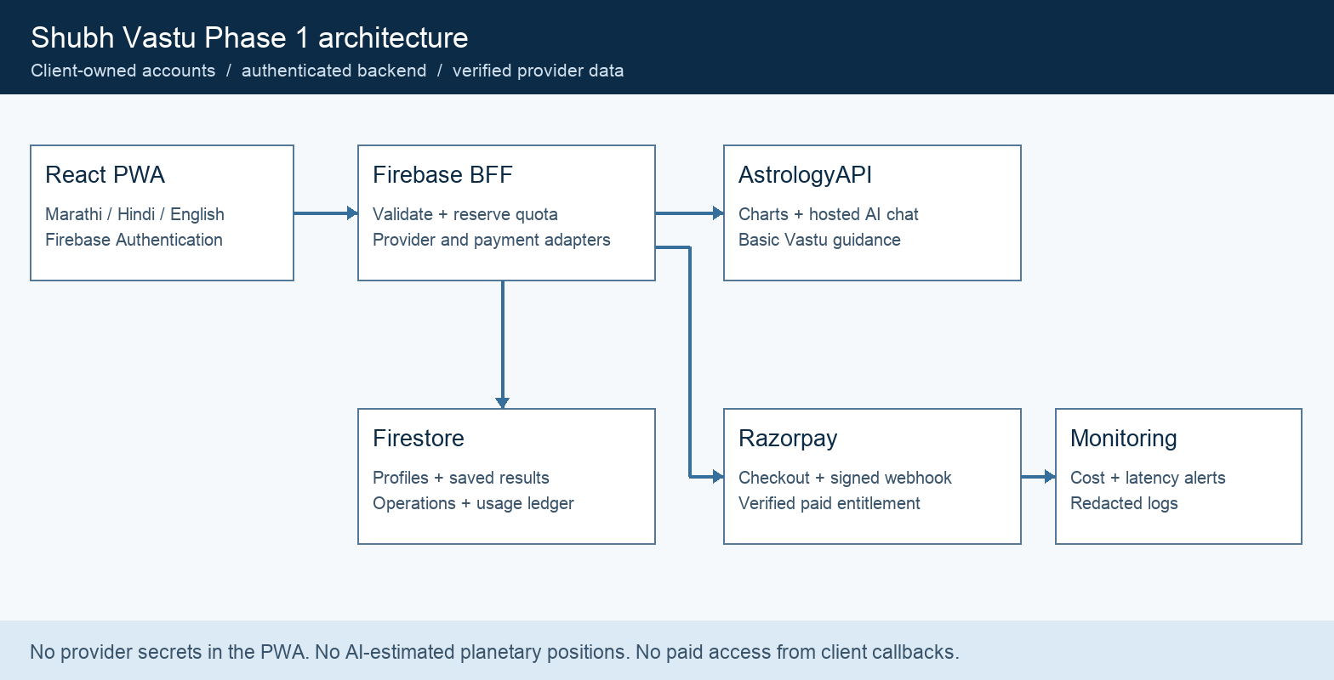
Figure 1. Customer requests cross the backend before reaching paid services.

Core components

Component | Responsibility | Primary storage | Failure behavior
React PWA | Forms, chat, plan display and language selection | Local UI preferences | Offline notice; no new paid calls
Firebase BFF | Validate, reserve quotas and orchestrate providers | Firestore operations | Fail closed; reconcile pending work
AstrologyAPI | Chart JSON, hosted chat and basic Vastu | Vendor service | Show unavailable; never invent facts
Firebase data | User records, saved output and usage ledger | Firestore | Do not start calls if reservation fails
Payments and ops | Razorpay webhooks, alerts and support | Payment ledger | Pending access until verified

5. Request Lifecycle
- A signed-in customer submits a birth profile, question or Vastu assessment with a unique request ID. The interface shows the relevant allowance before submission.
- The backend verifies the Firebase ID token, resource ownership, payload limits and rate limits. It normalizes birth time, location, timezone and calculation settings.
- Load the server-owned plan version, active period, quota counters and consent state. Reuse valid cached natal data only when the complete calculation key matches.
- Atomically reserve the required allowance and create a pending operation. Call the selected provider adapter outside the Firestore transaction; never make external calls inside a retried transaction.
- Persist provider responses and provenance before marking the operation complete. AI receives verified chart facts; missing facts produce a clarification or unavailable state, not guessed positions.
- Use explicit provider deadlines. Retry only safe reads with bounded backoff. A timed-out chat or payment call is uncertain; reconcile it rather than blindly issuing duplicate billable work.
- Commit usage once on successful delivery; release the reservation on confirmed failure. Return the saved response and remaining quota. Log request IDs, latency and costs without birth details or message bodies.

6. API and Data Contracts

Primary data contract

Field | Type | Required | Description
requestId | UUID | Yes | User-scoped idempotency key; reject changed payload.
operation | Enum | Yes | chart, chat, vastu or prashna; validated allowlist.
profileId | String | Conditional | Owned saved profile for chart-dependent requests.
locale | Enum | Yes | mr, hi or en; Marathi is the default.
inputs | Object | Yes | Validated birth, question or property fields.
provenance | Object | Server | Endpoint, input hash, timezone, settings and timestamp.
status | Enum | Server | pending, succeeded, failed or uncertain.

Contract guarantees

- Plan enforcement and payment verification happen on the backend. Client-visible prices and counters cannot grant entitlement.
- Use a request ID scoped to the user and operation. Reject the same ID with a different payload. Deduplicate payment events by provider event ID.
- Store provider name, endpoint, calculation settings, input hash, schema version and calculation timestamp. Pin the plan and prompt version for each operation.
- Provider calculations supply chart facts. AI output is an interpretation and must not override those facts. Payment webhooks and reconciliation establish paid access.
Implementation contracts will live in contracts/openapi.yaml and contracts/schemas/.
These are planned repository paths; freeze v1 schemas and representative fixtures during milestone M1.

7. Consistency, Idempotency, and Replay

Firestore transactions serialize entitlement changes and quota reservations. External provider execution cannot be made exactly once without vendor support. A durable operation record allows pending and uncertain attempts to be reconciled without charging the customer twice.
Scenario | Expected behavior | Reasoning
Duplicate request ID | Return saved output or pending state. | One customer quota debit per operation.
Reservation write fails | Return retryable error; no provider call. | Avoid untracked paid work.
Provider timeout | Mark uncertain; reconcile or resolve via support. | A timeout may still be billed by the vendor.
Plan changes mid-request | Use reserved plan version and period. | Prevent ambiguous quota changes.

8. Security and Privacy Considerations

- Use Firebase Authentication with Google sign-in in the MVP. Firestore rules restrict users to their own profiles and saved results. Deny direct writes to payments, entitlements, usage and operations.
- Collect only necessary birth and property information with clear consent. Do not place birth details, questions or access tokens in URLs, analytics or routine logs. Keep sensitive responses out of service-worker caches.
- Store provider keys and webhook secrets in Secret Manager. Use separate development and production projects, least-privilege service identities and server-only credentials.
- Require privileged roles for support tools. Keep provider calls and quota mutations behind authenticated routes; add per-user limits and App Check where supported. Disable sensitive debug logging in production.
- Offer deletion of profiles and saved conversations. Propose 90-day chat retention and profile retention until deletion, subject to client approval. Keep legally required payment records separately; verify provider retention and region availability before launch.

9. Operational Readiness
Signal | SLO or alert | Owner | Launch gate
Successful requests | Proposed target >= 98% over 7 days | Developer | Pilot validation
Latency | Proposed p95: chart < 10s, chat < 30s | Developer | Measure vendor
Cost and wallet | Alert at 70% and 90% of budget | Client + dev | Required
Entitlement integrity | Zero duplicate grants in replay tests | Developer | Required
Recovery checks | Test timeout, rollback and account deletion | Developer | Required
Rollout: invite-only pilot; feature flags for paid calls and Prashna. Disable new paid work when the configured server budget is reached. Keep saved results readable.

10. Alternatives Considered

Alternative | Why considered | Decision
Native Android | Play Store distribution and native features | Defer; PWA minimizes initial build scope.
Direct browser API calls | Fewer backend components | Reject; exposes keys and bypasses quotas.
Own OpenAI or Gemini layer | Control prompts and response quality | Fallback if hosted chat fails validation; re-cost first.
Fixed AstrologyAPI plan | Predictable bill at higher volume | Begin with pay-as-you-go; assess eligible call mix.

11. Open Questions
- Vendor validation: confirm Marathi quality, chat context and calculation provenance, Vastu response structure, commercial caching rights and failure billing.
- Prashna: consultant must approve the question-time method, required coordinates, chart settings and interpretation workflow before this feature is enabled.
- Commercial terms: confirm tax treatment, refunds, renewal terms, usage expiry, third-party invoices and actual launch traffic. Proposed prices are not an approved tariff.
- Launch ownership: client supplies final logo, domain choice, privacy copy and consultant sign-off. Select Firebase region after checking function and database availability.

12. Decision and Next Steps
Proceed with a five-week, milestone-based PWA build after a vendor spike. Start with a small invited pilot, validate Marathi responses and payment reconciliation, then expand only after cost and error metrics meet the agreed gates.
Milestone | Deliverable | Exit criteria
M1 Week 1 | Vendor spike and signed scope | Language, endpoints and cost assumptions validated
M2 Weeks 2 to 3 | PWA, identity, chart, chat and Vastu | Owned data rules and core flows pass tests
M3 Week 4 | Plans, checkout and usage ledger | Webhook replay and concurrency tests pass
M4 Week 5 | Pilot, QA and client handover | Consultant sign-off; alerts and rollback demonstrated

13. UI Design and Customer Journeys
Use white surfaces, deep blue navigation, royal blue primary actions and restrained teal accents. Present home services as compact rows rather than repeated cards. A geometric sun mark is a proposed placeholder until the client supplies a logo. Use system Devanagari fonts and generous line height; keep all inputs and touch targets at least 44 pixels high.
Screen | Primary action | Required states
Home | Ask AI Guruji or create a birth chart | Marathi welcome, language control, usage summary
Birth Chart | Confirm birth data and generate | Missing or unknown time, place selection, loading, unavailable
AI Guruji | Ask and follow up | Profile needed, thinking, sourced response, quota exhausted
Vastu | Submit directions and room details | Missing direction, traditional guidance, practical advice
Prashna | Confirm question time and place | Method not enabled, confirmation, calculation failure
Plans | Choose a 30-day prepaid plan | Current plan, pending payment, confirmed payment
Consultation | Open WhatsApp | Consultant profile; separate human consultation fee
Navigation: Home, Guruji, Birth Chart, Vastu and More. More contains Prashna, Plans and Contact. On desktop, show these sections in a persistent sidebar. A language switch preserves the current flow and local input values; translate app copy with react-i18next and Ant Design component labels with ConfigProvider.
The prototype is a local interactive design, not a live service. It demonstrates all seven screens in Marathi, Hindi and English. Forms show a safe provider-unavailable state; no astrological results, payments or authentication are simulated as successful.
Detailed output layout: verified calculation summary, traditional interpretation, practical considerations, limits and consultation action. Display provider and calculation timestamp. Never show fabricated chart geometry or planetary values while loading. Unknown birth time blocks ascendant and time-sensitive conclusions.
Accessibility: visible focus, semantic labels, readable contrast, status announcements, keyboard access and error text next to the affected field. Respect reduced motion. Test at 360 px, 390 px and desktop widths with long Marathi labels.

14. Backend Interfaces and Data Model
Interface | Purpose | Controls
POST /v1/profiles | Save birth data and confirmed location | Ownership, consent, timezone validation
POST /v1/charts | Create or reuse a verified chart | Chart allowance; complete cache key
POST /v1/chat | Submit question or follow-up | AI allowance; session ownership; context limit
POST /v1/vastu | Basic directional assessment | Vastu allowance; validated directions
POST /v1/prashna | Question-time chart workflow | Feature flag; consultant-approved method
POST /v1/checkout | Create provider payment order | Server price and plan version
POST /v1/webhooks/razorpay | Verify and reconcile payment events | Raw-body signature; deduplication
GET /v1/me/usage | Show current period and allowances | Authenticated user only
Firestore collections: users/{uid}, profiles/{id}, conversations/{id}/messages/{id}, results/{id}, entitlements/{uid}, usage/{uid_period}, operations/{uid_requestId}, payments/{paymentId}, webhookEvents/{eventId}, and versioned plans/{planId}. Store ownerUid on owned records; use server timestamps and validate collection-specific rules.
Birth profile: local date and exact time, selected place label, latitude, longitude, IANA timezone, UTC instant and time certainty. Cache keys include normalized inputs, ayanamsa, chart settings, provider and calculation version. Natal data can be reused; transits and Panchang require date-sensitive keys and expiry.
AstrologyAPI adapter: geo_details, timezone_with_dst, astro_details, planets, horo_chart/:chart_id, major_vdasha and current_vdasha form the proposed chart bundle. Guruji uses hosted /api/chat with Standard or Advanced level. Basic Vastu uses score, findings and remedies. Confirm exact routes, auth, response shapes and language support in M1.
Payment flow: create order, complete checkout, show pending, receive signed webhook, verify captured payment and matching amount/currency, then activate a 30-day period atomically. Do not activate from a browser success callback. For MVP, prohibit overlapping purchases; refunds and disputes require recorded entitlement adjustments.

15 Commercial Model and Sources
Planning estimates carried forward from the pricing discussion on 17 October 2026. Validate the live vendor catalogue before purchase. AstrologyAPI hosted chat is the AI layer; a separate OpenAI or Gemini invoice is not included. Prices exclude applicable taxes and acquisition costs.
Plan and price | 30-day allowance | Contribution at full use
Free INR 0 | Lifetime: 3 AI questions and 1 chart | Cost INR 2.16 per activated trial
Basic INR 49 | 20 Standard AI, 1 chart, 1 Vastu | INR 36.12 or 73.7%
Standard INR 149 | 75 Standard AI, 3 charts, 3 Vastu | INR 102.80 or 69.0%
Premium INR 349 | 150 AI; 5 charts; 5 Vastu | INR 211.48 or 60.6%
Assumptions: chart bundle INR 0.66; Standard chat INR 0.50 per question; Advanced INR 0.80; basic Vastu bundle INR 0.75; payment reserve 3%. Each follow-up counts. Cached viewing is free; changed inputs count as a new calculation. No rollover. Contribution excludes fixed maintenance and build recovery.
Monthly scenario: 50 Basic, 35 Standard, 15 Premium and 100 new Free users. Revenue INR 12,900; API budget INR 4,200–4,700; Firebase INR 0–500; domain annualized INR 100–150; maintenance INR 1,500–2,500; payment reserve INR 387. Operating surplus INR 4,663–6,713 before taxes, marketing and development recovery. This is not guaranteed profit.
Developer proposal: INR 45,000 one time, split INR 18,000 / 18,000 / 9,000, with 30 days of defect fixes. Then INR 1,500–2,500 monthly for agreed support hours; new features quoted separately. Vendor bills belong to the client. A sub-INR 10,000 budget requires a smaller unpaid pilot.
Firebase uses Blaze billing for backend functions. Small-pilot estimates: Firestore INR 0–150; Hosting INR 0–100; Functions, secrets and logs INR 0–250. Google sign-in avoids SMS charges. Domain registration is separate and the proposed domain has not been checked for availability.
Sources: astrologyapi.com/credits-calculator; astrologyapi.com/developers/v1/chat-api; astrologyapi.com/developers/v1/guides/pay-as-you-go; firebase.google.com/pricing; razorpay.com/pricing. Hosted chat rates may be introductory. Marathi quality, Prashna compatibility and any additional endpoint costs remain launch gates.

Build estimate excludes taxes, service bills and future-phase features.

